SLAC Magnetic Measurement Plan and Traveller for LCLSII RF Gun Solenoid Type 2.90SO8.209, known as SOL1B, and its associated magnets, dated 19th August 2013
This magnetic measurement plan and traveler is for the LCLS-II gun solenoid magnet (SOL1B), its associated corrector dipoles (XC00B & YC00B), internal corrector quadrupoles (CQ01B, SQ01B), and the gun solenoid bucking coil (SOL1BKB). The quadrupole correctors are incorporated into the gun solenoid magnet. The X & Y dipole correctors are attached directly to the beampipe inside the solenoid magnet, and the bucking coil (also a solenoid) is attached to the rear flange of the photocathode gun when in the beamline. For the magnetic measurements a special jig will be provided to hold the bucking coil in place. All these magnets are exact replicas of the ones made for LCLS and it will be helpful to look back at the information kept from when they were measured in May-July 2006; this old magnetic measurement data can be found here;
http://www-group.slac.stanford.edu/met/MagMeas/MAGDATA/LCLS/Solenoid/SOL1/ .
The details of the solenoid design and analysis can be found in LCLS-TN-05-14. A jpg file showing the positions of the solenoid, bucking coil and plane of the gun’s cathode will be provided.

The solenoid is about 8.3" long, 17.4 "tall and 17.4 wide, it weighs about 334 lb. When the special jig/spool piece carrying the bucking coil and X & Y correctors is added to the solenoid, the overall length will be about 14.6".

Receiving Information

Gun Solenoid
Received by (MMG initials) | SDA
Date received : (dd-mm-yyyy): | 7/25/2013
Look for Magnet Beamline Number and type it here. | SOL1B
Look for serial number on vendor plate and type it here | 23355
Enquire if Magnet Engineer has authorized MMG to do the magnetic measurements in this plan.
If solenoid does not have a barcode sticker then ask Magnet Engineer to add one and in any event write the 6 digit barcode number here: | 002748

Upon receipt of the magnet, the following information should be recorded:

Responsible measurement operator name (initials): | SDA

Verify that the magnet is complete and undamaged, including wiring and water cooling connections.

Incoming inspection OK (initials): | SDA

Bucking Coil and X and Y Correctors, on a special spool.
Will be delivered by Erik Jongewaard, who authorizes their measurement by their delivery to MMG
Received by (MMG initials) | SDA
Date received : (dd-mm-yyyy): | 8/7/2013
Look for bucking coil magnet beamline number and type it here. | Probably no labels on this temp b. coil. It will be SOL1BKB
Look for serial number on vendor plate and type it here
Look for X and Y correctors beamline numbers and type them here | Probably no labels. Will be XC00B & YC00B
The bucking coil will not have a barcode sticker. It is part of the solenoid assembly and shares the solenoid’s barcode.
The X&Y corrector assembly will not have a barcode sticker. They are part of the solenoid assembly and share the solenoid’s barcode.

Power Supplies Required and LCW Required

Power Supply for the solenoid SOL1B
A unipolar supply capable of producing 240 amps up to 30 volts will be needed. In the beamline the solenoid's PS will be controlled with a EPIC controller with a cosine theta ramp. Please arrange for your PS to ramp this way.

Power Supply for the bucking coil SOL1BKB
A bipolar 6 amp MCOR supply will be needed to power the bucking coil.

Power Supplies for the internal quadrupole correctors, CQ01B and SQ01B
Two bipolar 12 amp MCOR supplies will be needed to power the quad correctors.

Power Supplies for the X and Y dipole correctors, XC00B and YC00B.
Two bipolar 6 amp MCOR supplies will be needed to power the dipole correctors. In the beamline all these MCORs will be controlled on the "3-linear trim" mode. Please have your MMG MCORs mimic this way of ramping.

LCW Required
The solenoid has 8 parallel cooling water circuits and the LCW should be provided at a delta pressure of 100 psi, this should produce a total water flow of 4.8 gpm. All the other magnets have solid wire coils. ” Someone” needs to make the Synflex hoses for this solenoid; at this moment I don’t know if there is a manifold for all these hoses, MMG can probably provide their own hoses for their test set-up in building 26.

Magnets Orientations Relative to Beam Direction
A beam direction arrow is visible on the gun solenoid and the bucking coil and correctors will come to MMG already oriented on their special spool piece. If there is no beam direction arrow on the bucking coil then add a temporary one, it sits upstream of the solenoid.
Solenoid beam-direction arrow in place (initials): | SDA
Bucking coil beam-direction arrow in place (initials): | Can only be installed one direction -SDA

Name and URL of Magnetic Measurements Data Files
All the data files MMG generates should be placed in a subdirectory which has the beamline name of the gun solenoid as its identifier; the data files showing the effects of the bucking coil and various correctors will all be stored in the solenoids sub-directory. The major directory should include the name LCLS2.
Enter URL of on-line magnetic measurements data (please modify or correct if necessary):
http://www-group.slac.stanford.edu/met/MagMeas/MAGDATA/LCLS2/solenoid/SOL1B

Solenoid Fiducialization and Set-up on Table in MMG Lab in Bld 26
The solenoid will have been fiducialized on the CMM and with the Faro arm according to these instructions:

The solenoid magnet should be fiducialized by the Metrology Group using the CMM in building 25, using the same methodology as was used for the LCLS gun solenoids. This will require the installation of removable tooling balls, location of the geometric axis of the bore of the magnet, and location of tooling balls with respect to the X, Y and Z center of this geometric axis. Five tooling ball holes have been created in the upstream endplate of the solenoid magnets. The tooling ball holes in the flux return plates WILL ALSO BE USED.
The following measurements should be made:
- Precise location of the axis of the magnet, relative to the bores of the endplates (not to the inner bore of the magnet, which is only a carrier for the corrector coils).
- Measurement of the perpendicularity of the endplates with respect to the axis.
- Flatness of the endplates.
- Distance between the endplates.
- X and Y locations of the downstream bore relative to the upstream bore.
CMM technician (initials):
Date CMM performed (mm-dd-yyyy):

URL of on-line CMM fiducialization data (please modify or correct URL if necessary):
\\Web07\www-group\met\Quality\FIDUCIAL REPORTS\LCLS II SOLENOID

Set up the solenoid on a flat, horizontal and stable and not-steel support table.
Hook up the LCW hoses and the power connections (see next section for polarity definition).

Polarity of Solenoid and Bucking Coil
Hook up the power leads so the direction of the magnetic field along the beam direction is as shown in figure 1.

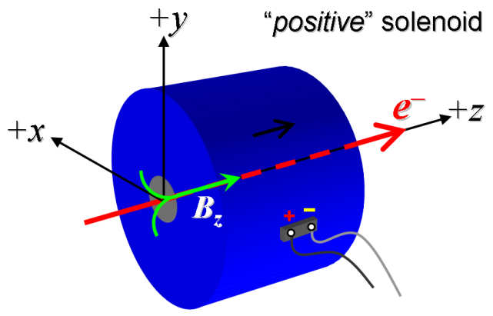

Figure 1. Polarity of solenoid field with positive power supply output current (‘normal’ polarity). The bucking coil should also produce this field orientation when in positive polarity.

Beam direction arrow applied (initials): | SDA
Magnet polarity (Fig. 1) has been marked (initials): | SDA
Name of photograph file: | SOL1B Hall Setup 003.jpg

Alignment of Solenoid and Hall Probe
Set up a precise 1-axis Hall Probe so it sits in the bore of the solenoid, at the geometric center as best as one can tell by eye. Then the Alignment Crew will make sure the solenoid is sitting horizontal on the support table and will alter the position of the Hall Probe sensor so it is at the geometric center of the solenoid’s bore and it will travel along the geometric Z axis as it is moved on its arm. Later on, if it turns out the magnetic centerline is quite different from the geometric axis, then the Hall Probe will be re-aligned along the magnetic axis.

Solenoid sitting horizontal confirmed | SDA
Hall Probe aligned to move along z axis of solenoid | SDA

Test Sufficient Water Flow
With 100 psi delta P across the LCW manifold run the LCW through the 8 parallel LCW cooling circuits and measure how much the total water flow is – should be 4.8 +/-0.2 gpm. If it is less than 4gpm at 100 psi then check for blocked hoses.
Delta P in effect when LCW flow measured: 120 | Total LCW flow: | Date

Standardization Procedure for the Solenoid
Considering the capabilities of the power supply the solenoid will run off in the beamline and the solenoid’s resistance, the maximum standardization current will be 240 amps. The standardization cycle will go between 5 and 240 amps using a cosine theta approach to the end points of any ramp. The equivalent linear ramp rate during the standardization should be 15 amps per second. The equivalent linear ramp rate during ramping to an operating current should be 5 amps per second.
Pause times at 5 amps and 240 amps during the standardization procedure are to be 30 seconds. The pause time before a magnetic measurement should start, after an operating current has been reached, is 10 seconds.
The number of standardization cycles will be three, ending at 5amps.

Thermal tests for main and trim coils

MAIN COILS
Run the solenoid at 240 amps for 2 hours and record the temperatures on at least one pancake coil and one mirror plate and the inner bore every 2 minutes; also the magnet’s resistance, and input and output LCW temperatures.

Ambient temperature (°C) at start of test: | 30.39 °C
Ambient temperature (°C) at end of test: | 30.76 °C
Final LCW delta temperature (°C): | 1.65 °C
Temperature Run | Rtdat.ru1

Inform the responsible magnet engineer when this thermal test's data is available, it need to be checked before any further measurements are taken on the solenoid.

QUADRUPOLE TRIM COILS
Turn off the main coils, but leave the LCW running.
Put a thermocouple or two on the surface of the solenoid's aperture (without the X-Y correctors there). Place them close to where you know the quad correctors' windings pass.
Place other thermocouples on a mirror plate, one on a main coil, on LCW input and output (where you put them for the main coil thermal test).
Turn the quad and skew quad corrector on to 6 amps each and take the thermocouples' readings every 2 minutes for at least 4 hours. The quad corrector’s PS can provide 12 A, but very unlikely will need over 6 A.
If the temperatures are still increasing then continue with the test until they appear to be leveling off.

Ambient temperature (°C) at start of test: | °C
Ambient temperature (°C) at end of test: | °C
Solenoid aperture surface temperature at start of test: | °C
Solenoid aperture surface temperature at end of test: | °C

Initialization of the solenoid
In case this solenoid was run in its past in the opposite polarity to what is required, it must be taken through an initialization procedure, just once, before any magnetic measurements are taken:
Run the solenoid through 5 standardization procedures, that is 5 times 3 = 15 cycles from 5 to 240 and back to 5 amps.

Initialization carried out by | Name of operator Scott Anderson | Date 8/19/2013

Establish the nominal operating current of the solenoid so that current can be used to find the magnetic axis of the solenoid
The nominal field value of this solenoid, at its center in X,Y and Z is 0.2422 T. From calculations and previous solenoid's measurements it is predicted the nominal operating current is around 170 amps. We need to find the magnetic axis at the nominal operating current, so we first need to establish what that current is. Follow this short procedure:
(a) Standardize the solenoid.
(b) Put the Hall Probe at the center of the solenoid, i.e. at X,Y and Z =0.
(c) Measure the B(z) component at 165, 170 and 175 amps
(d) From these three measurements calculate the current that produces a B(z) of 0.2422T .
B(z) measurement run | bhvszdat.ru2. See Fit for Bz vs current to find Bz = 0.2422.bmp for linear fit.

Nominal operating current to produce 0.2422T | I _{nom} =163.497 | Date and operator 8/22/2013

Short rotating coil measurements to determine the magnetic axis:

Remove the X and Y correctors from the bore of the solenoid so the short rotating coil can be set up and used as described below.
- Align the short rotating coil so it travels in the z-direction, along the mechanical axis of the solenoid.
- Standardize the magnet and set the current to I_{nom,} as determined in step 12.
- Position the short rotating coil at the beam entrance to the solenoid with the coil longitudinally (z-axis) centered in the plane of the solenoid end plate. Adjust the rotating coil in the transverse direction (x and y) to minimize the dipole field. Record the coordinates relative to the mechanical axis (as known through the tooling balls) below and in the data file.
- Position the short rotating coil at the beam exit of the solenoid with the coil longitudinally (z-axis) centered in the plane of the solenoid end plate. Adjust the rotating coil in the transverse direction (x and y) to minimize the dipole field. Repeat steps 3 and 4 and take an average of their data. Record the coordinates relative to the mechanical axis (as known through the tooling balls) below and in the data file.
- Determine the line between the points found in 3 & 4 and move the rotating coil along this z-line for the next set of measurements. This line is the magnetic axis of the solenoid. Complete the table below with listed coordinate values in thousandths of an inch (=mils).
- Have Alignment Crew make any necessary adjustments to the orientation of the solenoid so the Hall Probe or short rotating coil will move along the magnetic axis. Fill in following table.

Data filename:

Where to measure the minimal dipole component | x | y
Magnetic center at solenoid entrance (mil)
Magnetic center at solenoid exit (mil)
Magnet axis displacement error (mil)
Magnet axis angle error (mrad) |  | mrad
Describe the adjustments Alignment make to the solenoid’s orientation

Calibrate the skew, SQ01B, and normal quadrupole, CQ01B, correctors using a long rotating coil:

- Turn off the main solenoid power supply in a controlled way, but leave the LCW running.
- Connect the normal and skew corrector leads so that the 4 poles of the correctors have the north and south polarities shown in figure 2 below. Put plus and minus sticky labels on the appropriate terminal block screws and label which pair of screws are for the normal quad and which for the skew quad.

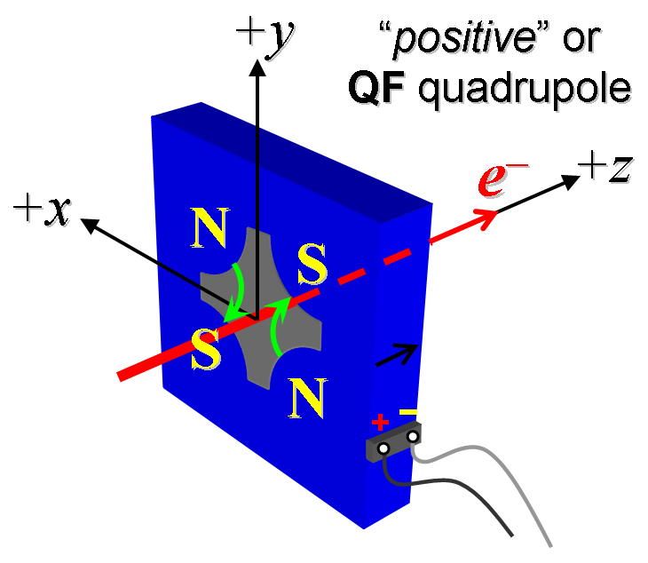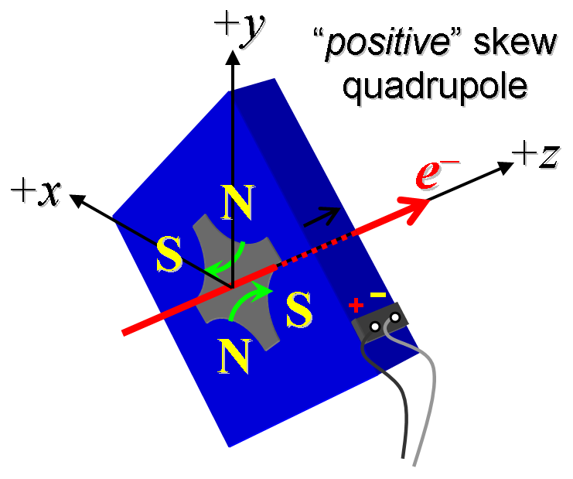

Figure 2. Connect normal and skew quadrupole leads to create the polarities as shown above.
- Install a long rotating coil through the solenoid’s aperture, it must be at least 60 cm long and be positioned so it senses the field of the bucking coil as well as the fringe field of the solenoid. Align this long coil to the magnetic axis of the solenoid which was determined in step 13. Set the angular orientation of the wires in the rotating coil so the first normal quadrupole’s pole is at 45 degrees.
- Turn on the normal quadrupole corrector’s power supply and set it to -6 amps. (Do not do any standardization). Measure the integrated gradient and harmonics up to at least n= 16 at -6, -3, 0, +3, +6 amps. Quote the harmonics in the data file at r = 1 cm. Fill in the table below with the name of the rotating coil and the strength and harmonics data files.
Name, radius and length of rotating coil
Name of normal quad strength calibration data file:
Name of normal quad harmonics calibration data file

- Turn off the normal quad corrector’s power supply and turn on the on the skew quadrupole corrector’s power supply and set it to -6 amps. (Do not do any standardization). Measure the integrated gradient and harmonics up to at least n= 16 at -6, -3, 0, +3, +6 amps. Quote the harmonics in the data file at r = 1 cm. Fill in the table below with the name of the rotating coil and the strength and harmonics data files.
Name, radius and length of rotating coil
Name of skew quad strength calibration data file:
Name of skew quad harmonics calibration data file

- Take a photo of the terminal block which has the quad correctors’ leads, properly labeled, attached to it. Inform the cognizant magnet engineer when the data files are available to study; do not proceed to the next step before said engineer gives the go-ahead.
Polarity of norm. & skew quad correctors labeled | Initials and date:
Photograph file name:

Install the bucking coil, near, and dipole correctors, inside the solenoid’s aperture
Take the spool piece which has the solid wire bucking coil and a pair of solid wire dipole correctors already installed on it at their correct relative positions and insert the correctors into the solenoid’s aperture, so that the bucking coil is upstream of the solenoid. The distance between the z center of the solenoid and the z center of the bucking coil should be 9.182” (+/- 0.010”). The length of the solenoid, from the outer surface of one mirror plate to the outer surface of the other is 8.209”. Refer to the drawing provided separately to see all the distances and dimensions of the magnets. Orient the rotation of the spool piece so the horizontal coils of the Y corrector are as horizontal as you can make them.

Bring the corrector leads out through the holes of the disk at the end of the spool piece, label them.

Connect up the bucking coil and X and Y correctors to produce the magnetic polarities shown here
Refer to section 6 and figure 1 for the definition of the bucking coil’s magnetic polarity, namely it will be the same as the main solenoid’s polarity, so the bucking coil’s current will be a negative current when it is running to reduce the fringe field of the solenoid to zero.

Refer to figure 3 below for the definitions of the polarities of the X and Y correctors.
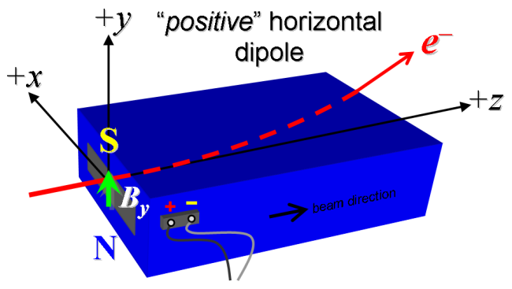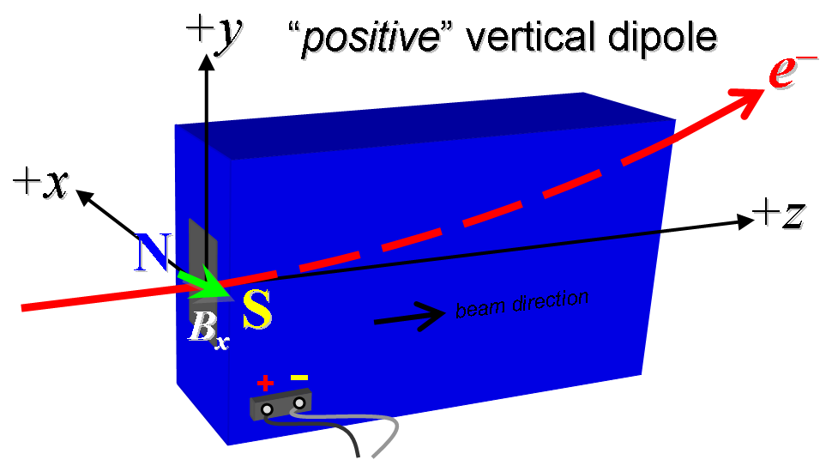
Figure 3. Definitions of the magnetic polarities of the X and Y correctors for positive currents

Put plus and minus labels next to the appropriate terminal block screws, put numbered labels next to each screw on the terminal blocks and wrap the same number around the coil lead that attaches to that screw. Take digital photographs of the whole set-up from various viewpoints and close-up photos of the terminal blocks and post them in the same directory as the measurement data.
Electrical polarities of X & YCOR labeled | Initials and date:
Electrical polarity of bucking coil labeled | Initials and date:
Photographs taken of set-up & terminals | Initials and date:

Hall probe measurements of the axial B field at the z center of the solenoid at range of currents
- Align the Hall probe to travel along the magnetic axis (centerline) of the solenoid [this axis was determined in section 13.]
- Position the Hall probe at the Z center of the solenoid and at the X=Y=0 position of the magnetic axis.
- Standardize the solenoid as described in section 9. Do not turn on the bucking coil or any correctors.
- Measure the axial field, B_{z}, at the following currents: 5, 10, 20 and in steps of 10 amps up to 240 amps. Inform the cognizant magnet engineer when this dataset is available so they will analyze it to determine the nominal operating current (= that which produces an axial field at the center of 0.2422T) more precisely than when it was found in section 12.
Name of file with B_{z} measured from 5 to 240 A
Nominal operating current to produce 0.2422T | I _{nom} | Date and operator

Calibration of the bucking coil and Hall probe measurements of the longitudinal field distribution
- Determine the Z position of the Hall probe when it is where the plane of the RF gun's cathode would be. The plane of the cathode will be 3.6135 inches upstream of the outside surface of the upstream mirror plate of the solenoid. Calculate the cathode location in the solenoid's coordinate system and put its value in the window below. Position the Hall probe at the cathode location to within 0.001”.
Position of gun cathode given in solenoid's coordinate system | Z=

- Turn off solenoid power supply and disconnect to assure zero current.
- Position hall probe at cathode location. Measure B_{z} vs. bucking coil current for I_{buck} = −6, −4, −3, -2, -1, 0, 1, 2, 3, 4, 6 A.
Name of bucking coil V. current measurements file:

- With solenoid still off, measure B_{z} vs. z for I_{buck} = 6 A. The measurements should be done around the X, Y, Z center of the bucking coil, from z = −20 cm to +20 cm in 2-mm steps, where z = 0 is the bucking coil center and X=Y=0 are based on the solenoid's coordinate system. Note the value of the bucking coil's Z center in the solenoid's coordinate system.
Name of magnetic field measurements file:
Position of Hall probe in solenoid's coord system

- Re-connect the solenoid to it’s PS. Standardize the solenoid and set the current to I_{nom} as was determined in section 16. Turn on the bucking coil, it does not get standardized.
- Adjust the bucking coil current so it cancels the solenoid field at the cathode location. Record bucking coil current required:
Bucking current to null solenoid field at I_{nom} | A

- Repeat Steps 2 & 3 for solenoid currents of 100, 125, 150, 175, 200, 220, and 240 amps. Put all the bucking coil currents in one data file and record the file's name below.
Name of bucking coil measurements file:

- Standardize the solenoid and set the current to I_{nom}. Set the bucking coil to zero the field at the cathode.
- Measure the axial field vs. the z-distance along the magnetic centerline. The measurements should be done from z = −30 cm to +30 cm in 2-mm steps where z = 0 is the center of the solenoid.
Name of B_{z} versus Z measurements file:
Solenoid current= | Bucking coil current=

- Standardize the solenoid and set the current to (I_{nom} − 25 A). Set the bucking coil to zero the field at the cathode.
- Measure the axial field vs. the z-distance along the magnetic centerline. The measurements should be done from z = −30 cm to +30 cm in 2-mm steps where z = 0 is the center of the solenoid.
Name of B_{z} versus Z measurements file:
Solenoid current= | Bucking coil current=

- Repeat steps 7 and 8 with solenoid set to (I_{nom} + 25 A) and bucking coil current set to zero field at cathode location.
Name of B_{z} versus Z measurements file:
Solenoid current= | Bucking coil current=

Inform the cognizant magnet engineer when the three measurement files above have been posted. They will be used to determine the effective length of the solenoid. Looking at previous solenoids of this style the effective length will hardly change at these three currents.

Hall probe calibration of the dipole correctors:

- With the Hall probe aligned along the magnetic axis and oriented to measure the appropriate field, position it in the center (z = 0) of the solenoid.
- Set solenoid to zero current. (Disconnect from supply.) Measure the transverse magnetic field for each of the two dipole corrector coils at: −6, −4, −2, 0, 2, 4, 6, amps. Only one corrector on at a time.
Name of XCOR field measurements file:
Name of YCOR field measurements file:

- Measure the transverse fields of each dipole coil vs. z at 4 A. The measurements should be done from z = −30 cm to +30 cm in 2-mm steps where z = 0 is the center of the solenoid. Solenoid remains off.
Name of XCOR field along z measurements file:
Name of YCOR field along z measurements file:

Inform the cognizant magnet engineer when the files in steps 2 and 3 are available so they can analyze the data, calculate the effective lengths of these correctors and decide to proceed.

Long rotating coil measurements: Measure integrated multipoles in the bucking coil and solenoid
- Align the long rotating coil along the magnetic axis so it encompasses the fields of both the bucking coil and the solenoid. Disconnect the normal, skew quad and dipole correctors from their power supplies.
- Standardize the solenoid and set the current to I_{nom}. Set the bucking coil to the current which zeros the cathode field. (See measurements above.)
- Use the long rotating coil to measure the integrated multipole fields through n= 16 at the nominal solenoid current setting. Quote harmonics at radius = 1 cm.
Solenoid current |  | Name of rotating coil data file:

- Standardize the solenoid and set the current to (I_{nom} − 25 A) and set bucking coil to the appropriate current to zero cathode field. Measure the integrated multipole fields through n= 16, quote harmonics at radius = 1 cm.
Solenoid current |  | Name of rotating coil data file:

- Standardize the solenoid and set the current to (I_{nom} + 25 A) and set bucking coil to the appropriate current to zero cathode field. Measure the integrated multipole fields through n= 16, quote harmonics at radius = 1 cm.
Solenoid current |  | Name of rotating coil data file:

Measure the integrated multipole fields of the X and Y dipole correctors at various currents
- Standardize the solenoid and set the current to I_{nom}. Set the bucking coil to the current which zeros the cathode field. Turn on just the X dipole corrector.
- Measure the integrated strength and multipoles through n=16 with the X dipole corrector running at these currents: -8, -6, -4, -2, 0, 2, 4, 6, 8 amps.
Name of XCOR integrated field measurements file:
- Keep the solenoid and bucking coil currents as in step 1. Turn off the X corrector and on the Y corrector.
- Measure the integrated strength and multipoles through n=16 with the Y dipole corrector running at these currents: -8, -6, -4, -2, 0, 2, 4, 6, 8 amps.
Name of YCOR integrated field measurements file:

Determine the normal and skew quad corrector currents which best cancel the integrated quadrupole field at I_{nom} and I_{nom} ± 25A.

- Connect the normal and skew quad correctors to their power supplies; disconnect the X and Y correctors from their power supplies.
- Standardize the solenoid to I_{nom} and set the bucking coil to the current which zeros the cathode field.
- With the long rotating coil, set along the magnetic axis, measure the integrated quadrupole field.
- Adjust the currents in the normal and skew quad correctors to zero the integrated quadrupole field. These correctors were already calibrated in section 14.
- Record the normal and skew quad currents, polarities and associated data file below.
- Standardize the solenoid to (I_{nom} - 25 A) and set the bucking coil to the current which zeros the cathode field.
- With the long rotating coil, set along the magnetic axis, measure the integrated quadrupole field.
- Adjust the currents in the normal and skew quad correctors to zero the integrated quadrupole field.
- Record the normal and skew quad currents, polarities and associated data file below.
- Standardize the solenoid to (I_{nom} + 25 A) and set the bucking coil to the current which zeros the cathode field.
- With the long rotating coil, set along the magnetic axis, measure the integrated quadrupole field.
- Adjust the currents in the normal and skew quad correctors to zero the integrated quadrupole field.
- Record the normal and skew quad currents, polarities and associated data file below.
I-solenoid | I-bucking coil | Normal quad | Skew quad | Data file name
I_{nom} =
I_{nom} - 25 A =
I_{nom} + 25 A =

Accepting the solenoid, bucking coil and correctors. What to do when measurements finished.
Upon completion of above tests, inform cognizant magnet engineer and update the filled-in version of this plan and traveler on the measurement directory. Do not break down the solenoid set-up until you receive permission from the cognizant magnet engineer. There may be additional measurements requested.

Approval signatures:
Magnets accepted - Cherrill Spencer: | Signed & dated
Magnets accepted –Tor Raubenheimer: | Signed & dated

Upon acceptance of all magnets tested in this plan, move solenoid to the Magnet Shop.
Return spool, bucking coil and X & Y correctors to Erik Jongewaard.

Further tasks on the solenoid will be done in the Magnet Shop, described on a different traveler.

