Traveler for LCLS2 Injector Solenoid SOL1
Revised March 16, 2017

This traveler describes procedures for the reception, installation, alignment, and magnetic field measurements of the solenoid magnet, SOL1, and the imbedded skew and normal quadrupole correctors, SK_QUAD_S1 and NM_QUAD_S1, respectively. The quadrupole correctors are incorporated into the solenoid magnet as shown in the drawing. The solenoid should be characterized with the vacuum pipe and heater tape installed to determine their effect on the field. Details of the solenoid design and operating parameters can be found in LCLSII-2.3-PR-0165-R1. Figure 1 shows assembled cutaway 3D view of the solenoid with the vacuum pipe installed. The dipole correctors will have their fields characterized at LBNL and are not covered by this traveler.

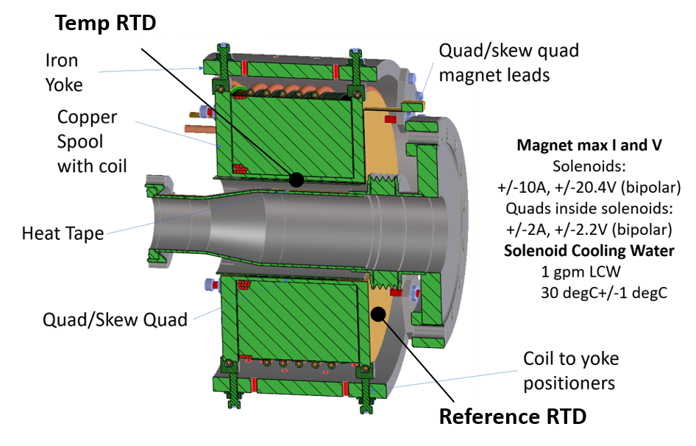
Figure 1. The LCLS2 injector solenoid with normal and skew quadrupole correctors.

- Receiving the Magnet:
Upon receipt of the magnet, the following information should be recorded:

Responsible measurement operator name (initials): | SDA

Verify that the magnet is complete and undamaged, including wiring and water cooling connections.

Incoming inspection OK (initials): | JA

The following information is to be noted upon receipt of the solenoid magnets by the SLAC MFD group:
SLAC barcode number: | N/A
Vendor serial number from magnet label: | N/A
SLAC or LBNL drawing number:

Use the following URL for archiving all magnetic measurement data files, analysis reports and photographs:
http://www-group.slac.stanford.edu/met/MagMeas/MAGDATA/LCLS-II/Solenoid/4050

- Preparation:
A beam direction arrow, with text “beam direction”, is to be applied to the top and connector side of the magnet, preferably by stenciling or rubber stamp, or by sticker supplied by LCLS. The beam pipe should have the “beam direction” labeled in a prominent location. The beam direction should be clearly labeled on the solenoid and the field polarity should be arranged as shown in Fig. 2, with power supply generating positive current (‘normal’ polarity). Positive polarity is with the electrons traveling in the +Bz direction.

Clearly label the normal and skew quadrupole correctors terminals and their polarities.

Log this data on the magnet traveler and in the gun solenoid directory of the LCLS injector e-log, including a digital photograph of the solenoid polarity and serial number markings.

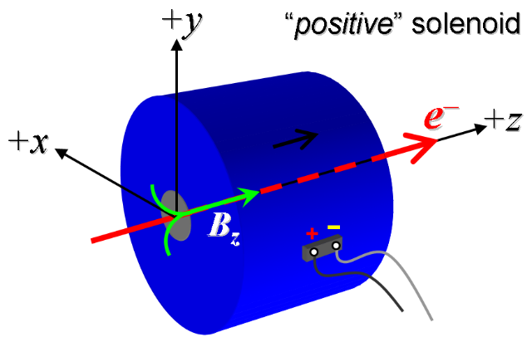
Figure 2. Polarity of solenoid field with positive power supply output current (‘normal’ polarity). The bucking coil should also produce this field orientation when in positive polarity.

Beam direction arrow applied (initial): | SDA
Magnet polarity (Fig. 2) has been marked (initials): | SDA
Name of archived photograph file: | C:\Magdata\LCLS-II\Solenoid\SOL1\Setup Pictures

- Determine the Mechanical Axis wrt. the Solenoid’s Fiducials:
The alignment group should reference the solenoid’s mechanical axis to the alignment fixtures mounted on the solenoid (see Figure 1). The removable tooling balls should be installed and a CMM be used to locate these balls with respect to the inner diameter of the beam holes in the two end plates. The line connecting the centers of these holes defines the mechanical axis of the solenoid. Reference this line to the tooling balls.

The following measurements should be made:

- Use CMM to define the mechanical axis or centerline of the magnet. The inner bore and ends of the copper spool are potential reference surfaces.
- Measure and log the perpendicularity of the copper spool ends with respect to the solenoid centerline.
- Use the centerline to define solenoid-fixed x-y-z coordinate system with +z in the beam direction, +y vertical, and +x to the left as shown in Figure 2. Define the coordinate origin with z=0 at the mechanical center defined as equal distance between the spool ends. This defines the geometric axes of the solenoid.
- Use the CMM to reference external fiducials, such as tooling bars and/or optical targets, to the solenoid-fixed, geometric coordinate system.

CMM technician (initials): | KC
Date CMM performed (mmm-dd-yyyy): | 5/11/2017

URL of on-line CMM alignment data:
http://www-group.slac.stanford.edu/met/MagMeas/MAGDATA/LCLS-II/Fiducial%20Reports/4050_Fiducial_Report%20(Solenoid).pdf

- Installation and C/O
4a. Installation and requirements:
The solenoid test requires a bipolar power supply capable of delivering +/-10 A and +/-20.4 V (approximately 2 Ω) with a current regulation of 0.01%. All power supplies should be configured for constant current mode.

Water system requirements:
The solenoid requires a 30 PSI pressure drop to give a 1 GPM flow rate of low conductivity water (LCW) at 30°C +/-1degC. The magnet lab LCW system has sufficient capacity at 110 PSI.

The skew and normal quadrupole correctors each require a bipolar power supply which can deliver +/-2 A at +/-2.2 V with 0.01% current regulation. With the power supply in constant current mode, the power supply voltage should be monitored to indicate the quad’s temperature rise.

All magnetic measurements should be done with the beam pipe and heater tape installed, along with any other items to be used near or inside the bore of the solenoid, like a steering coil.

Initial measurement configuration:
For the initial measurements, the solenoid should be installed with a 3-axis Hall probe aligned along the mechanical axis or z-axis using the CMM tooling ball/fiducial data. z=0 is the mechanical center of the magnet. Program the 3-axis Hall probe to move along the mechanical axis of the solenoid. Install thermocouples to measure the inlet and outlet water temperatures. Install RTDs at the temporary and reference locations shown in Fig 1. Connect power supplies, thermocouples, current shunts, flow meter, Hall probe, rotating coil, etc. to data logger.

Current ramp rate:
For all the following magnetic measurements, the solenoid and quad corrector currents should be ramped to the set current, $I_{set}$, using a cosine-function for the ramp rate defined by
$ramp rate \left(\frac{A}{s}\right)=\frac{πI_{set}}{2t_{0}}\cos\left(\frac{π}{2}\frac{t}{t_{0}}\right)$ for $0<t<t_{0}$ ;
where for these measurements $t_{0}=10$ seconds followed by a 10 second settle time before measuring the magnetic field.

4b. Warmup and power dissipation:
Run the solenoid at 10 A for 1 hour to determine its maximum operating temperature. Measure inlet and outlet temperatures with flow rate to determine power consumption of solenoid.
Adjust power and measure correlation between the reference RTD and the temporary RTD vs. dissipated power.
Ambient (off, with water flowing) temperature (°C): | 22.24
Final magnet temperature (°C): | 34.97
Meas. Flow Rate (GPM): | 0.55
Meas. B_{z} (G): | 0.094100
Inlet temperature (°C): | 26.53
Outlet temperature (°C): | 28.29
Maximum power dissipation (W) | 233

4c. Validation of the Standardization Cycle:
Position the Hall probe at z=0. Test the reproducibility of the solenoid axial field for the following current settings:

meas. # | set current (A) | meas. B_{z} (G)
1 | 0 | 0.000000
2 | 5 | 0.047060
3 | 10 | 0.094100
4 | 5 | 0.047080
5 | 0 | 0.000020
6 | -5 | -0.047070
7 | -10 | -0.094160
8 | 0 | -0.000040
9 | -5 | -0.047080
10 | -10 | -0.094160
11 | 5 | 0.047040
12 | 0 | 0.000010
13 | -5 | -0.047070
14 | 10 | 0.094100
15 | 5 | 0.047070
16 | 0 | 0.000010

Decide if a field standardization procedure is needed. If standardization is required, then describe, and test the procedure.

Standardization procedure needed (Y or N): | Y
Document describing procedure, if needed: | 2 Cycles
Name of standardization data file: | See folder Standardize Measurements

4d. Recovery from Power Supply Trip:
Position the Hall probe at z = 0. Standardize the magnet, set to 10 A and log B_{z}, then switch/trip the power supply off. Turn the power supply on and set to 10 A. Record B_{z}. Re-standardize (if necessary). Do this multiple times to verify the solenoid returns to the same field at the same current after a power supply trip.

Name of power supply trip data file: | bhxyzvsxydat.r10 and bhxyzvsxydat.ru9

- Mechanical axis field map:
These measurements along the mechanical axis will determine the solenoid calibration in terms of the peak field vs. current, and the effective length, the focal strength, and 3rd-order aberration integrals.
- Connect the solenoid to its power supply. Disconnect skew and normal quad power supplies.
- Align 3-axis Hall probe to the mechanical axis. Move probe along axis and position at the mechanical center of the solenoid, this is z=0.
- With Hall probe at $z=0$ measure the three field components fields vs solenoid currents from $-10$ A to $10$A in steps of $0.5$ A.
- Measure the field vs. z from z=-15 cm to 15 cm in steps of 2 mm for solenoid currents of -10, -5, +5, +10A.
- Disconnect the solenoid power supply. Measure the field vs. z from z=-15 cm to 15 cm in steps of 2 mm.
- Analyze data to obtain the solenoid calibration in KG-m as well as the four field integrals.

-10 to 10 A at center data filename: | bhxyzvsxydat.ru2, bhxyzvsxyplt.ru2
Bx,y,z vs z data filename: | bhxyzvsxydat.ru3, bhxyzvsxyplt.ru3
Zero field Bx,y,z vs z data filename: | bhxyzvsxydat.ru4, bhxyzvsxyplt.ru4

- Long Rotating Coil Measurements of the Solenoid:
To determine the multipole content of the solenoid’s integrated magnetic multipole fields, measurements are performed using a long rotating coil. The long rotating coil is first installed with its axis of rotation along the magnetic axis, defined as the axis with zero or minimized dipole field.
- Disconnect the skew and normal quad correctors from their power supplies.
- Align long rotating coil along magnetic axis by zeroing the dipole field.
- Measure the solenoid’s integrated multipole fields from -10 A to 10 A in steps of 2A.
- Set solenoid to 10 A.
- Move rotating coil horizontally to x=+2 mm. and measure multipole fields
- Move rotating coil to x=-2mm and measure multipole fields.
- Return coil to x=0 and measure multipole fields.

Data filename: | hardat.ru6, harplt.ru6

- Heating measurements of the skew and normal quadrupole correctors:
- Turn off the solenoid power supply and disconnect from solenoid. Connect both skew and normal quads to power supplies. Set currents to zero. Leave the water flowing through the solenoid. Monitor the temperature of the temporary RTD inside the solenoid.
- Monitor the multipole fields with the long coil aligned along the magnetic axis.
- Set skew quad to 2A and log the p/s current and voltage and the RTD temperature for several minutes to determine if excessive heating is changing the resistance.
- Measure the field multipole spectrum, while the skew quadrupole is heating and monitor during test.
- With the skew quad still on, set normal quad to 2A and log the p/s current and voltage for both the skew and normal quads for several minutes.
- Monitoring V for each quad determines if excessive heating is changing the resistance. With the p/s in constant current mode, the p/s voltage rise will be proportional to the temperature rise of the quad. Specifically, $∆T=T-T_{0}=\frac{1}{α}\frac{V\left(T\right)-V_{0}}{V_{0}}$ for copper $α=0.0057$ per degC. For example, a 10 degC temperature rise of the quad increases the voltage 5.7%. This assumes all the voltage drop is across the quadrupole, otherwise the effect could be smaller. Since the power supply regulates the current to 0.01%, a few percent change in the voltage can only be attributed to heating and should be measurable with a o-scope or other low-noise voltage probe connected across the quad leads.
- With both quads on at maximum current, is temperature rise acceptable? Does field change with temperature?
Name of quad heating data file: | Rtdat.ru7, rtplt.ru7

- Long coil calibration of the skew quadrupole corrector:
- Turn off the solenoid power supply and disconnect from solenoid. Disconnect normal quad from its p/s. Connect skew quad.
- Align the long rotating coil along the magnetic axis.
- Measure the integrated multipole fields for skew quad currents from -2A to 2A in steps of 0.2A.
Name of skew quad calibration data file: | hardat.ru8, strdat.ru8

- Long coil calibration of the normal quadrupole corrector:
- Turn off the solenoid power supply and disconnect from solenoid. Disconnect skew quad from its p/s. Connect normal quad.
- Align the long rotating coil along the magnetic axis.
- Measure the integrated multipole fields for normal quad currents from -2A to 2A in steps of 0.2A.
Name of normal quad calibration data file: | hardat.ru9, strdat.ru9

- Determine quad corrector currents which cancel the solenoid’s quad fields:
- Connect solenoid power supply. Connect both skew and normal quads to power supplies. Set skew and normal quad currents to zero. Set the solenoid current to 10A.
- Align the long rotating coil along the solenoid’s magnetic axis.
- Measure the integrated multipole spectrum while adjusting the skew and normal quadrupole correctors to cancel the quadrupole field. Log the quadrupole currents, etc.
Name of data file with currents etc.: | Strdat.r14, strplt.r14, hardat.r14

- Short Rotating Coil Measurements of the Solenoid:
To determine the solenoid’s multipole field as a function of z, measurements are performed using a short rotating coil. First, a short rotating coil measurement is done along the mechanical axis. Second, to establish the magnetic axis, the rotating coil is moved transversely at each end of the solenoid to zero the dipole field which determines the magnetic axis. When the magnetic axis is found, its position should be referenced to the tooling balls located on the outer surface of the magnet and its location compared with that of the mechanical axis.

11a. Short rotating coil measurements along the mechanical axis:
- Standardize the solenoid (if necessary) and set the current to 10 A. Skew and normal quadrupoles should be disconnected from power supplies.
- Align the short rotating coil so it travels in the z-direction, along the mechanical axis of the solenoid.
- Measure the multipoles vs. z for solenoid currents from -10A to 10 A in steps of 5A. Use step-size in z of 1.25 cm (or half the length of the rotating coil), from z= −15 cm to +15 cm with z = 0 being the center of the solenoid.
Data filenames: | bnvszdat.r18, bnvszdat.r19, bnvszdat.r20

11b. Short rotating coil measurements along the magnetic axis:
- Position the short rotating coil at the beam entrance to the solenoid with the coil longitudinally (z-axis) centered in the plane of the solenoid end plate. Adjust the rotating coil in the transverse direction (x and y) to minimize the dipole field. Record the coil’s coordinates relative to the mechanical axis (tooling balls) below and in the data file.
- Position the short rotating coil at the beam exit of the solenoid with the coil longitudinally (z-axis) centered in the plane of the solenoid end plate. Adjust the rotating coil in the transverse direction (x and y) to minimize the dipole field. Record the coil’s coordinates relative to the mechanical axis (tooling balls) below and in the data file.
- Determine the line between the points found in 1 & 2 and align the rotating coil to move along this line for the next set of measurements. This line defines the magnetic axis of the solenoid. Compare these coordinates with the mechanical and magnetic (using the long coil) axes determined above. Log the x, x’, y and y’ offsets between the two axes.
- Measure the multipoles vs. z for solenoid currents from -10A to 10A in steps of 5A. Use step-size in z of 1.25 cm (or half the length of the rotating coil), from z= -15 cm to +15 cm with z = 0 being the center of the solenoid.

Data filename: | bnvszdat.r21, bnvszplt.r21

*angles and displacements are wrt. the mechanical (solenoid-based) coordinates. | x | y
Magnetic center at solenoid entrance (m) | 0.000318 | 0.000000
Magnetic center at solenoid exit (m) | 0.000267 | 0.000038
Magnet axis displacement error (m) | 0.000293 | 0.000019
Magnet axis angle error (mrad) | 0.528 | 0.394

12a. Short coil measurements of the skew quadrupole corrector:
- Turn off the solenoid power supply and disconnect from solenoid. Disconnect normal quad from its p/s. Connect skew quad.
- Align the short coil to move along the magnetic axis, see 11b.
- Measure the field multipole spectrum vs. z, from z=-15 cm to z= 15 cm in steps of 1.25 cm at skew quadrupole currents of -2A -1A, 0 1A, and 2A.

Name of skew quad multipole data file: | bnvszdat.r23, bnvszplt.r23

12b. Short coil measurements of the normal quadrupole corrector:
- Turn off the solenoid power supply and disconnect from solenoid. Disconnect skew quad from its p/s. Connect normal quad.
- Align the short coil to move along the magnetic axis.
- Measure the field multipole spectrum vs. z, from z=-15 cm to z= 15 cm in steps of 1.25 cm at normal quadrupole currents of -2A -1A, 0 1A, and 2A.

Name of normal quad multipole data file: | nvszdat.r22, bnvszplt.r22

- Label Terminals:
Label the terminal polarities when field orientations are established as in Fig. 3, and photograph the terminals and magnet in general.
Polarity of norm. and skew labeled (initials): | SDA
Photograph file name: | See folder Setup Pictures

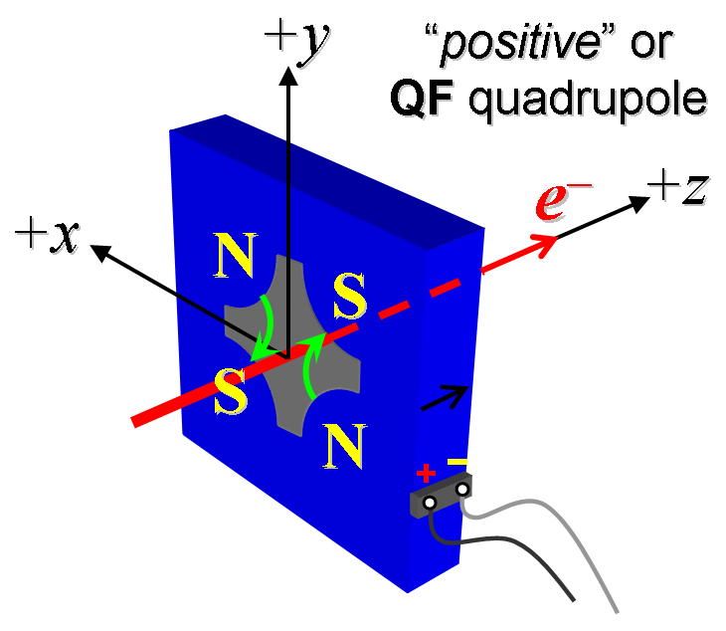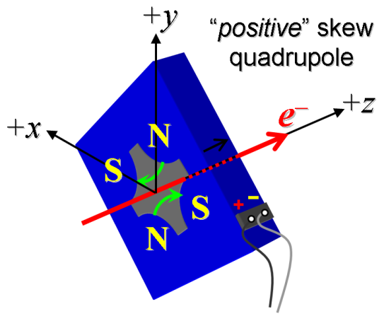
Figure 3. Normal and skew quadrupole coil polarities are set to arrange fields as shown above.

- Documentation and Analysis:
Analyze and review all data to determine calibrations in SLAC-units, operating limits, and ranges, etc. Does the magnet meet the design specifications? Is the magnet acceptable for installation and long term operation in the LCLS2 injector? Have all parameters needed for the simulations and other analysis been measured? These and similar questions should be asked throughout the characterization process.

Approval signatures:
Magnet approved by engineering-
Magnet approved by physics-

Acceptance:
SLAC approved electrical safety covers? (Y or N): | N
SLAC approved lifting eyes? (Y or N): | N
Shipping Damage? (Y or N): | N
Vendor tests passed on magnet label? (Y or N):

Upon completion, send traveler to F. Zhou

