ISRDD Measurements Notes

10/23/2020
Eliminated extra runs from some of the measurement folder and put them into a folder ‘Extra Runs’. This makes it so each SXU has the same number of runs and at the same time frames. The last run before beam was brought to the SXU line is run 6, so the runs up to this point will be used as the baseline for now.

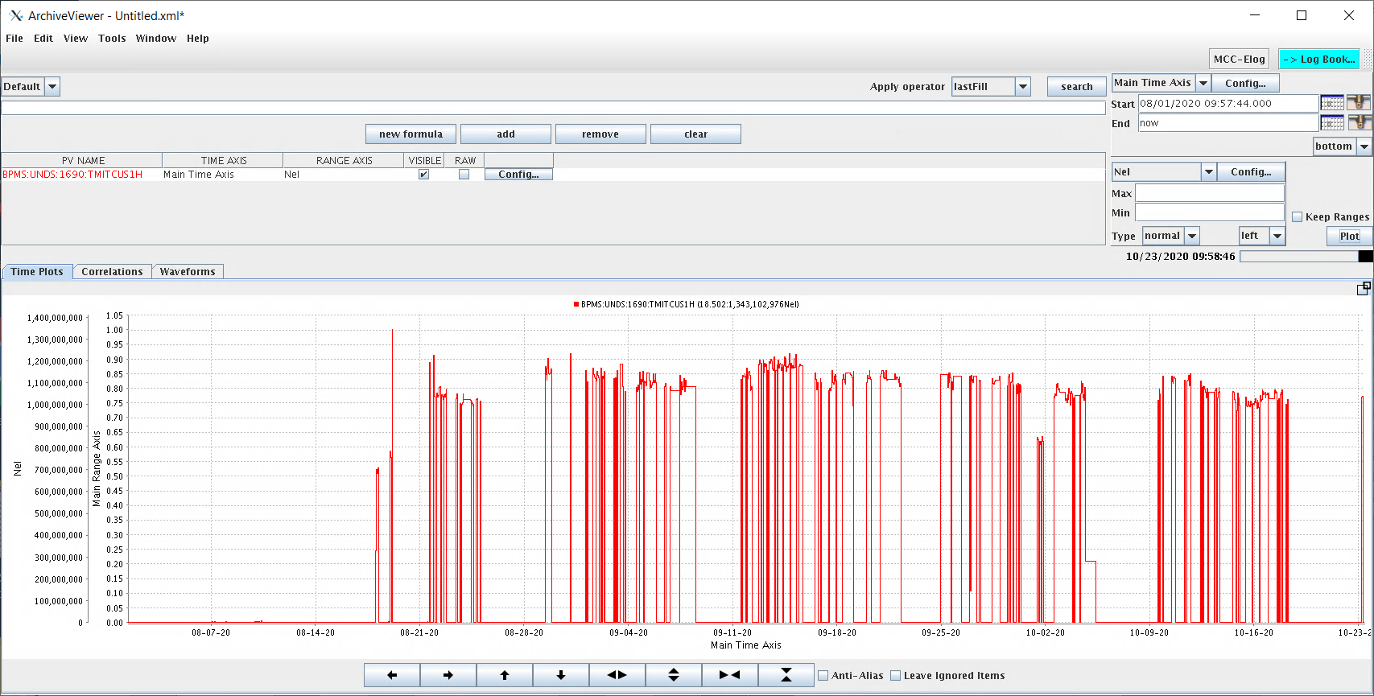
Figure 1: SXR Line Beam Current

- Upstairs Run 9 and Tunnel run 16 had all the gaps put to 7.6 mm before the measurements.
- Upstairs Run 10 had all the gaps put to 7.5 mm before the measurements. This will be done before each measurement from now on.
- Run 11. Set all gaps to 7.5 before starting measurements. Some undulators had been moved to < 7.5 mm during the previous week so will probably need to start taking gaps to 7.4 from now on. Will do some hysteresis experiments on Cell 26. Looking at the gap vs By for SXU 004 (Cell 27), 60 mm was chosen after looking at the field level in the SXU 004 at various gaps and seeing that this is the flattening point of the magnet poles. The 60 mm gap peak field at z = 2.1630 is ~165 G. 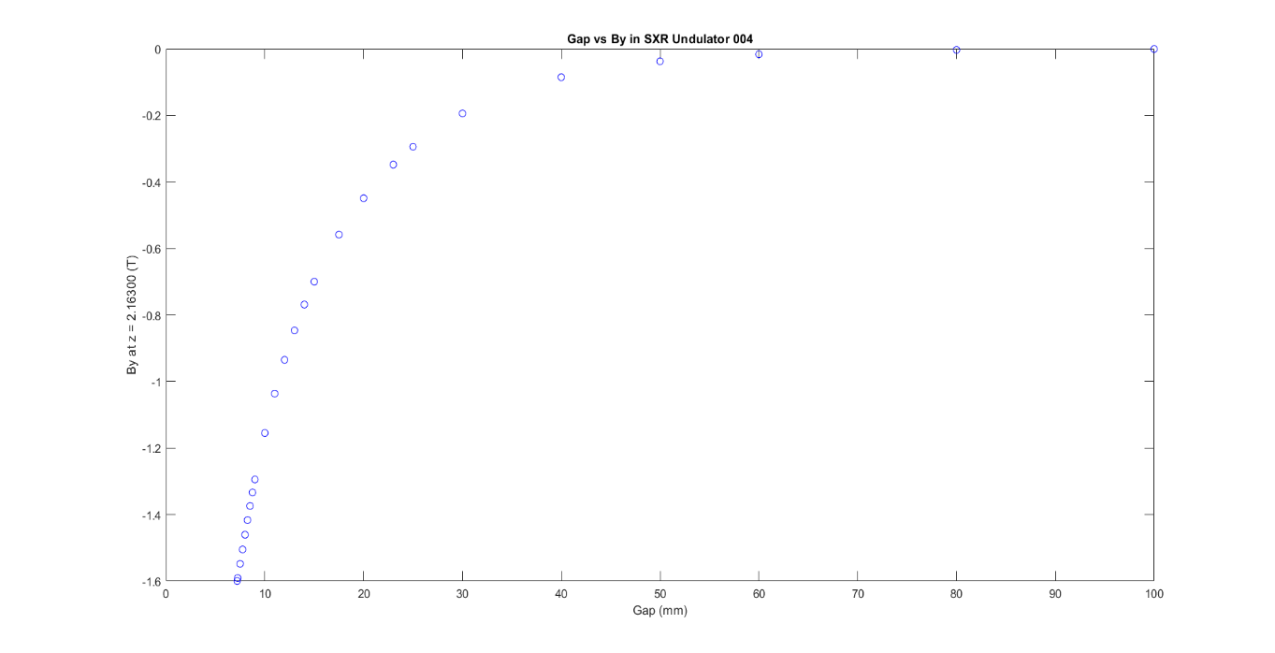
Figure 2: SXU-004 By Fiedl vs Gap at z =2.163 m
- Cell 26 SXU Hysteresis measurements were made right after Upstairs run 11 measurements. These were performed on SXU-006 in cell 26. The purpose of the measurements was to see how the history of maximum and minimum gap effects the subsequent ISRDD measurements. The descriptions of the runs are as follows:
Run 2: Hysteresis checks, No changes from run 1 (aka Upstairs run 11)
Run 3: Gap set to 7.5 mm then back to 8 mm for start of run.
Run 4: Gap set to 7.4 then back to 8 before run.
Run 5: Gap set to 7.3 mm then back to 8 mm.
Run 6: Gap to 60 mm then to 8 mm
Run 7: Gap moved between 8 and 7.5 three times.
Run 8: Gap to 20 mm then 7.3 then to 8 mm.
Run 9: Gap cycled 3 times between 7.5 and 8 mm.
Run 10: Gap to 60 mm then 8 mm.
Run 11: Same as run 10, 1 hour later
Run 12: Gap open to 80 mm then to 12, then cycled between 8 and 12 3x.

A plot of the plus data is seen below in figure 3. There are a few intersecting items to note. The first is that there is a difference between the temperature corrected and non-corrected data, specifically runs 10 and 11 which have the same parameters except them were taken 1 hour apart and the temperature changed during that time by 0.013 ºC. The normalized integral voltage difference between the two runs is 1.6907e-04 which is an order of magnitude larger than one would expect from a 0.1% temperature coefficient, so some form of these measurements should be performed in a more temperature stable time. As far as changes from the hysteresis there are some slight differences between runs but nothing that stands out. In the future it would be good to standardize the undulators before measurement by going to 60 mm then 7.4 mm then 12 and finally to 8 mm to start. For future hysteresis tests it would be good to test this standardize cycle by going to 7.3 mm then to 12 then to 8 and measure, then standardize once and measure, then standardized 3 times and measure.
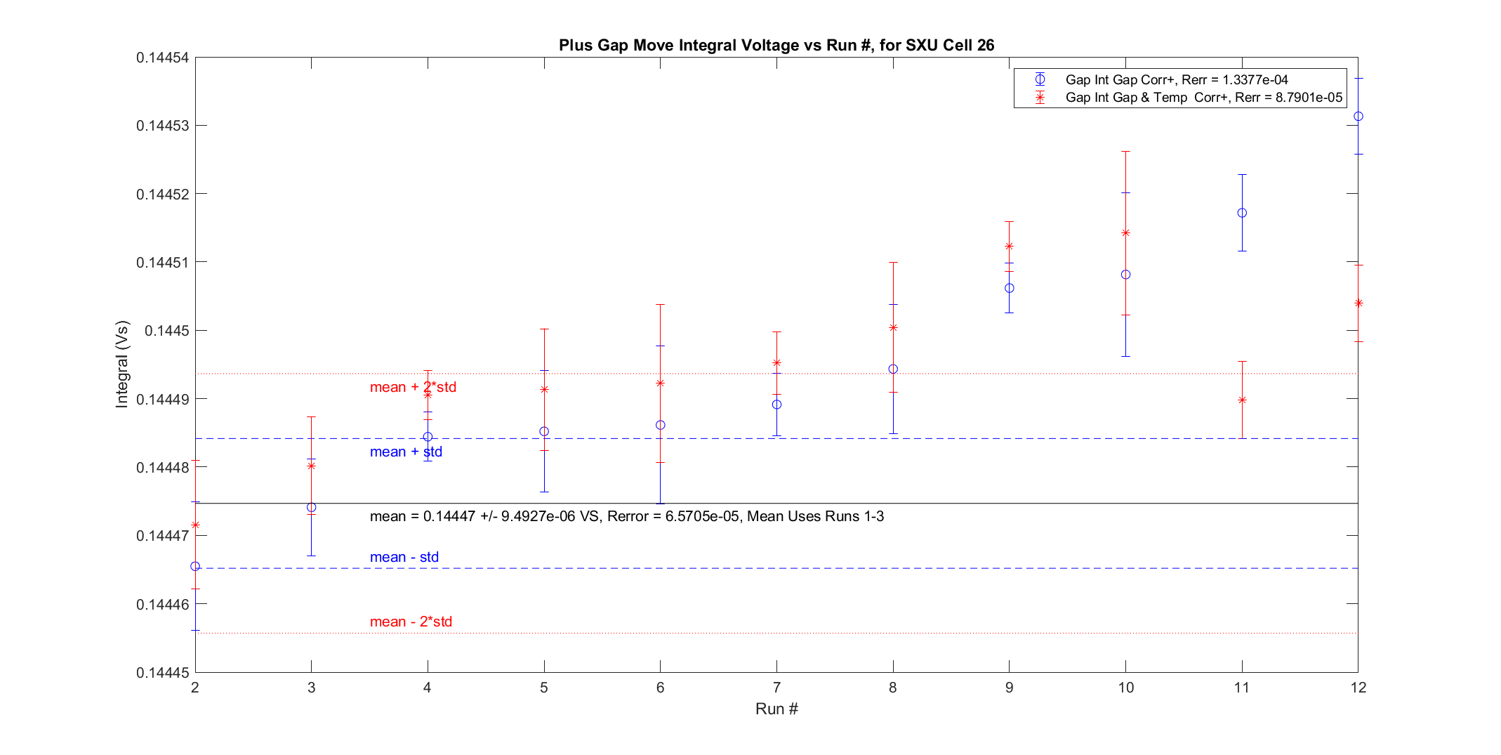
Figure 3: SXU-006 Hysteresis Plus (8-12mm) Gap and Temperature Corrected Run Data.
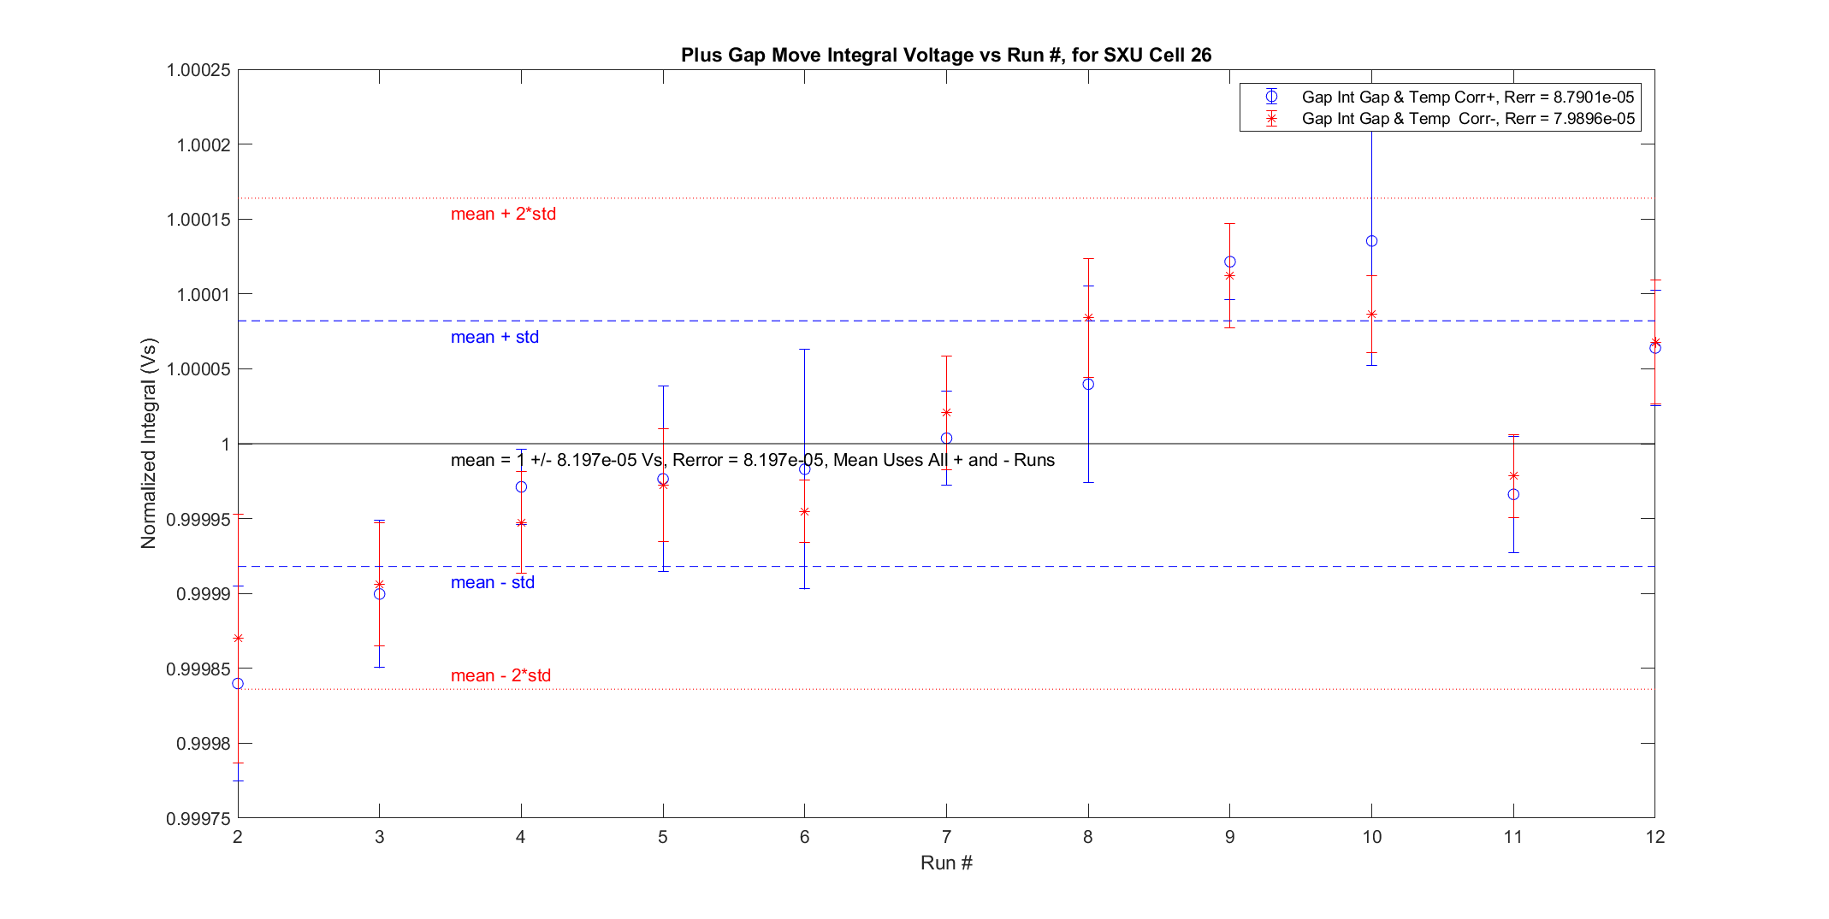
Figure 4: Normalized Hysteresis Test Integrals
The changes in the integrals during this hysteresis test are not satisfying and there looks to be some kind of temperature correlation during this measurement set. If one plots all of the Upstairs cell 26 data, with the hysteresis data in between run 11 and 12 one sees something curious. The measurements during the hysteresis measurements change about as much as the measurements change in between sets. This doesn’t seem to correlate to the hysteresis changes during the measurements set. During that time the outside temperature was dropping from 19.4 to 13.9 ºC, could this have an effect? To test this will need to run some ~8 hours tests both in the tunnel and in the upstairs building.
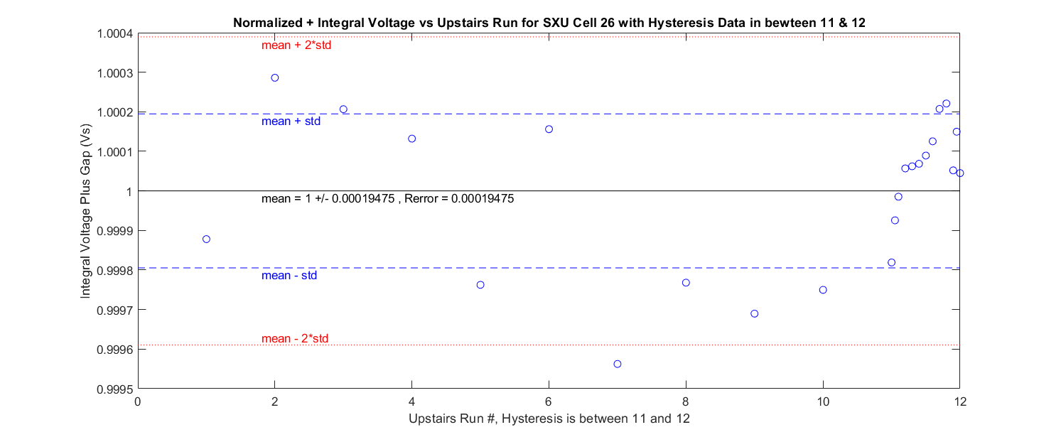

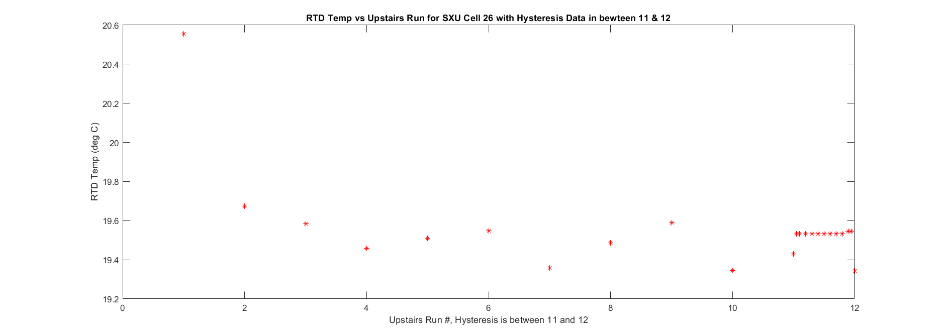

- Run 12. To try and have repeatable measurements from run 12 on, the SXUs will be standardized before each measurement. This consists of opening the gap to 60 mm and then closing it to 7.4 mm before each measurement. The exact gap sequence for each SXU was set to 60 mm then to 7.4 mm then 8 mm then 12 mm then back to 8 mm. This is the first ISRDD measurement with the tunnel in no access and it has been closed for 5 days. Heinz-Dieter believes the measurements should be more stable when the tunnel is closed and I should be able to make measurements about once a week, when there is no scheduled beam in the SXU line.

