Test Procedure for the 1st Article LCLS-II Undulator Quadrupole Magnet
(Revision 02)
This test procedure is intended to cover mechanical fiducialization and magnetic measurements of the 1st article(s) of the LCLS-II undulator quadrupole magnets at SLAC. It requires three bipolar power supplies (one ±6 A for the main coils; two ±1 A for the trim coils)
Receiving:
The following information is to be noted upon receipt of the magnets by the SLAC MFD group:
Received by (initials): | SDA
Date received (dd-mmm-yyyy): | 5/11/2016
SLAC barcode number: | 4070
Vendor serial number on the magnet: | 1
Shipping damage (Y or N): | N

Place a barcode sticker on the magnet and
also duplicate the barcode sticker here →

Preparation:
A beam direction arrow, with text “beam direction”, is to be applied during fiducialization to the top and/or connector side of the magnet with a sticker supplied by the SLAC QC Group.
Beam-direction arrow in place (initials): | SDA

Note: Except for step 17, all measurements will be done with the quadrupole mirror plates installed.

Fiducialization:
The magnet is to be fiducialized by the Quality Inspection group. This will require the installation of removable tooling balls. The fiducialization process will include the determination of the geometric axis of the pole faces and should yield the following data: (a) the location of the tooling balls with respect to the center of this geometric axis when the poles are aligned precisely horizontally; (b) all six distances between the four tooling balls on the four individual quadrants; (c) the pole face curves.
CMM operator (initials):

URL of on-line CMM fiducialization data (please modify or correct if necessary):
http://www-group.slac.stanford.edu/met/Quality/FIDUCIAL REPORTS/

Procedures:
Ramp Rates and Wait Times:
Main Coil – 1 A/s
Trim Coil – 0.2 A/s
Three linear ramp
Wait time of 10 s for ramp and standardize.
PROC01: Magnet Standardization:
Standardize the magnet by changing the quadrupole current, starting from 0 A to +6 A, then through 3 full cycles from +6 A to 6 A and back up to +6 A.

PROC02: Measurement of the change of the magnetic quadrupole center as a function of quadrupole excitation current:
a) Starting at –4.5 A, measure the magnetic quadrupole center for the following current settings:
–4.5, –5.0, –5.5, –5.0, –4.5, –4.0, –3.5, –4.0, –4.5
b) Starting at +4.5 A, measure the magnetic quadrupole center for the following current settings:
+4.5, +5.0, +5.5, +5.0, +4.5, +4.0, +3.5, +4.0, +4.5

PROC03: Magnet Warm Up:
Magnet should be run for 5 hours (at least, can be run for more) at -4.5 Amps to reach nominal temperature

Magnetic Measurements:
Enter URL of on-line magnetic measurements data:
http://www-group.slac.stanford.edu/met/MagMeas/MAGDATA/LCLS-II/Quad/Und_1st_Article

- Determine the connection polarity (with supply outputting positive current) which produces a “positive” (horizontally focusing) field polarity of the quadrupole field, as shown below:
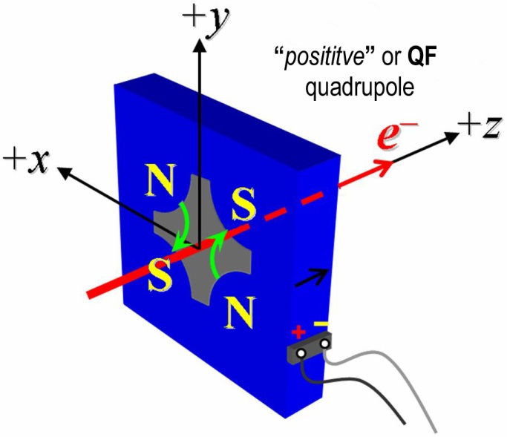
Figure 1: The undulator quadrupole magnets are all defined as “positive” polarity.

- Mark the polarity near the magnet leads with clear “Q+” and “Q−” labels as shown above.
Quad field polarity has been labeled (initials): | SDA

- Measure the inductance and resistance of the quadruple coils:
Inductance of coils (mH): | 55.5 mH
Resistance of coils (Ω): | 0.505 Ω

- Determine the connection polarity (with supply outputting positive current), which produces a “positive” field polarity of the horizontal trim field, as shown below:
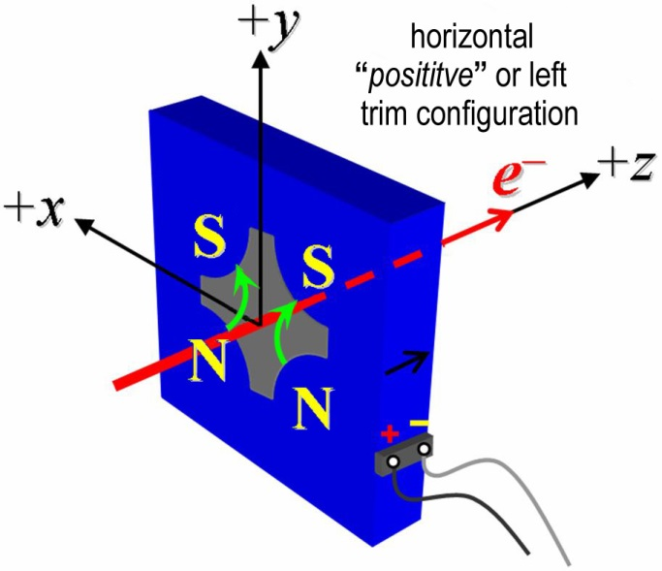
Figure 2: The undulator quadrupole magnets are all defined as “positive” horizontal trim polarity.

- Mark the polarity near the magnet leads with clear “H+” and “H−” labels as shown above.
Horizontal trim polarity has been labeled (initials):

- Measure the inductance and resistance of the horizontal trim coils:
Inductance of horizontal trim coils (mH): | 2.4 mH
Resistance of horizontal trim coils (Ω): | 0.45 Ω

- Determine the connection polarity (with supply outputting positive current), which produces a “positive” field polarity of the quadrupole field, as shown below:
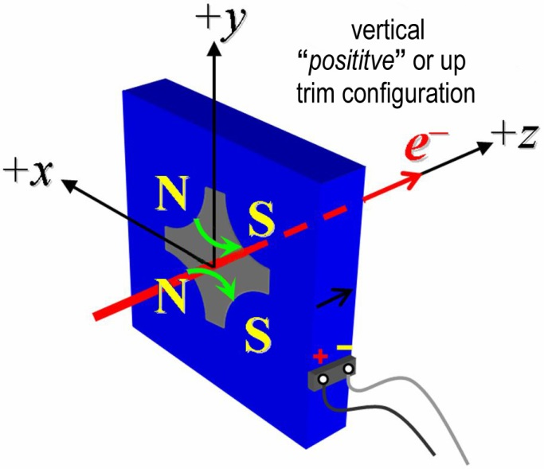
Figure 3: The undulator quadrupole magnets are all defined as “positive” vertical trim polarity.

- Mark the polarity near the magnet leads with clear “V+” and “V−” labels as shown above.
Vertical trim polarity has been labeled (initials):

- Measure the inductance and resistance of the vertical trim coils:
Inductance of vertical trim coils (mH): | 2.4 mH
Resistance of vertical trim coils (Ω): | 0.455 Ω

- Connect the quadrupole field magnet terminals (Q+, Q-) in the correct polarity as established above, to a bipolar power supply (preferably MCOR6) with maximum current |I| ≥ 6 A. Check that the trim terminals are disconnected.
Quad terminals have been connected (initials):

- Run the quadrupole current at 4.5 A for 10 hours and record the ambient temperature and the temperature of a coil, the stand, and the magnet steel.
Ambient temperature (xx.x °C): | °C
Final magnet temperature (xx.x °C): | °C

- Follow PROC03 to warm up the magnet. Standardize the magnet according to PROC01, finally ending at −6 A (if the MCOR6 ramp rate is not controllable, use a flat-top pause time of 10 seconds at each maximum and minimum current).
Standardization complete (initials):
Pause used at each max. and min. (s): | s

- Measure the length-integrated field gradient, ∫Gdl, for quadrupole current settings from −6.0 A to +6.0 A in 0.5-A steps (25 ‘up’ measurements), and then back down from +6 A to −6.0 A in 0.5-A steps (25 ‘down’ measurements). Measure the field harmonics at quadrupole currents of +4.5 A and −4.5 A using a rotating probe of adequate diameter (e.g., 8−10 mm).
Rotating coil name
Rotating coil radius (m): | m
Harmonics data file name:
Run # of ∫Gdl up & down data:
Filename of ∫Gdl up & down data:

- Standardize the magnet according to PROC01, finally ending at −6A. Follow PROC03 to warm up the magnet. Determine the magnetic quadrupole ‘Center Reference’ at a quadrupole current of −4.5 A to be used in the following procedure steps, with respect to the magnet fiducials.
Run number:
Filename of data:

- Measure the change of the magnetic quadrupole center with respect to the ‘Center Reference’ as a function of quadrupole excitation current according to PROC02. Keep magnet at temperature per PROC03.
Run number:
Filename of data:

- Remove the mirror shield plates and measure the change of the magnetic quadrupole center with respect to the ‘Center Reference’ as a function of quadrupole excitation current according to PROC02. Reinstall the mirror plates after this test. Keep magnet at temperature per PROC03.
Run number:
Filename of data:

- Standardize the magnet according to PROC01, finally ending at −6.0 A. Warm up the magnet using PROC03. Measure the magnetic quadrupole center with respect to the ‘Center Reference’ as a function of quadrupole excitation current according to PROC02,
Operator (initials):

- Connect the horizontal trim field terminals (H+, H-) with the correct polarity as established above, to a bipolar power supply with maximum current |I| ≥ 1 A.
Operator (initials):

- Connect the vertical trim field terminals (V+, V-) with the correct polarity as established above, to a bipolar power supply with maximum current |I| ≥ 1 A.
Operator (initials):

- With the quadrupole current at +4.5 A run both, the horizontal and vertical trim currents up to +1 A for 5 hours to warm the magnet up (record temperature).
Ambient temperature (xx.x °C): | °C
Final magnet temperature (xx.x °C): | °C

- With both, the horizontal and vertical trim currents at 0.0 A, standardize the magnet with the quadrupole field supply according to PROC01, finally ending at +4.5 A (destination QF, corresponding to length-integrated field gradient, ∫Gdl of +3 T).
Standardization complete (initials):
Pause used at each max. and min. (s): | s

The next two measurements will determine by how much the steering function of the trim correctors is affected by hysteresis. Ideally, each trim corrector should shift the magnetic center, in one plane only. The coupling to the orthogonal plane needs to be negligibly small (1 µm or less for small current changes).
- Measure the change of the magnetic quadrupole center with respect to the ‘Center Reference’ as a function of trim excitation current for the following trim current settings (maximum range) and at a quadrupole current of +4.5 A:
Description | H-Cur | V-Cur | x-center | y-center
Center | 0 A | 0 A | µm | µm
Upper Right Corner | +1 A | + 1 A | µm | µm
Lower Right Corner | + 1 A | - 1 A | µm | µm
Lower Left Corner | - 1 A | - 1 A | µm | µm
Upper Left Corner | - 1 A | + 1 A | µm | µm
Center | 0 A | 0 A | µm | µm

Run number:
Filename:

- Measure the change of the magnetic quadrupole center with respect to the ‘Center Reference’ as a function of small trim excitation current changes for the following trim current settings and at a quadrupole current of +4.5 A:
Description | H-Cur | V-Cur | x-center | y-center
Home | +0.5 A | +0.5 A | µm | µm
Upper Right | +0.6 A | + 0.6 A | µm | µm
Lower Right | + 0.6 A | + 0.4 A | µm | µm
Lower Left | +0.4 A | +0.4 A | µm | µm
Upper Left | +0.4 A | +0.6 A | µm | µm
Home | +0.5 A | +0.5 A | µm | µm

Run number:
Filename:

- Measure the length-integrated trim fields, ∫Bdl, as a function of trim excitation current. for the following trim current settings. The measurement is to be taken at the ‘Center Reference’ for a quadrupole current of +4.5 A.
Description | H-Cur | V-Cur | ∫Bdl
Center | +0 A | + 0 A | Tm
Horizontal Left-Kick | +1 A | + 0 A | Tm
Horizontal Right-Kick | -1 A | + 0 A | Tm
Vertical Up-Kick | +0 A | + 1 A | Tm
Vertical Down-Kick | +0 A | - 1 A | Tm
Left & Up Kick | +1 A | + 1 A | Tm
Left & Down Kick | + 1 A | - 1 A | Tm
Right & Down Kick | - 1 A | - 1 A | Tm
Right & Up Kick | - 1 A | + 1 A | Tm

Run number of ∫Bdl trim data:
Filename of ∫Bdl trim data:

- Measure the field harmonics at trim current settings of H-Cur = +1 A and V-Cur = +1 A using a rotating probe of adequate diameter (e.g., 8-10 mm) for a quadrupole current of +4.5 A.
Rotating coil designation (coil name):
Rotating coil radius (m): | m
Harmonics data file name:

- Fiducialize the two quadrupole tooling balls with respect to the magnetic center based on vibrating wire measurements in the CMM.
Fiducialization result:
Data file name:

- If time permits, take the two quadrupole halves apart and reassemble them again according to specified procedure.
- Standardize the magnet according to PROC01, finally ending at −6.0 A. Warm magnet using PROC03.
- Measure the magnetic quadrupole center at −4.5 A before and after splitting to determine the effect of splitting and reassembling of the two quadrupole halves.
Operator (initials):
Run number:
Filename of data:

- Upon completion of tests, send this test procedure to Heinz-Dieter Nuhn at mailstop 18.

This section is to be completed by H.-D. Nuhn.
Magnet accepted (signed):

Assigned beamline location
(e.g., MAD-deck name):

