SLAC Magnetic Measurement Plan for
LCLS-II Quad Corrector CQ02B (DSG-000050058)

This traveler is intended to cover mechanical fiducialization and magnetic measurements of the new quadrupole corrector CQ02B magnet, which is needed to replace the flexible printed circuit board quad of the same MAD name. It will be designated a 3.37Q1.2 type magnet. The magnet will be installed in the LCLS-II electron gun area. The quadrupole corrector CQ02B has a positive polarity.

Receiving:
The following information is to be noted upon receipt of the magnet by the SLAC MM group:
Received by (initials): | SDA
Date received (mm/dd/yyyy): | 10/12/2022
SLAC barcode number: | L204266
Serial number on the magnet: | None

Preparation:
A beam direction arrow, with text “beam direction”, is to be applied to the magnet with a sticker
Beam-direction arrow in place (initials): | SDA

Fiducialization:
There is no fiducialization for this magnet. Alignment is to be made using a level.
Magnetic Measurements:
Enter URL of on-line magnetic measurements data (please modify or correct if necessary):
http://www-group.slac.stanford.edu/met/MagMeas/MAGDATA/LCLS-II/Quad/4266

- Measure the inductance and resistance of the magnet:
Inductance of coil (mH): | 58.2 µH @ 100 Hz
Resistance of coil (Ohms): | 0.0522 Ohm
Ambient temperature in degrees C | 23.4 ºC

- Determine the connection polarity (with main supply outputting positive current) which produces a “positive” field polarity for CQ02B as shown below:

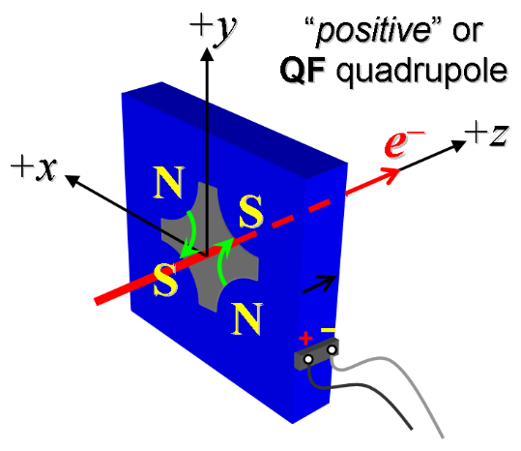
Figure 1. The magnet CQ02B is “positive”.

- Mark the polarity near the magnet leads with clear “+” and “−” labels as shown above.
Magnet polarity chosen from Fig. 1 is (P): | P

- Run the magnet up to 6 A for 2 hours to warm it up (magnet coil temperature).
Upper Left Coil (°C) | 26.0 °C
Ambient temperature (°C): | 23.3 °C

- Standardize the magnet, starting from zero go to +6 A, then go through 1 full cycle from +6 A to -6 A, finally ending at -6 A, with a flat-top pause time (at both -6 A and +6 A) of 10 seconds. Use a linear ramp rate of 1 A/sec. Record the ramp rate used.
Standardization complete (initials): | SDA
Ramp type and rate used (A/sec): | Linear 1 A/sec

- Measure the integral gradient, ∫Gdl, from -6 to 6 A and then from 6 A to -6 A in 1 amp steps. Measure harmonics at +/-6 A.
Filename of ∫Gdl data: | Strdat.ru1
Filename of Harmonics data: | Hardat.ru1

- Measure the By vs x field at the magnet center 6 A and with the power supply off.
Filename of By vs x data at 6 amps: | bhvszdat.ru3
Filename of By vs x data power supply off: |  | bhvszdat.ru4

- Confirm the pole-tip field using a Hall probe at the surface of the inside ring, at an excitation current of 6 A.
Hall probe pole-tip field at 6 A (mean of 4 poles): | 29.5 +/- 0.9 G @ 5.9995A

- Upon completion of tests, email URL of on-line data to Mark Woodley. Mark Woodley will determine if the magnet is accepted. Upon acceptance of magnet, analysis data will be placed in on-line data folder.
Magnet accepted and Analysis file(s) put into on-line data folder (initials): | SDA
Assigned beamline location (MAD-deck name): | CQ02B

