SLAC Magnetic Measurement Plan and Traveler for 200A Unipolar
LCLS-II Quadrupoles of Type 1.085Q4.31 (SA-902-675-01)
Revision 2, Final Release May. 9, 2019 (Reviewed Mar 1, 2019 – T. Smith)

This traveler is intended to cover mechanical fiducialization and magnetic measurements of some of the 1.085Q4.31 quadrupole magnets needed for LCLS-II. There are a total of 4 of these magnets needed for the Cu to SXR line in LCLS-II. The MAD names of the 200A unipolar 1.085Q4.31 quadrupoles are QCUS4, QCUS5, QCUS6 and QCUS7.

Receiving:
The following information is to be noted upon receipt of the magnets by the SLAC MM group:
Received by (MMG initials): | SDA
Date received (dd-mm-yyyy): | 5/17/2019
SLAC barcode number: | 4248
Vendor serial number on the magnet: | E019

Preparation:
A beam direction arrow, with text “beam direction”, is to be applied to the top and/or connector side of the magnet with a sticker supplied by LCLS-II.
MAD Name | Eng. Name | Barcode | Polarity | Bus bars
QCUS4 | 1.085Q4.31 | 4247 | P | Downstream
QCUS5 | 1.085Q4.31 | 4248 | N | Downstream
QCUS6 | 1.085Q4.31 | 4249 | N | Downstream
QCUS7 | 1.085Q4.31 | 4250 | P | Downstream

Beam-direction arrow in place (initials): | SDA

Fiducialization:
Fiducialization may be done before or after magnetic measurements. The magnet is to be fiducialized by the CMM group. This will require the installation of removable tooling balls, location of the geometric axis of the poles of the magnet, and location of tooling balls with respect to the center of this geometric axis when the poles are aligned precisely horizontal.
CMM technician (initials): | KC

URL of on-line CMM fiducialization data (please modify or correct if necessary):
http://www-group.slac.stanford.edu/met/MagMeas/MAGDATA/LCLS-II/Fiducial%20Reports/4248_Fiducial_Report.pdf

Magnetic Measurements:
Enter URL of on-line magnetic measurements data (please modify or correct if necessary):
http://www-group.slac.stanford.edu/met/MagMeas/MAGDATA/LCLS-II/Quad/4248

- Determine the connection polarity (with main supply outputting positive current) which produces a “positive” field polarity (below left), or a “negative” field polarity (below right), as shown below:

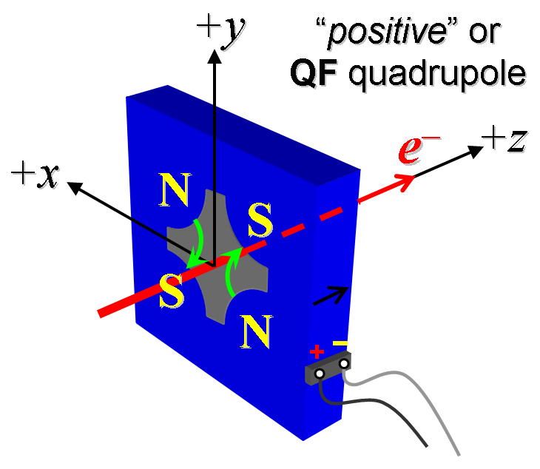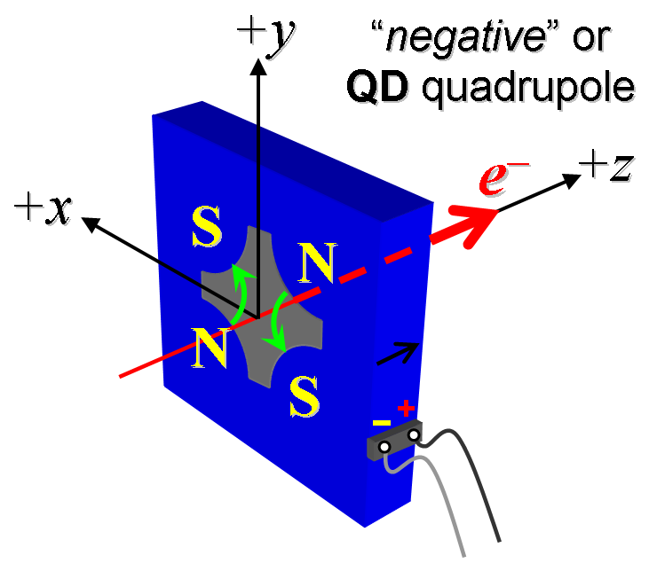
Figure 1. The left magnet is “positive” (left) while right is “negative” (right).

- Mark the polarity near the magnet leads with clear “+” and “−” labels as shown above.
Magnet polarity chosen from Fig. 1 is (P or N): | N

- Connect the magnet to the LCW supply. At a ΔP of 120 psi per circuit, the total magnet flow should be 1.5gpm. Record the actual ΔP required to achieve a total flow rate 1.5 gpm below.

ΔP (psi) to achieve a total flow rate of 1.5gpm | 1.15 gpm at 113 ΔP (psi)

- Connect the magnet terminals in the correct polarity as established above, to a unipolar power supply with maximum current I ≥ 200 A.

- Run the magnet up to 200 A for ~30 minutes to warm it up (record temperature).
Ambient temperature (°C): | 19.6 °C
Final magnet temperature (°C): | 26.3 °C
Delta Water Temperature (°C): | 6.9 °C

- Standardize the magnet, starting from zero to 200 A and back to zero, through three full cycles, finally ending at zero, with a flat-top pause time (at both 0 and 200 A) of 10 seconds. Use a three liner ramp rate of 20 A/sec, if possible, and record the ramp rate used.
Standardization complete (initials): | SDA
Ramp rate used (A/sec): | 20 A/sec

- If the power supply can be run as low as 4 A with <10-mA (0.5%) rms current regulation, then measure ∫Gdl from 0 to 20 A in 4-A steps (5 ‘up’ measurements), and then continue monotonically in 10-A steps from 20 A to 200 A (10 more ‘up’ measurements) and then back down from 200 A to 20 A in −20-A steps (10 ‘down’ measurements), and finally 20 A to 0 in −10-A steps (2 more ‘down’ measurements).
Filename & run number of ∫Gdl up & down data: | Strdat.ru1, strplt.ru1

- Measure harmonics at 20, 100 and 200 Amps.
Filename & run number of harmonic data: | Hardat.ru1, harplt.ru1
Probe radius used for harmonics (m): | 0.0093472
Rotating Coil Designation (Name) | 0.75DQB26

- Confirm the pole-tip field using a Hall probe at an excitation current of 200 A.
Hall probe pole-tip field at 200 A (mean of 4 poles): | 1.074+/- 0.01 T @ 199.9828 A

- For one magnet only, perform a final thermal test. Run the current up to 200 A. Measure the magnet temperature after it stabilizes (2-4 hours?). Record the temperature below.
Ambient temperature (°C): | Measured on LCLS-II Quad 4247
Final stable magnet temperature at 200 A (°C): | Measured on LCLS-II Quad 4247
Delta Water Temperature (°C): | Measured on LCLS-II Quad 4247

- Measure the inductance and resistance of the magnet:
Inductance of coil (mH): | 5.106 mH
Resistance of coil (Ohms): | 0.0886 Ohm
Ambient temperature in degrees C | 26.3 ºC

- Upon completion of tests, email URL of on-line data to Mark Woodley. Mark Woodley will determine if the magnet is accepted. Upon acceptance of magnet, analysis data will be placed in on-line data folder.
Magnet accepted and Analysis file(s) put into on-line data folder (initials): | SDA
Assigned beamline location (MAD-deck name): | QCUS5

