SLAC Magnetic Measurement Plan and Traveler for 110 A Unipolar
XLEAP-II (LCLS-II) Quadrupoles of Type 1.085Q4.31 (SA-902-675-01)

This traveler is intended to cover mechanical fiducialization and magnetic measurements of three 1.085Q4.31 quadrupole magnets needed for XLEAP-II. There are a total of 2 of these magnets needed for the XLEAP-II part of LCLS-II, plus one spare. The MAD names of the 110 A unipolar 1.085Q4.31 quadrupoles are QFXL1, QFXL2 and SPARE and all are positive polarity quadrupoles

Receiving:
The following information is to be noted upon receipt of the magnets by the SLAC MM group:
Received by (MMG initials): | SDA
Date received (MM-DD--YYYY): | 10/12/2020
SLAC barcode number: | 4243
Vendor serial number on the magnet: | n/a

Preparation:
A beam direction arrow, with text “beam direction”, is to be applied to the top and/or connector side of the magnet with a sticker supplied by LCLS-II. The bus bars are downstream.
Beam-direction arrow in place (initials): | SDA

Fiducialization:
Fiducialization should be done before magnetic measurements. The magnet is to be fiducialized by the CMM group. This will require the installation of removable tooling balls, location of the geometric axis of the poles of the magnet, and location of tooling balls with respect to the center of this geometric axis when the poles are aligned precisely horizontal.
CMM technician (initials): | KC

URL of on-line CMM fiducialization data (please modify or correct if necessary):
http://www-group.slac.stanford.edu/met/MagMeas/MAGDATA/LCLS-II/Fiducial%20Reports/L204243_Fiducial_Report.pdf

Magnetic Measurements:
Enter URL of on-line magnetic measurements data (please modify or correct if necessary):
http://www-group.slac.stanford.edu/met/MagMeas/MAGDATA/LCLS-II/Quad/4243

- Determine the connection polarity (with main supply outputting positive current) which produces a “positive” field polarity for QFXL1, QFXL2 and SPARE as shown below:

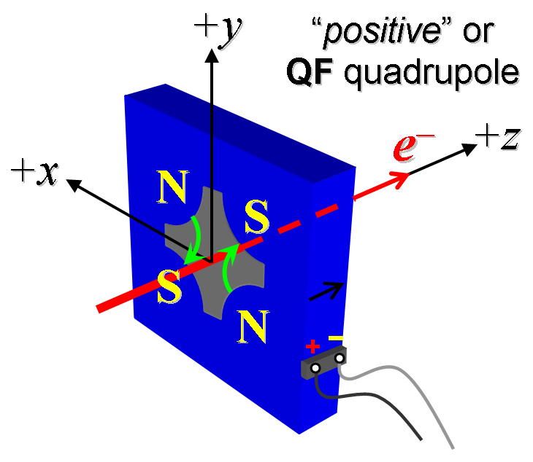
Figure 1. The QFXL1, QFXL2 and SPARE magnets are “positive” (left).

- Mark the polarity near the magnet leads with clear “+” and “−” labels as shown above.
Magnet polarity chosen from Fig. 1 is (P): | P

- Connect the magnet to the LCW supply. At a ΔP of 110 psi per circuit, measure the total magnet flow, it should be 1.5 gpm. Record the actual ΔP and the total flow rate below.

ΔP (psi) | 114
Total flow rate of (gpm) | 1.15

- Connect the magnet terminals in the correct polarity as established above, to a unipolar power supply with maximum current I ≥ 110 A.

- Run the magnet up to 110 A for ~30 minutes to warm it up and record these temperatures.
Ambient temperature (°C): | 27.4 °C
Coil temperature (°C): | 29.9 °C
Core temperature (°C): | 28.7 °C
Delta Water Temperature (°C): | 2.36 °C

- Standardize the magnet, starting from zero to 110 A and back to zero, through three full cycles, finally ending at zero, with a flat-top pause time (at both 0 and 110 A) of 10 seconds. Use a cosine ramp rate of 10 A/sec, if possible, and record the ramp rate used.
Standardization complete (initials): | SDA
Ramp rate used (A/sec): | 10 A/sec

- If the power supply can be run as low as 5 A with <10-mA (0.5%) rms current regulation, then measure ∫Gdl from 0 to 110 A in 5-A steps and and then back down from 110 A to 0 A in −10 A steps.
Filename & run number of ∫Gdl up & down data: | Strdat.ru1, strplt.ru1

- Measure harmonics at the 20, 50, 80 and 110 amp up currents.
Filename & run number of harmonic data: | Hardat.ru1, harplt.ru1
Probe radius used for harmonics (m): | 0.0093472
Rotating Coil Designation (Name) | 0.75DQB26

- Confirm the pole-tip field using a Hall probe at an excitation current of 110 A.
Hall probe pole-tip field at 110 A (mean of 4 poles): | 0.612 T at 110.0521 Amps

- Measure the inductance and resistance of the magnet:
Inductance of coil (mH): | 5.069 mH
Resistance of coil (Ohms): | 0.0811 Ohm
Ambient temperature in degrees C | 25.8 ºC

- Upon completion of tests, email URL of on-line data to Mark Woodley. Mark Woodley will determine if the magnet is accepted. Upon acceptance of magnet, analysis data will be placed in on-line data folder.
Magnet accepted and Analysis file(s) put into on-line data folder (initials): | SDA
Assigned beamline location (MAD-deck name): | QFXL2

