SLAC Magnetic Measurement Plan and Traveler for 165A Unipolar
LCLS-II Quadrupoles of Type 2Q10 (SA-344-113-01, SA-344-113-21, SA-344-113-28, SA-375-156-50)

This traveler is intended to cover mechanical fiducialization and magnetic measurements of the 2Q10 quadrupole magnets needed for LCLS-II. There are a total of 36 of these magnets needed for the LCLS-II. There are 4 different configurations for this magnet, SA-344-113-01, SA-344-113-21, SA-344-113-28, SA-375-156-50. The table below gives the MAD names and polarities of the 165A unipolar 2Q10 quadrupoles.

MAD Name | Eng. Name | Drawing# | Barcode | Polarity
QDOG1 | 2Q10 | SA-375-156-50 |  | P
QDOG2 | 2Q10 | SA-375-156-50 |  | N
QDOG3 | 2Q10 | SA-375-156-50 |  | P
QDOG4 | 2Q10 | SA-375-156-50 |  | N
QDOG5 | 2Q10 | SA-375-156-50 |  | P
QDOG6 | 2Q10 | SA-375-156-50 |  | N
QDOG7 | 2Q10 | SA-375-156-50 |  | P
QDOG8 | 2Q10 | SA-375-156-50 |  | N
QL1P | 2Q10 | SA-344-113-01 |  | P
QL2P | 2Q10 | SA-344-113-01 |  | N
QSP1H | 2Q10 | SA-344-113-01 | 4188 | P
QSP1 | 2Q10 | SA-344-113-01 | 4206 | P
QSP2 | 2Q10 | SA-344-113-01 | 4207 | N
QSP4H | 2Q10 | SA-344-113-01 | 4205 | N
QSP5H | 2Q10 | SA-344-113-01 | 4203 | P
QSP6H | 2Q10 | SA-344-113-01 | 4198 | N
QSP4S | 2Q10 | SA-344-113-01 | 4199 | N
QSP1D | 2Q10 | SA-344-113-01 | 4202 | N
QSP2D | 2Q10 | SA-344-113-01 | 4193 | P
QSP5S | 2Q10 | SA-344-113-01 | 4196 | P
QSP8H | 2Q10 | SA-344-113-01 | 4192 | N
QSP6S | 2Q10 | SA-344-113-01 | 4190 | N
QSP9H | 2Q10 | SA-344-113-28 | 4195 | P
QSP10H | 2Q10 | SA-344-113-28 | 4201 | N
QSP13H | 2Q10 | SA-344-113-28 | 4200 | P
QDL11 | 2Q10 | SA-344-113-28 | 4183 | P
QDL12 | 2Q10 | SA-344-113-28 | 4187 | N
QDL13 | 2Q10 | SA-344-113-28 | 4185 | P
QDL14 | 2Q10 | SA-344-113-28 | 4208 | N
QDL15 | 2Q10 | SA-344-113-28 | 4182 | P
QDL16 | 2Q10 | SA-344-113-28 | 4181 | N
QDL17 | 2Q10 | SA-344-113-28 | 4184 | P
QDL18 | 2Q10 | SA-344-113-28 | 4191 | N
QDL19 | 2Q10 | SA-344-113-28 | 4186 | P
QUE1B | 2Q10 | SA-344-113-21 |  | N
QUE2B | 2Q10 | SA-344-113-21 |  | P
SPARE | 2Q10 | SA-344-113-21 | 4194 | N

Receiving:
The following information is to be noted upon receipt of the magnets by the SLAC MFD group:
Received by (MMG initials): | SDA
Date received (dd-mm-yyyy): | 1/23/2019
SLAC barcode number: | 4207
Vendor serial number on the magnet: | 7

Preparation:
A beam direction arrow, with text “beam direction”, is to be applied to the top and/or connector side of the magnet with a sticker supplied by LCLS-II (J. Amann will determine the direction).
Beam-direction arrow in place (initials): | SDA

Fiducialization:
Fiducialization may be done before or after magnetic measurements. The magnet is to be fiducialized by the CMM group. This will require the installation of removable tooling balls, location of the geometric axis of the poles of the magnet, and location of tooling balls with respect to the center of this geometric axis when the poles are aligned precisely horizontal.
CMM technician (initials): | KC

URL of on-line CMM fiducialization data (please modify or correct if necessary):
http://www-group.slac.stanford.edu/met/MagMeas/MAGDATA/LCLS-II/Fiducial%20Reports/4207_Fiducial_Report.pdf

Magnetic Measurements:
Enter URL of on-line magnetic measurements data (please modify or correct if necessary):
http://www-group.slac.stanford.edu/met/MagMeas/MAGDATA/LCLS-II/Quad/4207

- Determine the connection polarity (with main supply outputting positive current) which produces a “positive” field polarity and “negative” field polarity as shown below:

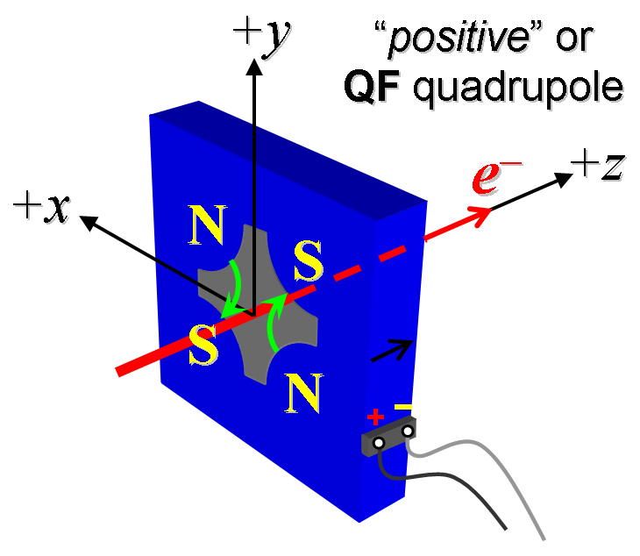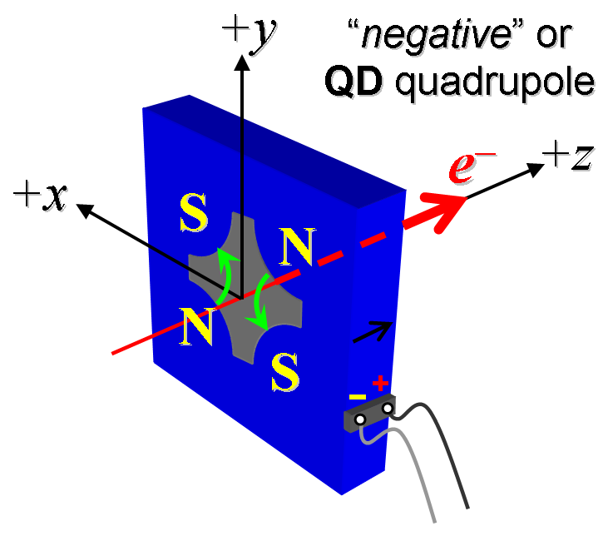
Figure 1. Polarity convention for magnets having “positive” (left) and “negative” (right) polarities.

- Mark the polarity near the magnet leads with clear “+” and “−” labels as shown above.
Magnet polarity chosen from Fig. 1 is (P or N): | N

- Connect the magnet to the LCW supply. At a deltaP of ~91 psi per circuit, the total magnet flow should be 0.6gpm. Record the actual deltaP required to achieve a total flow rate 0.6gpm below.

Record total flow rate and pressure. | 0.69 gpm @114 psi
- Connect the magnet terminals in the correct polarity as established above, to a unipolar power supply with maximum current I ≥ 165 A.

- Run the magnet up to 165 A for ~30 minutes to warm it up (record temperature).
LCW delta T (°C) | 10.9 °C
Ambient temperature (°C): | 20.0 °C
Final magnet steel temperature (°C): | 29.0 °C

- Standardize the magnet, starting from zero to 165 A and back to zero, through three full cycles, finally ending at zero, with a flat-top pause time (at both 0 and 165 A) of 10 seconds. Use a three liner ramp rate of 20 A/sec, if possible, and record the ramp rate used.
Standardization complete (initials): | SDA
Ramp rate used (A/sec): | 20 A/sec

- If the power supply can be run as low as 2 A with <10-mA (0.5%) rms current regulation, then measure ∫Gdl from 0 to 165 A following the current range step sizes given in the table below.
Current Range | Step Size
0 to 20 A | 2-A
20 to 140 A | 20-A
140 to 165 A | 5-A

Filename & run number of ∫Gdl up & down data: | Strdat.ru1, strplt.ru1

- For all magnets, with rotating coil, measure the magnet harmonics at 20, 40, 80, 165 A current setting. Multipole values should be given as a percentage of the quadrupole moment evaluated at the probe radius.
Filename & run number of harmonic data: | Hardat.ru1, harplt.ru1
Probe radius used for harmonics (cm): | 1.95965
Rotating Coil Designation (Name) | 48BC1.6

- Confirm the pole-tip field using a Hall probe at an excitation current of 165 A.
Hall probe pole-tip field at 165 A (mean of 4 poles): | 0.496 +/- 0.01 T @ 165.0186 A

- For one magnet only, perform a final thermal test. Run the current up to 165 A. Measure the magnet temperature after it stabilizes (2-4 hours?). Record the temperature below.
LCW delta T (°C) | Measurement performed on 4187
Ambient temperature (°C): | Measurement performed on 4187
Final magnet steel temperature (°C): | Measurement performed on 4187

- Measure the inductance and resistance of the magnet:
Inductance of coil (mH): | 4.344 mH
Resistance of coil (Ohms): | 0.0997 Ohm
Magnet temperature in degrees C | 21.4 ºC

- Upon completion of tests, email URL of on-line data to Mark Woodley. Mark Woodley will determine if the magnet is accepted. Upon acceptance of magnet, analysis data will be placed in on-line data folder.
Magnet accepted and Analysis file(s) put into on-line data folder (initials): | SDA
Assigned beamline location (MAD-deck name): | QSP2

