SLAC Magnetic Measurement Plan and Traveler for 120A Bipolar
LCLS-II Quadrupoles of Type 1.085Q4.31 (SA-902-675-01)
Revision 3, Initial Release Apr. 17, 2018 (Reviewed Apr. 17, 2018 – P. Emma)

This traveler is intended to cover mechanical fiducialization and magnetic measurements of some of the 1.085Q4.31 quadrupole magnets needed for LCLS-II. There are a total of 21 of these magnets needed for the LCLS-II. The MAD names of the ten 120A Bipolar 1.085Q4.31 quadrupoles are QX01, QX02, QDBL1, QDBL2, QEM3B, QEM4B, QUM1B, QUM2B, QUM3B, and QUM4B. QX01, QX02, QDBL1, QDBL2, QEM3B, QEM4B, QUM1B, QUM2B, QUM3B, and QUM4B have “positive” polarity.

Receiving:
The following information is to be noted upon receipt of the magnets by the SLAC MFD group:
Received by (MMG initials): | SDA
Date received (dd-mm-yyyy): | 10/22/2018
SLAC barcode number: | 4130
Vendor serial number on the magnet: | E014

Preparation:
A beam direction arrow, with text “beam direction”, is to be applied to the top and/or connector side of the magnet with a sticker supplied by LCLS-II (J. Amann will determine the direction).
Beam-direction arrow in place (initials): | SDA

Fiducialization:
Fiducialization may be done before or after magnetic measurements. The magnet is to be fiducialized by the CMM group. This will require the installation of removable tooling balls, location of the geometric axis of the poles of the magnet, and location of tooling balls with respect to the center of this geometric axis when the poles are aligned precisely horizontal.
CMM technician (initials): | KC

URL of on-line CMM fiducialization data (please modify or correct if necessary):
http://www-group.slac.stanford.edu/met/MagMeas/MAGDATA/LCLS-II/Fiducial%20Reports/4130_Fiducial_Report.pdf

Magnetic Measurements:
Enter URL of on-line magnetic measurements data (please modify or correct if necessary):
http://www-group.slac.stanford.edu/met/MagMeas/MAGDATA/LCLS-II/Quad/4130

- Determine the connection polarity (with main supply outputting positive current) which produces a “positive” field polarity for QX01, QX02, QDBL1, QDBL2, QEM3B, QEM4B, QUM1B, QUM2B, QUM3B, and QUM4B (below left), as shown below:

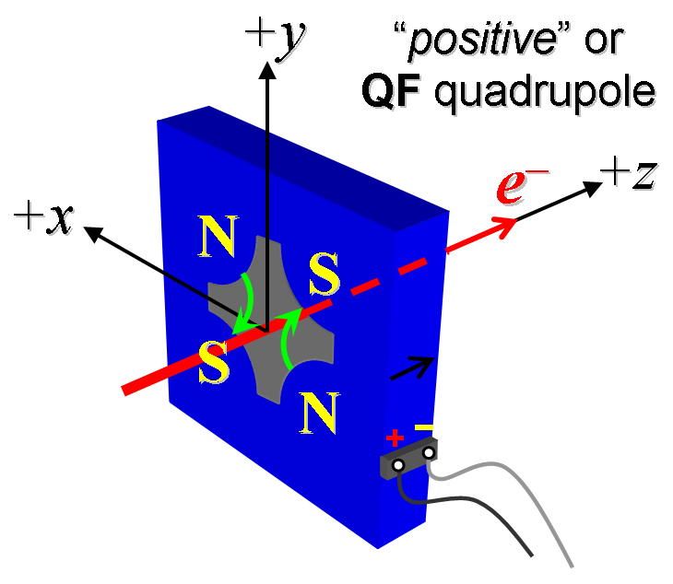
Figure 1. The QX01, QX02, QDBL1, QDBL2, QEM3B, QEM4B, QUM1B, QUM2B, QUM3B, and QUM4B magnets are “positive”.

- Mark the polarity near the magnet leads with clear “+” and “−” labels as shown above.
Magnet polarity chosen from Fig. 1 is (P or N): | P

- Connect magnet to LCW supply. Adjust supply pressure to a delta P of 120 psi to achieve a flow rate of 1.5 gpm. Run the magnet up to 120 A for 30 minutes to warm it up (record, delta P, flow rate, and magnet coil and steel temperature).
LCW delta P (psi) | psi
LCW flow rate (gpm) | 1.15 gpm
LCW delta T (°C) | °C
Ambient temperature (°C): | °C
Final magnet steel temperature (°C): | °C

- Standardize the magnet, starting from zero go to +120 A, then go through 3 full cycles from +120 A to -120 A, finally ending at -120 A, with a flat-top pause time (at both -120 A and +120 A) of 10 seconds. Use a three-linear ramp rate of 20 A/sec, if possible, and record the ramp rate used.
Standardization complete (initials): | SDA
Ramp rate used (A/sec): | 20 A/sec

- If the power supply can be run as low as 2 A with <10-mA (0.5%) rms current regulation, then measure ∫Gdl from -120 to 120 A and then back down from 120 A to -120 A following the current range step sizes given in the table below. Measure harmonics at Harmonics at +/-20, 60 & 120 A.
Current Range | Step Size
-120 to -10 A, (add -15, -115 to up) | 10-A (up), 20-A (down)
-10 to 10 A | 2-A
10 to 120 A, (add 15, 115 to up) | 10-A (up), 20-A (down)

Filename & run number of ∫Gdl up & down data: | Strdat.ru1, strplt.ru1
Filename & run number of Harmonics data: | hardat.ru1, harplt.ru1

- Confirm the pole-tip field using a Hall probe at an excitation current of 120 A.
Hall probe pole-tip field at 120 A (mean of 4 poles): | 0.740 +/- 0.02 T @ 120.06131 A

- For one magnet only, perform a final thermal test. Run the current up to 120 A. Measure the magnet temperature after it stabilizes (2-4 hours?). Record the temperature below.
Ambient temperature (°C): | Measured on 4121
Final stable magnet temperature at 120 A (°C): | Measured on 4121

- Measure the inductance and resistance of the magnet:
Inductance of coil (mH): | 5.011 mH
Resistance of coil (Ohms): | 0.0786 Ohm
Ambient temperature in degrees C | 22.7 ºC

- Upon completion of tests, email URL of on-line data to Mark Woodley. Mark Woodley will determine if the magnet is accepted. Upon acceptance of magnet, analysis data will be placed in on-line data folder.
Magnet accepted and Analysis file(s) put into on-line data folder (initials): | SDA
Assigned beamline location (MAD-deck name): | QDBL2

