SLAC Measurement Plan and Traveler for the LCLS Q50Q3 BSY Quadrupole Magnet, AD-902-673-00
Revision 0, Initial Release March 31, 2016 (approved: P. Emma, Nov. 10, 2016)

This traveler covers mechanical fiducialization and magnetic measurements of the LCLS Q50Q3 BSY quadrupole magnet needed for the 2017 LCLS run. There is one of these magnets needed for the LCLS BSY Copper linac to HXR beamline. This quadrupole magnet is 10.9” long and is an existing, installed magnet in the BSY. Note, the magnet polarity will be changed from a QD to a QF.

Receiving:
The following information is to be noted upon receipt of the magnets by the SLAC MM group:
Received by (initials): | SDA
Date placed on test stand (dd-mmm-yyyy): | 2/16/2017
SLAC barcode number: | 4110
Vendor serial number from magnet label:
SLAC approved electrical safety covers? (Y or N): | N
SLAC approved lifting eyes? (Y or N): | N
Shipping Damage? (Y or N): | N/A
Vendor tests passed on magnet label? (Y or N): | N/A
SLAC drawing number (enter number): | AD 902-673-00

Preparation:
As this is an existing magnet the beam direction should already be indicated on the magnet. If not, a beam direction arrow, with text “beam direction”, is to be applied to the top and/or connector side of the magnet with a sticker supplied by LCLS. Power leads ar located at the up beam end as shown in Figure 1.
Beam-direction arrow in place (initials): | SDA

Figure 1) Q50Q3
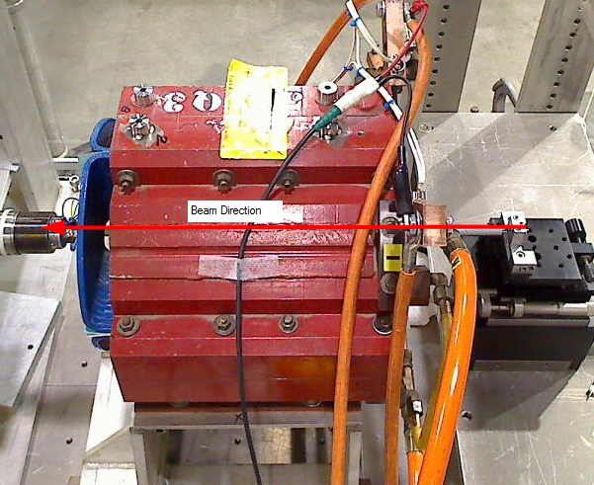

Fiducialization:
Fiducialization may be done before or after magnetic measurements. The magnet is to be fiducialized by the CMM group. This will require the installation of removable tooling balls, location of the geometric axis of the poles of the magnet, and location of tooling balls with respect to the center of this geometric axis when the poles are aligned precisely horizontal.

CMM technician (initials): | KC

URL of on-line CMM fiducialization data (please modify or correct if necessary):
http://www-group.slac.stanford.edu/met/MagMeas/MAGDATA/LCLS-II/Quad/4110/4110_Fiducial_Report.pdf
Magnetic Measurements:
- Verify that the magnets are complete and undamaged, including wiring connections.
Incoming inspection OK (initials): | SDA
Date of arrival to mag. meas.(mm-dd-yyyy): | 2/16/2017

Enter URL of on-line magnetic measurements data (please modify or correct if necessary):
http://www-group.slac.stanford.edu/met/MagMeas/MAGDATA/LCLS-II/Quad/4110

- Mark Q50Q3 magnet as a “QF” (positive polarity).
Magnet marked as “QF” | SDA

- Determine the connection polarity (with supply outputting positive current) which produces the correct field polarity for the “QF” magnet as shown below:

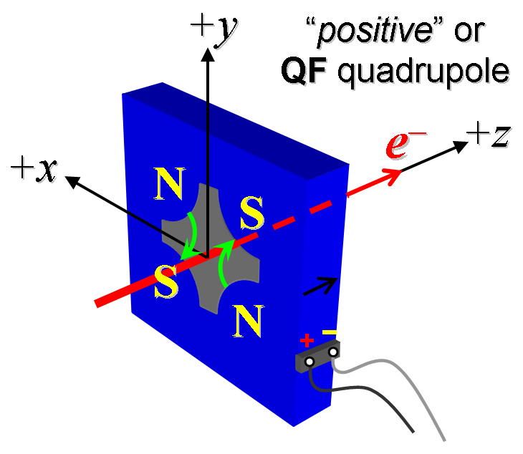
Figure 2. The QF quadrupole: Q50Q3 has “positive” polarity.
- Mark the polarity near the magnet leads with clear “+” and “−” labels as shown above.
Polarity has been labeled (technician initials): | SDA

- Connect the magnet terminals in the correct polarity as established above, to a unipolar power supply with maximum current I ≥ 200 A.

- Connect magnet to LCW supply. Adjust supply pressure to a delta P of ~90 psi to achieve a flow rate of 0.6 gpm. Run the magnet up to 100 A for ~1 hour to warm it up (record, delta P, flow rate, and magnet coil and steel temperature).
LCW delta P (psi) | 110 psi
LCW flow rate (gpm) | 0.6 gpm
LCW delta T (°C) | 1.3 °C
Ambient temperature (°C): | 18.3 °C
Final magnet steel temperature (°C): | 18.3°C

- Training Q50Q3: Standardize into saturation at 200 amps and repeat 8x. Then standardize again, but now at 100 A, starting from zero to 100 A and back to zero, through 30 full cycles, finally ending at zero, with a flat-top pause time (at both 0 and 100 A) of 10 seconds. Use a ramp rate of 10 A/sec, and ramp style three-linear, and record the ramp rate and ramp style used.

Standardization complete (technician initials): | SDA
Ramp rate used (A/sec): | 10 A/sec

- Measure the length-integrated field gradient, ∫Gdl, from 0 to 100 A in 10-A steps (11 ‘up’ measurements), and then back down from 100 A to 0 in 10-A steps (11 ‘down’ measurements).
Filename & run number of ∫Gdl up & down data: | Strdat.ru1, strplt.ru1

- Confirm the pole-tip field using a Hall probe at an excitation current of 75 A.
Hall probe pole-tip field at 75 A (mean abs val of 4 poles): | 0.260 +/- 0.005 T

- Measure the field harmonics at a 75 A current setting using a 0.75-inch diameter probe, or similar.
Rotating coil designation (coil name): | 0.75DQB26
Rotating coil radius (m): | 0.0093472 m
Harmonics data file name: | Hardat.ru1, harplt.ru1

- Measure the inductance and resistance of the magnet:
Inductance of coil (mH): | 300.5 mH
Resistance of coil (Ohms): | 0.027 Ohm

- Upon completion of tests, send data link to Mark Woodley who will produce a data analysis file. Place data analysis file in magnetic measurements data directory
Magnet data accepted and data analysis file produced | Via email, 2/21/2017

Enter URL of on-line magnetic measurements analysis data :
http://www-group.slac.stanford.edu/met/MagMeas/MAGDATA/LCLS-II/Quad/4110/0.813Q10_4110.pptx

