SLAC Measurement Plan and Traveler for the LCLS Q50Q1 (2Q10) BSY Quadrupole Magnet, SA-344-113-30
Revision 0, Initial Release March 31, 2016 (approved: P. Emma, Nov. 8, 2016)

This traveler covers mechanical fiducialization and magnetic measurements of the LCLS Q50Q1 (2Q10) BSY quadrupole magnet needed for the 2017 LCLS run. There is one of these magnets needed for the LCLS BSY Copper linac to HXR beamline. This quadrupole magnet is 10” long and was originally located in the PEPII LE SIT Inj. Beamline (QM28).

Receiving:
The following information is to be noted upon receipt of the magnets by the SLAC MM group:
Received by (initials): | SDA
Date placed on test stand (dd-mmm-yyyy): | 1/19/2017
SLAC barcode number: | 4105
Vendor serial number from magnet label: | N/A
SLAC approved electrical safety covers? (Y or N): | Y
SLAC approved lifting eyes? (Y or N): | N
Shipping Damage? (Y or N): | N
Vendor tests passed on magnet label? (Y or N): | N/A
SLAC drawing number (enter number): | SA34411325-01

Preparation:
A beam direction arrow, with text “beam direction”, is to be applied to the top and/or connector side of the magnet with a sticker supplied by LCLS. Power leads at up beam end as shown in Figure 1.
Beam-direction arrow in place (initials): | SDA

Figure 1.
Q50Q1 Quad
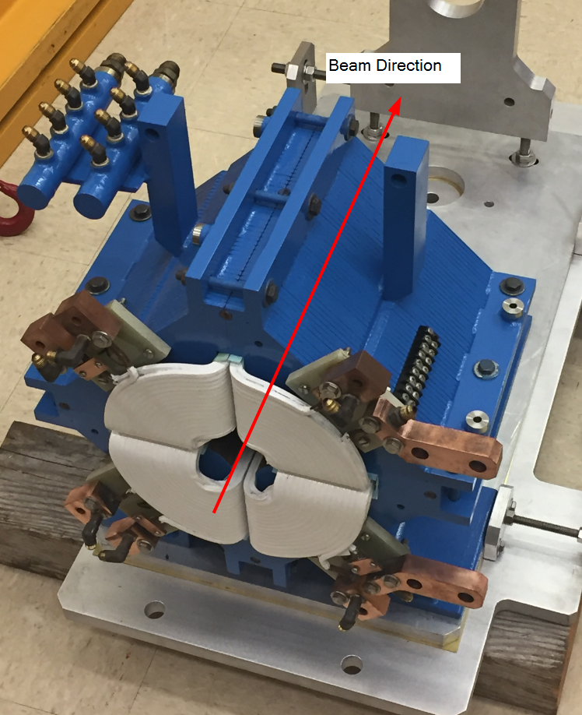
Fiducialization:
Fiducialization may be done before or after magnetic measurements. The magnet is to be fiducialized by the CMM group. This will require the installation of removable tooling balls, location of the geometric axis of the poles of the magnet, and location of tooling balls with respect to the center of this geometric axis when the poles are aligned precisely horizontal.

CMM technician (initials): | KC

URL of on-line CMM fiducialization data (please modify or correct if necessary):
http://www-group.slac.stanford.edu/met/MagMeas/MAGDATA/LCLS-II/Quad/4105/4105_Fiducial_Report.pdf

Magnetic Measurements:
Enter URL of on-line magnetic measurements data (please modify or correct if necessary):
http://www-group.slac.stanford.edu/met/MagMeas/MAGDATA/LCLS-II/Quad/4105/

- Mark Q50Q1 magnet as a “QD” (negative polarity).
Magnet marked as “QD”: | SDA

- Determine the connection polarity (with supply outputting positive current) which produces the correct field polarity for the “QD” magnet as shown below:

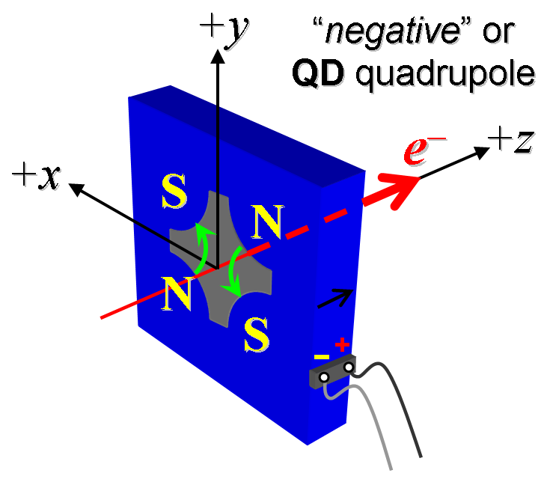
Figure 2. The Q50Q1 quadrupole “negative” polarity.

- Mark the polarity near the magnet leads with clear “+” and “−” labels as shown above.
Polarity has been labeled (technician initials): | SDA

- Connect the magnet terminals in the correct polarity as established above, to a unipolar power supply with maximum current I ≥ 150 A.

- Connect magnet to LCW supply. Adjust supply pressure to a delta P of ~110 psi to achieve a flow rate of 1.2 gpm. Run the magnet up to 100 A for ~1 hour to warm it up (record, delta P, flow rate, and magnet coil and steel temperature).
LCW delta P (psi) | 115.4 psi
LCW flow rate (gpm) | 0.7 gpm
LCW delta T (°C) | 7.9 °C
Ambient temperature (°C): | 18.3 °C
Final magnet steel temperature (°C): | 29.4 °C

- Standardize the magnet, starting from zero to 150 A and back to zero, through ten full cycles, finally ending at zero, with a flat-top pause time (at both 0 and 150 A) of 10 seconds. Use a ramp rate of 10 A/sec, and ramp style three-linear, and record the ramp rate and ramp style used.
Standardization complete (technician initials): | SDA
Ramp rate used (A/sec): | 10 A/sec

- Measure the length-integrated field gradient, ∫Gdl, from 0 to 150 A in 15-A steps (11 ‘up’ measurements), and then back down from 150 A to 0 in 15-A steps (11 ‘down’ measurements).
Filename & run number of ∫Gdl up & down data: | Strdat.ru2, strplt.ru2

- Confirm the pole-tip field using a Hall probe at an excitation current of 100 A.
Hall probe pole-tip field at 100 A (mean of 4 poles): | 0.299 +/- 0.005 T

- Measure the field harmonics at a 100A current setting using a 0.75-inch diameter probe.
Rotating coil designation (coil name): | 1_124DQB22_4_Layer
Rotating coil radius (m): | 0.0140208 m
Harmonics data file name: | Hardat.ru2, Harplt.ru2

- Measure the inductance and resistance of the magnet:
Inductance of coil (mH): | 4.5 mH
Resistance of coil (Ohms): | 0.103 Ohm

- Upon completion of tests, send data link to Mark Woodley who will produce a data analysis file. Place data analysis file in magnetic measurements data directory
Magnet data accepted and data analysis file produced | SDA 1/25/2017

Enter URL of on-line magnetic measurements analysis data :
http://www-group.slac.stanford.edu/met/MagMeas/MAGDATA/LCLS-II/Quad/4105/2Q10_4105.pptx

