Test Procedure for the Production Units LCLS-II Undulator Quadrupole Magnet
(Revision 04)
This test procedure is intended to cover mechanical fiducialization and magnetic measurements of the Production Units of the LCLS-II undulator quadrupole magnets at SLAC. It requires three bipolar power supplies (one ±6 A for the main coils; two ±1 A for the trim coils)
Receiving:
The following information is to be noted upon receipt of the magnets by the SLAC MM group:
Received by (initials): | SDA
Date received (dd-mmm-yyyy): | 7/5/2017
SLAC barcode number: | 4070
Vendor serial number on the magnet: | 001
Shipping damage (Y or N): | N

Preparation:
A beam direction arrow, with text “beam direction”, is to be applied during fiducialization to the top and/or connector side of the magnet with a sticker supplied by the SLAC QC Group.
Beam-direction arrow in place (initials): | Y

Fiducialization:
The magnet is to be fiducialized by the Quality Inspection group. This will require the installation of removable tooling balls. The fiducialization process will include the determination of the geometric axis of the pole faces and should yield the following data: (a) the location of the tooling balls with respect to the center of this geometric axis when the poles are aligned precisely horizontally; (b) all six distances between the four tooling balls on the four individual quadrants; (c) the pole face curves.
CMM operator (initials): | K. Caban

URL of on-line CMM fiducialization data (please modify or correct if necessary):
http://www-group.slac.stanford.edu/met/MagMeas/MAGDATA/LCLS-II/Quad/4070/4070_Fiducial_Report.pdf

Procedures:
Ramp Rates and Wait Times:
Main Coil – 1 A/s
Trim Coil – 0.2 A/s
Three Linear Ramp
Wait time of 10 s for ramp and standardize.
PROC01: Magnet Standardization:
Standardize the magnet by changing the quadrupole current, starting from 0 A to +6 A, then through 3 full cycles from +6 A to -6 A and back up to +6 A.

PROC02: Measurement of the change of the magnetic quadrupole center as a function of quadrupole excitation current:
a) Starting at –4.5 A, measure the magnetic quadrupole center for the following current settings:
–4.5, –5.0, –5.5, –5.0, –4.5, –4.0, –3.5, –4.0, –4.5
b) Starting at +4.5 A, measure the magnetic quadrupole center for the following current settings:
+4.5, +5.0, +5.5, +5.0, +4.5, +4.0, +3.5, +4.0, +4.5

PROC03: Magnet Warm Up:
Magnet should be run for 5 hours (at least, can be run for more) at -4.5 Amps to reach nominal temperature

Magnetic Measurements:
Enter URL of on-line magnetic measurements data:
http://www-group.slac.stanford.edu/met/MagMeas/MAGDATA/LCLS-II/Quad/4070

- Determine the connection polarity (with supply outputting positive current) which produces a “positive” (horizontally focusing) field polarity of the quadrupole field, as shown below:
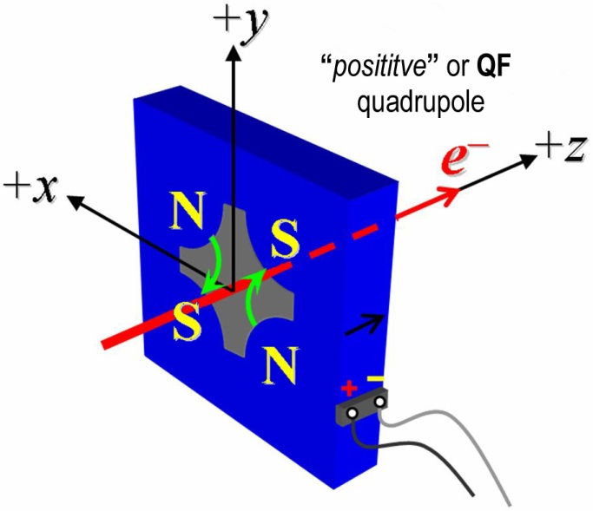
Figure 1: The undulator quadrupole magnets are all defined as “positive” polarity.

- Mark the polarity near the magnet leads with clear “Q+” and “Q−” labels as shown above.
Quad field polarity has been labeled (initials): | SDA

- Determine the connection polarity (with supply outputting positive current), which produces a “positive” field polarity of the horizontal trim field, as shown below:
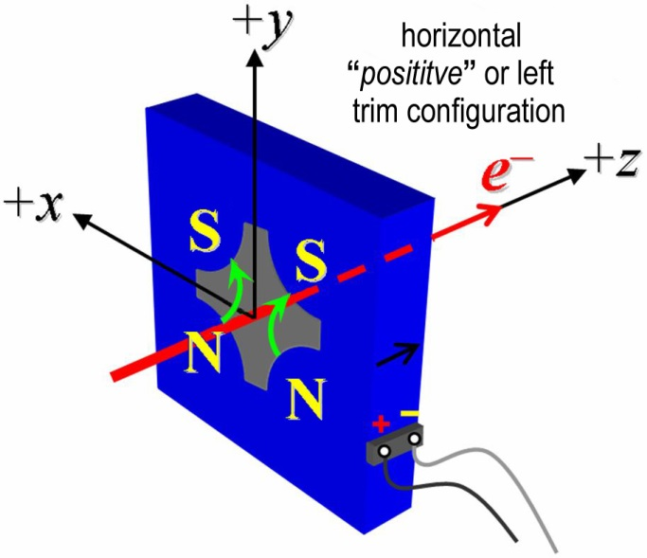
Figure 2: The undulator quadrupole magnets are all defined as “positive” horizontal trim polarity.

- Mark the polarity near the magnet leads with clear “H+” and “H−” labels as shown above.
Horizontal trim polarity has been labeled (initials): | SDA

- Determine the connection polarity (with supply outputting positive current), which produces a “positive” field polarity of the quadrupole field, as shown below:
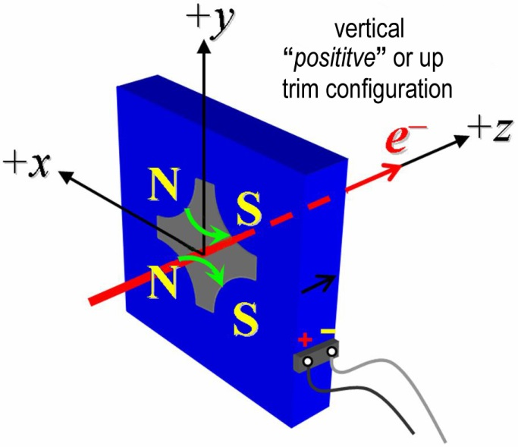
Figure 3: The undulator quadrupole magnets are all defined as “positive” vertical trim polarity.

- Mark the polarity near the magnet leads with clear “V+” and “V−” labels as shown above.
Vertical trim polarity has been labeled (initials): | SDA

- Measure the inductance and resistance of the quadruple coils:
Inductance of coils (mH): | 53.8mH
Resistance of coils (Ω): | 0.509 Ω

- Measure the inductance and resistance of the horizontal trim coils:
Inductance of horizontal trim coils (mH): | 2.34 mH
Resistance of horizontal trim coils (Ω): | 0.464 Ω

- Measure the inductance and resistance of the vertical trim coils:
Inductance of vertical trim coils (mH): | 2.33 mH
Resistance of vertical trim coils (Ω): | 0.458 Ω

- Connect the quadrupole field magnet terminals (Q+, Q-) in the correct polarity as established above, to a bipolar power supply (preferably MCOR6) with maximum current |I| ≥ 6 A. Check that the trim terminals are disconnected.
Quad terminals have been connected (initials): | SDA

- Run the quadrupole current at 4.5 A for 10 hours and record the ambient temperature and the temperature of a coil, the stand, and the magnet steel.
Ambient temperature (xx.x °C): | 24.6 °C
Final magnet steel temperature (xx.x °C): | 28.3°C
Final magnet coil temperature (xx.x °C): | 31.3°C

- Follow PROC03 to warm up the magnet. Standardize the magnet according to PROC01, finally ending at −6 A (if the MCOR6 ramp rate is not controllable, use a flat-top pause time of 10 seconds at each maximum and minimum current).
Standardization complete (initials): | SDA
Pause used at each max. and min. (s): | 10 s

- Measure the length-integrated field gradient, ∫Gdl, for quadrupole current settings from −6.0 A to +6.0 A in 0.5-A steps (25 ‘up’ measurements), and then back down from +6 A to −6.0 A in 0.5-A steps (25 ‘down’ measurements). Measure the field harmonics at quadrupole currents of +4.5 A and −4.5 A using a rotating probe of adequate diameter (e.g., 8−10 mm).
Rotating coil name | 26bc0_25q_dqbuck
Rotating coil radius (m): | 0.0029972
Harmonics data file name: | Hardat.ru1
Filename of ∫Gdl up & down data: | Strdat.ru1

- Standardize the magnet according to PROC01, finally ending at −6A. Follow PROC03 to warm up the magnet. Determine the magnetic quadrupole ‘Center Reference’ at a quadrupole current of −4.5 A to be used in the following procedure steps, with respect to the magnet fiducials. Measure the change of the magnetic quadrupole center with respect to the ‘Center Reference’ as a function of quadrupole excitation current according to PROC02. Keep magnet at temperature per PROC03.
Filename of data: | Ctrdat.ru2

- Connect the horizontal trim field terminals (H+, H-) with the correct polarity as established above, to a bipolar power supply with maximum current |I| ≥ 1 A.
Operator (initials): | SDA

- Connect the vertical trim field terminals (V+, V-) with the correct polarity as established above, to a bipolar power supply with maximum current |I| ≥ 1 A.
Operator (initials): | SDA

- With the quadrupole current at +4.5 A run both, the horizontal and vertical trim currents up to +1 A for 5 hours to warm the magnet up (record temperature).
Ambient temperature (xx.x °C): | 28.1°C
Final magnet temperature (xx.x °C): | 29.7°C

- With both, the horizontal and vertical trim currents at 0.0 A, standardize the magnet with the quadrupole field supply according to PROC01, finally ending at +4.5 A (destination QF, corresponding to length-integrated field gradient, ∫Gdl of +3 T).

The next two measurements will determine by how much the steering function of the trim correctors is affected by hysteresis. Ideally, each trim corrector should shift the magnetic center, in one plane only. The coupling to the orthogonal plane needs to be negligibly small (1 µm or less for small current changes).
- Measure the change of the magnetic quadrupole center with respect to the ‘Center Reference’ as a function of trim excitation current for the following trim current settings (maximum range) and at a quadrupole current of +4.5 A:
Description | H-Cur | V-Cur | x-center | y-center
Center | 0 A | 0 A | 27.2 µm | -9.83µm
Upper Right Corner | +1 A | + 1 A | -217.2 µm | -185.2µm
Lower Right Corner | + 1 A | - 1 A | -160.7µm | 220.9µm
Lower Left Corner | - 1 A | - 1 A | 252.5µm | 165.1µm
Upper Left Corner | - 1 A | + 1 A | 197.3µm | -241.0µm
Center | 0 A | 0 A | 22.0µm | -13.4µm

Center Filename: | Ctrdat.ru3
Harmonics File: | Hardat.ru3

- With both, the horizontal and vertical trim currents at 0.0 A, standardize the magnet with the quadrupole field supply according to PROC01, finally ending at+4.5 A (destination QF, corresponding to length-integrated field gradient, ∫Gdl of +3 T).

- Measure the change of the magnetic quadrupole center with respect to the ‘Center Reference’ as a function of trim excitation current for the following trim current settings (maximum range) and at a quadrupole current of +4.5 A:
Description | H-Cur | V-Cur | x-center | y-center
Center | 0 A | 0 A | 20.6µm | -12.8µm
Upper Right Corner | +0.5 A | + 0.5 A | -98.0µm | -99.8µm
Lower Right Corner | + 0.5 A | - 0.5 A | -70.3µm | 103.2µm
Lower Left Corner | - 0.5 A | - 0.5 A | 136.3µm | 74.0µm
Upper Left Corner | - 0.5 A | + 0.5 A | 109.1µm | -128.3µm
Center | 0 A | 0 A | 21.4µm | -14.4µm

Filename: | Ctrdat.ru4

- Measure the change of the magnetic quadrupole center with respect to the ‘Center Reference’ as a function of small trim excitation current changes for the following trim current settings and at a quadrupole current of +4.5 A:
Description | H-Cur | V-Cur | x-center | y-center
Home | +0.5 A | +0.5 A | -99.4 µm | -101.2µm
Upper Right | +0.6 A | + 0.6 A | -122.7 µm | -118.4µm
Lower Right | + 0.6 A | + 0.4 A | -117.1µm | -78.9µm
Lower Left | +0.4 A | +0.4 A | -76.8µm | -84.1µm
Upper Left | +0.4 A | +0.6 A | -82.8µm | -124.0µm
Home | +0.5 A | +0.5 A | -99.5µm | -102.0µm

Filename: | Ctrdat.ru5

- Measure the length-integrated trim fields, ∫Bdl, as a function of trim excitation current. for the following trim current settings. The measurement is to be taken at the ‘Center Reference’ for a quadrupole current of +4.5 A.
Description | H-Cur | V-Cur | ∫Bdl
Center | +0 A | + 0 A | 0.000117 Tm
Horizontal Left-Kick | +1 A | + 0 A | 0.000546 Tm
Horizontal Right-Kick | -1 A | + 0 A | 0.000736 Tm
Vertical Up-Kick | +0 A | + 1 A | 0.000578 Tm
Vertical Down-Kick | +0 A | - 1 A | 0.000687 Tm
Left & Up Kick | +1 A | + 1 A | 0.000782 Tm
Left & Down Kick | + 1 A | - 1 A | 0.000864 Tm
Right & Down Kick | - 1 A | - 1 A | 0.000997 Tm
Right & Up Kick | - 1 A | + 1 A | 0.000929 Tm

Filename of ∫Bdl trim data: | Strdat.ru6, strdplt.ru6

- Fiducialize the quadrupole tooling balls with respect to the magnetic center based on vibrating wire measurements in the CMM.
Fiducialization complete: | SDA
Data file name: | Quad 4070 Wire Fiducial Tooling Ball Data.txt

- Upon completion of tests, send link to all data to Heinz-Dieter Nuhn. Acceptance of magnet should be given by email to Magnetic Measurements Group.
Magnet accepted by H.-D. Nuhn

