SLAC Magnetic Measurement Plan and Traveler for
LCLS-II Unipolar QDG001, QDG002, QDG003 Quadrupoles of Type 1.51Q7.0
Revision 0, Initial Release Mar. 8, 2017 (approved: P. Emma, Mar. 7, 2017)

This traveler is intended to cover mechanical fiducialization and magnetic measurements of the DIAG0 quadrupole magnets needed for LCLS-II. There are 3 of these magnets addressed in this traveler and needed for installation in the LCLS-II DIAG0 beamline, each of which is about 10” long. After installation, two will be powered in series (QDG001, 3) with a unipolar supply, and one on a separate unipolar supply. The QDG001 and QDG003 have "P" polarity, and QDG002 has "N" polarity.

Receiving:
The following information is to be noted upon receipt of the magnets by the SLAC MFD group:
Received by (MMG initials): | SDA
Date received (dd-mmm-yyyy): | 3/14/2017
SLAC barcode number: | 4069
Vendor serial number on the magnet: | 4

Preparation:
A beam direction arrow, with text “beam direction”, is to be applied to the top and/or connector side of the magnet with a sticker supplied by LCLS-II (J. Amann will determine the direction).
Beam-direction arrow in place (initials): | SDA

Fiducialization:
Fiducialization may be done before or after magnetic measurements. The magnet is to be fiducialized by the CMM group. This will require the installation of removable tooling balls, location of the geometric axis of the poles of the magnet, and location of tooling balls with respect to the center of this geometric axis when the poles are aligned precisely horizontal.
CMM technician (initials): | KC

URL of on-line CMM fiducialization data (please modify or correct if necessary):
http://www-group.slac.stanford.edu/met/MagMeas/MAGDATA/LCLS-II/quad/4069

Magnetic Measurements:
Enter URL of on-line magnetic measurements data (please modify or correct if necessary):
http://www-group.slac.stanford.edu/met/MagMeas/MAGDATA/LCLS-II/quad/4069

- Mark 2 of these magnets as a “QF” (positive polarity) and 1 of them as a “QD” (negative polarity). These marks will be replaced with MAD magnet name assignments after all 3 magnets are measured.
Magnet marked as (please enter “QF” or “QD”): | QF

- Determine the connection polarity (with supply outputting positive current) which produces the correct field polarity for the “QF” or “QD” magnet as shown below (depending on its QF or QD assignment):
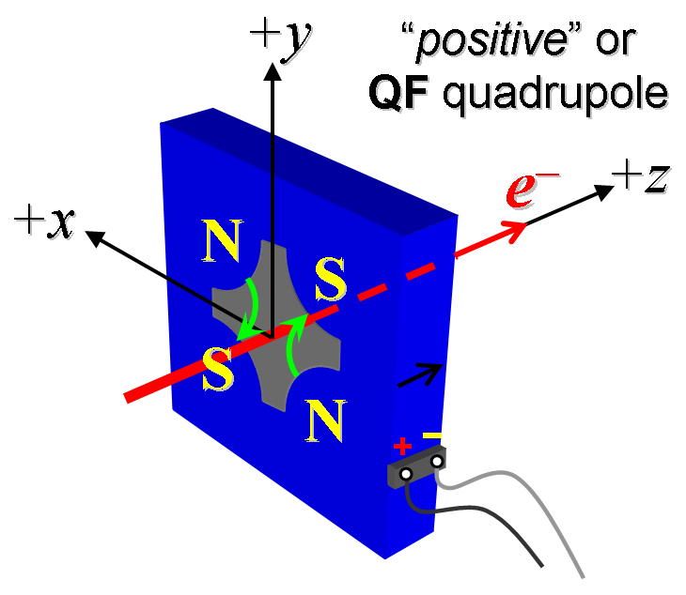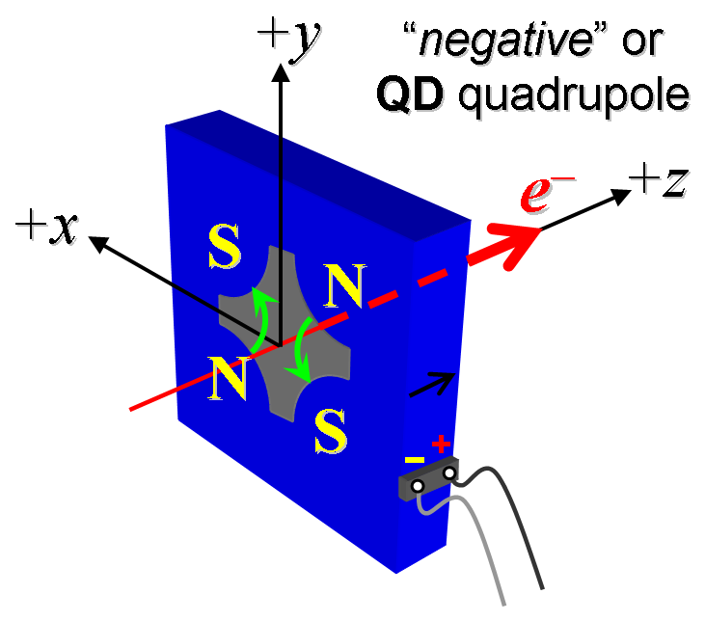
Figure 1. The quadrupoles: QDG001 and QDG003 have “positive” polarity (left), while the quadrupole: QDG002 has “negative” polarity (right).

- Mark the polarity near the magnet leads with clear “+” and “−” labels as shown above.
Polarity has been labeled (initials): | SDA
Magnet polarity chosen from Fig. 1 is (P or N): | P

- Connect the magnet terminals in the correct polarity as established above, to a power supply with maximum current I ≥ 30 A (e.g., MCOR30). Use "3-Linear Ramping Trim" control.

- For all magnets, connect magnet to LCW supply. Adjust supply pressure to a delta P of ~15 psi to achieve a flow rate of 0.2 gpm. Run the magnet up to 30 A for ~1 hour to warm it up, record delta P, flow, ambient, magnet coil and magnet steel temperature in table below.
LCW delta P (psi) | 110 psi
LCW flow rate (gpm) | 0.4 gpm
LCW delta T (°C) | 0 °C
Ambient temperature (°C): | 22.2 °C
Final coil temperature (°C): | 26.5 C
Final magnet steel temperature (°C): | 25.6 °C

- Standardize the magnet, starting from zero to 30 A and back to zero, through three full cycles, finally ending at zero, with a flat-top pause time (at both 0 and 30 A) of 10 seconds. Use a ramp rate of 3 A/sec, if possible, and record the ramp rate used.
Standardization complete (initials): | SDA
Ramp rate used (A/sec): | 3 A/sec

- Measure the length-integrated field gradient, ∫Gdl, from 0 to 30 A in 3-A steps (11 ‘up’ measurements), and then back down from 30 A to 0 in 3-A steps (11 ‘down’ measurements).
Filename & run number of ∫Gdl up & down data: | Strdat.ru1, strplt.ru1

- With rotating coil, measure the magnet harmonics at 30 A current setting. Multipole values should be given as a percentage of the quadrupole moment evaluated at the probe radius.
Filename & run number of harmonic data: | Hardat.ru1, Harplt.ru1
Probe radius used for harmonics (cm): | 1.41349 cm

- Confirm the pole-tip field using a Hall probe at an excitation current of 30 A.
Hall probe pole-tip field at 30 A (mean of 4 poles): | 0.097 +/- 0.005 T

- Measure the inductance and resistance of the magnet:
Inductance of coil (mH): | 0.730 mH
Resistance of coil (Ohms): | 0.0641Ohm

- Upon completion of tests, send traveler to Mark Woodley for acceptance at mailstop 54.
Magnet accepted (signed): | MDW via email
Assigned beamline location (MAD-deck name): | QDG001

