SLAC Magnetic Measurement Plan and Traveler for
LCLS-II Unipolar LH Quadrupoles of Type 2Q4 (SA-344-112-01)
Revision 1, Initial Release Nov. 20, 2017 (Reviewed Dec. 5, 2017 – P. Emma)

This traveler is intended to cover mechanical fiducialization and magnetic measurements of some of the 2Q4 quadrupole magnets needed for LCLS-II. There are a total of 12 of these magnets needed for the LCLS-II laser heater area, 8 of which are unipolar. The MAD names of these eight are Q0H06, Q0H07, QHD02, QHD04 ("P" polarity), and Q0H05, Q0H08, QHD01, QHD03 ("N" polarity).

Receiving:
The following information is to be noted upon receipt of the magnets by the SLAC MFD group:
Received by (MMG initials): | SDA
Date received (dd-mmm-yyyy): | 2/2/2017
SLAC barcode number: | 4047
Vendor serial number on the magnet: | P14

Preparation:
A beam direction arrow, with text “beam direction”, is to be applied to the top and/or connector side of the magnet with a sticker supplied by LCLS (J. Amann will determine the direction).
Beam-direction arrow in place (initials): | SDA

Fiducialization:
Fiducialization may be done before or after magnetic measurements. The magnet is to be fiducialized by the CMM group. This will require the installation of removable tooling balls, location of the geometric axis of the poles of the magnet, and location of tooling balls with respect to the center of this geometric axis when the poles are aligned precisely horizontal.
CMM technician (initials): | KC

URL of on-line CMM fiducialization data (please modify or correct if necessary):
http://www-group.slac.stanford.edu/met/MagMeas/MAGDATA/LCLS-II/Fiducial%20Reports/4047_Fiducial_Report.pdf

Magnetic Measurements:
Enter URL of on-line magnetic measurements data (please modify or correct if necessary):
http://www-group.slac.stanford.edu/met/MagMeas/MAGDATA/LCLS-II/Quad/4047

- Mark 4 of these magnets as a “QF” (positive polarity) and 4 of them as a “QD” (negative polarity). These marks will be replaced with MAD magnet name assignments after all 8 magnets are measured.
Magnet marked as (please enter “QF” or “QD”): | QD

- Determine the connection polarity (with supply outputting positive current) which produces the correct field polarity for the “QF” or “QD” magnet as shown below (depending on its QF or QD assignment):
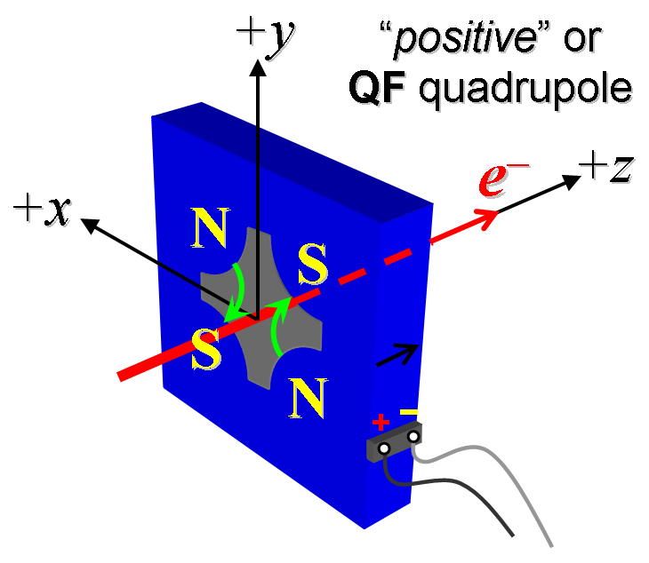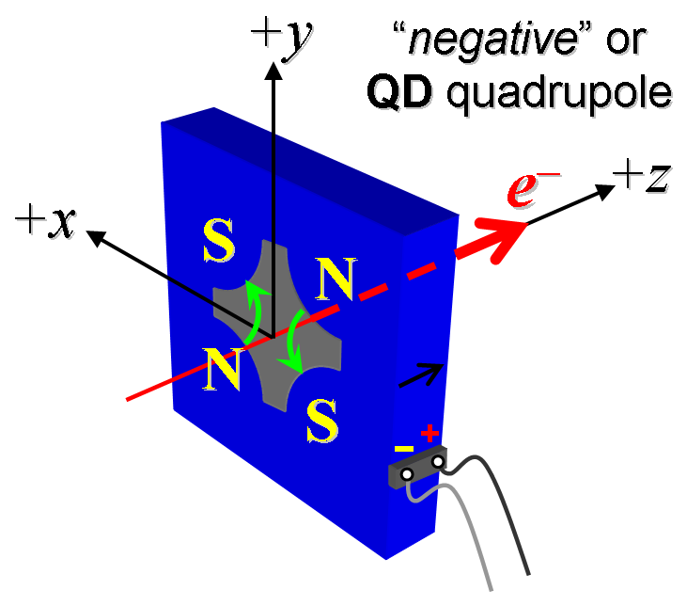
Figure 1. The quadrupoles: Q0H06, Q0H07, QHD02, QHD04 have “positive” polarity (left), while the quadrupoles: Q0H05, Q0H08, QHD01, QHD03 have “negative” polarity (right).

- Mark the polarity near the magnet leads with clear “+” and “−” labels as shown above.
Polarity has been labeled (initials): | SDA
Magnet polarity chosen from Fig. 1 is (P or N): | N

- Connect the magnet terminals in the correct polarity as established above, to a power supply with maximum current I ≥ 45 A.

- For one of these 8 magnets, run the magnet up to 45 A for ~4 hr (or as needed) for a thermal test (record maximum temperature).
Ambient temperature (°C): | N/A °C
Final magnet temperature at 45 A maximum (°C): | N/A °C

- Standardize the magnet, starting from zero to 45 A and back to zero, through three full cycles, finally ending at zero, with a flat-top pause time (at both 0 and 45 A) of 5 seconds. Use a three linear ramp rate of 5 A/sec, if possible, and record the ramp rate used.
Standardization complete (initials): | SDA
Ramp rate used (A/sec): | 5 A/sec

- Measure the length-integrated field gradient, ∫Gdl, from 0 to 45 A in 3-A steps (16 ‘up’ measurements), and then back down from 45 A to 0 in 3-A steps (16 ‘down’ measurements).
Filename & run number of ∫Gdl up & down data: | Strdat.ru1

- For just one of these magnets, degauss the magnet and then re-standardize the magnet at a lower current, starting from zero to 30 A and back to zero, through three full cycles, finally ending at zero, with a flat-top pause time (at both 0 and 30 A) of 5 seconds. Use a three linear ramp rate of 5 A/sec, if possible, and record the ramp rate used.
Special 30-A standardization complete (initials): | M/A
Ramp rate used (A/sec): | 5 A/sec

- For this same magnet, again re-measure the length-integrated field gradient, ∫Gdl, from 0 to 30 A in 3-A steps (11 ‘up’ measurements), and then back down from 30 A to 0 in 3-A steps (11 ‘down’ measurements).
Filename & run no. of 30-A ∫Gdl up & down data: | N/A

- For all magnets, with rotating coil, measure the magnet harmonics at 15, 30 & 45 A current setting. Multipole values should be given as a percentage of the quadrupole moment evaluated at the probe radius.
Filename & run number of harmonic data: | Hardat.ru1
Probe radius used for harmonics (cm): | 1.9596
Rotating Coil Designation (Name) | 48BC1.6

- Confirm the pole-tip field using a Hall probe at an excitation current of 45 A.
Hall probe pole-tip field at 45 A (mean of 4 poles): | 0.1398 T @ 44.993 Amps

- Measure the inductance and resistance of the magnet:
Inductance of coil (mH): | 2.44 mH
Resistance of coil (Ohms): | 0.0611 Ohm
Ambient temperature in degrees C | 23.3 ºC

- Upon completion of tests, email traveler to Mark Woodley for acceptance.
Magnet accepted (signed): | Via email
Assigned beamline location (MAD-deck name): | QHD03

