SLAC Magnetic Measurement Plan and Traveler for
LCLS-II Bipolar LH Quadrupoles of Type 2Q4 (SA-344-112-01)
Revision 1, Initial Release Feb. X, 2018 (Reviewed Feb. X, 2018 – P. Emma)

This traveler is intended to cover mechanical fiducialization and magnetic measurements of some of the 2Q4 quadrupole magnets needed for LCLS-II. There are a total of 12 of these magnets needed for the LCLS-II laser heater area, 4 of which are bipolar. The MAD names of these four are Q0H01, Q0H02, Q0H03, Q0H04.

Receiving:
The following information is to be noted upon receipt of the magnets by the SLAC MMG group:
Received by (MMG initials): | SDA
Date received (dd-mmm-yyyy): | 2/13/2018
SLAC barcode number: | 4045
Vendor serial number on the magnet: | P19

Preparation:
A beam direction arrow, with text “beam direction”, is to be applied to the top and/or connector side of the magnet with a sticker supplied by LCLS-II (J. Amann will determine the direction).
Beam-direction arrow in place (initials): | SDA

Fiducialization:
Fiducialization may be done before or after magnetic measurements. The magnet is to be fiducialized by the CMM group. This will require the installation of removable tooling balls, location of the geometric axis of the poles of the magnet, and location of tooling balls with respect to the center of this geometric axis when the poles are aligned precisely horizontal.
CMM technician (initials): | KC

URL of on-line CMM fiducialization data (please modify or correct if necessary):
http://www-group.slac.stanford.edu/met/MagMeas/MAGDATA/LCLS-II/Fiducial%20Reports/4045_Fiducial_Report.pdf

Magnetic Measurements:
Enter URL of on-line magnetic measurements data (please modify or correct if necessary):
http://www-group.slac.stanford.edu/met/MagMeas/MAGDATA/LCLS-II/Quad/4045

- Mark these 4 magnets as a “QF” (positive polarity).
Magnet marked as “QF”: | QF

- Determine the connection polarity (with supply outputting positive current) which produces the correct field polarity for the “QF”.
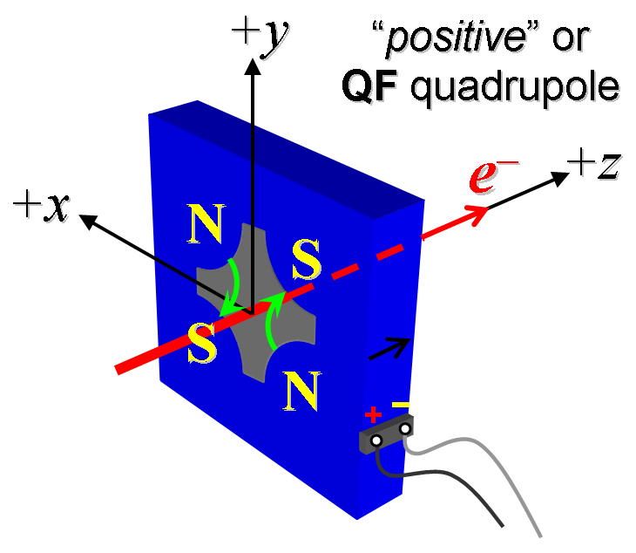
Figure 1. The quadrupoles: Q0H01, Q0H02, Q0H03, Q0H04 have “positive” polarity.

Mark the polarity near the magnet leads with clear “+” and “−” labels as shown above.
Polarity has been labeled (initials): | SDA

- Connect the magnet terminals in the correct polarity as established above, to a power supply with maximum current I ≥ 30 A.

- For one of these 8 magnets, run the magnet up to 30 A for 5 hr (or as needed) for a thermal test (record maximum temperature).
Ambient temperature (°C): | 20.2 °C
Final magnet temperature at 30 A maximum (°C): | 25.5 °C

- Standardize the magnet, starting from zero amps, go to +30 A, then go through 3 full cycles from +30A to -30A, finally ending down at -30A from which the first operating current will be reached. Use a flat-top pause time (at both -30 and 30 A) of 5 seconds. Use a three linear ramp rate of 5 A/sec, if possible, and record the ramp rate used.
Standardization complete (initials): | SDA
Ramp rate used (A/sec): | 5 A/sec

- Measure the length-integrated field gradient, ∫Gdl, from -30 to 30 A in 2-A steps (31 ‘up’ measurements), and then back down from 30 A to -30 in 2-A steps (31 ‘down’ measurements).
Filename & run number of ∫Gdl up & down data: | Strdat.ru1, Strplt.ru1

- For all magnets, with rotating coil, measure the magnet harmonics at -30, -20, -10, +10, +20 & +30 A current setting. Multipole values should be given as a percentage of the quadrupole moment evaluated at the probe radius.
Filename & run number of harmonic data: | Hardat.ru1, harplt.ru1
Probe radius used for harmonics (cm): | 1.9596
Rotating Coil Designation (Name) | 48BC1.6

- Confirm the pole-tip field using a Hall probe at an excitation current of 30 A.
Hall probe pole-tip field at 30 A (mean of 4 poles): | 0.0945 +/- 0.003 T at 29.9952 A

- Measure the inductance and resistance of the magnet:
Inductance of coil (mH): | 2.38 mH
Resistance of coil (Ohms): | 0.0591 Ohm
Ambient temperature in degrees C | 23.5 ºC

- Upon completion of tests, email traveler to Mark Woodley for acceptance.
Magnet accepted (signed): | Via email
Assigned beamline location (MAD-deck name): | Q0H01

