SLAC Traveler Addendum for LCLS-II 1.26Q3.5 Quadrupole Magnet (barcode 4005)
(Oct. 6, 2016)

The Magnetic Measurements Group has measured 21 LCLS-II quadrupoles of the type 1.26Q3.5 to date. Each magnet was standardized -12 A to +12 A (bipolar) and measured -12 A to +12 A. The present LCLS-II optics (29JUN16) calls for only one quadrupole of this type to be 12 A bipolar … the remaining magnets will be run unipolar, with maximum currents of either 12 A or 6 A. We want to measure an “average” magnet of this type in both polarities, with either 6 A maximum current or 12 A maximum current. The magnet with barcode 4005 has been chosen as the “average” 1.26Q3.5 magnet. Six measurements are requested, with the magnet to be degaussed between measurements. In brief, the measurements requested are:
- connect magnet to power supply in “P” polarity (current > 0, ∫Gdl > 0); standardize and measure -12 A to +12 A bipolar (this is a repeat of the measurements described in this magnet’s original Traveler (Mst1.26Q3.5_4005.docx)); degauss
- leave magnet connected to power supply in “P” polarity; standardize and measure -6 A to +6 A bipolar (following same procedure); degauss
- leave magnet connected to power supply in “P” polarity; standardize and measure 0 A to +12 A unipolar; degauss
- leave magnet connected to power supply in “P” polarity; standardize and measure 0 A to +6 A unipolar; degauss
- connect magnet to power supply in “N” polarity (current > 0, ∫Gdl < 0); standardize and measure 0 A to +12 A unipolar; degauss
- leave magnet connected to power supply in “N” polarity; standardize and measure 0 A to +6 A unipolar; degauss
The order in which you do these measurements is up to you … do whatever you think best.
Please refer to section 9, “Initialization”, of the original Traveler (V:\MET\MagServe\MagData\LCLS-II\Quad\4005\Mst1.26Q3.5_4005.docx), for suggested degaussing procedure. Use your own discretion as to how to make the magnet “forget” any previous measurement. Refer to this original Traveler for other details concerning setup, standardization, and measurement procedures. Note that pauses during standardization (section 10, “Standardization Procedure”) can be reduced to 10 seconds from the specified 30 seconds.
This data will be analyzed to estimate the optical errors (BMAG) which would be incurred if we use IVB polynomials, which have been fitted to bipolar measurements, to set magnets which run unipolar, with different standardize currents.
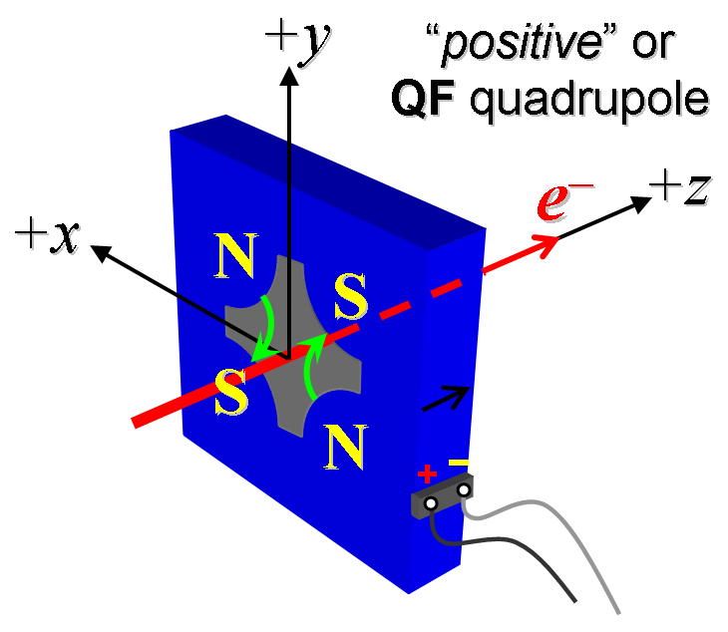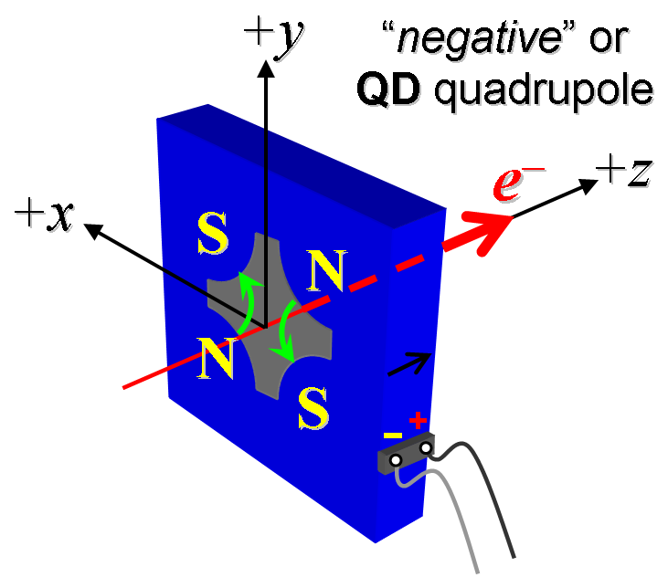
Figure 1. Positive (“P”) polarity (left); Negative (“N”) polarity (right).

Data files:
Filename & run number of ∫Gdl up & down data:  [“P” polarity, -12 A to +12 A bipolar standardize and measure] | Strplt.ru5
Filename & run number of ∫Gdl up & down data:  [“P” polarity, -6 A to +6 A bipolar standardize and measure] | Strplt.ru7
Filename & run number of ∫Gdl up & down data:  [“P” polarity, 0 A to +12 A unipolar standardize and measure] | Strplt.ru9
Filename & run number of ∫Gdl up & down data:  [“P” polarity, 0 A to +6 A unipolar standardize and measure] | Strplt.r11
Filename & run number of ∫Gdl up & down data:  [“N” polarity, 0 A to +12 A unipolar standardize and measure] | Strplt.r13
Filename & run number of ∫Gdl up & down data:  [“N” polarity, 0 A to +6 A unipolar standardize and measure] | Strplt.r15

Upon completion of tests, send data link to Mark Woodley who will produce a data analysis file. Place data analysis file in magnetic measurements data directory
Magnet data accepted and data analysis file produced

Enter URL of on-line magnetic measurements analysis data :

