NON-COMPLIANCE REPORT # 33260-55
PART NAME: | YAG MIRROR MOUNT | DATE: | 11/1/16
PF/SA NO.: | PF-380-520-11 R1 | INSPECTOR: | K. CABAN
WORK ORDER NO.: | 33260-55 | ENGINEER: | M. KRAFT | EXT.: | 2061
VENDOR | SYNTEC OPTICS | PLANNER: | B. MISSON
Reason for Non-Compliance: | Disposition (UAI, Rework, Scrap, Other):
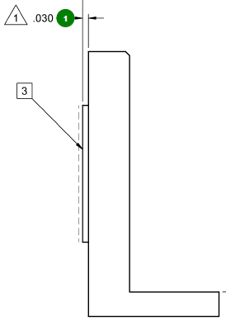

- ± 0.005” measures 0.0451 (+0.0101 out of tolerance) .

