NON-COMPLIANCE REPORT # 33196-11
PART NAME: | SUPPORT COLLAR | DATE: | 9/19/16
PF/SA NO.: | PF-391-738-71 R4 | INSPECTOR: | K. CABAN
WORK ORDER NO.: | 33196-11 | ENGINEER: | D. RICH | EXT.: | 4637
VENDOR | ALTAMONT | PLANNER: | DIANNA
Reason for Non-Compliance: | Disposition (UAI, Rework, Scrap, Other):

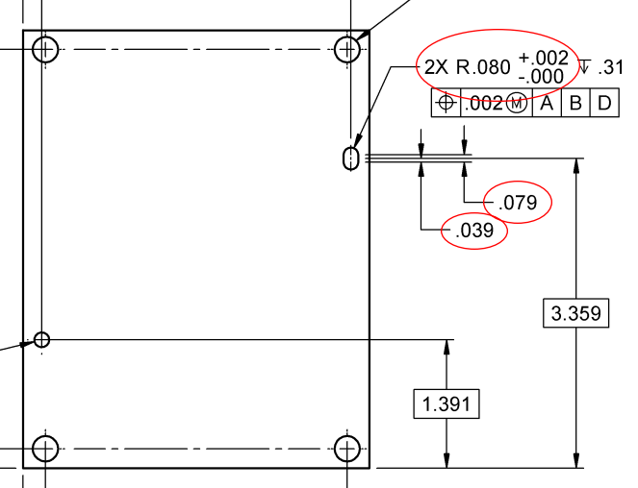
- 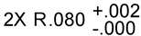 measures 0.0862 & 0.0864 on both parts (~+0.004” out of tolerance) .

- ±0.005 (length of slot) measures 0.1471 & 0.1466 on both parts (~+0.063” out of tolerance).

- ±0.005 (middle of slot to center of radius) measures 0.0736 & 0.0733 on both parts (~0.029” out of tolerance).

