NON-COMPLIANCE REPORT # 32970-2
PART NAME: | 3S DRIFT PUMP CAN (TOP HALF ONLY) | DATE: | 4/6/16
PF/SA NO.: | PF-444-412-23 R0 | INSPECTOR: | K. CABAN
WORK ORDER NO.: | 32970-2 | ENGINEER: | J. VARGAS | EXT.:
VENDOR | MFD | PLANNER: | BILL
Reason for Non-Compliance: | Disposition (UAI, Rework, Scrap, Other):
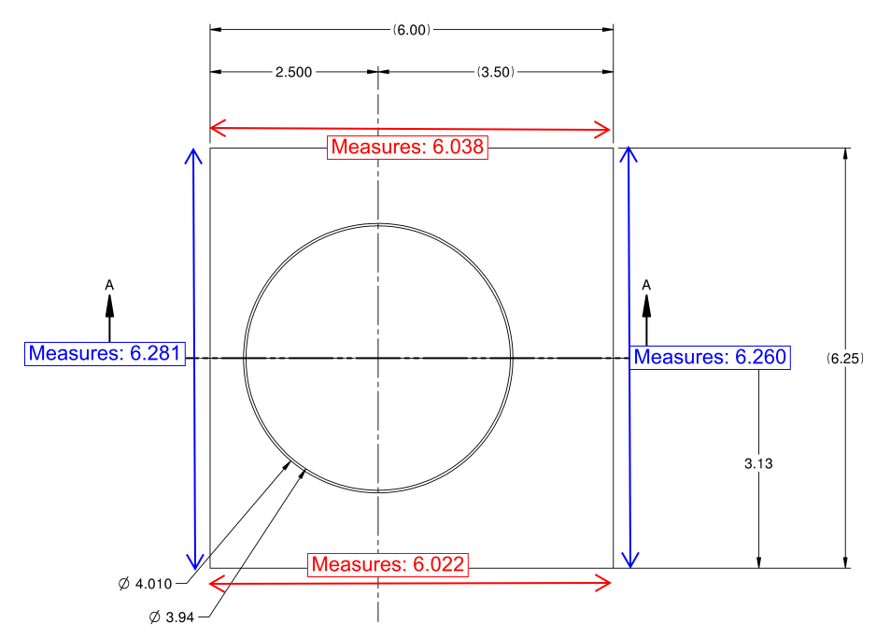
1. 6.00 ±0.01 tapers from 6.022 - 6.038 (+.012” to + .028” oversized)
2. 6.25 ±0.01 tapers from 6.260 - 6.281 (up to +.021” oversized)

**Inspection is for Top part only. Part is a remake (32811-2)-which was not QC’d by SLAC Metrology.

