NON-COMPLIANCE REPORT # 32659-50
PART NAME: | PROBE WELDMENT | DATE: | 2/26/16
PF/SA NO.: | SA-382-907-87 | INSPECTOR: | K. CABAN
WORK ORDER NO.: | 32659-50 | ENGINEER: | V. SRINIVASAN | EXT.: | 2494
VENDOR | MFD | PLANNER: | DIANNA T.
Reason for Non-Compliance: | Disposition (UAI, Rework, Scrap, Other):

- 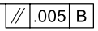 is out of tolerance, measuring 0.00815.

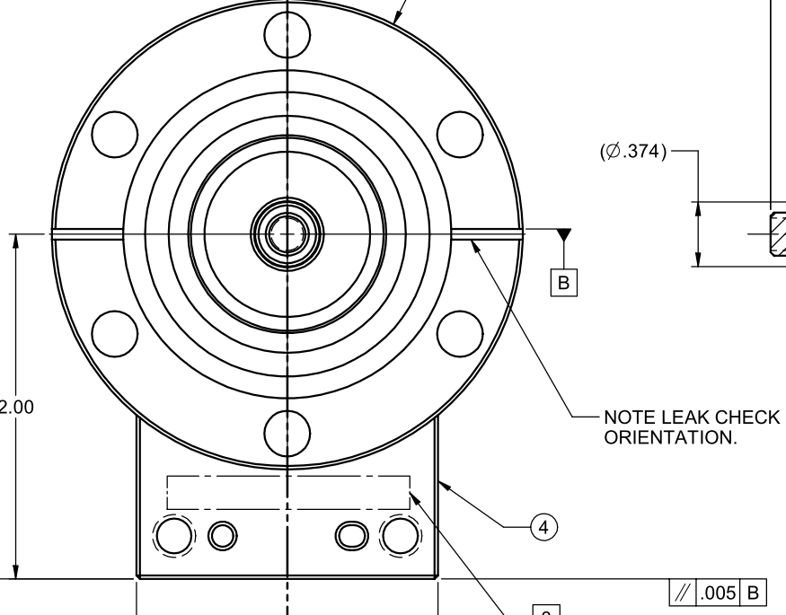
1.9954
2.0036

