NON-COMPLIANCE REPORT # 32054-9
PART NAME: | VACUUM TUBE | DATE: | 7/20/15
PF/SA NO.: | PF-391-834-15 | INSPECTOR: | K. CABAN
WORK ORDER NO.: | 32054-9 | ENGINEER: | JC | EXT.: | 5109
VENDOR | PRO-TEK | PLANNER: | DIANNA
Reason for Non-Compliance: | Disposition (UAI, Rework, Scrap, Other):

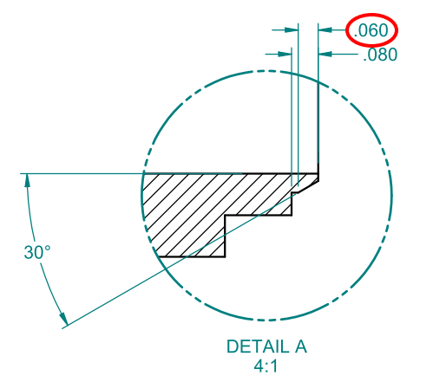
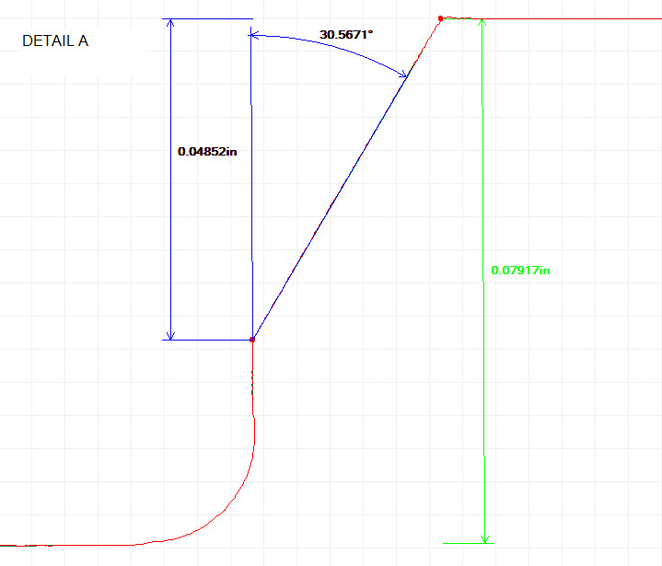
- ±.005 measures 0.0485 (-.0075” out of tolerance, see images below for clarity)

