NON-COMPLIANCE REPORT # 31791-79
PART NAME: | WINDOW FLANGE, 15mm ID | DATE: | 7/7/15
PF/SA NO.: | PF-391-440-05 R0 | INSPECTOR: | K. CABAN
WORK ORDER NO.: | 31791-79 | ENGINEER: | JC | EXT.: | 5109
VENDOR | KLY MACH SHOP | PLANNER: | DIANNA T.
Reason for Non-Compliance: | Disposition (UAI, Rework, Scrap, Other):

FLANGE KNIFE EDGE DETAIL
- ± .005 fits only a 0.7938 gage pin, .7942 does not fit.
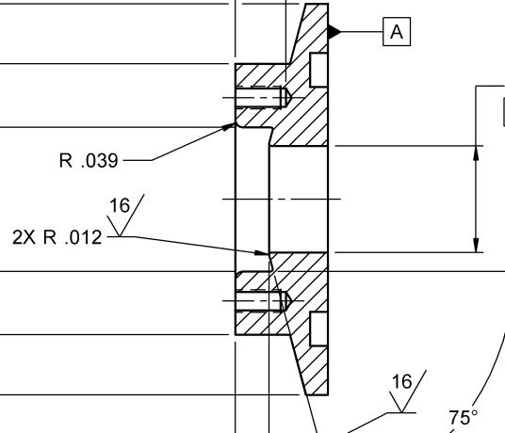
- Flange Knife Edge Detail is NOT machined
  - ±.005 measures .0014
  - ±.5° is not machined measuring 89.1227°
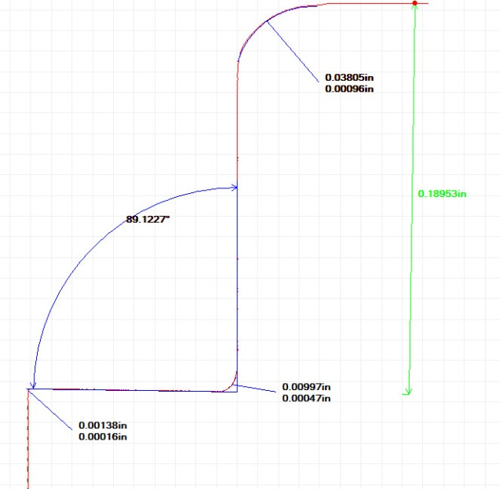
Flange Knife Edge
Actual

