Leave Blank MFD NON-COMPLIANCE REPORT # 27498-63

PART NAME: | ALIGNMENT PIN 2 | DATE: | 7/6/12
PF/SA NO.: | PF-380-545-30 R0 | INSPECTOR: | K. CABAN
WORK ORDER NO.: | 27498-63 & 27937-50 | ENGINEER: | E. KRAFT | EXT.: | 2061
VENDOR | MFD | ROUTE TO: | MTLFNSH

Reason For Non-Compliance: | Action (UAI,RWK,SCRP)
** NCR IS FOR BOTH MFD W/O#: 27498-63 & 27937-50 (QTY: 4 PER W/O)

- ALL PARTS (8 TOTAL) 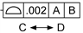 ARE UNDERSIZED. SEE ATTACHED PROFILE PLOTS FOR EACH PART.

- PART #3 ONLY, SPHERICAL RADIUS NOMINAL SR .188 MEASURES .179, BUT SHAFT DIAMETER TOLERANCE IS .375 ± 0.020.

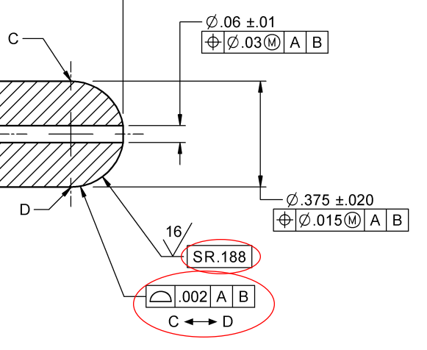

Engineer Signature: |  | Date:

