LCLS2 Bend Magnet 0.788D11.50

Alignment Engineering Group
L204549
SN 05
January 24, 2018

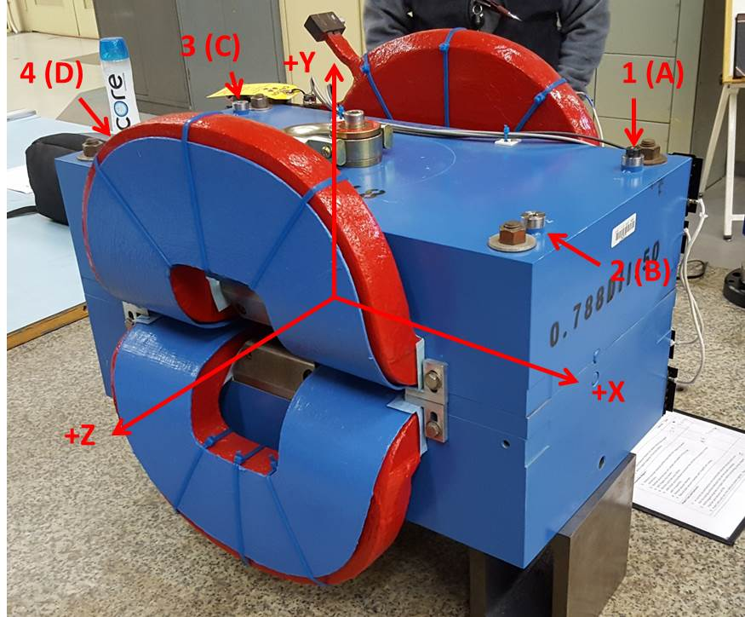

Numbered tooling balls are 1 inch offset lettered tooling balls are a 0.3125 inch offset. All units are inches. Coordinates and are to the Mechanical Center of the Poles.
Tooling Ball | Z (in) | X (in) | Y (in)
TBA | -3.456 | 9.473 | 6.224
TBB | 3.459 | 9.524 | 6.226
TBC | -3.440 | -9.489 | 6.219
TBD | 3.468 | -9.479 | 6.224
TB1 | -3.458 | 9.472 | 6.911
TB2 | 3.458 | 9.522 | 6.914
TB3 | -3.443 | -9.491 | 6.907
TB4 | 3.464 | -9.476 | 6.911

Pole gap = 0.796 inches at origin (0,0,0).

