LCLS2 Bend Magnet 0.788D11.50

Alignment Engineering Group
L204543
SN 20
January 11, 2018

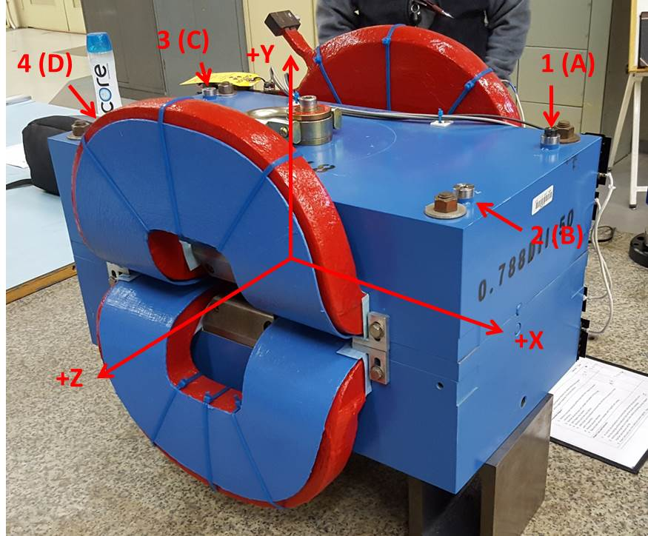

Numbered tooling balls are a 1 inch offset, lettered tooling balls are a 0.3125 inch offset. All units are inches. Coordinates are to the Mechanical Center of the Poles.
Tooling Ball | Z (in) | X (in) | Y (in)
TBA | -3.429 | 9.510 | 6.229
TBB | 3.479 | 9.505 | 6.227
TBC | -3.441 | -9.480 | 6.224
TBD | 3.464 | -9.469 | 6.223
TB1 | -3.426 | 9.508 | 6.916
TB2 | 3.480 | 9.507 | 6.914
TB3 | -3.441 | -9.479 | 6.911
TB4 | 3.463 | -9.468 | 6.911

Pole gap = 0.796 inches at origin (0,0,0).

