LCLS2 Bend Magnet 0.788D11.50

Alignment Engineering Group
L204542
SN 35
January 12, 2018

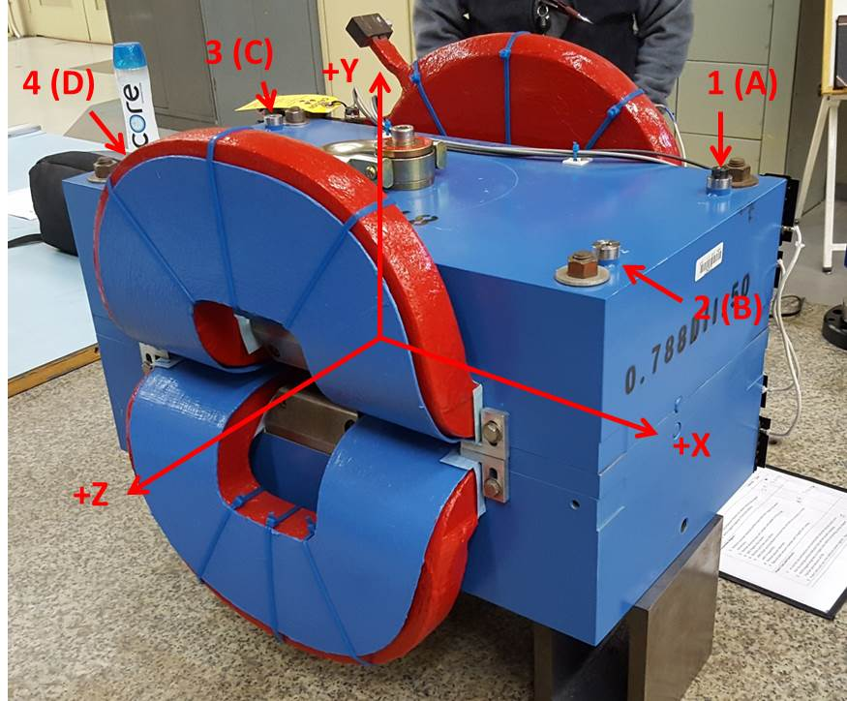

Numbered tooling balls are a 1 inch offset, lettered tooling balls are a 0.3125 inch offset. All units are inches. Coordinates are to the Mechanical Center of the Poles.
Tooling Ball | Z (in) | X (in) | Y (in)
TBA | -3.435 | 9.494 | 6.228
TBB | 3.461 | 9.497 | 6.226
TBC | -3.448 | -9.497 | 6.227
TBD | 3.459 | -9.481 | 6.224
TB1 | -3.433 | 9.493 | 6.915
TB2 | 3.455 | 9.497 | 6.913
TB3 | -3.449 | -9.498 | 6.914
TB4 | 3.461 | -9.482 | 6.912

Pole gap = 0.796 inches at origin (0,0,0).

