LCLS2 Bend Magnet 0.788D11.50

Alignment Engineering Group
L204540
SN 40
January 12, 2018

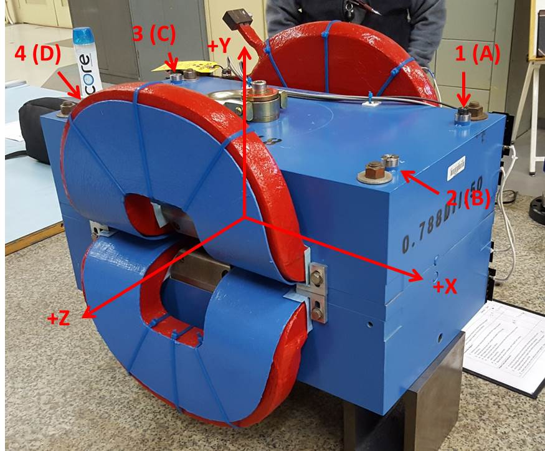

Numbered tooling balls are a 1 inch offset, lettered tooling balls are a 0.3125 inch offset. All units are inches. Coordinates are to the Mechanical Center of the Poles.
Tooling Ball | Z (in) | X (in) | Y (in)
TBA | -3.444 | 9.511 | 6.223
TBB | 3.460 | 9.504 | 6.225
TBC | -3.475 | -9.483 | 6.219
TBD | 3.436 | -9.499 | 6.223
TB1 | -3.446 | 9.509 | 6.910
TB2 | 3.459 | 9.504 | 6.912
TB3 | -3.476 | -9.483 | 6.906
TB4 | 3.442 | -9.499 | 6.911

Pole gap = 0.796 inches at origin (0,0,0).

