LCLS2 Bend Magnet 0.788D11.50

Alignment Engineering Group
L204538
SN 26
January 12, 2018

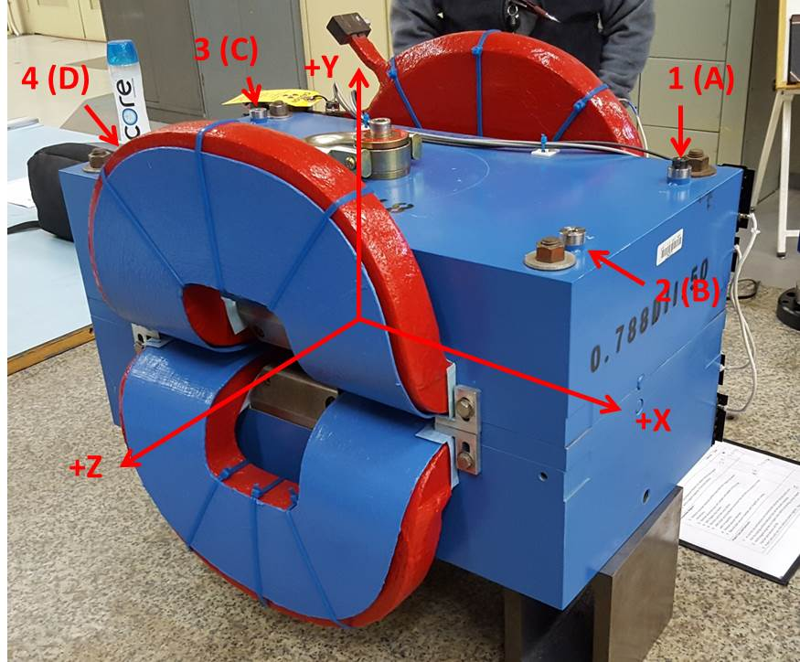

Numbered tooling balls are a 1 inch offset, lettered tooling balls are a 0.3125 inch offset. All units are inches. Coordinates are to the Mechanical Center of the Poles.
Tooling Ball | Z (in) | X (in) | Y (in)
TBA | -3.442 | 9.497 | 6.222
TBB | 3.459 | 9.506 | 6.221
TBC | -3.451 | -9.493 | 6.228
TBD | 3.444 | -9.490 | 6.228
TB1 | -3.447 | 9.495 | 6.909
TB2 | 3.461 | 9.505 | 6.908
TB3 | -3.453 | -9.494 | 6.916
TB4 | 3.447 | -9.491 | 6.915

Pole gap = 0.796 inches at origin (0,0,0).

