LCLS2 Bend Magnet 0.788D11.50

Alignment Engineering Group
L204531
SN 17
December 14, 2017

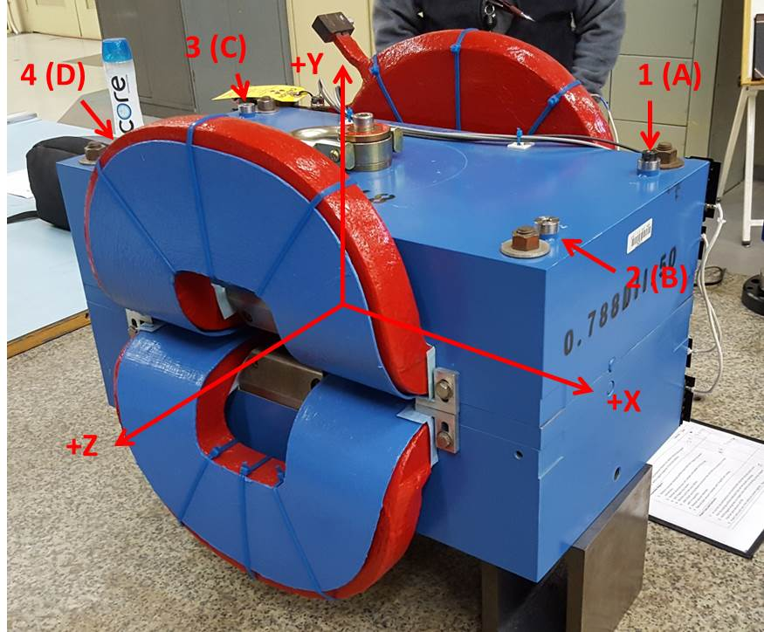

Numbered tooling balls are a 1 inch offset, lettered tooling balls are a 0.3125 inch offset. All units are inches. Coordinates are to the Mechanical Center of the Poles.
Tooling Ball | Z (in) | X (in) | Y (in)
TBA | -3.492 | 9.494 | 6.224
TBB | 3.509 | 9.505 | 6.227
TBC | -3.480 | -9.512 | 6.227
TBD | 3.517 | -9.498 | 6.224
TB1 | -3.490 | 9.493 | 6.913
TB2 | 3.513 | 9.503 | 6.913
TB3 | -3.482 | -9.514 | 6.913
TB4 | 3.513 | -9.499 | 6.913

Pole gap = 0.800 inches at origin (0,0,0).

