LCLS2 Bend Magnet 0.788D11.50

Alignment Engineering Group
L204525
SN 14
January 10, 2018

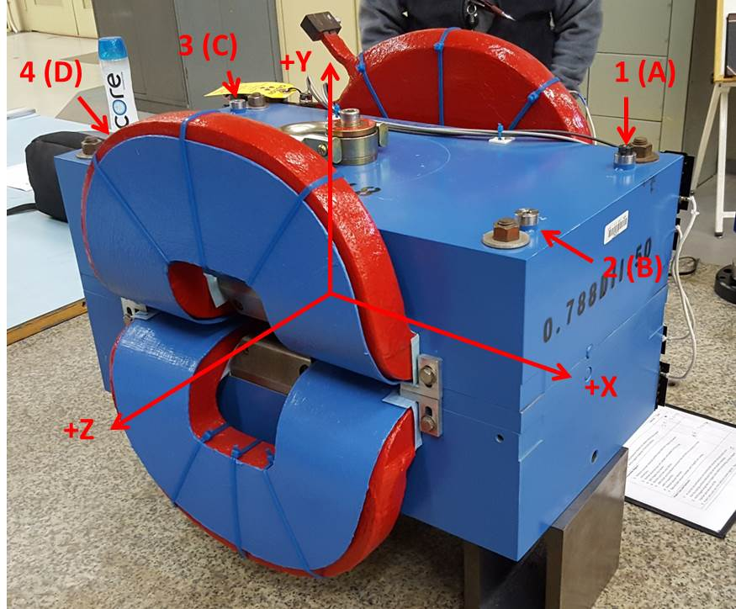

Numbered tooling balls are a 1 inch offset, lettered tooling balls are a 0.3125 inch offset. All units are inches. Coordinates are to the Mechanical Center of the Poles.
Tooling Ball | Z (in) | X (in) | Y (in)
TBA | -3.518 | 9.495 | 6.221
TBB | 3.479 | 9.511 | 6.218
TBC | -3.488 | -9.488 | 6.223
TBD | 3.543 | -9.492 | 6.221
TB1 | -3.517 | 9.497 | 6.909
TB2 | 3.480 | 9.516 | 6.906
TB3 | -3.481 | -9.485 | 6.911
TB4 | 3.541 | -9.489 | 6.908

Pole gap = 0.800 inches at origin (0,0,0).

