LCLS2 Bend Magnet 0.788D11.50

Alignment Engineering Group
L204524
SN 07
January 09, 2018

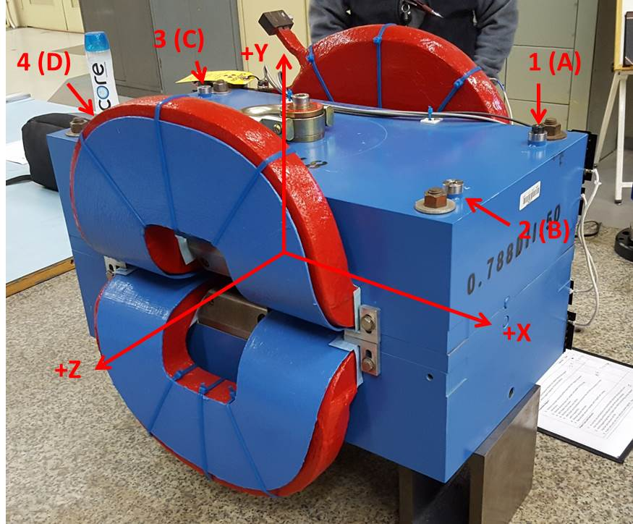

Numbered tooling balls are a 1 inch offset, lettered tooling balls are a 0.3125 inch offset. All units are inches. Coordinates are to the Mechanical Center of the Poles.
Tooling Ball | Z (in) | X (in) | Y (in)
TBA | -3.484 | 9.527 | 6.225
TBB | 3.530 | 9.505 | 6.225
TBC | -3.493 | -9.461 | 6.227
TBD | 3.491 | -9.498 | 6.228
TB1 | -3.483 | 9.533 | 6.912
TB2 | 3.533 | 9.507 | 6.913
TB3 | -3.493 | -9.466 | 6.915
TB4 | 3.483 | -9.504 | 6.915

Pole gap = 0.800 inches at origin (0,0,0).

