LCLS2 Bend Magnet 0.788D11.50

Alignment Engineering Group
L204523
SN 25
January 09, 2018

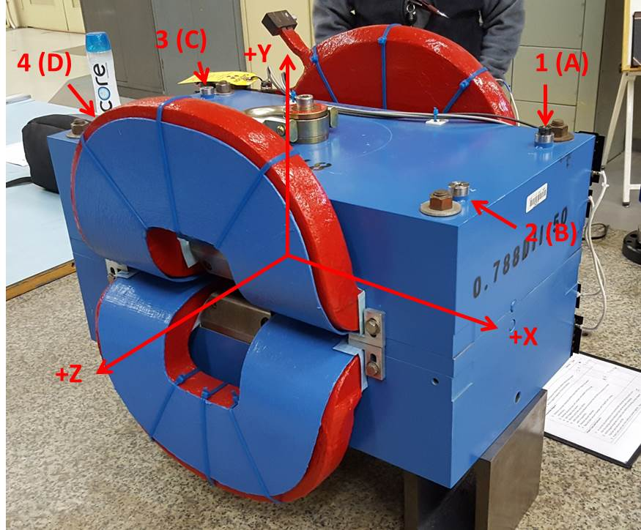

Numbered tooling balls are a 1 inch offset, lettered tooling balls are a 0.3125 inch offset. All units are inches. Coordinates are to the Mechanical Center of the Poles.
Tooling Ball | Z (in) | X (in) | Y (in)
TBA | -3.509 | 9.498 | 6.224
TBB | 3.517 | 9.472 | 6.220
TBC | -3.508 | -9.475 | 6.233
TBD | 3.509 | -9.490 | 6.229
TB1 | -3.507 | 9.500 | 6.913
TB2 | 3.519 | 9.474 | 6.907
TB3 | -3.505 | -9.477 | 6.920
TB4 | 3.510 | -9.492 | 6.917

Pole gap = 0.802 inches at origin (0,0,0).

