LCLS2 Bend Magnet 0.788D11.50

Alignment Engineering Group
L204522
SN 21
January 09, 2018

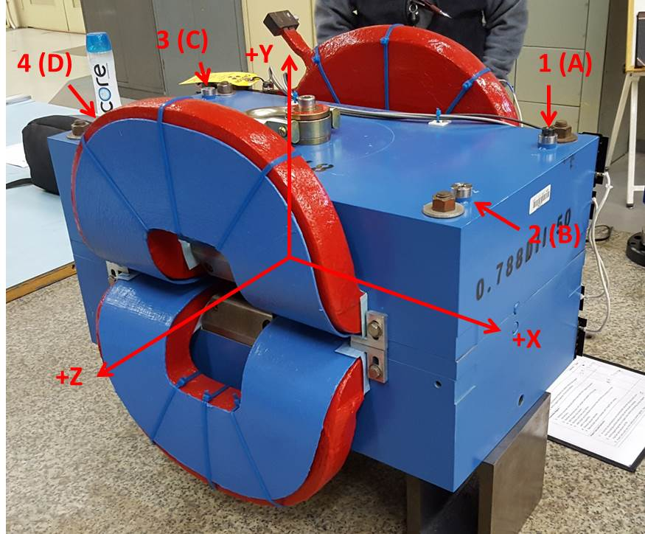

Numbered tooling balls are a 1 inch offset, lettered tooling balls are a 0.3125 inch offset. All units are inches. Coordinates are to the Mechanical Center of the Poles.
Tooling Ball | Z (in) | X (in) | Y (in)
TBA | -3.490 | 9.514 | 6.228
TBB | 3.500 | 9.520 | 6.228
TBC | -3.487 | -9.497 | 6.225
TBD | 3.523 | -9.495 | 6.223
TB1 | -3.492 | 9.509 | 6.914
TB2 | 3.502 | 9.515 | 6.912
TB3 | -3.487 | -9.499 | 6.913
TB4 | 3.523 | -9.496 | 6.910

Pole gap = 0.800 inches at origin (0,0,0).

