## SLAC Traveler for LCLS-II CuSXR 3D8.8MK3, SA-375-552-70 Dipole Magnets Rev. 2

**(May 8, 2019)**

This traveler is intended to cover reception, preparation, mechanical fiducialization, and magnetic measurements the 3D8.8 dipole magnets that have been proposed to be used for BRCUSDC1, BRCUSDC2, BYCUS1 and BYCUS2 in the Cu to SXR beamline (CLTS). The table below gives the MAD names, model drawing numbers, polarities, and installation directions of the 3D8.8 dipoles.

|  |  |  |  |  |  |
| --- | --- | --- | --- | --- | --- |
| **MAD Name** | **Eng. Name** | **Drawing#** | **Barcode** | **Polarity** | **Terminals** |
| BRCUSDC1 | 3D8.8MK3 | SA-375-552-70 | 4574 | P Vertical | upstream |
| BRCUSDC2 | 3D8.8MK3 | SA-375-552-70 | 4573 | P Vertical | upstream |
| BYCUS1 | 3D8.8MK3 | SA-375-552-70 | 4575 | P Vertical | upstream |
| BYCUS2 | 3D8.8MK3 | SA-375-552-70 | 4576 | N Vertical | upstream |

**Receiving:**

The following information is to be noted upon receipt of the magnets by the SLAC MM group:

|  |  |
| --- | --- |
| Received by (initials): | SDA |
| Date placed on test stand (dd-mmm-yyyy): | 5/23/2019 |
| SLAC barcode number: | 4575 |
| Serial number: | N/A |
| SLAC approved electrical safety covers? (Y or N): | N |
| SLAC approved lifting eyes? (Y or N): | N |

**Preparation:**

A beam direction arrow, with text “Beam Direction”, is to be applied to the top and/or connector side of the magnet with a sticker supplied by LCLS-II. The MAD name label should also be attached to the magnet. The terminals shall be oriented upstream.

|  |  |
| --- | --- |
| Beam-direction arrow and MAD name in place (initials): | SDA |

**Fiducialization:**

Fiducialization must be done before magnetic measurements. The magnet is to be fiducialized by the CMM group. This will require the installation of sockets for removable tooling balls, location of the geometric axis of the poles of the magnet, and location of tooling balls with respect to the center of this geometric axis when the poles are aligned precisely horizontal. The dipole gap should also be measured and noted in a report.

|  |  |
| --- | --- |
| CMM technician (initials): | MR, CM |

URL of on-line CMM fiducialization data (please modify or correct if necessary):

|  |
| --- |
| http://www-group.slac.stanford.edu/met/MagMeas/MAGDATA/LCLS-II/ Fiducial ReportS/Fiducial Report 4575.pdf |

**Magnetic Measurements:**

1. Verify that the magnets are complete and undamaged, including wiring connections.

|  |  |
| --- | --- |
| Incoming inspection OK (initials): | SDA |
| Date of arrival to mag. meas.(mmm-dd-yyyy): | 5/23/2019 |

Enter URL of on-line magnetic measurements data (please modify or correct if necessary):

|  |
| --- |
| http://www-group.slac.stanford.edu/met/MagMeas/MAGDATA/LCLS-II/Dipole/4575 |

1. Determine the main-coil connection polarity and mark the polarity near the magnet leads with clear “+” and “-” labels as shown below.

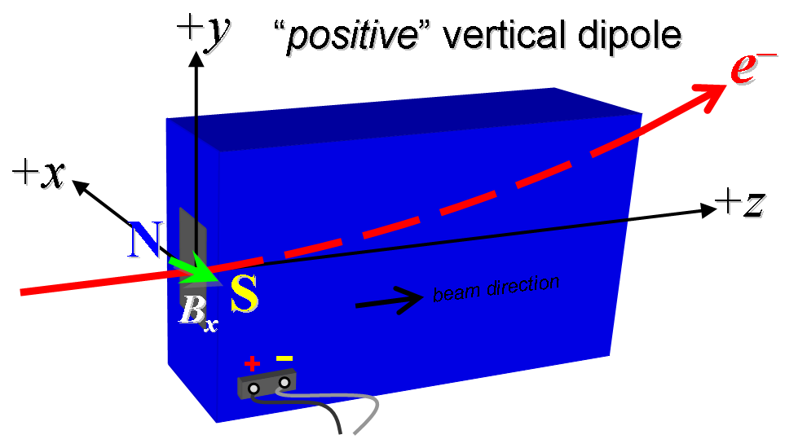

**Figure 1. “Positive” polarity (bending electrons up) . “Negative” polarity (bending electrons down).**

|  |  |
| --- | --- |
| Polarity is marked according to Fig. 1 (initials): | P |

1. Connect the magnet terminals, in the correct polarity as established above, to a bipolar power supply with maximum current *I* ≥ 6 A. Measure pole tip field of the main at 6 A.

|  |  |
| --- | --- |
| Pole Tip Field and Current | 0.0605 T at 6.0038 Amps |

1. Run the dipole up to 6 amps for 1 hour. Standardize the magnet, starting from zero to 6 A then to back to zero, through three full cycles, finally ending at zero, with a flat-top pause time (at 6 A) of 10 seconds. This standardize cycle will be used before all measurements. Use a three linear ramp rate of 1 A/sec, if possible, and record the ramp rate used.

|  |  |
| --- | --- |
| Standardization complete (initials): | SDA |
| Ramp rate used (A/sec): | 1 A/sec |

1. Maintaining this cycle history, measure the length-integrated horizontal dipole field, ∫*Bydl*, from 0 to 6 A in 0.5-A steps, including zero (13 ‘up’ measurements). Then, still maintaining the cycle history, measure ∫*Bydl* back down from 6 A to 0 in 0.5-A steps, including zero (13 ‘down’ measurements).

|  |  |
| --- | --- |
| Filename & run number of ∫*Bydl* up & down data: | Wiredat.ru1, wireplt.ru1 |

1. Standardize dipole and set to 6A, use a stretched wire to measure the length-integrated horizontal field at multiple positions in x. With the wire located at the vertical mid-plane (*y* = 0), measure the vertical length-integrated field at each 3-mm step of horizontal wire position, from *x* = 30 mm to +30 mm, with *x* = 0 centered at the magnet’s horizontal center. Record data file name:

|  |  |
| --- | --- |
| Filename: | Wirevsx.ru1, wirepltvsx.ru1 |

1. For one of the 3D8.8 dipoles, standardize dipole and use a rotating coil to measure harmonics with main coil at 2A, 4A, 6A with at least a 0.5-inch diameter (use smaller probe only if 0.5-inch is not available, staying with largest diameter possible). Record probe designation, radius, and data file names:

|  |  |
| --- | --- |
| Coil designation (text): | Measured on LCLS-II Dipole 4574 |
| Coil radius (m): | Measured on LCLS-II Dipole 4574 |
| Harmonics Filename: | Measured on LCLS-II Dipole 4574 |

1. For one of the 3D8.8 magnets, at a current of 6A, measure the vertical magnetic field component, By, at x = y = 0, as a function of the longitudinal beam-direction coordinate, z (from -5 cm to +20 cm in 1-cm steps, where z = 0 is defined at the iron edge), at both the downstream and upstream ends of the magnet. Please also measure the background field at z = -20 cm with magnet switched off (separate file).

|  |  |
| --- | --- |
| Filenames of *By* vs. *z* data: | Measured on LCLS-II Dipole 4574 |
| Background filenames of *By*(*z* = +/-20 cm), magnet OFF: | Measured on LCLS-II Dipole 4574 |

1. For the BRCUSDC1 and BRCUSDC2 dipoles, run the best degauss procedure known using cycling of the dipole current and record the smallest final measured |∫*Bydl*| achievable and reproducible with *Imain* = 0. Please also finish the degauss procedure with a positive step, by setting the current in the positive direction to zero (*i.e.*, from *Imain* < 0 to *Imain* = 0). Record the degauss procedure applied (ramp rate, hold times, current sequence, etc). See file SRXSS Dipole Degauss Procedure.docx for more details.

|  |  |
| --- | --- |
| Filename: | Wiredat.ru2, wireplt.ru2 |
| De-Gauss procedure’s achieved mean |∫*Bydl*|: | 9.0725e-05 +/- 3.0434e-06 Tm |
| Measurements used for mean and stdev. | 0.0000079, 0.0000058, 0.0000054, 0.0000071 |
| Ramp rate and Type: | 6 Amp/sec, 3 -Linear |
| Hold times: | 2 Seconds |
| Current sequence: | {0.0, 6.0000, -5.2800, 4.6464, -4.0888, 3.5982, -3.1664, 2.7864, -2.4521, 2.1578, -1.8989, 1.6710, -1.4705, 1.2940, -1.1387, 1.0021, -0.8818, 0.7760, -0.6829, 0.6010, -0.5288, 0.4654, -0.4095, 0.3604, -0.3171, 0.2791, -0.2456, 0.2161, -0.1902, 0.1674, -0.1473, 0.1296, -0.1141, 0.1004, -0.0883, 0.0777, -0.0684, 0.0602, -0.0530, 0.0466, -0.0410, 0.0361, -0.0318, 0.0280, -0.0246, 0.0216, -0.0190, 0.0168, -0.0148, 0.0130, -0.0114, 0.0}; |

1. Maintaining this cycle history, measure the length-integrated horizontal dipole field, ∫*Bydl*, from 0 to 6 A in 0.5-A steps, including zero (13 ‘up’ measurements). Then, still maintaining the cycle history, measure ∫*Bydl* back down from 6 A to 0 in 0.5-A steps, including zero (13 ‘down’ measurements).

|  |  |
| --- | --- |
| Filename & run number of ∫*Bydl* up & down data: | Wiredat.ru3, wireplt.ru3 |

1. For one of the 3D8.8 dipoles, run the magnet up to 6 A for 6 hours and record its current, resistance, core temperature and coil temperature.

|  |  |
| --- | --- |
| Ambient temperature (°C): | 24.5 |
| Final magnet core temperature (°C): | 27.2 |
| Final magnet coil temperature (°C): | 22.0 |

1. Measure the inductance and resistance of the main magnet coils:

|  |  |
| --- | --- |
| Inductance of main coil (mH): | 26.105 mH |
| Resistance of main coil (Ohms): | 0.543 Ohm |
| Magnet coil temperature (°C): | 19.9 |

1. Upon completion of tests, send data link to Mark Woodley who will produce a data analysis file. Place data analysis file in magnetic measurements data directory

|  |  |
| --- | --- |
| Magnet data accepted and data analysis file produced | SDA |

Enter URL of on-line magnetic measurements analysis data :

|  |
| --- |
| http://www-group.slac.stanford.edu/met/MagMeas/MAGDATA/LCLS-II/Dipole/4575/3D8.8_4575.pptx |