## SLAC Traveler for LCLS-II 1.0D22.625, SA-344-100-37 Vertical Dipole Magnets, BYSP1H, BYSP2H, BYSP1S, BYSP2S

**(Aug. 28, 2018)**

This traveler is intended to cover reception, preparation, mechanical fiducialization, and magnetic measurements of the four BSY (BYSP1H, BYSP2H, BYSP1S, BYSP2S) vertical dipole magnets. These magnets are refurbished versions of the 1.0D22.625 (SA-344-100-37) that were previously installed in the FFTB enclosure, are about 0.6m long, and have LCLS-II MAD designations of BYSP1H, BYSP2H, BYSP1S, and BYSP2S. It is assumed that the magnets will be oriented with horizontal fields (vertical bends) during magnetic measurements; therefore the field is described as *Bx* below.

**Receiving:**

The following information is to be noted upon receipt of the magnets by the SLAC MM group:

|  |  |
| --- | --- |
| Received by (initials): | SDA |
| Date placed on test stand (dd-mmm-yyyy): | 9/10/2018 |
| SLAC barcode number: | 4571 |
| Vendor serial number from magnet label: | N/A |
| SLAC approved electrical safety covers? (Y or N): | N |
| SLAC approved lifting eyes? (Y or N): | N/A |
| Shipping Damage? (Y or N): | N |
| Vendor tests passed on magnet label? (Y or N): | N/A |
| SLAC drawing number (enter number): | SA-344-100-37 |

**Preparation:**

A beam direction arrow, with text “beam direction”, is to be applied to the top and/or connector side of the magnet with a sticker supplied by LCLS-II. The terminals shall be oriented down beam.

|  |  |
| --- | --- |
| Beam-direction arrow in place (initials): | SDA |

**Fiducialization:**

Fiducialization may be done before or after magnetic measurements. The magnet is to be fiducialized by the CMM group. This will require the installation of removable tooling balls, location of the geometric axis of the poles of the magnet, and location of tooling balls with respect to the center of this geometric axis when the poles are aligned precisely horizontal.

|  |  |
| --- | --- |
| CMM technician (initials): | MR |

URL of on-line CMM fiducialization data (please modify or correct if necessary):

|  |
| --- |
| http://www-group.slac.stanford.edu/met/MagMeas/MAGDATA/LCLS-II/Fiducial%20Reports/LCLS-II 1D22.625 204570 Fiducial Data.txt |

**Magnetic Measurements:**

1. Verify that the magnets are complete and undamaged, including wiring connections.

|  |  |
| --- | --- |
| Incoming inspection OK (initials): | SDA |
| Date of arrival to mag. meas.(mmm-dd-yyyy): | 09/10/2018 |

Enter URL of on-line magnetic measurements data (please modify or correct if necessary):

|  |
| --- |
| <http://www-group.slac.stanford.edu/met/MagMeas/MAGDATA/LCLS-II/dipole/>4571 |

1. Mark each magnet as BYSP1H, BYSP2H, BYSP1S or BYSP2S. BYSP2H and BSYP2S are “positive” polarity (bending electrons up) and BYSP1H and BSYP1S are “negative” polarity (bending electrons down).

|  |  |
| --- | --- |
| Magnet marked as (BYSP1H, BYSP2H, BYSP1S or BYSP2S): | BSYP2S |

1. Determine the main-coil connection polarity (with main supply outputting positive current) which produces a “positive” field polarity for BYSP2H and BYSP2S and “negative” field polarity for BYSP1H and BYSP1S, as shown below:

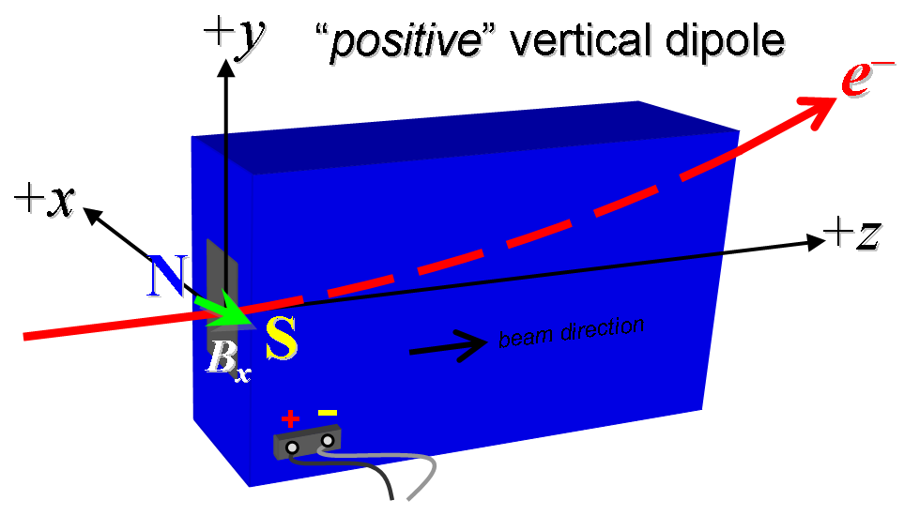



**Figure 1. BYSP2H and BSYP2S are “positive” polarity (bending electrons up) and BYSP1H and BSYP1S are “negative” polarity (bending electrons down).**

1. Mark the polarity near the magnet leads with clear “+” and “” labels as shown above. If trim coils exist, they are not used.

|  |  |
| --- | --- |
| Polarity is marked according to Fig. 1 (initials): | P |

1. Connect the magnet terminals, in the correct polarity as established above, to a unipolar (or bipolar) power supply with maximum current *I* ≥ 125 A.
2. Connect magnet to LCW supply. Adjust supply pressure to a delta P of ~100 psi to achieve a flow rate of 0.96 gpm. Run the magnet up to 125 A for ~1 hour to warm it up (record, delta P, flow rate, and magnet coil and steel temperature).

|  |  |
| --- | --- |
| LCW delta P (psi) | 110.2 psi |
| LCW flow rate (gpm) | 0.96 gpm |
| LCW delta T (°C) | 1.3 °C |
| Ambient temperature (°C): | 24.6 °C |
| Final magnet steel temperature (°C): | 26.3 °C |

1. Standardize the magnet, starting from zero to 125 A and back to zero, through three full cycles, finally ending at zero, with a flat-top pause time (at both 0 and 10 A) of 10 seconds. Use a ramp rate of 5 A/sec, if possible, and record the ramp rate used.

|  |  |
| --- | --- |
| Standardization complete (initials): | SDA |
| Ramp rate used (A/sec): | 5 A/sec |

1. Maintaining this cycle history, measure the length-integrated horizontal dipole field, ∫*Bxdl*, from 0 to 125 A in 5-A steps, including zero (26 ‘up’ measurements). Then, still maintaining the cycle history, measure ∫*Bxdl* back down from 125 A to 0 in 5-A steps, including zero (26 ‘down’ measurements).

|  |  |
| --- | --- |
| Filename & run number of ∫*Bxdl* up & down data: | Wiredat.ru1, wireplt.ru1 |

1. Standardize the magnet, starting from zero to 125 A and back to zero, through three full cycles, finally ending at zero, with a flat-top pause time (at both 0 and 10 A) of 10 seconds. Use a ramp rate of 5 A/sec, if possible, and record the ramp rate used.

|  |  |
| --- | --- |
| Standardization complete (initials): | N/A |
| Ramp rate used (A/sec): | N/A |

1. **For one magnet only**, with main coil at 95A, use a stretched wire to measure the length-integrated horizontal field at multiple positions in y. With the wire located at the horizontal mid-plane (*x* = 0), measure the horizontal length-integrated field at each 3-mm step of vertical wire position, from *y* = 30 mm to +30 mm, with *y* = 0 centered at the magnet’s vertical center. Record data file name:

|  |  |
| --- | --- |
| Harmonics filename: | 4570 was measured at 95 A |

1. For all magnets, with main coil at 125A, use a stretched wire to measure the length-integrated horizontal field at multiple positions in y. With the wire located at the horizontal mid-plane (*x* = 0), measure the horizontal length-integrated field at each 3-mm step of vertical wire position, from *y* = 30 mm to +30 mm, with *y* = 0 centered at the magnet’s vertical center. Record data file name:

|  |  |
| --- | --- |
| Harmonics filename: | Wirevsx.ru1, wirepltvsx.ru1 |

1. Standardize the magnet, starting from zero to 125 A and back to zero, through three full cycles, finally ending at zero, with a flat-top pause time (at both 0 and 10 A) of 10 seconds. Use a ramp rate of 5 A/sec, if possible, and record the ramp rate used.

|  |  |
| --- | --- |
| Standardization complete (initials): | SDA |
| Ramp rate used (A/sec): | 5 A/sec |

1. **For one magnet only**, use a rotating coil to measure the harmonics with main coil at 35A, 65A, 95A, 125A with at least a 0.5-inch diameter (use smaller probe only if 0.5-inch is not available, staying with largest diameter possible). Record probe designation, radius, and data file names:

|  |  |
| --- | --- |
| Coil designation (text): | 4570 was measured with coil |
| Coil radius (m): | 4570 was measured with coil |
| Harmonics filename: | 4570 was measured with coil |

1. Measure the inductance and resistance of the main magnet coils:

|  |  |
| --- | --- |
| Inductance of main coil (mH): | 1.196 mH |
| Resistance of main coil (Ohms): | 0.0345 Ohm |

1. Measure pole tip field of the main at 125 A

|  |  |
| --- | --- |
| Pole Tip Field and Current | 0.432 Tesla @ 125.00938 Amps |

1. Upon completion of tests, send data link to Mark Woodley who will produce a data analysis file. Place data analysis file in magnetic measurements data directory

|  |  |
| --- | --- |
| Magnet data accepted and data analysis file produced | SDA |

Enter URL of on-line magnetic measurements analysis data :

|  |
| --- |
| http://www-group.slac.stanford.edu/met/MagMeas/MAGDATA/LCLS-II/Dipole/4568/BYSP2S.pptx |