## SLAC Traveler for LCLS-II 1.0D38.37, SA-344-100-01 Dipole Magnets, BRSP1H, BXSP1S, BYSP1D, BXSP2S, BXSP3S, BYSP2D, BRSP2H, and BXSP1H

**(Oct. 8, 2018)**

This traveler is intended to cover reception, preparation, mechanical fiducialization, and magnetic measurements of the BRSP1H, BXSP1S, BYSP1D, BXSP2S, BXSP3S, BYSP2D, BRSP2H, and BXSP1H dipole magnets. These magnets are refurbished versions of the 1.0D38.37 (SA-344-100-01) that were previously installed in the PEPII Bypass and are about 1m long.

**Receiving:**

The following information is to be noted upon receipt of the magnets by the SLAC MM group:

|  |  |
| --- | --- |
| Received by (initials): | SDA |
| Date placed on test stand (dd-mmm-yyyy): | 12/3/2018 |
| SLAC barcode number: | 4558 |
| Vendor serial number from magnet label: |  |
| SLAC approved electrical safety covers? (Y or N): | N |
| SLAC approved lifting eyes? (Y or N): | N |
| Shipping Damage? (Y or N): | N |
| Vendor tests passed on magnet label? (Y or N): | Y |
| SLAC drawing number (enter number): | SA-344-100-01 |

**Preparation:**

A beam direction arrow, with text “beam direction”, is to be applied to the top and/or connector side of the magnet with a sticker supplied by LCLS-II. The terminals shall be oriented down beam.

|  |  |
| --- | --- |
| Beam-direction arrow in place (initials): | SDA |

**Fiducialization:**

Fiducialization may be done before or after magnetic measurements. The magnet is to be fiducialized by the CMM group. This will require the installation of removable tooling balls, location of the geometric axis of the poles of the magnet, and location of tooling balls with respect to the center of this geometric axis when the poles are aligned precisely horizontal.

|  |  |
| --- | --- |
| CMM technician (initials): | MR |

URL of on-line CMM fiducialization data (please modify or correct if necessary):

|  |
| --- |
|  |

**Magnetic Measurements:**

1. Verify that the magnets are complete and undamaged, including wiring connections.

|  |  |
| --- | --- |
| Incoming inspection OK (initials): | SDA |
| Date of arrival to mag. meas.(mmm-dd-yyyy): | 12/3/2018 |

Enter URL of on-line magnetic measurements data (please modify or correct if necessary):

|  |
| --- |
| http://www-group.slac.stanford.edu/met/MagMeas/MAGDATA/LCLS-II/Dipole/4558/ |

1. Mark each magnet as BRSP1H, BXSP1S, BYSP1D, BXSP2S, BXSP3S, BYSP2D, BRSP2H, and BXSP1H. BRSP2H, BXSP1S, BXSP2S, BYSP2D are “positive” polarity (bending electrons up) and BRSP1H, BXSP1H, BXSP3S, BYSP1D are “negative” polarity (bending electrons down).

|  |  |
| --- | --- |
| Magnet marked as (BRSP1H, BXSP1S, BYSP1D, BXSP2S, BXSP3S, BYSP2D, BRSP2H, BXSP1H): | BRSP1H |

1. Determine the main-coil connection polarity (with main supply outputting positive current) which produces a “positive” field polarity for BRSP2H, BXSP1S, BXSP2S, BYSP2D and “negative” field polarity for BRSP1H, BXSP1H, BXSP3S, BYSP1D, as shown below:

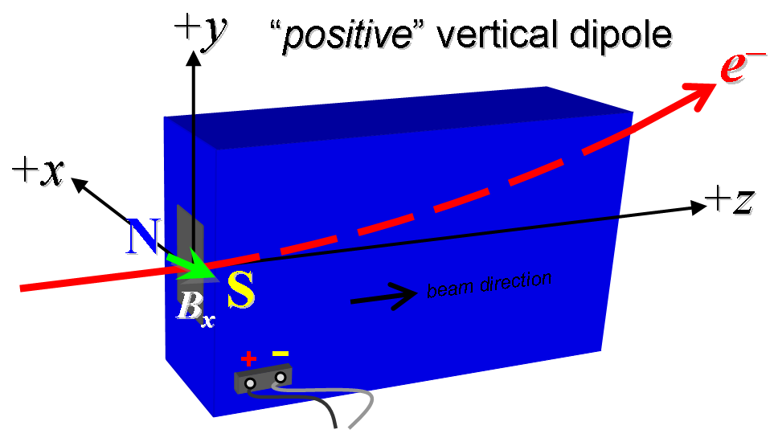



**Figure 1. BRSP2H, BXSP1S, BXSP2S, BYSP2D are “positive” polarity (bending electrons left or up) and BRSP1H, BXSP1H, BXSP3S, BYSP1D are “negative” polarity (bending electrons right or down).**

1. Mark the polarity near the magnet leads with clear “+” and “” labels as shown above. If trim coils exist, they are not used.

|  |  |
| --- | --- |
| Polarity is marked according to Fig. 1 (initials): | N |

1. Also for BXSP1S, BRSP1H, BXSP3S, BYSP1D, BXSP1H, BXSP2S mark the **trim** leads with clear “+” and “” labels such that, with the trim supply outputting positive current, the trim coil *increases* the absolute value of the magnetic field established by the main coil. This will set the trim polarity as “positive” for BXSP1S, BXSP2S and “negative” for BXSP1H, BRSP1H, BXSP3S, BYSP1D.

|  |  |
| --- | --- |
| **Trim** coil polarity chosen from Fig. 1 is (P or N): | N |

1. Connect the magnet terminals, in the correct polarity as established above, to a unipolar (or bipolar) power supply with maximum current *I* ≥ 200 A.
2. Connect magnet to LCW supply. Adjust supply pressure to a delta P of ~100 psi to achieve a flow rate of 2.32 gpm. Run the magnet up to 200 A for ~1 hour to warm it up (record, delta P, flow rate, and magnet coil and steel temperature).

|  |  |
| --- | --- |
| LCW delta P (psi) | 116 psi |
| LCW flow rate (gpm) | 2.6 gpm |
| LCW delta T (°C) | 0.3 °C |
| Ambient temperature (°C): | 17.8 °C |
| Final magnet steel temperature (°C): | 24.3 °C |

1. Standardize the magnet, starting from zero to 200 A and back to zero, through three full cycles, finally ending at zero, with a flat-top pause time (at both 0 and 200 A) of 10 seconds. Use a three-linear ramp rate of 10 A/sec, if possible, and record the ramp rate used.

|  |  |
| --- | --- |
| Standardization complete (initials): | SDA |
| Ramp rate used (A/sec): | 10 A/sec |

1. Maintaining this cycle history, measure the length-integrated horizontal dipole field, ∫*Bydl*, from 0 to 200 A in 10-A steps, including zero (22 ‘up’ measurements). Then, still maintaining the cycle history, measure ∫*Bydl* back down from 200 A to 0 in 10-A steps, including zero (22 ‘down’ measurements).

|  |  |
| --- | --- |
| Filename & run number of ∫*Bydl* up & down data: | Wiredat.ru1, wireplt.ru1 |

1. **For one magnet only**, with main coil at 42A (42A ~= nominal int field of 1.475kGm), use a stretched wire to measure the length-integrated vertical field at multiple positions in x. With the wire located at the vertical mid-plane (*y* = 0), measure the vertical length-integrated field at each 3-mm step of horizontal wire position, from *x* = 30 mm to +30 mm, with *x* = 0 centered at the magnet’s vertical center. Record data file name:

|  |  |
| --- | --- |
| Filename: | Measurement done on Dipole 4572 |

1. With the **main** coils still hooked up, connect the **trim** coil to a bipolar 6-A (MCOR6) supply with proper trim polarity as determined above.
2. Still maintaining the cycle history, run the **main** coil up to 200 A, pause at least 10 seconds, and measure ∫*Bydl* as a function of **trim** coil current from 0 to +6 A in 0.5-A steps, including zero (13 ‘up’ measurements), and again from +6 to 6 A in 0.5-A steps (25 ‘down’ measurements). Set the **trim** current back to 0.

|  |  |
| --- | --- |
| Filename & run # of ∫*Bydl* **trim** data at *I*main = 42 A: | Wiredat.ru2, wireplt.ru2 |

1. Set the **main** coil to 0 current by ramping first up to 200 A, then down to zero at the same ramp rate used in the standardization cycle. Measure ∫*Bydl* as a function of **trim** coil current from 0 to 6 in 0.5-A steps, including zero (13 ‘down’ measurements), and again from 6 to 6 A in 0.5-A steps (25 ‘up’ measurements). Set the **trim** current to 0.

|  |  |
| --- | --- |
| Filename & run # of ∫*Bydl* **trim** data at *I*main = 0: | Wiredat.ru3, wireplt.ru3 |

1. For all magnets, with main coil at 200A, use a stretched wire to measure the length-integrated vertical field at multiple positions in x. With the wire located at the vertical mid-plane (*y* = 0), measure the vertical length-integrated field at each 3-mm step of horizontal wire position, from *x* = 30 mm to +30 mm, with *x* = 0 centered at the magnet’s horizontal center. Record data file name:

|  |  |
| --- | --- |
| Filename: | wirevsx.ru1, wirepltvsx.ru1 |

1. **For one magnet only**, use a rotating coil to measure the harmonics with main coil at 25A, 75A, 125A, 175A, 200A with at least a 0.5-inch diameter (use smaller probe only if 0.5-inch is not available, staying with largest diameter possible). Record probe designation, radius, and data file names:

|  |  |
| --- | --- |
| Coil designation (text): | N/A |
| Coil radius (m): | N/A |
| Filename: | N/A |

1. **For one magnet only**, and at a **main** current of 200 A with **trim** at zero, measure the vertical magnetic field component, *By*, at *x* = *y* = 0, as a function of the longitudinal beam-direction coordinate, *z* (from 10 cm to +30 cm in 1-cm steps, where *z* = 0 is defined at the iron edge), at the *downstream* end of this one magnet. Please also measure the background field at *z* = +30 cm with magnet switched off (separate file).

|  |  |
| --- | --- |
| Filename of *By* vs. *z* data for exit edge: | bhvszdat.ru4, bhvszplt.ru4 |
| Background filename of *By*(*z* = 30 cm), magnet OFF: | bhvszdat.ru5, bhvszplt.ru5 |

1. Measure the inductance and resistance of the **main** and **trim** magnet coils:

|  |  |
| --- | --- |
| Inductance of **main** coil (mH): | 1.804 mH |
| Resistance of **main** coil (Ohms): | 0.0529 Ohm |
| Inductance of **trim** coil (mH): | 0.670 mH |
| Resistance of **trim** coil (Ohms): | 0.4277 Ohm |

1. Measure pole tip field of the main at 200 A

|  |  |
| --- | --- |
| Pole Tip Field and Current | 0. 686 +/- 0.001 T at 200.0716 +/- 0.0002 Amps |

1. Upon completion of tests, send data link to Mark Woodley who will produce a data analysis file. Place data analysis file in magnetic measurements data directory

|  |  |
| --- | --- |
| Magnet data accepted and data analysis file produced | SDA |

Enter URL of on-line magnetic measurements analysis data :

|  |
| --- |
| http://www-group.slac.stanford.edu/met/MagMeas/MAGDATA/LCLS-II/Dipole/4558/BRSP1H.pptx |