SLAC Magnetic Measurement Plan for LCLS-II XLEAP-II Chicane Dipole Magnets
(September 4, 2019)

This measurement plan covers the mechanical fiducialization, and magnetic measurements of the XLEAP-II chicane dipole magnets, BCXXL1, BCXXL2, BCXXL3 and BCXXL4, that have hds their gaps increased from 8 to 11 mm. The table below gives the MAD names, engineering name, barcode and polarities, of the XLEAP-II dipoles. The assembly drawing file for the magnets is ASM-20171113-6552 Red_Gap CHG_11mm_9_5_19.pdf

MAD Name | Eng. Name | Barcode | Polarity
BCXXL1 | 1.575D14-C | 4550 | P
BCXXL2 | 1.575D14-C | 4551 | N
BCXXL3 | 1.575D14-C | 4552 | N
BCXXL4 | 1.575D14-C | 4553 | P

Receiving:
The following information is to be noted upon receipt of the magnets by the SLAC MM group:
Received by (initials): | SDA
Date placed on test stand (dd-mmm-yyyy): | 10/24/2019
SLAC barcode number: | 4550
Serial number: | 1

Preparation:
A beam direction arrow, with text “Beam Direction”, is to be applied to the top and/or connector side of the magnet with a sticker supplied by LCLS-II. The MAD name label should also be attached to the magnet.
Beam-direction arrow and MAD name in place (initials): | SDA

Fiducialization:
Fiducialization must be done before magnetic measurements. The magnet is to be fiducialized by the CMM group. This will require the installation of sockets for removable tooling balls, location of the geometric axis of the poles of the magnet, and location of tooling balls with respect to the center of this geometric axis when the poles are aligned precisely horizontal. The pole gap, flatness and parallelism should also be measured and noted in a report.

CMM technician (initials): | KC

URL of on-line CMM fiducialization data (please modify or correct if necessary):
http://www-group.slac.stanford.edu/met/MagMeas/MAGDATA/LCLS-II/ Fiducial Reports/4550-BCXXL1.pdf

Magnetic Measurements:
- Verify that the magnets are complete and undamaged, including wiring connections.
Incoming inspection OK (initials): | SDA
Date of arrival to mag. meas.(mmm-dd-yyyy): | 10/24/2019

Enter URL of on-line magnetic measurements data (please modify or correct if necessary):
http://www-group.slac.stanford.edu/met/MagMeas/MAGDATA/LCLS-II/Dipole/4550

- Determine the main-coil connection polarity and mark the polarity near the magnet leads with clear “+” and “-” labels as shown below.
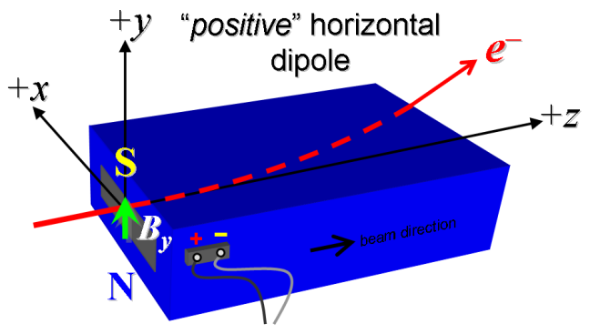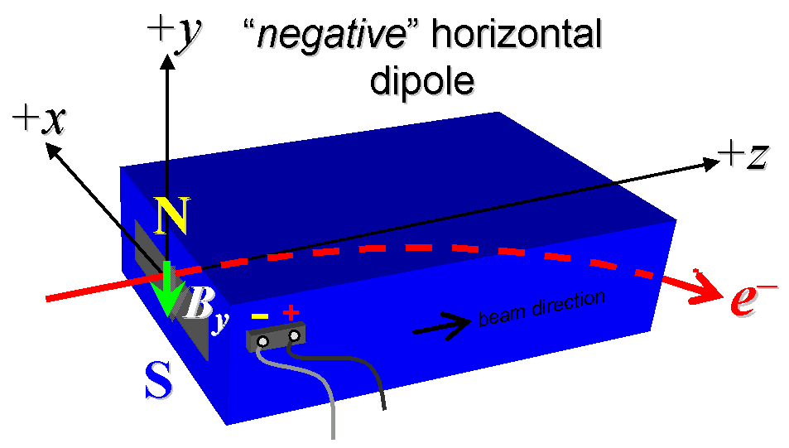

Figure 1. “Positive” polarity (bending electrons up) . “Negative” polarity (bending electrons down).
Main Coil Polarity is marked according to Fig. 1 (initials): | P

- Mark the trim leads with clear “+” and “−” labels such that, with the trim supply outputting positive current, the trim coil increases the absolute value of the magnetic field established by the main coil. This will set the trim polarity as “positive” (P) for BCXXL1 and BCXXL4 and “negative” (N) for BCXXL2 and BCXXL3, as described in LCLS-I PRD 1.1-010.
Trim coil polarity chosen from Fig. 1 is (P or N): | P

- Connect the magnet terminals, in the correct polarity as established above, to a bipolar power supply with maximum current I ≥ 17.5 A. Measure pole tip field of the main at 17.5 A.
Main Pole Tip Field and Current | 0.724 T @ 17.50337 Amps
Trim Pole Tip Field and Current | 0.01024 T @ 5.99495 Amps

- In an environment with ambient temperature of about 20°C (68°F), set the magnet’s main to 17.5 A for ~5 hours to warm it up (verify this is steady-state temp. and record value). Do not let the coil temperatures exceed 65 °C.
Ambient temperature (°C): | 21.2
Final magnet top steel surface temperature (°C): | 39.3
Final magnet top coil surface temperature (°C): | 56.2
Final magnet bottom coil surface temperature (°C): | 54.2

- Standardize magnet using a cosine cycle, starting from zero to +17.5 A, then to −17.5 A, and finally back to zero, through three of these full cycles, and ending again at -17.5 A, all with a flat-top pause time (at each setting of −17.5 and +17.5 A) of 10 seconds. Use a cosine ramp rate of 2.0 A/sec and record the ramp rate used.
Standardization complete (initials): | SDA
Ramp rate used (A/sec): | 2 A/sec

- Maintaining the cycle history, and with the trim coils still not powered, measure the length-integrated vertical dipole field, ∫B_{y}dl, from -17.5 to +17.5 A in 1.0 A steps (41 ‘up’ measurements with at least a 10-sec pause at each setting). Then, still maintaining the cycle history, measure ∫B_{y}dl back down from +17.5 A to −17.5 A in 1.0 A steps (40 ‘down’ measurements).
Filename & run number of ∫B_{y}dl up & down data: | Wiredat.ru1, wireplt.ru1

- Repeat the bipolar standardization of step #6 above with the trim coils still not powered, measure the length-integrated vertical dipole field, ∫B_{y}dl, at I_{main} = 0.
Filename & run number of ∫B_{y}dl at I_{main} = 0: | Wiredat.ru2, wireplt.ru2

- With the trim coil at zero, standardize the magnet as described above in step #6, then set the main coil at I_{main} = 0. Then measure ∫B_{y}dl as a function of trim coil current from 0 to −6 A in 0.5-A steps, including zero (13 ‘down’ measurements), and again from −6 to +6 A in 0.5-A steps (25 ‘up’ measurements). Then set the trim current to zero.
Filename & run # of ∫B_{y}dl trim data at I_{main} = 0: | Wiredat.ru3, wireplt.ru3

- Run the best degauss procedure known using cycling of the main coil current (trim current at zero) and record the smallest final measured |∫B_{y}dl| achievable and reproducible with I_{main} = 0. Please also finish the degauss procedure with a positive step, by setting the current in the positive direction to zero (i.e., from I_{main} < 0 to I_{main} = 0). Record the degauss procedure applied (ramp rate, hold times, current sequence, etc). See file SRXSS Dipole Degauss Procedure.docx for more details.
De-Gauss procedure’s mean |∫B_{y}dl| and Stdev: | 8.2625e-05 +/- 1.4891e-05 Tm
Measurements used for mean and stdev. | 9.2500e-05, 6.0500e-05, 9.0000e-05, 8.7500e-05
Ramp rate: | Cosine at 2 A/s
Hold times: | 5 sec
Current sequence: | 0.0, 17.5000, -15.4000, 13.5520, -11.9258, 10.4947, -9.2353, 8.1271, -7.1518, 6.2936, -5.5384, 4.8738, -4.2889, 3.7742, -3.3213, 2.9228, -2.5720, 2.2634, -1.9918, 1.7528, -1.5424, 1.3573, -1.1945, 1.0511, -0.9250, 0.8140, -0.7163, 0.6304, -0.5547, 0.4881, -0.4296, 0.3780, -0.3327, 0.2927, -0.2576, 0.2267, -0.1995, 0.1756, -0.1545, 0.1360, -0.1196, 0.1053, -0.0926, 0.0815, -0.0717, 0.0631, -0.0556, 0.0489, -0.0430, 0.0379, -0.0333, 0.0293, -0.0258, 0.0

- With the degauss procedure finished, the trim coil still at zero, and without having changed the main coil current at all from its I_{main} = 0 setting after step #10 above, please vary the trim coil current from 0 to -6 A in 0.5-A steps, while measuring the length-integrated vertical dipole field, ∫B_{y}dl, at each setting, including zero (13 ‘up’ measurements), and again from -6 A to +6 A in 0.5-A steps (25 ‘down’ measurements), and finally from +6 A to -6 A in 0.5-A steps (25 more ‘up’ measurements). These field integral values will be quite small, so please take care to resolve the measurements at the level of <0.001 kG-m, if possible.
Filename & run # of ∫B_{y}dl after degauss: | Wiredat.ru4, wireplt.ru4
Poletip Field | -0.6 +/- 0.1 Gauss
Filename & run # of ∫B_{y}dl vs. trim after degauss: | Wiredat.ru5, wireplt.ru5

- For all four dipoles (except as noted below), with stretched wire, and after re-standardization using the bipolar method of step #6, measure the length-integrated vertical field over a horizontal span of ±7 mm at each 1-mm interval, at the following main and trim coil current settings.
- I_{main} = +13 A, and I_{trim} = 0 (all 4 magnets)
- I_{main} = +17.5 A, and I_{trim} = 0 (all 4 magnets)

Filename & run # of ∫B_{y}dl vs. x data at 13 A, 0 A: | wirevsx.ru1, wirepltvsx.ru1
Filename & run # of ∫B_{y}dl vs. x data at 17.5 A, 0 A: | wirevsx.ru2, wirepltvsx.ru2

- For the BCXXL1 magnet only, after bipolar standardization (step #6 above) measure the harmonics with a rotating coil with main coil at +13 A and then at +17.5 A, with trim at zero, Record probe designation, radius, and data file names:
Coil designation (text): | 26DBQ0.25
Coil radius (mm): | 0.0029972
BCXXL1 harmonics filename: | Hardat.ru8, Harplt.ru8

- For the BCXXL1 magnet only, and at a main current of 17.5 A, with trim current at zero, measure the vertical magnetic fringe field component, B_{y}, at x = y = 0, as a function of the longitudinal beam-direction coordinate, z (from −10 cm to +30 cm in 1-cm steps, where z = 0 is defined at the iron edge), at one end of this one magnet. Please also measure the background field at z = +30 cm with magnet switched off (separate file).
Filename of B_{y} vs. z data for BCXXL1 exit edge: | bhvszdat.ru6, bhvszplt.ru6
Background filename of B_{y} (z = 30 cm), magnet OFF: | bhvszdat.ru7, bhvszplt.ru7

- Measure the inductance and resistance of the main and trim magnet coils and also verify the concurrent magnet temperature:
Magnet Coil temperature on top surface (ºC): | 25.5
Inductance of main coil (mH): | 85.96
Resistance of main coil (Ohms): | 0.5255
Inductance of trim coil (mH): | 0.1231
Resistance of trim coil (Ohms): | 0.1578

- Upon completion of tests, send data link to Mark Woodley who will produce a data analysis file. Place data analysis file in magnetic measurements data directory
Magnet data accepted and data analysis file produced | SDA

Enter URL of on-line magnetic measurements analysis data :
http://www-group.slac.stanford.edu/met/MagMeas/MAGDATA/LCLS-II/Dipole/BCXXL1

