SLAC Measurement Plan for LCLS-II R56 Chicane Dipole Magnets (0.788D11.50)

SA-237-005-02-R2
(February 9, 2018)
This traveler is intended to cover reception, preparation, mechanical fiducialization, and magnetic measurements of the 28 R56 chicane dipole magnets (0.788D11.50). There are a total of 7 R56 chicanes. Three of four magnets in each chicane will have +/- 1% trim coils for fine control.

Receiving:
The following information is to be noted upon receipt of the magnets by the SLAC MFD group:
Incoming Mag. Meas. inspection OK (initials): | SDA
Date of arrival to Mag. Meas.(mmm-dd-yyyy): | 3/26/2018
SLAC barcode number: | 4542
Vendor serial number from magnet label: | 35
Shipping Damage? (Y or N): | N
SLAC drawing number (enter number): | SA-237-005-02-R2

Preparation:
A beam direction arrow, with text “beam direction”, is to be applied to the top and/or connector side of the magnet with a sticker supplied by LCLS-II. John Amann will determine the beam direction in each magnet.
Beam-direction arrow in place (initials): | SDA

Fiducialization:
Fiducialization may be done before or after magnetic measurements. The magnet is to be fiducialized by the CMM group. This will require the installation of removable tooling balls, location of the geometric axis of the poles of the magnet, and location of tooling balls with respect to the center of this geometric axis when the poles are aligned precisely horizontal.

CMM technician (initials): | MR

URL of on-line CMM fiducialization data (please modify or correct if necessary):
http://www-group.slac.stanford.edu/met/MagMeas/MAGDATA/LCLS-II/Fiducial Reports/LCLS2 0.788D11.50 Bend L204542 SN35 Fiducial Report.docx

Magnetic Measurements:
Enter URL of on-line magnetic measurements data (please modify or correct if necessary):
http://www-group.slac.stanford.edu/met/MagMeas/MAGDATA/LCLS-II/dipole/4542

- Mark each magnet according to the following table. By choosing the magnet location initially, they will be tested in their proper polarities, since two are to be positive and two negative.
Magnet marked as (BCX351, BCX352, BCX353, BCX354): | BCX352

- Connect the magnet to the LCW supply. At a ΔP of 90 psi, the design flow rate per cooling circuit should be 1.1 gpm. The total magnet flow should be 2.2 gpm. Record the actual ΔP required to achieve a total flow rate 2.2 gpm below.

ΔP (psi) to achieve a total flow rate of 2.2gpm | 110 psi

- Determine the main-coil connection polarity (with main supply outputting positive current) which produces a “negative” field polarity for BCX351 and BCX354 (below left), but a “positive” field polarity for BCX352 and BCX353 (below right), as shown below:

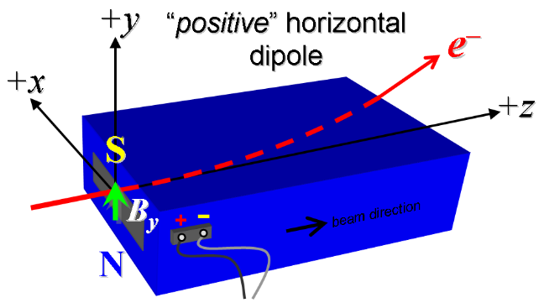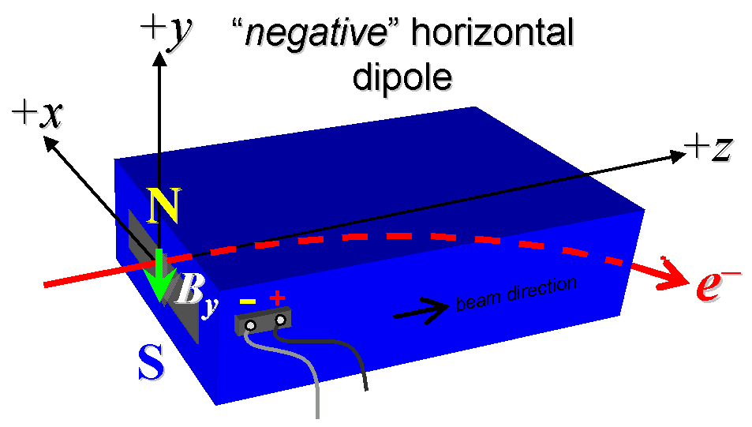
Figure 1. BCX351 and BCX354 are “negative” (left), while BCX352 and BCX353 are “positive” (right).

- Mark the polarity near the main magnet leads with clear “+” and “−” labels as shown above.
Main coil polarity chosen from Fig. 1 is (P or N): | P

- Also mark the trim leads with clear “+” and “−” labels such that, with the trim supply outputting positive current, the trim coil increases the absolute value of the magnetic field established by the main coil. This will set the trim polarity as “negative” for BCX351 and BCDLU4 and “positive” for BCX353, as described in LCLSII-2.4-PR-0081-R4, Magnets PRD. Note that BCX352, the second magnet in the chicane, has no trim coil.
Trim coil polarity chosen from Fig. 1 is (P or N):

- Connect the main magnet terminals (not the trims), in the correct polarity as established above, to a unipolar power supply with maximum current I ≥ 250 A (assuming this current produces about 4.4 kG-m integrated field as estimated by John Amann). Leave the trim coil disconnected for now.

- Run the magnet up to 250 A for ~2 hours to warm it up (record temperature).
Ambient temperature (°C): | °C
Final magnet temperature (°C): | °C

- Standardize the magnet, starting from zero to 250 A and back to zero, through 15 full cycles, finally ending at zero, with a flat-top pause time (at both 0 and 250 A) of 10 seconds. Use a three linear ramp rate of 10 A/sec and record the ramp rate used.
Standardization complete (initials):
Three Linear Ramp rate used (A/sec): | A/sec

- Standardize the magnet, from zero to 250 A, and back to zero, through three full cycles. Maintaining this cycle history, measure the length-integrated vertical dipole field, ∫B_{y}dl, from 0 to 250 A in 10-A steps, including zero (25 ‘up’ measurements). Please record (below) the current necessary to achieve 4.4 kG-m (max.) and call P. Emma at 4189 if it is not achieved at 250A. Then, still maintaining the cycle history, measure ∫B_{y}dl back down from 250 A to 0 in 10-A steps, including zero (25 ‘down’ measurements).
Main coil excitation current at 4.4 kG-m: | Amps
Filename & run number of ∫B_{y}dl up & down data:

- With the main coils still hooked up, connect the trim coil to a bipolar 3-A (MCOR3) supply with proper trim polarity as determined above. Use a linear ramp rate of 0.6 A/sec with a settle time of 10 seconds for the trim.
- Set the main coil to 0 current by ramping first up to 250 A, then down to zero at the same ramp rate used in the standardization cycle. Measure ∫B_{y}dl as a function of trim coil current from 0 to −3 in 0.25-A steps, including zero (13 ‘down’ measurements), and then from −3 to +3 A in 0.25-A steps (25 ‘up’ measurements). Set the trim current to 0.
Filename & run # of ∫B_{y}dl trim data at I_{main} = 0:

- For all four dipoles, with stretched wire, measure the vertical length-integrated field component over a horizontal span of ±10 mm, at each 1-mm interval, at the following main and trim coil current settings.
- I_{main} = 250 A, and I_{trim} = 0
- I_{main} = 250 A, and I_{trim} = 3 A

Filename & run # of ∫B_{y}dl vs. x data at 250, 0 A:
Filename & run # of ∫B_{y}dl vs. x data at 250, 3 A:

- For the BCX352 magnet only, use a rotating coil to measure the harmonics with main coil at 250 A, with at least a 0.5-inch diameter (use smaller probe only if 0.5-inch is not available, staying with largest diameter possible). Record probe designation, radius, and data file names:
Coil designation (text):
Coil radius (m): | m
BCX352 harmonics filename:

- For the BCX354 magnet only, and at a main current of 250 A with trim at zero, measure the vertical magnetic field component, B_{y}, at x = y = 0, as a function of the longitudinal beam-direction coordinate, z (from −10 cm to +30 cm in 1-cm steps, where z = 0 is defined at the iron edge), at the downstream end of this one magnet. Please also measure the background field at z = +30 cm with magnet switched off (separate file).
Filename of B_{y} vs. z data for BCX354 exit edge:
Background filename of B_{y}(z = 30 cm), magnet OFF:

- For the BCX354 magnet only, perform this final thermal test. Run the main current up to 250 A, and with trim also set at its maximum operating current of 3 A, and measure the magnet temperature after it stabilizes (2 hours). Record the temperature below.
Ambient temperature (°C): | °C
Final stable BCX354 magnet temperature at 250 A (°C): | °C

- Measure the inductance and resistance of the main and trim magnet coils:
Inductance of main coil (mH): | 1.754 mH
Resistance of main coil (Ohms): | 0.0438 Ohm
Inductance of trim coil (mH): | mH
Resistance of trim coil (Ohms): | Ohm

- Upon completion of tests, email URL of on-line data to Mark Woodley. Mark Woodley will determine if the magnet is accepted. Upon acceptance of magnet, analysis data will be placed in on-line data folder.
Magnet accepted and Analysis file(s) put into on-line data folder (initials):
Assigned beamline location (MAD-deck name): | BCX352

