SLAC Traveler for LCLS-II BC1 Dipole Magnets
(August 24, 2016)
This traveler is intended to cover reception, preparation, mechanical fiducialization, and magnetic measurements of the four bunch-compressor-1 (BC1) chicane dipole magnets (1.69D6.28T). These magnets are about 16 cm long and have MAD designations of: BCX11, BCX12, BCX13, and BCX14, and each has both main and trim coils, although only 3 of the 4 trims will be powered.

Receiving:
The following information is to be noted upon receipt of the magnets by the SLAC MFD group:
Received by (initials): | KC
Date received (dd-mmm-yyyy): | 9/15/2016
SLAC barcode number: | 4511
Vendor serial number from magnet label: | 003
SLAC approved electrical safety covers? (Y or N): | Y
SLAC approved lifting eyes? (Y or N): | N
Shipping Damage? (Y or N): | N
Vendor tests passed on magnet label? (Y or N): | N
SLAC drawing number (enter number): | SA-388-320-05

Preparation:
A beam direction arrow, with text “beam direction”, is to be applied to the top and/or connector side of the magnet with a sticker supplied by LCLS. John Amann will determine the beam direction in each magnet.
Beam-direction arrow in place (initials): | SDA

Fiducialization:
Fiducialization may be done before or after magnetic measurements. The magnet is to be fiducialized by the CMM group. This will require the installation of removable tooling balls, location of the geometric axis of the poles of the magnet, and location of tooling balls with respect to the center of this geometric axis when the poles are aligned precisely horizontal.

CMM technician (initials): | KC

URL of on-line CMM fiducialization data (please modify or correct if necessary):
http://www-group.slac.stanford.edu/met/MagMeas/MAGDATA/LCLS-II/Dipole/4511/Fiducial Report 4511.pdf

Magnetic Measurements:
- Verify that the magnets are complete and undamaged, including wiring connections.
Incoming inspection OK (initials): | SDA
Date of arrival to mag. meas.(mmm-dd-yyyy): | 10/13/2016

Enter URL of on-line magnetic measurements data (please modify or correct if necessary):
http://www-group.slac.stanford.edu/met/MagMeas/MAGDATA/LCLS-II/Dipole/4511/

- Mark each magnet as BCX11, BCX12, BCX13, or BCX14. By choosing the magnet location initially, they will be tested in their proper polarities, since two are to be positive and two negative.
Magnet marked as (BCX11, BCX12, BCX13, or BCX14): | BCX11

- Determine the main-coil connection polarity (with main supply outputting positive current) which produces a “positive” field polarity for BCX11 and BCX14 (below left), but a “negative” field polarity for BCX12 and BCX13 (below right), as shown below:

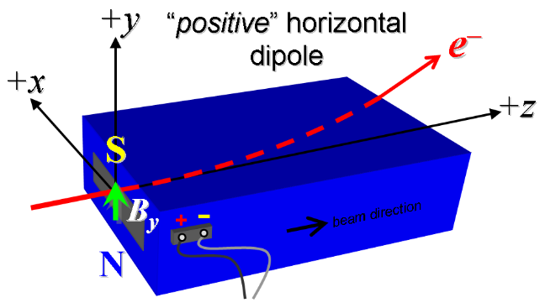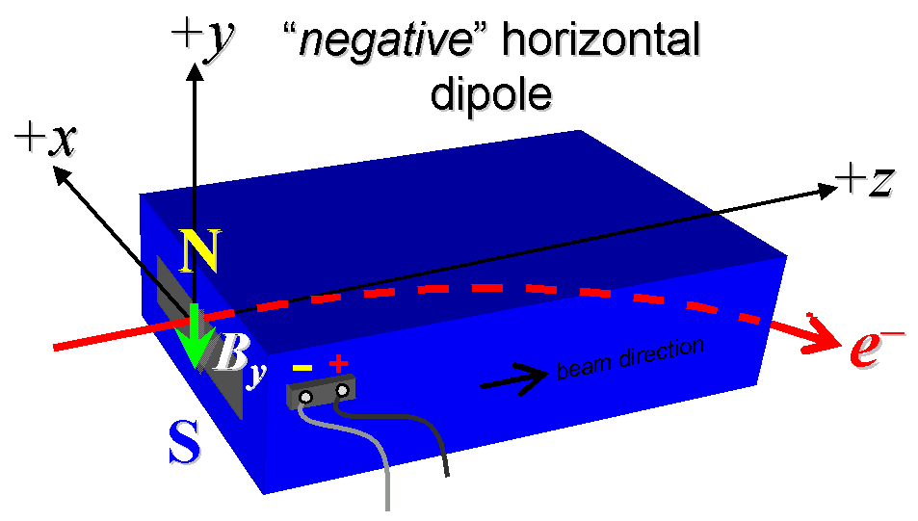
Figure 1. BCX11 and BCX14 are “positive” (left), while BCX12 and BCX13 are “negative” (right).

- Mark the polarity near the main magnet leads with clear “+” and “−” labels as shown above.
Main coil polarity chosen from Fig. 1 is (P or N): | P

- Also mark the trim leads with clear “+” and “−” labels such that, with the trim supply outputting positive current, the trim coil increases the absolute value of the magnetic field established by the main coil. This will set the trim polarity as “positive” for BCX11 and BCX14 and “negative” for BCX12 and BCX13, as described in PRD 1.1-010.
Trim coil polarity chosen from Fig. 1 is (P or N): | P

- Connect the main magnet terminals (not the trims), in the correct polarity as established above, to a unipolar power supply with maximum current I ≥ 380 A (assuming this current produces about 1.3 kG-m integrated field as estimated by Briant Lam). Leave the trim coil disconnected for now.

- Run the magnet up to 250 A for ~2 hours to warm it up (record temperature).
Ambient temperature (°C): | 23.05 °C
Final magnet core temperature (°C): | 27.46 °C

- Standardize the magnet, starting from zero to 380 A and back to zero, through three full cycles, finally ending at zero, with a flat-top pause time (at both 0 and 380 A) of 10 seconds. Use a ramp rate of 10 A/sec, if possible, and record the ramp rate used.
Standardization complete (initials): | SDA
Ramp rate used (A/sec): | 10 A/sec

- For the BCX12 magnet only, run the main coil current up to 250 A (trim at zero), and use a stretched wire to measure the vertical length-integrated field component over a horizontal span of ±75 mm (±3.0 inches) at each 4-mm interval. Do this measurement without a vacuum chamber in place, and also repeat it with a ~4-inch wide vacuum chamber in place using the same materials (e.g., SS) as in the final installation (do not remove vacuum chamber yet – see next step:
BCX12 filename of ∫B_{y}dl vs. x with vacuum chamber: | N/A
BCX12 filename of ∫B_{y}dl vs. x without vac. chamber: | N/A

- For the BCX12 magnet only, with main coil still at 250 A (trim at zero), use a rotating coil to measure the harmonics with at least a 1.5-inch diameter (use smaller probe only if 1.5-inch is not available, staying with largest diameter possible). Measure both with the 4-inch wide vacuum chamber in place and without. Record probe designation, radius, and data file names:
Coil designation (text): | N/A
Coil radius (m): | N/A m
BCX12 harmonics filename with vacuum chamber: | N/A
BCX12 harmonics filename without vacuum chamber: | N/A

- Re-standardize the magnet, from zero to 380 A, and back to zero, through three full cycles.
Re-standardization complete (initials): | SDA
Ramp rate used (A/sec): | 10 A/sec

- Maintaining this cycle history, measure the length-integrated vertical dipole field, ∫B_{y}dl, from 0 to 380 A in 14-A steps, including zero (26 ‘up’ measurements). Please record (below) the current necessary to achieve 1.3 kG-m (max.) and call P. Emma at 4189 if it is more than 20-A different than 380 A. If the maximum integrated field is <1.3 kG-m at 380 A, and after calling 4189, please record the current necessary to achieve this field and re-standardize up to the new current, starting the procedure again from that point. Then, still maintaining the cycle history, measure ∫B_{y}dl back down from 380 A to 0 in 14-A steps, including zero (26 ‘down’ measurements). BCX13 has an integral field of 1.21 kG-m at 380 A. Paul Emma says that is fine and that the measurements can continue with the magnet having a 380 A max current.
Main coil excitation current at 1.3 kG-m: | Amps
Filename & run number of ∫B_{y}dl up & down data: | wiredat.ru1/wireplt.ru1

- With the main coils still hooked up, connect the trim coil to a bipolar 12-A (MCOR12) supply with proper trim polarity as determined above.

- Still maintaining the cycle history, run the main coil up to 250 A, pause at least 10 seconds, and measure ∫B_{y}dl as a function of trim coil current from 0 to +12 A in 1-A steps, including zero (13 ‘up’ measurements), and again from +12 to −12 A in 1-A steps (25 ‘down’ measurements). Set the trim current back to 0.
Filename & run # of ∫B_{y}dl trim data at I_{main} = 250 A: | wireplt.ru2

- Set the main coil to 0 current by ramping first up to 380 A, then down to zero at the same ramp rate used in the standardization cycle. Measure ∫B_{y}dl as a function of trim coil current from 0 to −12 in 1-A steps, including zero (13 ‘down’ measurements), and again from −12 to +12 A in 1-A steps (25 ‘up’ measurements). Set the trim current to 0.
Filename & run # of ∫B_{y}dl trim data at I_{main} = 0: | wireplt.ru3

- For all four dipoles, with stretched wire, measure the vertical length-integrated field component over a horizontal span of ±75 mm (±3.0 inches), at each 4-mm interval, at the following main and trim coil current settings (no vacuum chamber in place for these steps).
- I_{main} = 250 A, and I_{trim} = 0 (already done for BCX12 as described above)
- I_{main} = 250 A, and I_{trim} = 12 A
- I_{main} = 380 A, and I_{trim} = 0
Filename & run # of ∫B_{y}dl vs. x data at 250, 0 A: | wirepltvsx.ru4
Filename & run # of ∫B_{y}dl vs. x data at 250, 12 A: | wirepltvsx.ru5
Filename & run # of ∫B_{y}dl vs. x data at 380, 0 A: | wirepltvsx.ru6

- For the BCX14 magnet only, and at a main current of 250 A with trim at zero, measure the vertical magnetic field component, B_{y}, at x = y = 0, as a function of the longitudinal beam-direction coordinate, z (from −10 cm to +30 cm in 1-cm steps, where z = 0 is defined at the iron edge), at the downstream end of this one magnet. Please also measure the background field at z = +30 cm with magnet switched off (separate file).
Filename of B_{y} vs. z data for BCX14 exit edge: | N/A
Background filename of B_{y}(z = 30 cm), magnet OFF: | N/A

- For the BCX14 magnet only, perform this final thermal test. Run the main current up to 380 A, and with trim also set at its maximum operating current of 12 A, and measure the magnet temperature after it stabilizes (2-4 hours?). Record the temperature below.
Ambient temperature (°C): | N/A°C
Final stable BCX14 magnet temperature at 380 A (°C): | N/A°C

- Measure the inductance and resistance of the main and trim magnet coils:
Inductance of main coil (mH): | 0.622 mH
Resistance of main coil (Ohms): | 0.0377 Ohm
Inductance of trim coil (mH): | 0.185 mH
Resistance of trim coil (Ohms): | 0.0431 Ohm

- Upon completion of tests, email Mark Woodley that measurements are complete.

This section is to be completed by M. Woodley.
Magnet accepted | Via email
Assigned beamline location (MAD-deck name): | BCX11

