SLAC Magnetic Measurement Plan for LCLS-II BX31B/BX32B Dipole Magnets (1.06D103.3T)
(Sept. 4, 2019)

This magnetic measurement plan is intended to cover reception, preparation, mechanical fiducialization, and magnetic measurements of the two LTUS dog-leg dipole magnets. These magnets are 2.656 m long and have MAD designations of: BX31B and BX32B. Each magnet has trim coils. Magnet requirements are listed in LCLS-II-2.4-PR-0081.
Receiving:
The following information is to be noted upon receipt of the magnets by the SLAC MM group:
Received by (initials): | SDA
Date received (dd-mmm-yyyy): | 9/17/2019
SLAC barcode number: | 4509
Vendor serial number from magnet label: | 16101
SLAC approved electrical safety covers? (Y or N): | N
SLAC drawing number (enter number): | LCL0351-006802

Preparation:
A beam direction arrow, with text “beam direction”, is to be applied to the top and/or tunnel aisle side of the magnet with a sticker supplied by LCLS II. The beam direction should point toward the end without the terminals.
Beam-direction arrow in place (initials): | SDA

Fiducialization:
Fiducialization may be done before or after magnetic measurements. The magnet is to be fiducialized by the CMM group. This will require the installation of removable tooling balls, location of the geometric axis of the poles of the magnet, and location of tooling balls with respect to the center of this geometric axis when the poles are aligned precisely horizontal.
CMM technician (initials): | HI

URL of on-line CMM fiducialization data (please modify or correct if necessary):
http://www-group.slac.stanford.edu/met/MagMeas/MAGDATA/LCLS-II/Fiducial Reports/

Magnetic Measurements:
- Verify that the magnets are complete and undamaged, including wiring connections.
Incoming inspection OK (initials): | SDA
Date of arrival to mag. meas.(mm-dd-yyyy): | 9/10/2019

Enter URL of on-line magnetic measurements data (please modify or correct if necessary):
http://www-group.slac.stanford.edu/met/MagMeas/MAGDATA/LCLS-II/Dipole/4509/

- Mark each magnet as BX31B or BX32B. By choosing the magnet location initially, they will be tested in their proper polarities; since one is “positive” and the other is “negative” (see below for definition).
Magnet marked as (BX31B or BX32B): | BX32B

- Determine the main-coil connection polarity (with main supply outputting positive current) which produces a “positive” field polarity for BX31B (below left), but a “negative” field polarity for BX32B (below right), as shown below:
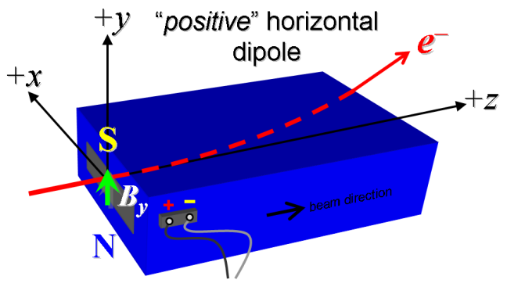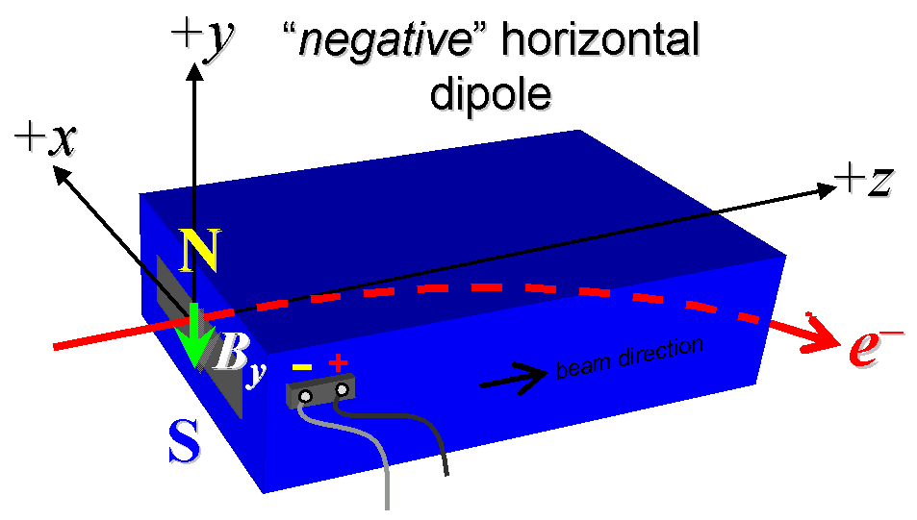
Figure 1. BX31B is “positive” (left), while BX32B is “negative” (right).

- Mark the polarity near the main magnet leads with clear “+” and “−” labels as shown above.
Main coil polarity chosen from Fig. 1 is (P or N): | N

- Also mark the trim leads with clear “+” and “−” labels such that, with the trim supply outputting positive current, the trim coil increases the absolute value of the magnetic field established by the main coil. This will set the trim polarity as “positive” for BX31B, and “negative” for BX32B, as described in LCLS-II-2.4-PR-0064 (https://docs.slac.stanford.edu/sites/pub/Publications/Polarity.pdf).
Trim coil polarity chosen from Fig. 1 is (P or N): | N

- Connect the main magnet terminals (not the trims), in the correct polarity as established above, to a unipolar power supply with maximum current I ≥ 200 A. Leave the trim coil disconnected for now.

- Connect magnet to LCW supply. Adjust supply pressure to a delta P of ~100 psi to achieve a flow rate of 1.76 gpm. Run the magnet up to 200 A for ~1 hour to warm it up (record, delta P, flow rate, and temperature).
LCW delta P (psi) | 118 psi
LCW flow rate (gpm) | 2.3 gpm
LCW delta T (°C) | 3.2 °C
Ambient temperature (°C): | 23.1 °C
Final magnet temperature (°C): | 28.7 °C

- Standardize the magnet, starting from zero to 200 A and back to zero, through three full cycles, finally ending at zero, with a flat-top pause time (at both 0 and 200 A) of 10 seconds. Use a Cosine ramp type, with a ramp rate of 5 A/sec, and record the ramp type, rate, and settle time used. Also, use these ramp parameters for setting the current.
Standardization complete (initials): | SDA
Ramp type, ramp rate (A/sec), and settle time (s): | Cosine, 5 A/sec, 10 sec

- Maintaining this cycle history, measure the length-integrated vertical dipole field, ∫B_{y}dl, from 0 to 200 A in 10 A steps, including zero. Also include a measurement at 126.4349 A, which is the nominal current at the maximum beam energy of 10 GeV for these magnets because they are on the BYDB string (22 ‘up’ measurements). Please record (below) the current necessary to achieve 6.2154 kG-m (10 GeV requirement). Then, still maintaining the cycle history, measure ∫B_{y}dl back down from 200 A to 0 in 20 A steps, including zero (11 ‘down’ measurements).
Main coil excitation current at 6.2154 kG-m: | 126.6095 Amps
Filename & run number of ∫B_{y}dl up & down data: | Wiredat.ru1, wireplt.ru1

- With the main coils still hooked up, connect the trim coil to a bipolar 6 A (MCOR6) supply with proper trim polarity as determined above, so that a positive current on the trim adds to the main field. Please note the ramp type, ramp rate, and settle time used for the trim.
Ramp type, ramp rate (A/sec), and settle time (s): | LINEAR, 1 A/sec, 10 sec

- Standardize the main coil, then set I_{main} = 126.4349 amps. Measure ∫B_{y}dl as a function of trim coil current from 0 to −6 in 0.5 A steps, including zero (13 ‘down’ measurements), and again from −6 to +6 A in 0.5 A steps (24 ‘up’ measurements). Finally, set the trim current to 0.
Filename & run # of ∫B_{y}dl trim data at I_{main} = 126.4349: | Wiredat.ru2, wireplt.ru2

- Standardize the main coil, then set it to 0 amps. Measure ∫B_{y}dl as a function of trim coil current from 0 to −6 in 0.5 A steps, including zero (13 ‘down’ measurements), and again from −6 to +6 A in 0.5 A steps (24 ‘up’ measurements). Finally, set the trim current to 0.
Filename & run # of ∫B_{y}dl trim data at I_{main} = 0: | Wiredat.ru2, wireplt.ru3

- For each magnet, with stretched wire, measure the ∫B_{y}dl over a horizontal span of ±30 mm, at each 3-mm interval, at the following main and trim coil current settings.
- I_{main} = 126.4349 A, and I_{trim} = 0
Filename & run # of ∫B_{y}dl vs. x data at 126.4349, 0 A: | Wirevsx.ru1 wirepltvsx.ru1

- For the BX32B magnet only, and at a main current of 126.4349 A, with trim current at zero, measure the vertical magnetic fringe field component, B_{y}, at x = y = 0, as a function of the longitudinal beam-direction coordinate, z (from −10 cm to +30 cm in 1-cm steps, where z = 0 is defined at the iron edge), at the one end of this one magnet. Please also measure the background field at z = +30 cm with magnet switched off (separate file).
Filename of B_{y} vs. z data for BX32B exit edge: | Not measured due to time constraints
Background filename of B_{y} (z = 30 cm), magnet OFF: | Not measured due to time constraints

- Measure the inductance and resistance of the main and trim magnet coils for each magnet:
Inductance of main coil (mH): | 1.504 mH
Resistance of main coil (Ohms): | 0.0690 Ohm
Inductance of trim coil (mH): | 1.4124 mH
Resistance of trim coil (Ohms): | 0.7130 Ohm

- Measure pole tip field of the main at 200 amps, then Main at 0 and Trim at 6 A
Pole Tip Field and Current with Main at 200 A | 0.366 Tesla at 199.93214 Amps
Pole Tip Field and Current with Main at 0 A, Trim = 6A | 0.00944 Tesla at 6.00382 Amps

- Upon completion of tests, send data link to Mark Woodley who will produce a data analysis file. Place data analysis file in magnetic measurements data directory.
Magnet data accepted and data analysis file produced | SDA

Enter URL of on-line magnetic measurements data and analysis:
http://www-group.slac.stanford.edu/met/MagMeas/MAGDATA/LCLS-II/Dipole/4509/ BX32B.pptx

