|  |
| --- |
| **Document Approval:** |
| Originator: Gabriel Marcus, Chicane Subsystem Lead |
| Approver: Scott Andersen, Magnet Measurements |

Revision History

|  |  |  |
| --- | --- | --- |
| Revision | Date Released | Description of Change |
| R0 | 1/18/2022 | Original Release. |

## SLAC Magnetic Measurement Plan for LCLS CBXFEL Chicane Dipole Magnets

**(July 30, 2021)**

This measurement plan covers the mechanical fiducialization, and magnetic measurements of the Cavity Based X-ray Free Electron Laser (CBXFEL) chicane dipole magnets (0.276D14-C). These rectangular C-type dipole magnets are 14 inches long with a 7 mm gap height and have the following MAD names: BCXCBX0, BCXCBX11, BCXCBX12, BCXCBX13, BCXCBX14, BCXCBX21, BCXCBX22, BCXCBX23, and BCXCBX24. The table below gives the MAD names, engineering name, barcode and polarities of the CBXFEL dipoles. The assembly drawing file for the magnets is DSG-000014858.

|  |  |  |  |
| --- | --- | --- | --- |
| **MAD Name** | **Eng. Name** | **Barcode** | **Polarity** |
| BCXCBX0 | 0.276D14-C | 4590 | P |
| BCXCBX11 | 0.276D14-C | 2319 | P |
| BCXCBX12 | 0.276D14-C | 2320 | N |
| BCXCBX13 | 0.276D14-C | 2321 | N |
| BCXCBX14 | 0.276D14-C | 2322 | P |
| BCXCBX21 | 0.276D14-C | 2323 | P |
| BCXCBX22 | 0.276D14-C | 2324 | N |
| BCXCBX23 | 0.276D14-C | 2325 | N |
| BCXCBX24 | 0.276D14-C | 2326 | P |

**Receiving:**

The following information is to be noted upon receipt of the magnets by the SLAC MM group:

|  |  |
| --- | --- |
| Received by (initials): | SDA |
| Date placed on test stand (dd-mmm-yyyy): | 2/8/2022 |
| SLAC barcode number: | 2321 |
| Serial number: | 006 |

**Preparation:**

A beam direction arrow, with text “Beam Direction”, is to be applied to the top and connector side of the magnet. The MAD name label should also be attached to the magnet.

|  |  |
| --- | --- |
| Beam-direction arrow and MAD name in place (initials): | SDA |

**Fiducialization:**

Fiducialization should be done before magnetic measurements. The magnet is to be fiducialized on a CMM by the Metrology group. This will require the installation of sockets for removable tooling balls, location of the geometric axis of the poles of the magnet, and location of tooling balls with respect to the center of this geometric axis when the poles are aligned precisely horizontal. The pole gap, flatness and parallelism on both upstream and downstream end should also be measured and noted in a report.

|  |  |
| --- | --- |
| CMM technician (initials): | KC |

URL of on-line CMM fiducialization data (please modify or correct if necessary):

|  |
| --- |
| [https://www-group.slac.stanford.edu/met/MagMeas/MAGDATA/LCLS-II/Fiducial%20Reports/2321_Fiducial_Report.pdf](https://www-group.slac.stanford.edu/met/MagMeas/MAGDATA/LCLS-II/Fiducial%20Reports/2319_Fiducial_Report.pdf) |

**Magnetic Measurements:**

1. Verify that the magnets are complete and undamaged, including wiring connections.

|  |  |
| --- | --- |
| Incoming inspection OK (initials): | SDA |
| Date of arrival to mag. meas.(mmm-dd-yyyy): | 2/8/2022 |

1. Measure the inductance and resistance of the **main** and **trim** magnet coils and also verify the concurrent magnet temperature:

|  |  |
| --- | --- |
| Magnet Coil temperature on top surface (oC): | 15.5 |
| Inductance of **main** coil (mH): | 109.5 |
| Resistance of **main** coil (Ohms): | 0.5419 |
| Inductance of **trim** coil (mH): | 3.99 |
| Resistance of **trim** coil (Ohms): | 1.642 |

Enter URL of on-line magnetic measurements data (please modify or correct if necessary):

|  |
| --- |
| [www-group.slac.stanford.edu - /met/MagMeas/MAGDATA/LCLS-II/Dipole/2319/](https://www-group.slac.stanford.edu/met/MagMeas/MAGDATA/LCLS-II/Dipole/2319/) |

1. Determine the main-coil connection polarity and mark the polarity near the magnet leads with clear “+” and “-” labels as shown below.

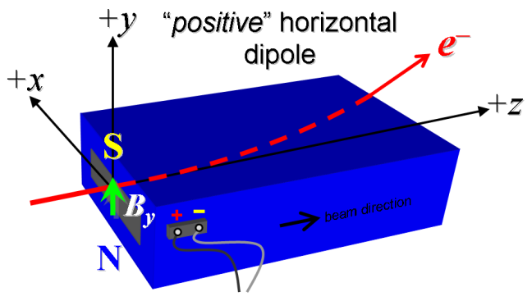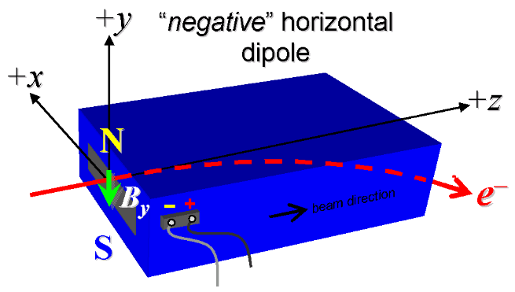

**Figure 1. “Positive” polarity (bending electrons left) . “Negative” polarity (bending electrons right).**

|  |  |
| --- | --- |
| Main Coil Polarity marked from Fig. 1 is (P or N): | N |

1. Mark the **trim** leads with clear “+” and “” labels such that, with the trim supply outputting positive current, the trim coil *increases* the absolute value of the magnetic field established by the main coil. This will set the trim polarity as “positive” (P) for BCXCB0, BCXCB11, BCXCB14, BCXCB21, and BCXCB24 and “negative” (N) for BCXCB12, BCXCB13, BCXCB22, and BCXCB23 as described in LCLSII-2.4-PR-0064.

|  |  |
| --- | --- |
| **Trim** coil polarity marked from Fig. 1 is (P or N): | N |

1. Connect the magnet terminals, in the correct polarity as established above, to a bipolar power supply with maximum current *I* ³ 12 A. Measure pole tip field of the main at 12 A.

|  |  |
| --- | --- |
| Pole Tip Field and Current | -0.941 T at 12.00027 Amps |

1. In an environment with ambient temperature of about 20°C (68°F), set the magnet’s main to 12 A for ~5 hours to warm it up (verify this is steady-state temp. and record value). Do not let the coil temperatures exceed 65 °C.

|  |  |
| --- | --- |
| Ambient temperature (°C): | 21.5 |
| Final magnet top core surface temperature (°C): | 25.6 |
| Final magnet top coil surface temperature (°C): | 30.1 |
| Final magnet side coil surface temperature (°C): | 34.2 |

1. Standardize magnet using a three cycles, starting from zero to +12 A, then to  A, and finally back to zero, through three of these full cycles, and ending again at -12 A, all with a flat-top pause time (at each setting of 12 and +12 A) of 10 seconds. Use a cosine ramp rate of 2.0 A/sec and record the ramp rate used. The integrated field at 10.56 Amps should be close to 0.306 T-m.

|  |  |
| --- | --- |
| Standardization complete (initials): | SDA’ |
| Ramp rate used (A/sec): | 2 A/sec |

1. Maintaining thecycle history, and with the trim coils still not powered, measure the length-integrated vertical dipole field, ò*Bydl*, from -12 to +12 A in 1.0 A steps except between 12 and 10 and –10 an 12 amps where the step size should be 0.5 amps (31‘up’ measurements with at least a 10-sec pause at each setting). Then, still maintaining the cycle history, measure ò*Bydl* back down from +12 A to 12 A in 1.0 A steps (30‘down’ measurements).

|  |  |
| --- | --- |
| Filename & run number of ò*Bydl* up & down data: | Wiredat.ru1, wireplt.ru1 |

1. Repeat the *bipolar* standardization of step #6 above with the trim coils still not powered, measure the length-integrated vertical dipole field, ò*Bydl*, at *Imain* = 0.

|  |  |
| --- | --- |
| Filename & run number of ò*Bydl* at *Imain* = 0: | Wiredat.ru2, wireplt.ru2 |

1. With the trim coil at zero, standardize the magnet as described above in step #6, then set the main coil at *Imain* = 0. Then measure ò*Bydl* as a function of **trim** coil current from 0 to 2 A in 0.2-A steps, including zero (11 ‘down’ measurements), and again from 2 to 2 A in 0.2-A steps (20 ‘up’ measurements). Then set the **trim** current to zero.

|  |  |
| --- | --- |
| Filename & run # of ò*Bydl* **trim** data at *Imain* = 0: | Wiredat.ru3, wireplt.ru3 |

1. Run the best degauss procedure known using cycling of the main coil current (trim current at zero) and record the smallest final measured |ò*Bydl*| achievable and reproducible with *Imain* = 0. Please also finish the degauss procedure with a positive step, by setting the current in the positive direction to zero (*i.e.*, from *Imain* < 0 to *Imain* = 0). Record the degauss procedure applied (ramp rate, hold times, current sequence, etc). See file SRXSS Dipole Degauss Procedure.docx for more details.

|  |  |
| --- | --- |
| De-Gauss procedure’s mean |ò*Bydl*| and Stdev: | 0.000095+/- 0.000046 |
| Measurements used for mean and stdev. | 0.000160, 0.000051, 0.000083, 0.000087 |
| Pole Tip Field at Magnet Center | 0.45 G |
| Pole Tip Field at Magnet Z Center at Outer Pole Edge (Top of Chamfer) | 0.23 G |
| Ramp rate: | 2 A/s |
| Hold time: | 2 sec |
| Current sequence: | {0.0, 12.0000, -10.4400, 9.0828, -7.9020, 6.8748, -5.9811, 5.2035, -4.5271, 3.9385, -3.4265, 2.9811, -2.5935, 2.2564, -1.9631, 1.7079, -1.4858, 1.2927, -1.1246, 0.9784, -0.8512, 0.7406, -0.6443, 0.5605, -0.4877, 0.4243, -0.3691, 0.3211, -0.2794, 0.2431, -0.2115, 0.1840, -0.1601, 0.1393, -0.1211, 0.1054, -0.0917, 0.0798, -0.0694, 0.0604, -0.0525, 0.0457, -0.0398, 0.0346, -0.0301, 0.0262, -0.0228, 0.0198, -0.0172, 0.0150, -0.0131, 0.0114, 0.0}; |

1. With the degauss procedure finished, the trim coil still at zero, and without having changed the main coil current at all from its *Imain* = 0 setting after step #10 above, please vary the trim coil current from 0 to -2 A in 0.2-A steps, while measuring the length-integrated vertical dipole field, ò*Bydl*, at each setting, including zero (11 ‘up’ measurements), and again from -2 A to 2 A in 0.2-A steps (20 ‘down’ measurements), and finally from 2 A to -2 A in 0.2-A steps (20 more ‘up’ measurements). *These field integral values will be quite small, so please* ***take care*** *to resolve the measurements at the level of <0.001 kG-m, if possible.*

|  |  |
| --- | --- |
| Filename & run # of ò*Bydl* after degauss: | Wiredat.ru4, wireplt.ru4 |
| Filename & run # of ò*Bydl* vs. trim after degauss: | Wiredat.ru5, wireplt.ru5 |

1. For all four dipoles (except as noted below), with stretched wire, and after re-standardization using the *bipolar* method of step #6, measure the length-integrated vertical field over a horizontal span of ±10 mm at each 2-mm interval, at the following **main** and **trim** coil current settings.

* *Imain* = +10.56 A, and *Itrim* = 0 (all 4 magnets)
* *Imain* = +12 A, and *Itrim* = 0 (all 4 magnets)

|  |  |
| --- | --- |
| Filename & run # of ò*Bydl* vs. *x* data at 10.56 A, 0 A: | Wirevsx.ru1, wirepltvsx.ru1 |
| Filename & run # of ò*Bydl* vs. *x* data at 12 A, 0 A: | Wirevsx.ru2, wirepltvsx.ru2 |

1. **For the BCXCB0 magnet *only***, after *bipolar* standardization (step #6 above) measure the harmonics with a rotating coil with **main** coil at +10.56 A and then at +12 A, with **trim** at zero, Record probe designation, radius, and data file names:

|  |  |
| --- | --- |
| Coil designation (text): | 0.25DQB26 |
| Coil radius (mm): | 2.997 |
| BCXCB0 harmonics filename: | See data in folder LCLS-II\Dipole\4590\hardat.ru8 |

1. **For the BCXCB0 magnet only**, and at a **main** current of 10.56 A, with **trim** current at zero, measure the vertical magnetic fringe field component, *By*, at *x* = *y* = 0, as a function of the longitudinal beam-direction coordinate, *z* (from 10 cm to +20 cm in 0.5-cm steps, where *z* = 0 is defined at the iron edge), at *one* end of this one magnet. Please also measure the background field at *z* = +20 cm with magnet switched off (separate file).

|  |  |
| --- | --- |
| Filename of *By* vs. *z* data for **BCXCB0** exit edge: | LCLS-II\Dipole\4590\ bhvszdat.ru9 |
| Background filename of *By* (*z* = 20 cm), magnet OFF: | LCLS-II\Dipole\4590\ bhvszdat.r10 |

1. Upon completion of tests, send data link to Mark Woodley who will produce a data analysis file. Place data analysis file in magnetic measurements data directory

|  |  |
| --- | --- |
| Magnet data accepted and data analysis file produced | SDA |

Enter URL of on-line magnetic measurements analysis data :

|  |
| --- |
| https://www-group.slac.stanford.edu/met/MagMeas/MAGDATA/LCLS-II/Dipole/2321/BCXCBX13.pptx |