Earth’s Field Measurements for the LCLS-II Undulators Lines and MMF Benches
Scott Anderson, Heinz-Dieter Nuhn, Zachary Wolf
SLAC National Accelerator Laboratory
March 9, 2020

Abstract
This note details the Earth’s field background measurements performed along the LCLS-II HXR and SXR undulator lines and at the HXR and SXR measurement benches in the MMF. These measurements are needed to properly set the undulator beam pipe corrector coil in the tunnel.

Introduction
The Earth’s field strength must be taken into account when tuning and deploying the HXR and SXR undulators so their performance will not detrimentally impacted. Measurements of the Earth’s field along the HXR and SXR undulator lines, as well as at the HXR and SXR measurement benches are needed so that the field differences between the tunnel locations and the Magnetic Measurements Facility (MMF) measurement benches can be determined and corrected by the corrector coil windings on the undulator beam pipes. This note details the Earth’s field measurements made in the LCLS-II undulator tunnel and in the MMF.

Measurement Equipment and Setup
The Earth’s field measurements were made using a +/-1 Gauss Bartington 3 axis fluxgate whose voltage output was read out by a Keysight 34970A multimeter. Measurements were made at the undulator vacuum chamber center x and y position and at the ¼, ¹/₂ and ¾ z location points along the undulator length. The measurement signs for the Earth’s field conform to the LCLS-II right handed coordinated system. The MMF benches and the undulator lines are aligned in the same direction and have the same coordinate systems.

HXR Tunnel Field Measurements
The HXR field measurements were made at each HXR undulator cell location at the approximate ¼, ¹/₂ and ¾ z location points of the undulator length. These ¼, ¹/₂ and ¾ z locations correspond to z = 0.9, 1.7 and 2.5 meters respectively, with z = 0 being the upstream end of the HXR undulator. The HXR undulator pedestals and cam movers were in place for these measurements. Figure 1 shows the apparatus setup used for the measurements.

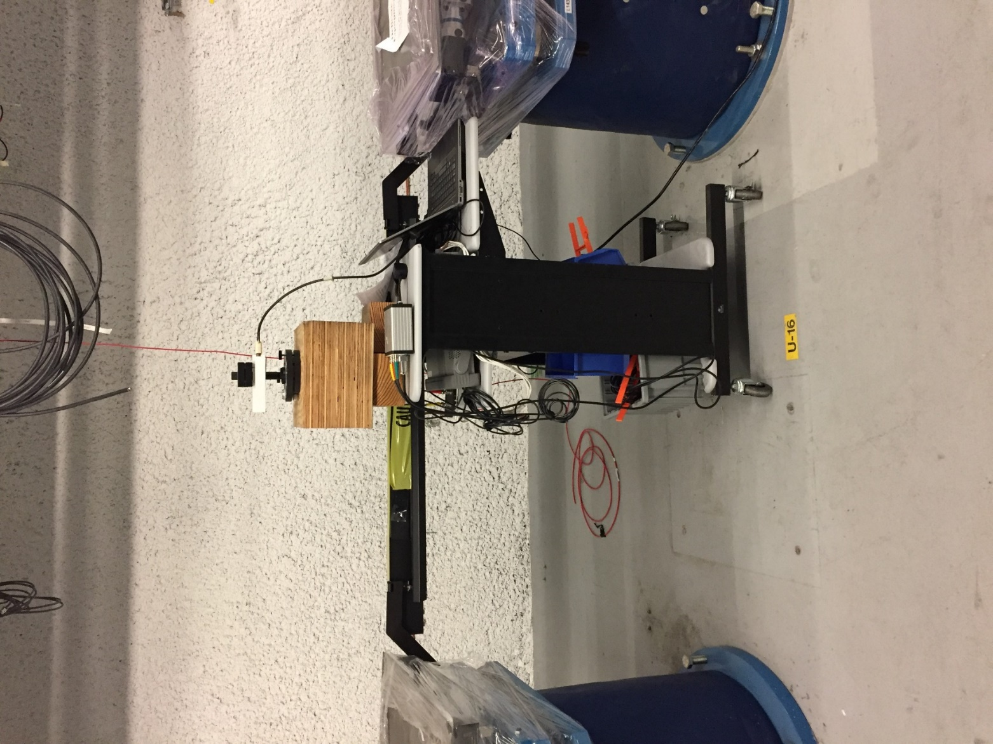

Figure 1: HXR Earth's Field Measurement Apparatus

Measurements were made at each undulator cell location. Figure 2 shows the mean value and standard deviation of the Earth’s magnetic field measurement at each cell location along with the individual measurements made in each cell. There are two horizontal lines showing the mean value of the HXR tunnel measurements and the HXR bench measurements for each Earth’s field axis. The HXR tunnel mean values of all the cells, for each axis are in Table 1. 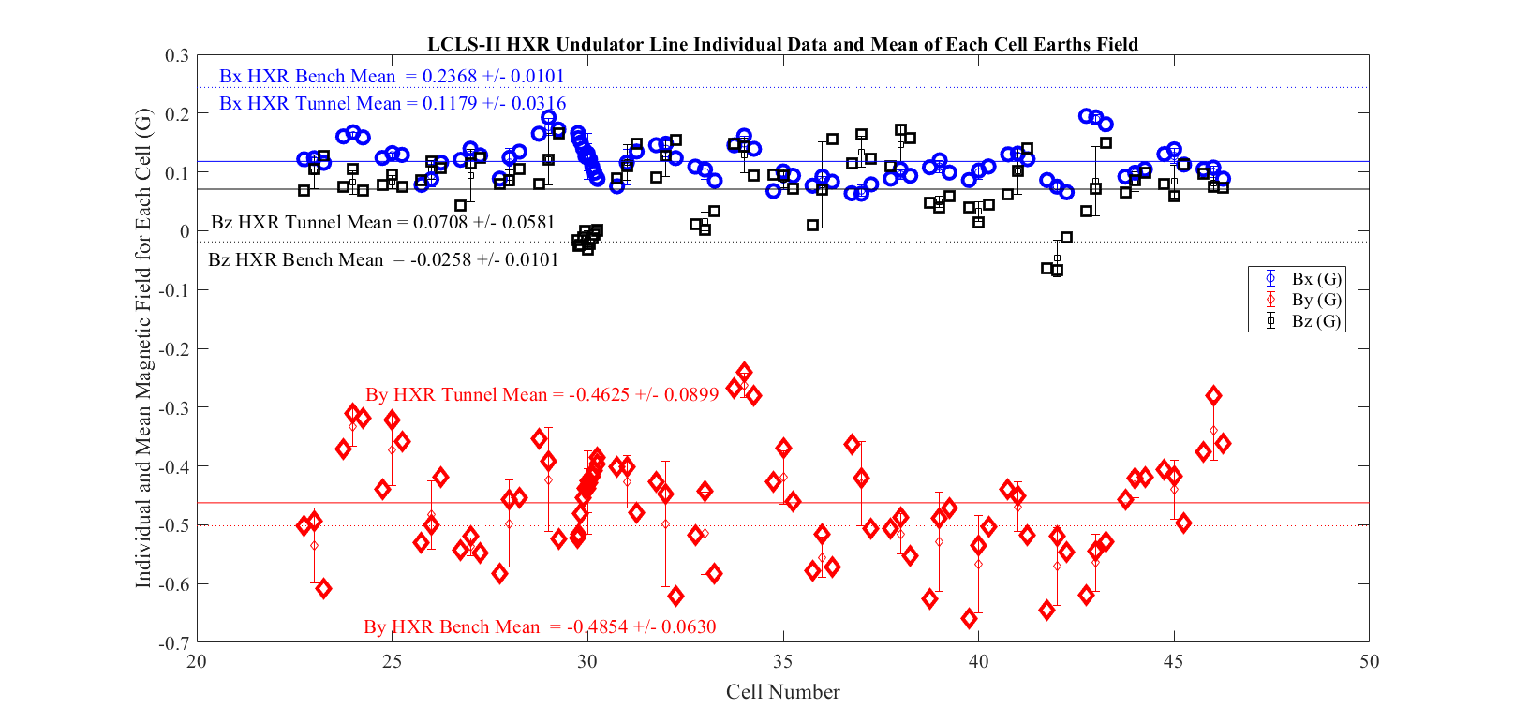
Figure 2: LCLS-II HXR Undulator Earth's Field at Each Cell

Field Orientation | Mean Field (G) | Standard Deviation (G)
B_{x} | 0.118 | 0.032
B_{y} | -0.463 | 0.090
B_{z} | 0.071 | 0.058
Table 2: HXR Line Earth's Field Measurements Mean and Standard Deviation Values

The By field has the largest deviations in each cell and from cell to cell. The difference between the HXR MMF bench Bx Earth’s field and the mean HXR undulator cell position Bx field values are nearly 0.12 Gauss while the differences between the HXR MMF bench By Earth’s fields and the HXR undulator cell position By field values are smaller, around 0.02 Gauss. Individual cell differences with respect to the HXR bench will be taken into account when setting the HXR undulator beam pipe correctors.

SXR Tunnel Field Measurements
The SXR field measurements were made at each SXR undulator cell location at the ¼, ¹/₂ and ¾ z location points along the cell length at each undulator cell slot. These ¼, ¹/₂ and ¾ z locations correspond to z measured location of 1.4, 2.2 and 3.0 meters respectively, with z = 0 being the upstream end of the SXR undulator cell. The SXR interspace pedestals, with their cam movers and the SXR undulator mounting plates were in place for these measurements. Figure 3 shows the mean value and standard deviation of the Earth’s magnetic field measurement at each SXR cell location along with the individual measurements made in each cell. There are two horizontal lines showing the mean value of the SXR tunnel measurements and the SXR bench measurements for each Earth’s field axis. The mean field values of all the SXR tunnel locations are in Table 2.
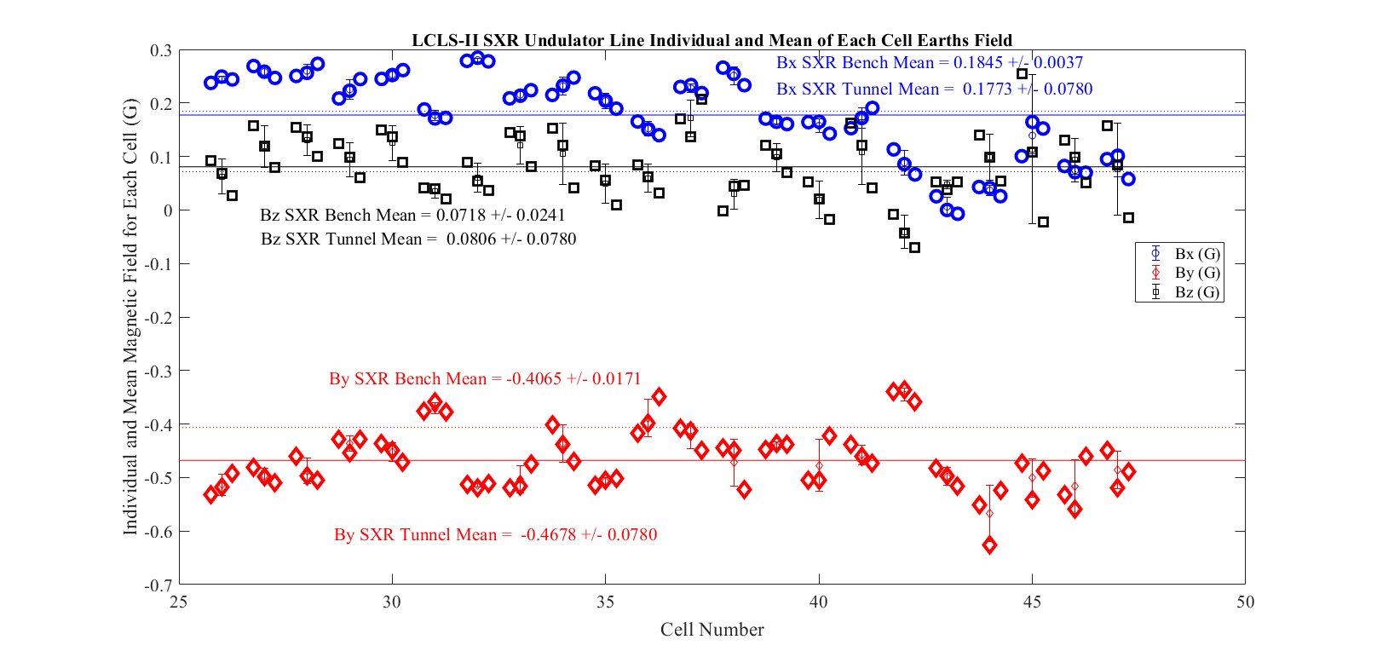
Figure 3: LCLS-II SXR Undulator Earth's Field at Each Cell

SXR Field Orientation | Mean Field (G) | Standard Deviation (G)
B_{x} | 0.177 | 0.078
B_{y} | -0.468 | 0.057
B_{z} | 0.081 | 0.061
Table 2: SXR Line Earth's Field Measurements Mean and Standard Deviation Values

Both the B_{x} and B_{y} tunnel field have a fairly large spread over the length of tunnel The difference between the SXR MMF bench Bx Earth’s field and the mean SXR undulator cell position B_{x} field values are small, 0.01 Gauss, while the differences between the SXR MMF bench B_{y} Earth’s fields and the mean SXR undulator tunnel By field values are around 0.06 Gauss. Individual cell differences with respect to the SXR bench will be taken into account when setting the SXR undulator beam pipe correctors.

Figure 4 below shows the SXR apparatus setup.

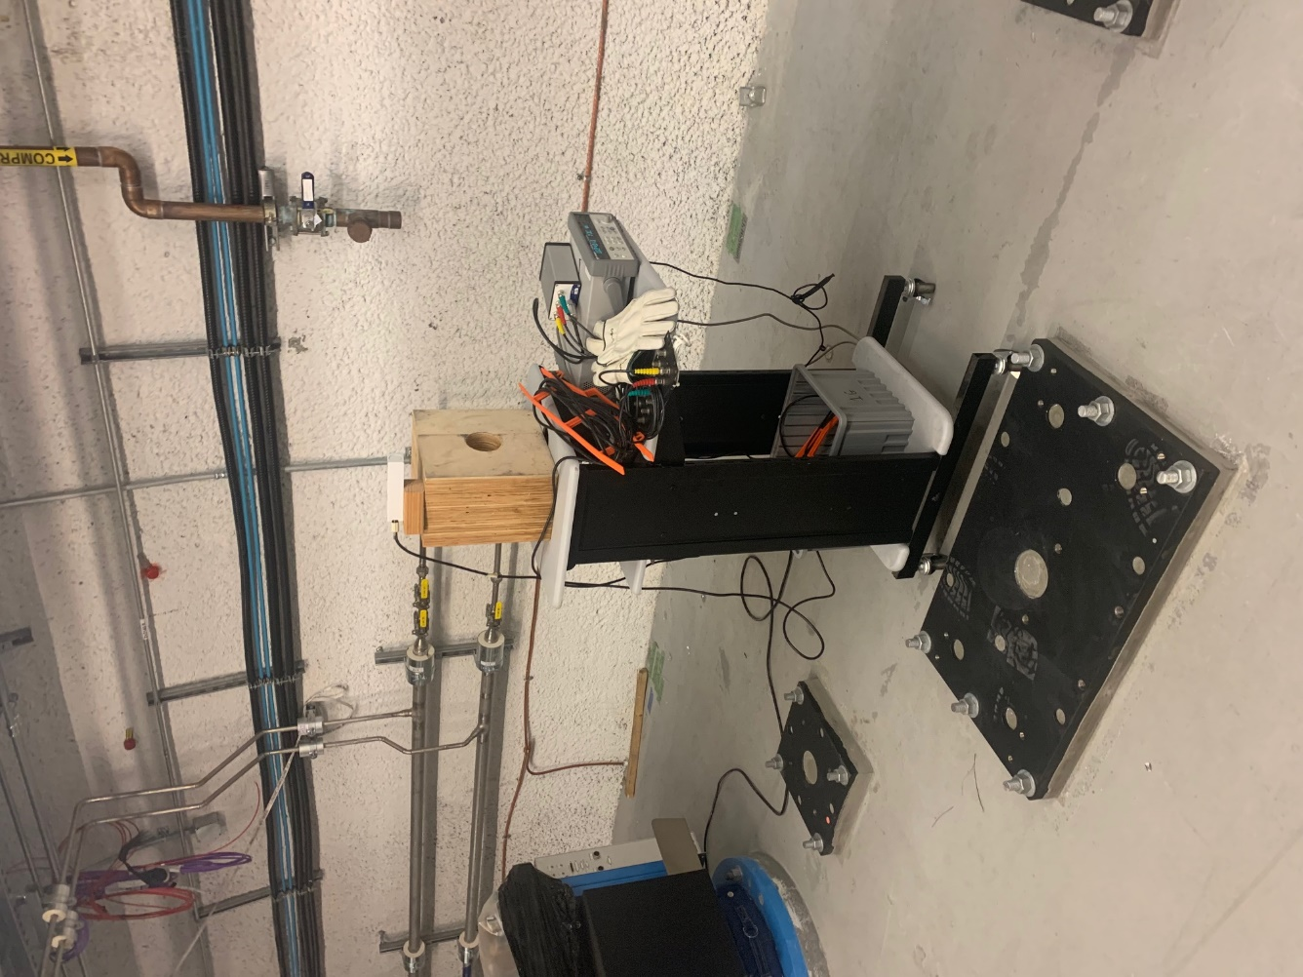
Figure 4: SXR Line Measurement Apparatus Setup

MMF SXR and HXR Bench Earth’s Field Measurements.
Earth’s Field measurements were made at both the SXR and HXR measurement benches in the same manner as they were for the undulator lines, though more points were taken for the bench measurements. Taking extra data points allows a comparison of data taken at three points, like in the tunnel, versus more densely taken data, as in the bench measurements where data is taken every 20 cm. Figures 5 & 6 show the respective data for the HXR and SXR benches. These measurements show that the mean value of the three point data is nearly identical to the mean of the 20 cm spaced data. The mean value of the Earth’s field for the bench and the tunnel measurements are what will be used to determine the differences between the Earth’s field at the measurement benches in the MMF and at each cell location in the undulator tunnel.
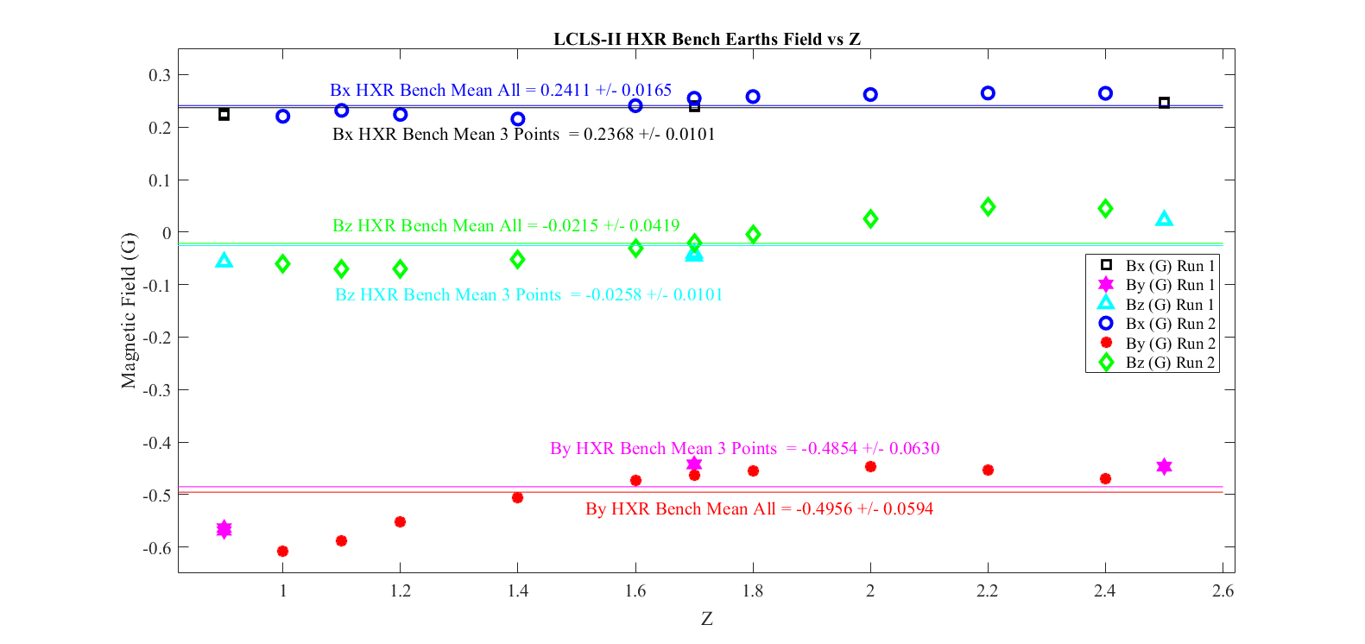
Figure 5: LCLS-II HXU Measurement Bench Earth's Field Measurements

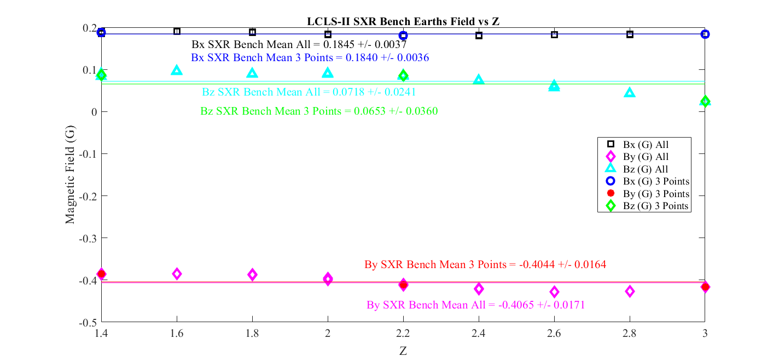
Figure 6: LCLS-II SXU Measurement Bench Earth's Field Measurements

The mean value and standard deviation of the bench measurements are seen in Table 3.

Bench  Field Orientation | Mean Field  3 Point (G) | Stdev Field  3 Point.(G) | Mean Field All (G) | Stdev Field  All (G)
HXR B_{x} | 0.237 | 0.010 | 0.241 | 0.017
HXR B_{y} | -0.485 | 0.063 | -0.496 | 0.059
HXR B_{z} | -0.026 | 0.010 | -0.022 | 0.042
SXR B_{x} | 0.184 | 0.004 | 0.185 | 0.004
SXR B_{y} | -0.404 | 0.016 | -0.407 | 0.017
SXR B_{z} | 0.065 | 0.036 | 0.072 | 0.024
Table 3: MMF Earth's Field Measurements for HXR and SXR Benches

Conclusion
The Earth’s magnetic field was measured along the HXR and SXR undulator lines at each beam line cell location. The Earth’s magnetic field was also measured at the HXR and SXR MMF measurement benches so that the background field differences between the measurements at the tuning benches and the installed undulator locations could be taken into account when setting the beam pipe trim correctors. The measurements show that the bench to undulator line differences are relatively small and that the beam pipe correctors have more than adequate field strength to make all corrections required.

Appendix A Tunnel Minus MMF Measurement Differences

For the HXR and SXR tunnel cell locations, the Bx and By field measurements minus the MMF (Mean All) bench measurements are listed, by cell, in Tables 4 & 5.

Table 4: HXR Tunnel - MMF Bench Earth's Field Measurements for each cell

Table 5: SXR Tunnel - MMF Bench Earth's Field Measurements for each cell

Work supported in part by the DOE Contract DE-AC02-76SF00515. This work was performed in support of the LCLS-II project at SLAC National Accelerator Laboratory.
“LCLS-II General Undulator Requirements”, SLAC-I-060-103-014-00-R001.
Zachary Wolf, Yurii Levashov. March 2012, “Beam Pipe Corrector Study”. LCLS-TN-12-1

