Document Approval:
Originator: David Cesar, Accelerator Physicist

• Content/Format • Req ID’s/Source ID’s • Verif. Planning • SME Input, as appl
Approver: Tor Raubenheimer, Accelerator Physicist

• Complete/Accurate • Req ID’s/Source ID’s • SME Input, as appl
Approver: Ted Price, Systems Engineering Lead

• Complete/Accurate • SME Involvement • Meets Higher/Lower Level Expectations
Approver: Fernanda G. Garcia, Accelerator Systems Manager

• Clarity • Format • Req ID’s/Traceability • Change Control, as appl
Approver: Matt Boyes, Controls Systems Manager

• Clarity • Format • Req ID’s/Traceability • Change Control, as appl
Approver: Eliazar Ortiz, Photon Systems Manager

• Clarity • Format • Req ID’s/Traceability • Change Control, as appl
Approver: Hong Bach– Quality Assurance Manager

• General QA Provisions • Req’s Validation/Verification, as appl
Approver: Marc Ross – Project Technical Director

• Scope Alignment
Revision History
Revision | Date Released | Description of Change
R0 | Month Day, Year | Original Release.

Table of Contents
1 Purpose 2
2 Scope 3
3 Acronyms 3
4 References 4
5 Roles and Responsibilities 4
6 LCLS-II-HE Overview 5
7 SXR Undulator Overview 6
8 SXR Undulator Requirements 8
9 Undulator Segments 12
10 Undulator Magnetic Tuning 13
11 Undulator and quadrupole alignment 14
12 Electron beam based heating of undulator components 16
13 Break (Interspace) Components 18
14 Phase Shifters 18
15 Vacuum Requirements 22
16 Alignment Strategy Overview 23
17 Self-seeding chicane 23
18 Impact on other projects 24
19 End Notes 24

Purpose
This Physics Requirements Document (PRD) identifies and outlines physics requirements that apply to the portion of the LCLS-II facility that is referenced in this document, and that must be addressed as part of the LCLS-II-HE project. From this information, the engineering team will formulate engineering requirements that provide the basis for hardware and software design, development, and integration. Thus, the PRD primarily focuses on performance criteria that can be traced back to top-level system/facility performance parameters. However, PRD preparation and approval also ensures that requirements can be properly interpreted at lower levels of specification, for purposes of accurate system developmental definition.

Scope
This document sets requirements for modifications to the Soft X-ray (SXR) Undulator Systems as part of the LCLS-II-HE project. The LCLS-II-HE project will deliver an 8 GeV beam to the undulator instead of the 4 GeV beam from the LCLS-II SRF linac. To this end, the SXR Undulator will be modified and extended to lase over the soft X-ray spectrum while operating with 8 GeV beam. This document will also describe other undulator system changes related to the increase in operating electron beam energy from 4 to 8 GeV including the modifications to the Undulator Phase Shifters. The LCLS-II SXR and HXR undulator systems are described in Ref. [10]; the HXR undulator system is not modified by the LCLS-II-HE project.

Acronyms
BBA | Beam Based Alignment
BSY | Beam Switchyard
CDS | Cryogenic Distribution System
CM | Cryomodule
CP | Cryoplant
CuRF | Copper Radio Frequency
EXT | Linac Extension
FEL | Free Electron Laser
FODO | Focusing-Drift-Defocusing-Drift
GRD | Global Requirements Document
HE | High-Energy
HXR | Hard X-ray
HXU | Undulator Segment of the hard x-ray undulator beamline
KPP | Key Performance Parameters
LCLS | Linac Coherent Light Source
LLRF | Low-Level Radio Frequency
LTU | Linac-To-Undulator
PRD | Physics Requirements Document
SASE | Self-Amplified Spontaneous Emission
SCRF | Superconducting Radio Frequency
SRF | Superconducting Radio Frequency
SSA | Solid State Amplifier
SXR | Soft X-ray
SXU | Undulator Segment of the soft x-ray undulator beamline
XFEL | X-ray Free Electron Laser

References
1 | LCLSII-1.1-DR-0251 | LCLS-II Final Design Report
2 | LCLSII-HE-1.1-PR-0235 | LCLS-II-HE Beamline Overview PRD
3 | LCLSII-HE-1.1-PR-0028 | LCLS-II-HE Beamline Boundaries PRD
4 | LCLSII-HE-1.1-PR-0039 | LCLS-II-HE Parameters PRD
5 | SLAC-PUB-15062 | H.-D. Nuhn, “LCLS-II Undulator Tolerance Analysis”
6 | LCLSII-3.2-PR-0101 | LCLS-II Soft X-ray Self-Seeding (SXRSS) System Requirements PRD
7 | www.sirepo.com | Synchrotron radiation workshop (https://www.sirepo.com/srw#/  findByName/calculator/Undulator%20Radiation)
8 | LCLS-II-TN-14-06 | K. Bane, G. Stupakov, Roughness Tolerance Studies for the Undulator Beam Pipe Chamber of LCLS-II
9 | LCLSII-3.2-PR-0105-R1 | LCLS-II Undulator Phase Shifter PRD
10 | LCLSII-XX-PR-XXXX | LCLS-II Undulator System PRD
11 | LCLSII-3.2-ES-0317-R0 | LCLS-II Quadrupole Magnet ESD
12 | LCLSII-3.2-ES-0049-R3 | LCLS-II RF Beam Position Monitor ESD
13 | LCLSII-3.2-ES-0486-R0 | LCLS-II Undulator Interspace Vacuum
14 | LCLSII-2.7-ES-0812-R1 | LCLS-II SXR Undulator Motion Control ESD
15 | SLAC-I-060-102-120-00 | LCLS-II Undulator Beam Loss Monitor ESD
16 | FEL2006 Proceeding, 2006, Berlin, Germany | H.-D. Nuhn, P.J. Emma, G.L. Gassner, C.M. LeCocq, F. Peters and R.E. Ruland, Electron Beam Alignment Strategy in the LCLS Undulators
17 | FEL2009 Proceeding, 2009, Liverpool, UK (SLAC-PUB-13781) | H.-D. Nuhn, et al., LCLS Undulator Commissioning, Alignment, and Performance
 | SLAC-I-081-101-003-00 | Soft X-Ray Self-Seeding (SXRSS) System PRD,

Roles and Responsibilities
Project Technical Director | Provides overall technical guidance for development and commissioning of LCLS-II HE features added to the LCLS-II facility
Accelerator Physicist | Provides direction for the LCLS-II HE physics team. Scope includes development of system performance requirements; identification, analysis, and selection of technological solutions that address performance expectations; and scientific consultation for associated project engineering design efforts.
Accelerator Systems Manager | Manages and controls engineering design, development, test, and commissioning for Accelerator system portions of the LCLS-II HE project.
Photon Systems Manager | Manages and controls engineering design, development, test, and commissioning for Photon system portions of the LCLS-II HE project.
Control Systems Manager | Manages and controls engineering design, development, test, and commissioning for control system portions of the LCLS-II HE project.
Infrastructure Systems Manager | Manages and controls engineering design, development, test, and commissioning for infrastructure system portions of the LCLS-II HE project.
Systems Engineer | Ensures proper requirements definition, documentation, traceability, validation, verification, and change control.

LCLS-II-HE Overview
The LCLS-II-HE upgrade is designed to deliver photons between 200 eV and 12.8 keV at repetition rates as high as 929 kHz using a superconducting RF (SRF) linac while still providing pulses at short wavelengths and high X-ray pulse energies over the photon range of 1 to 25 keV using the existing 120 Hz copper RF (CuRF) LCLS linac. The upgrade builds on the LCLS-II, which is described in Ref. [1].
The LCLS-II-HE accelerator upgrade project will extend the LCLS-II SRF linac to generate an 8 GeV beam, upgrade the beam spreader kickers for 8 GeV operation, upgrade the SXR Undulator to cover the soft X-ray spectral region with an 8 GeV beam, and add a Self-Seeding system to the HXR undulator. The LCLS-II-HE upgrade will reuse the LCLS-II injector, laser heater, and bunch compression systems without modification. The LCLS-II-HE beamlines are described in the LCLS-II-HE Beamline Overview, Ref. [2] and a schematic of the LCLS-II-HE is shown in Figure 1.
The LCLS-II-HE lattice description and MAD8 output files can be found in: https://www.slac.stanford.edu/grp/ad/model/lcls2he.html. Values and locations in the current MAD decks supersede the approximate values specified in this document.
LCLS-II-HE beamline names frequently add a “B” suffix to distinguish them from the LCLS CuRF beamlines. A full description of all the beamline names can be found in LCLS-II-HE Beamline Boundaries PRD, Ref. [3].
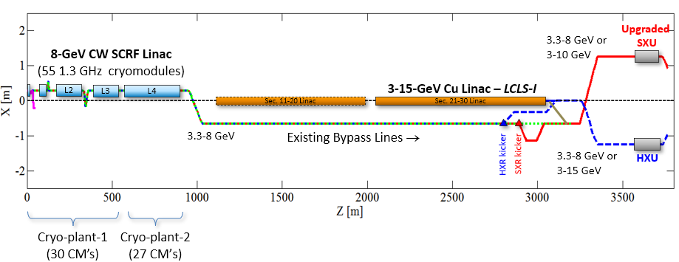
Figure 1. Schematic layout of the LCLS-II in the SLAC linac tunnels.

SXR Undulator Overview
The LCLS-II-HE SXR undulator system will deliver high power FEL pulses to instruments located in the near experimental hall. These instruments use photon energies from 280 eV up to 5000 eV in a variety of modalities, including: SASE, self-seeded, two-color and attosecond. Importantly, the undulator system must be able to run independently of and in parallel with the HXR undulator system. This will be achieved by making a gap ($K$) tunable undulator, such that the resonant wavelength of the SXR undulator system can be changed independently of the electron beam energy:
$$λ_{r}=\frac{λ_{u}}{2 γ^{2}}\left(1+\frac{K^{2}}{2}\right), K=\frac{q_{e}Bλ_{u}}{2πm_{e}c}$$
The range of the undulator system is limited on the long-wavelength (low-energy) side by the largest possible $K$ (smallest gap) the system can support, and on the short-wavelength (high-energy) side it is limited by interaction strength to $K≳1$. The LCLS-II SXR undulator system was designed such that it could produce 250 eV photons – see Ref. [4] – at the minimum gap when using a 4 GeV electron beam. For LCLS-II-HE the beam energy will be boosted to 8 GeV, and therefore $K$ must also be increased. This is done easily (on paper) by increasing the undulator period from 39 mm to 56 mm. In practice, this requires designing, manufacturing, installing, and re-tuning the magnetic blocks of both the undulators and the phase shifters.
In addition to changing the magnetic period, the LCLS-II-HE SXR undulator system will need to add more undulators than presently exist in the LCLS-II SXR system. This happens because the pierce parameter $ρ$ does not significantly change from LCLS-II to HE, but the gain length scales like $L_{g}=λ_{u}/ρ$. Thus, to support the same level of operations as the LCLS-II system, the LCLS-II-HE system will need 30 undulators sections, rather than the 21 sections built for LCLS-II.
To illustrate this point, we show simulations of the FEL power along the undulator in the LCLS-II-SXR case and in the LCLS-II-HE-SXR case in Figure 2. The comparison shows that they saturate at a similar fraction of the total undulator distance, provided that we add 9 new segments for the HE lattice (notice that the x-axis on the upper and lower plots differ by these 9 segments). The HE lattice must also be built to provide 5 keV “tender” photons (these may be from direct SASE, as shown below, or from harmonic lasing). From this chart, we can also see how the increased beam power will help HE deliver a higher saturation energy.

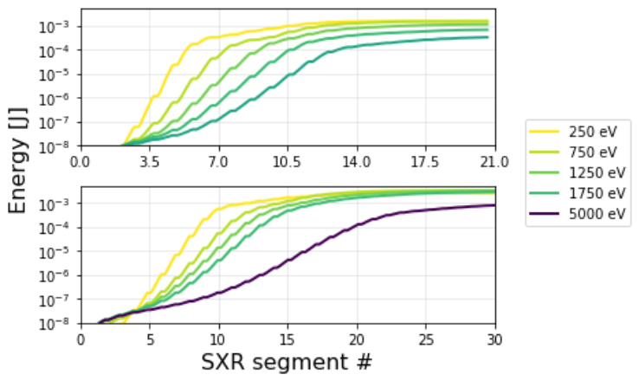

Figure 2: SASE FEL energy along the LCLS-II (upper) and LCLS-II-HE (Lower) SXR beamlines. Note the difference in the x-axis. Simulations are perofrmed in Genesis, with initial particle distribution from start to end simulations of the beam in IMPACT. For the upper plot, the beam core parameters are $E=3.8GeV, I=1.3kA, ΔE=1.1MeV,ϵ_{n}=0.27x0.31μm$ for the, while for the lower plot the beam core parameters are $8GeV, I=1.3kA, ΔE=1.1MeV,ϵ_{n}=0.25x0.28μm$. Note that LCLS-II does not support operation at 5keV. In all cases, a small quadratic taper is applied. Neithier simulation takes into account the break for the self-seeding chicane.
LCLS-II-HE will support not only the SASE mode shown in Figure 2, but also advanced schemes such as self-seeding, two-color, and attosecond pulse generations. These modalities require more undulators than SASE, and in order to assure that the FEL saturation length is short enough to support them, a demanding set of tolerances have to be met both by the undulator system itself, and by the electron bunches delivered to the undulator system. The electron beam needs to be matched to the undulator FODO channels with the correct average beta-function as set by the undulator lattice and specified below. The main tolerances have been established and balanced in a tolerance budget. This is described in a separate document as described in Ref. [5]. For the budget in this document, the estimated power loss is less than 30% at 5 keV and is less than 20% at 2 keV. Most tolerances are equivalent to LCLS-II, while some potentially effected by magnetic forces have been loosened.

SXR Undulator Requirements
The LCLS-II-HE SXR line is based on the existing SXR line. Figure 3 shows a CAD rending of the LCLS-II beamline, including a full cell consisting of two undulators and two breaks (break sections have different vacuum components depending on their location in the beamline).
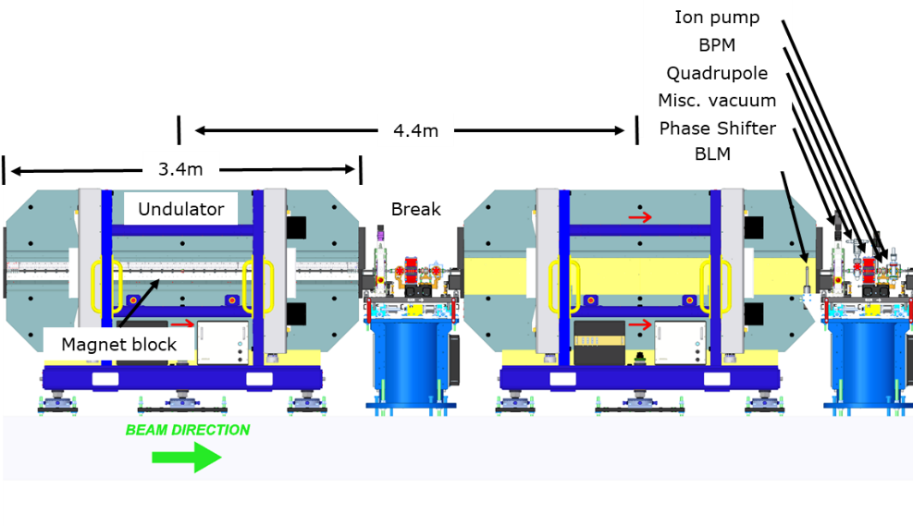
Figure 3: Schematic elevation view of segment and break section arrangements of the LCLS-II SXR undulator line. The left section has its cover removed to reveal the magnet block. The right-handed coordinate system, used throughout this document, has the Z axis pointing in beam direction, the Y axis upwards and the X axis into the paper.
In Figure 4, we show an enlarged figure of a single undulator assembly, highlighting the location and size of the magnet block. Much of the frame, strongback, driver system, encoders, and control systems can all be directly reused. Some additional modification, for example to the compensation spring, can be expected.
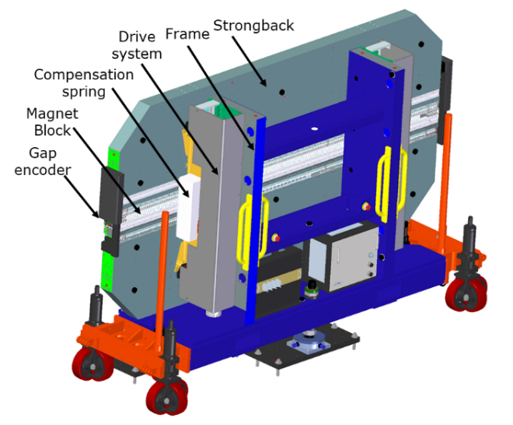
Figure 4: View of a single undulator section for LCLS-II. For LCLS-II-HE the magnet blocks must be exchanged for new blocks with a longer undulator period. Much of the reamining structure will be directly resued.
LCLS-II-HE will also add nine new SXR undulator segments and move the position of the self-seeding (SS) chicane, Ref. [6], correspondingly. A layout of the existing (LCLS-II) undulator hall is shown in Figure 5, and the corresponding figure for HE is shown in Figure 6. Note that LCLS-II specified two RFBPM’s upstream of the first undulator segment, and two RFBPM’s as well as one quadrupole after the last segment. This should remain true, such that HE must move the two upstream BPM’s further upstream. These BPM’s help determine the orbit going into the undulator system.
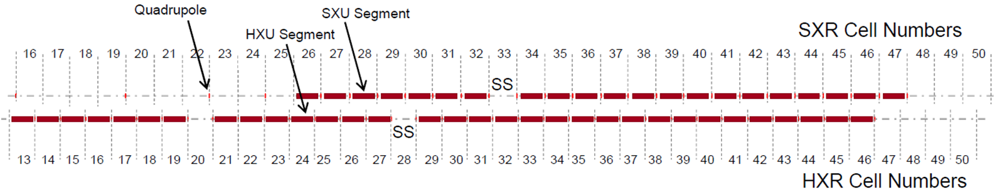
Figure 5: Schematic layout of segment and break section arrangements of each of the LCLS-II undulators.
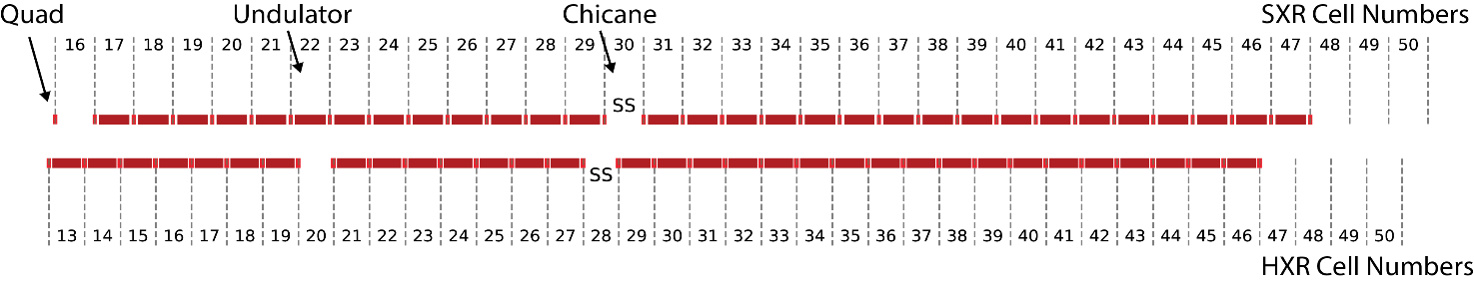
Figure 6: Schematic layout of segment and break section arrangements of each of the LCLS-II-HE undulators. 9 new SXR undulators have been added and the self-seeding chicance has been moved.
The new SXR lattice parameters are listed in Table 1. The cell length and break length are unchanged but populating the new cells requires adding additional components.

Table 1: Basic undulator lattice parameters.
Requirement # | Parameter | New SXR Values | Old SXR Values | Unit | Verif. Method | Parent Requirement
PR.###### | Number of cell slots from first to the last segment | 31 | 22 |  | Inspection | PR.######
PR.###### | Number of undulator segments | 30 | 21 |  | Inspection | PR.######
PR.###### | Number of quadrupoles | 31+2 | 22+4 |  | Inspection | PR.######
PR.###### | Number of RF cavity beam position monitors | 31+3 | 22+3 |  | Inspection | PR.######
PR.###### | Number of Phase Shifters | 29 | 20 |  | Inspection | PR.######
PR.###### | Number of beam loss monitors | 30 | 21 |  | Inspection | PR.######
PR.###### | Nominal break section length | 1.0 | 1.0 | m | Inspection | PR.######
PR.###### | Total magnetic undulator length | 102.0 | 71.4 | m | Inspection | PR.######
PR.###### | Total undulator length incl. interspaces and SXRSS | 136.4 | 95.800 | m | Inspection | PR.######
PR.###### | Cell length | 4.4 | 4.4 | m | Inspection | PR.######
PR.###### | FODO length | 8.8 | 8.8 | M | Inspection | PR.######
PR.###### | Max quadrupole integrated gradient | ±4 | ±4 | T | Test | PR.######
PR.###### | Max electron beam energy | 10 | 10 | GeV | Test | PR.######
PR.###### | Min. electron beam energy, $E$ | 2.6 | 2.6 | GeV | Test | PR.######

The new SXR undulator segment parameters are defined in Table 2. The main difference is the change of the number of periods and period length of the segment. The minimum operational gap specifies undulator parameters for 250 eV photons. For HE, the maximum operational gap is set to produce 5 keV photons. At the time of writing this PRD, the undulator design has a K vs gap ($g$) dependence which is well fit to the following halbach form: $$K≈0.340\left[\frac{1}{mm}\right]λ_{u}e^{-6.031\left(\frac{g}{λ_{u}}\right)+2.867 {\left(\frac{g}{λ_{u}}\right)}^{2}}$$

Table 2: Basic undulator segment parameters.
Requirement # | Parameter | New SXU Values | Old SXU Values | Unit | Verif. Method | Parent Requirement
PR.###### | Undulator period length (λ_{u}) | 56 | 39 | mm | Test | PR.######
PR.###### | Segment length | 3.4 | 3.4 | m | Inspection | PR.######
PR.###### | Number of effective periods per segment (N_{p}) | 60 | 87 |  | Inspection | PR.######
PR.###### | Number of poles per segment | 120 | 174 |  | Inspection | PR.######
PR.###### | Undulator type | Planar | Planar |  | Inspection | PR.######
PR.###### | Undulator magnet type | PM Hybrid | PM Hybrid |  | Inspection | PR.######
PR.###### | Gap type | Variable | Variable |  | Inspection | PR.######
PR.###### | Magnet material | Nd₂Fe₁₄B | Nd₂Fe₁₄B |  | Inspection | PR.######
PR.###### | Linear polarization direction of the xray radiation | horizontal | horizontal |  | Inspection | PR.######
PR.###### | Magnetic Field Symmetry | antisymmetric | antisymmetric |  | Inspection | PR.######
PR.###### | Minimum operational magnetic gap | 7.2 | 7.2 | mm | Inspection | PR.######
PR.###### | Maximum operational magnetic gap | 33 | 22 | mm | Inspection | PR.######
PR.###### | On-axis vertical effective field at min. oper. Gap | >1.76 | >1.49 | T | Test | PR.######
PR.###### | K_{eff} at minimum operational gap | >9.21 | >5.43 |  | Analysis/  Test | PR.######
PR.###### | Minimum full open gap | 100 | 100 | mm | Inspection | PR.######
PR.###### | Minimum operational K values | 1.51 | 1.24 |  | Analysis/  Test | PR.######

Undulator Segments
The undulator segments shall be planar variable strength permanent magnet type undulator magnets. The basic parameters of the undulator segments are listed in Table 2. The wiggle plane shall be oriented horizontally for the SXU segments. In keeping with LCLS-II nomenclature, “U” references the wiggle plane and “V” the perpendicular direction.
Table 3 lists tolerances for key quantities of each of the undulator segments: The parameter, “Magnet array straightness”, refers to the deviation of the lines through the centers of the pole tips from a straight line and insures that the space between the magnet poles and the vacuum chamber is not compromised. This tolerance is independent of tolerances on gap consistency along the undulator (e.g. $∆g_{defl}$,) which are given at the bottom of Table 3 and in Table 7. The tighter constraints on gap consistency (for HE compared to LCLS-II) follow from the fact that $\frac{∂_{g}K}{K}Δg≈ρ$, and amounts to about a 10% change in sensitivity.
Table 3: Undulator segment tolerance parameters
Requirement # | Parameter | New SXU Values | Old SXU Values | Unit | Verif. Method | Parent Requirement
PR.###### | Magnet array straightness (rms) | <50 | <50 | µm | Inspection | PR.######
PR.###### | Undulator period length variation (rms) | <35 | <25 | µm | Inspection | PR.######
PR.###### | Maximum gap variation $∆g_{defl}$ | <27 | <29 | µm | Inspection | PR.######

Alignment tolerances between individual segments, as well as between the two strongbacks within a segment are listed separately in Table 6 and Table 7. It is assumed that each of the two undulator segment strongbacks will be connected to the drive motors at discrete positions by a two-point strongback support. The magnetic forces will cause deviations of the actual undulator gap from the requested gap due to z dependent and gap dependent strongback deflections at z locations other than the support points. These deflections, in turn, will generate gap dependent changes to field integrals, total phase, phase shake, $K_{eff}$, and total FEL power. The effect depends non-linearly on the gap. The strongest changes per gap change occur close to the minimum gap. Tuning will not be done at the minimum gap but at a slightly larger gap, which will be chosen such that the total phase error is roughly balanced, i.e., that absolute deviation in phase error at the smallest gap is roughly the same as the maximum at some intermediate gap.
The tuning procedure will cancel errors at the tuning gap (nominally $g_{tune}$=12.75 mm for HE). The strongback deflection tolerance is expressed as the maximum deviation, $∆g_{defl}$, from the nominal gap when changing that nominal gap between the minimum and the maximum operational gap (see Table 2):
$$∆g_{defl}=\text{max}\left(∆g_{act}\left(z\right)\right)-\text{min}\left(∆g_{act}\left(z\right)\right)$$
$$∆g_{act}\left(z,g_{req}\right)=g_{act}\left(z,g_{req}\right)-g_{act}\left(z,g_{req}=g_{tune}\right)$$
Here, $g_{act}\left(z,g_{req}\right)$, refers to the list of gap encoder settings, $g_{req}$, and separations between adjacent poles at their longitudinal centers, $z$.

Undulator Magnetic Tuning
In order for the SASE process to produce optimum gain, four tuning considerations need to be satisfied for each operational gap:
- Control of the undulator parameter, K_{eff}.
- Phase shake reduction throughout each segment.
- Reduction of the overall phase error across each segment.
- Reduction of the first and second integrals of the horizontal and vertical field components.
- The phase errors are based on the segment cell length, L_{cell}, which is defined as the length of a line along the magnetic segment axis over which the total phase slippage is 2πN_{p} for the Tuning Gap height, when centered longitudinally at the segment center. N_{p} is the number of segment poles per strongback. A consequence of the field integral tolerances in Table 4 is that differences between environmental field components (earth field etc.) in the undulator hall and those in the magnet measurement facility need to be smaller than 0.1 G, which is very likely not going to be the case without special effort (see section about beam pipe correctors, above). The Undulator parameter, and the phase shake are determined over the segment core, i.e., without considering the end sections.

Table 4. Basic undulator segment tuning requirements
Requirement # | Parameter | New SXU | Old SXU | Unit | Verif. Method | Parent Requirement
PR.###### | Undulator parameter tolerance ΔK_{eff}/K_{eff} | ±5.5×10⁻⁴ | ±3.0×10⁻⁴ |  | Test/Analysis | PR.######
PR.###### | Horizontal K sextupole $\left|\frac{1}{2}\left(1/{K_{eff}}\right) {∂^{2}K_{eff}}/{∂x^{2}}\right|$ | <10×10⁻⁴ | <10×10⁻⁴ | 1/mm² | Test/Analysis | PR.######
PR.###### | Equivalent ΔK/K @ x = ±0.4 mm | <1.6×10⁻⁴ | <1.6×10⁻⁴ |  | Test/Analysis | PR.######
PR.###### | Tuning Gap height | 12.75 | 10 | mm | Inspection | PR.######
PR.###### | Tuning good field radius | 1 | 1 | mm | Inspection | PR.######
PR.###### | Phase shake (rms) over L_{cell} | ±5.0 | ±5.0 | deg Xray | Test/Analysis | PR.######
PR.###### | Cell phase error | ±10.0 | ±10.0 | deg Xray | Test/Analysis | PR.######
PR.###### | First field integral of B_{y} per cell (abs) | <30 | <40 | µTm | Test/Analysis | PR.######
PR.###### | Second field integral of B_{y} per cell (abs) 8 | <200 | <150 | µTm² | Test/Analysis | PR.######
PR.###### | First field integral of B_{x} per cell (abs) | <30 | <40 | µTm | Test/Analysis | PR.######
PR.###### | Second field integral of B_{x} per cell (abs) | <200 | <150 | µTm² | Test/Analysis | PR.######
Note that in this table ΔK_{eff}/K_{eff} refers to the variations in K due to manufacturing (±0.04.2%), thermal variation (±0.5°C), and gap uniformity (after tuning ±8 µm).

Undulator and quadrupole alignment
In order for the SASE process to produce optimum gain, three main alignment considerations need to be satisfied:
- Align the quadrupoles such that the electron trajectory is straight, in order to reduce phase errors and improve overlap between the electron and photon beams.
- Center the vacuum chamber to the electron beam to minimize emittance degradation from transverse wakefields.
- Center the undulator to the beam to minimize errors of the undulator parameters (K_{eff}).
All alignment operations will be based on the magnetic or electrical centers (rather than the mechanical shape, with the exception of RFPMs) of the components, which will be determined in a separate process and fiducialized to tooling ball (sockets) or appropriate features on the device body.
The tolerances are listed in Tables 5 through 8. Transverse quadrupole alignment is specified with respect to a virtual straight line. The local straightness requirements refer to a z interval of 5 m (roughly one HXR field gain length), while global straightness requirements refer to the total undulator length. It is assumed that initial alignment, based on conventional metrological methods, will provide good local straightness but might suffer from some degree of random walk-off, globally. The quadrupoles are the main focus of the alignment procedure; the other components will be aligned with respect to the quadrupoles. The final alignment tolerances for the quadrupoles are extremely tight and will be met by using electron beam based alignment in a similar way as with LCLS and LCLS-II.
Table 5: Basic quadrupole alignment requirements with respect to the reference coordinate system
Requirement # | Parameter | New SXU Values | Old SXU Values | HXU Values | Unit | Verif. Method | Parent Requirement
PR.###### | Initial quadrupole alignment (x,y) | ±175 | ±175 | ±175 | µm | Inspection | PR.######
PR.###### | Final quadrupole position settability (x,y) | ±0.5 | ±0.30 | ±0.25 | µm | Test | PR.######
PR.###### | Quadrupole x/y position stability (rms) | ±0.5 | ±0.30 | ±0.25 | µm | Test | PR.######
PR.###### | Roll tolerance (rms) | <1.0 | <1.0 | <1.0 | mrad | Inspection | PR.######
PR.###### | Pitch tolerance (rms) | <15 | <15 | <15 | mrad | Inspection | PR.######
PR.###### | Yaw tolerance (rms) | <15 | <15 | <15 | mrad | Inspection | PR.######

Table 6: Undulator alignment requirements relative to electron beam trajectory
Requirement # | Parameter | New SXU Values | Old SXU Values | HXU Values | Unit | Verif.  Method | Parent Requirement
PR.###### | V plane mag. segment axis alignment | ±300 | ±150 | ±70 | µm | Inspection | PR.######
PR.###### | U plane mag. segment axis alignment | ±500 | ±478 | ±290 | µm | Inspection | PR.######
PR.###### | Segment roll tolerance (rms) | <1 | <1 | <1 | mrad | Inspection | PR.######
PR.###### | Segment pitch tolerance (around U axis) | ±170 | ±170 | ±50 | µrad | Inspection | PR.######
PR.###### | Segment yaw tolerance (around V axis) | ±400 | ±400 | ±260 | µrad | Inspection | PR.######
PR.###### | Segment chamber V mid-plane (rms) | <50 | <50 | <60 | µm | Inspection | PR.######

Table 7: Alignment and stability tolerances of upper jaw with respect to lower jaw
Requirement # | Parameter | New SXU Values | Old SXU Values | HXU Values | Unit | Verif. Method | Parent Requirement
PR.###### | Yaw error (around V axis) | ±2 | ±1 | ±1.75 | mrad | Inspection | PR.######
PR.###### | Pitch error (around U axis) | ±2 | ±2 | ±1.5 | µrad | Inspection | PR.######
PR.###### | Roll error (rms) | <4 | <4 | <1 | mrad | Inspection | PR.######
PR.###### | Wiggle plane (U) position error (rms) | <400 | <400 | <400 | µm | Inspection | PR.######
PR.###### | Gap error (rms) | <5 | <5 | <1.5 | µm | Inspection | PR.######

Table 8: Miscellaneous alignment tolerances
Requirement # | Parameter | New SXU Values | Old SXU Values | HXU Values | Unit | Verif. Method | Parent Requirement
PR.###### | Undulator z position tolerance (rms) | 1.0 | 1.0 | 0.3 | mm | Inspection | PR.######

Electron beam based heating of undulator components
The undulator system is sensitive to heating, due to the tight tolerance on $K$ variation and quadrupole positions. In this section we calculate the heat terms driven by the electron beam. Other heat sources (e.g. from motors) are not assessed here. We consider two primary contributions: firstly, the incoherent synchrotron radiation produced by bending a relativistic electron beam; and secondly, heating from the resistive wall wakefield.
Spontaneous (incoherent) radiation is produced by bending individual electrons, irrespective of the collective FEL instability. It is broadband and highly divergent. The total intensity per bunch can be calculated from the electron beam energy, $E$, electron bunch charge, $Q$, effective magnetic undulator field, $B_{u}$, and undulator length, $L_{u}$. The total spontaneous energy per bunch, integrated over all wavelengths and angles, becomes:
$$E_{spont}=\text{633}\frac{\text{J}}{{\text{GeV}}^{2} {\text{T}}^{2}\text{ m C }} E^{2} B_{u}^{2} L_{u} Q$$
This formula is evaluated in Table 9 for the minimum undulator gap (leading to the largest power). This spontaneous radiation will be absorbed by the undulator beam pipe, and must be dissipated to prevent components from overheating. Calculation (see Ref. [7]) of the radiation profile shows that, for the LCLS-II-HE system at minimum gap, the spontaneous radiation has a far-field divergence of $500 μrad x 50 μrad$ (the divergence is larger in the horizontal, bending, plane). Consequently about 30% of the spontaneous radiation will be absorbed by the racetrack undulator pipe and the remainder will hit the aperture of the beampipe running through the quadrupole and RFBPM.
In addition to heating from synchrotron radiation, there will be heating due to wakefields in the undulator system. Studies for LCLS-II, Ref. [8], showed that for the specified (Table 14) vacuum chamber roughness, the wakefield is dominated by the resistive wall contribution. For a round chamber of radius $a$ this impediance is given by:
$$Z=\frac{Z_{0}}{2πa}{\left(\sqrt{\frac{2Z_{0}σ_{ac} }{|k|}}\left(\frac{i+sign\left(k\right)}{k}\right)-\frac{ika}{2}\right)}^{-1}$$
where $σ_{ac}=σ_{dc}/(1-i k c τ)$ is the Drude model conductivity. For our case we approximate the beampipe as round with radius $=2.5 mm$, and use (for Aluminium) $σ_{dc}=3.5⋅{10}^{7}\frac{1}{Ωm},τ=8 fs$. In Table 9 we integrate the resulting wake function over the entire beam (and the undulator beam pipe length). Note that the resulting wake increases with both current and total charge, such that there is a large difference in energy/shot for the SC and Cu systems. The calculation also depends weakly on the pulse length and the detailed current structure, such that these numbers may be taken as representative of the heating during HE operation. Unlike the incoherent synchrotron radiation, which travels far downstream, this heating is local, and so the power is distributed evenly along the beamline. Additionally, we point out that this heating does not depend explicitly on beam energy. However this estimate is about 50% higher than the one in the LCLS-II undulator PRD because we consider a 1.3 kA beam, rather than a 1 kA beam.

Table9: Maximum spontaneous per pulse energy estimates for the proposed operational range.
Requirement # | Parameter | SXR/SCRF | SXR/CuRF | Unit | Verif. Method | Parent Requirement
PR.###### | Min. Undulator gap | 7.2 | 7.2 | mm | Inspection | PR.######
PR.###### | Max. Electron beam energy, $E$ | 8.0 | 10.0 | GeV | Test | PR.######
PR.###### | Max. Effective undulator magnetic field, $B_{u}$ | 1.76 | 1.76 | T | Test | PR.######
PR.###### | Undulator magnetic length, $L_{u}$ | 3.4 | 3.4 | m | Inspection | PR.######
PR.###### | Nominal Electron bunch charge, $Q$ | 100×10⁻¹² | 250×10⁻¹² | C | Test | PR.######
PR.###### | Nominal spontaneous energy per pulse per undulator,$E_{spont}$ | 60 | 220 | $$μJ$$ | Calculation? | PR.######
PR.###### | Flattop current (for wake calculation) | 1.3 | 3 | kA | Calculation/Analysis | PR.######
PR.###### | Undulator beam pipe length (for wake calculation) | 4 | 4 | m | Calculation/Analysis | PR.######
PR.###### | Total resistive wake heating per pulse per undulator | 30 | 160 | $$μJ$$ | Calculation/Analysis | PR.######

For reference we also repeat in Table 10 the undulator hall temperature stability, as defined in the LCLS-II undulator PRD, Ref. [10]:

Table 10: Basic undulator hall requirements.
Requirement # | Parameter | Values | Unit | Verif. Method | Parent Requirement
PR.###### | Local temperature stability | ±0.1 | °C | Inspection | PR.######
PR.###### | Maximum temperature variation along the undulator line | ±1.0 | °C | Inspection | PR.######
PR.###### | Average undulator temperature | 20 | °C | Inspection | PR.######
PR.###### | Differential floor stability between points separated by 10 m | ±0.2 | $$μm/day$$ | Inspection | PR.######

Break (Interspace) Components
In each break section (interspace section), there will be components (i.e., quadrupoles, radio frequency cavity beam position monitors, phase shifters, and beam loss monitors), that are necessary for controlling and monitoring the electron beam as well as monitoring radiation levels. Table 1 lists the total number for each component type. Note that some components are required upstream and downstream of the entire chain (see schematic in Figure 6).
With the exception of the phase shifters, the break space components have the same requirements as for LCLS-II.
This includes the quadrupoles, BPMs, Ambient Field Correctors, Beam Loss Monitors, Temperature monitoring, Gap Monitoring, and Radiation detection. Please see the LCLS-II documentation for details, Refs. [10] and [11-15].
The break section components will be mounted on a common support that can be precisely positioned by remote control. The supports will have the same requirements as LCLS-II. Motion ranges and component stability are reprinted in Table 11 for convenience.
Table11: Break section components mover parameters

Parameter | New SXU Values | Old SXU Values | HXU Values  (for reference) | Unit
Horizontal motion range | $±$1.0 | $±$1.0 | $±$1.0 | mm
Horizontal motion accuracy (rms) | 0.30 | 0.30 | 0.25 | µm
Vertical motion range | $±$1.0 | $±$1.0 | $±$1.0 | mm
Vertical motion accuracy (rms) | 0.30 | 0.30 | 0.25 | µm
Horiz./Vert. vibration amplitude >1 Hz | <0.30 | <0.30 | <0.25 | µm
Roll stability over full motion range (rms) | <1 | <1 | <1 | mrad

Phase Shifters
The phase shifters, like the undulators, are built on permanent magnet technology that will not scale to 8 GeV without modification. Like the undulators, it is possible to modify the phase shifter “period” to increase the phase shift. This corresponds to lengthening the magnet block. The following specifications can be met by scaling the magnet block by 30%. A full design will follow in an ESD. A solid model of the LCLS-II phase shifter is shown in Figure 7 for reference.
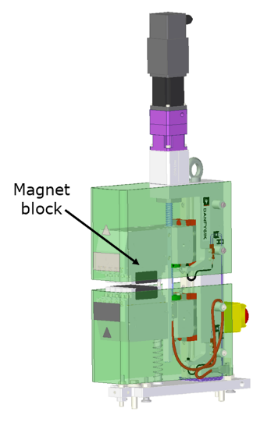
Figure 7: LCLS-II phase shifter. For HE, the magnet block will need to be lengthend by 30%. As a result, several other components (such as the plexiglass shield and the compensation spring) should be modified.

The HE phase shifter has been simulated in Radia, based on the phase shifter designed for LCLS-II, Ref. [9]. The resulting phase integral as a function of gap is well described the following function:
$PI\left[T^{2}mm^{2}\right]≈1280\left[T^{2}mm^{2}\right]e^{-8\left(\frac{g-7\left[mm\right]}{106\left[mm\right]}\right)+2.1 {\left(\frac{g-7\left[mm\right]}{106\left[mm\right]}\right)}^{2}}$,
giving slippage:
$$cΔt=PI\frac{1}{2}{\left(\frac{q}{γ m c}\right)}^{2}$$
To provide a 5 nm delay at 8 GeV requires a phase integral of $7100 T^{2}mm^{2}$. This, however, does not properly express the needed phase change, since we would like to be able to continuously scan the undulator gap without creating jumps in the phase shifter. An example set of scans is shown in Figure 8 as a function of the undulator gap. The required phase shift is calculated from the Halbach formula and an effective phase shift, $L_{eff}$, which is based on the definition in the LCLS-II phase shifter PRD, Ref. [9], (the exact $L_{eff}$ may different for HE and should be determined from the prototype—this amounts to horizontally shifting the curves in Figure 8). Notice that for small gaps the phase shifter has to move about 3x as far as the undulator.
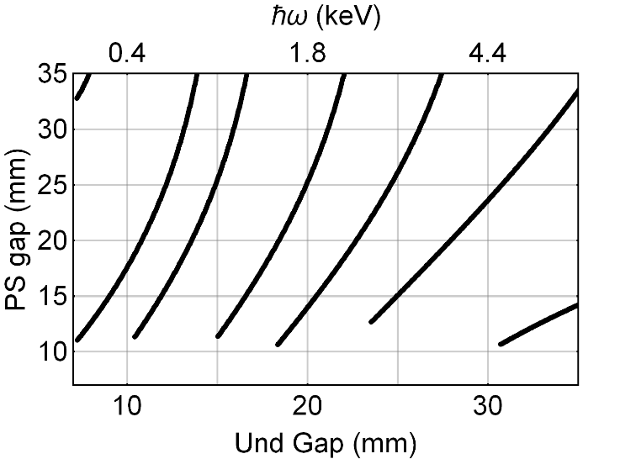
Figure 8: Phase shifter gap vs undulator gap. The total phase shift may be multiples of $2π$, so for large undulator gaps there are many possible phase shifter settings. We show only a few of the overlapping curves which may be used during photon energy scans.

The requirements in Tables [12] and [13] express the range of the phase shifter gap scan, in addition to magnetic and alignment tolerances. Most importantly, the increased phase integral provided by the increased phase shifter length leads to an increased magnetic force as illustrated in Table [12].

Table 12. Basic Undulator Phase Shifter Parameters
Requirement # | Parameter | New SXR PS | Old SXR PS | Unit | Verif. Method | Parent Requirement
PR.###### | Phase Shifter Type | PPM variable gap | PPM variable gap |  | Inspection | PR.######
PR.###### | Vertical force at 10 mm gap | 250 | 190 | Lbs | Inspection | PR.######
PR.###### | Approximate device length | 106 | 82.5 | mm | Inspection | PR.######
 | Operational electron energy range | 2.6-8 | 2 – 4 | GeV | Test | PR.######
PR.###### | Operational photon energy range | 250-5000 | 200 – 1300 | eV | Test | PR.######
PR.###### | Number of undulator phase shifters | 29 | 20 |  | Inspection | PR.######

The phase shifter tolerances at 8 GeV become:
Table 13. Phase shifter requirements
Requirement # | Parameter | New SXR PS | Old SXR PS | Unit | Verif. Method | Parent Requirement
PR.###### | Minimum phase shifter gap, g_{PS,min} | 10 | 10 | mm | Inspection | PR.######
PR.###### | Maximum phase shifter gap, g_{PS,max} | 100 | 100 | mm | Inspection | PR.######
PR.###### | Maximum operational phase shifter gap | 35 | 30 | mm | Inspection | PR.######
PR.###### | Maximum phase integral (PI_{max}) | >9500 | 4,200 | T²mm³ | Test/Analysis | PR.######
PR.###### | Minimum phase integral used in calculations (PI_{min}) | 200 | 750 | T²mm³ | Calculation | PR.######
PR.###### | Range of first vertical field integral I1B_{y} | ±20 | ±20 | µTm | Test/Analysis | PR.######
PR.###### | Range of second vertical field integral I2B_{y} | ±60 | ±50 | µTm² | Test/Analysis | PR.######
PR.###### | Range of first horizontal field integral I1B_{x} | ±20 | ±20 | µTm | Test/Analysis | PR.######
PR.###### | Range of second horizontal field integral I2B_{x} | ±60 | ±45 | µTm² | Test/Analysis | PR.######
PR.###### | General upper photon scan range ${∆E_{Ph}}/{E_{Ph}}$ | ±2.5 | ±2.5 | % | Test/Analysis | PR.######
PR.###### | Minimum upper photon scan range $∆E_{Ph,min}$ | ±25 | ±25 | eV | Test/Analysis | PR.######
PR.###### | Maximum phase shifter gap scan range @${∆E_{Ph}}/{E_{Ph}}$ | 15 | 9.5 | mm | Inspection | PR.######
PR.###### | Phase shifter accuracy (rms) | 5.8° | 5.8° | Deg | Inspection | PR.######
PR.###### | Gap accuracy | ±85 | ±70 | µm | Inspection | PR.######
PR.###### | Minimum phase shifter gap settability (rms) | 50 | 40 | µm | Test/Analysis | PR.######
PR.###### | Max variation of I1B_{y} during scan | ±2.2 | ±2.2 | µTm | Test/Analysis | PR.######
PR.###### | Max variation of I2B_{y} during scan | ±45 | ±45 | µTm² | Test/Analysis | PR.######
PR.###### | Max variation of I1B_{x} during scan | ±2.2 | ±2.2 | µTm | Test/Analysis | PR.######
PR.###### | Max variation of I2B_{x} during scan | ±45 | ±45 | µTm² | Test/Analysis | PR.######
PR.###### | Max stray field within operational phase shifter gap range (Δz defined from phase shifter center) | ±0.00001  at Δz=19 cm | ±0.00001  at Δz=20 cm | T | Test/Analysis | PR.######

The parameters are to be interpreted as follows:
- The minimum phase shifter gap is left unchanged from LCLS-II. The extra phase integral is not worth the extra force. It is better to lengthen the device.
- The maximum phase shifter gap ensures that the phase shifter can effectively be turned off, i.e., that the on-axis magnetic field strength can be made sufficiently small.
- The maximum operational gap indicates the maximum phase shifter gap likely to be used during operation. Larger gaps increase the ratio of gap change to phase shift change and the ratio of phase shifter to undulator gap change speeds.
- The maximum operational phase integral provides the estimated maximum values that should be required during operations.
- The minimum phase integral estimate at maximum gap is based on RADIA simulations.
- The minimum phase integral used in simulations is used to control the maximum ratio of phase shifter gap change to undulator gap change.
- The ranges of the field integrals limits are valid for any gap setting of the phase shifter.
- The photon energy scan ranges are used in the calculations of some of the other parameters
- The parameters “Max variation of field integrals during scan” limit the disturbance of the phase shifter to the electron beam to betatron amplitudes of about 1 µm while changing its gap during photon energy scans.
- The maximum stray field sets the range within which no other ferromagnetic components should be placed on the beam axis. This should be tested at the location of the undulator and the quadrupole.

Vacuum Requirements
The LCLS-II-HE vacuum requirements are the same as those of LCLS-II, described in Ref. [13]. These requirements are duplicated here for the nine new sections that need to be fabricated. Each undulator segment vacuum chamber needs to be operated at a pressure better than 10⁻⁶ Torr in order to keep bremsstrahlung and emittance growth to a minimum.

Table 14: Undulator segment chamber vacuum parameters

Requirement # | Parameter | Values | Unit | Verif. Method | Parent Requirement
PR.###### | Maximum vacuum pressure | 1 ×10⁻⁶ | Torr | Test | PR.######
PR.###### | Maximum average vacuum pressure (along entire undulator) | 2 ×10⁻⁷ | Torr | Test | PR.######
PR.###### | Segment chamber material | Aluminum |  | Inspection | PR.######
PR.###### | Segment chamber inner cross section | Racetrack |  | Inspection | PR.######
PR.###### | Segment chamber inner height (V direction) | 5 | mm | Inspection | PR.######
PR.###### | Segment chamber inner width (U direction) | 11 | mm | Inspection | PR.######
PR.###### | Beam stay clear radius | 2.3 | mm | Inspection | PR.######
PR.###### | Segment chamber straightness | ±100 | µm | Inspection | PR.######
PR.###### | Segment rms longitudinal surface roughness slope, $α_{z}$ | <20 [] | mrad | Inspection | PR.######
PR.###### | Segment rms azimuthal surface roughness slope, $α_{θ}$ | Arbitrary |  |  | PR.######
PR.###### | Segment rms surface roughness amplitude | <0.5 | µm | Inspection | PR.######
PR.###### | Number of horizontal chamber corrector coils (CUXs) | 1 |  | Inspection | PR.######
PR.###### | Number of vertical chamber corrector coils (CUYs) | 1 |  | Inspection | PR.######

Alignment Strategy Overview
The LCLS alignment strategy, see Refs. [16,17], has been very successful in producing a straight electron beam trajectory sufficient for high FEL gain using a BBA procedure based on variable electron energies. LCLS-II will use a quite similar strategy and LCLS-II-HE will learn from LCLS-II’s experience aligning the SXR undulator and interspace components. An outline of the procedure and the tolerances are described in Section 11 of this referenced document.

Self-seeding chicane
In Figure 6, we show the new location for the soft x-ray self-seeding chicane (SXRSS). But the chicane needs not only to be moved, but also to be upgraded for compliance with an 8 GeV electron beam. The existing chicane, Ref. [18], was designed only to service beam energies up to 5.2 GeV, and thus the bending magnets are not sufficient to deflect an 8 GeV beam beyond the x-ray optics.
Basic parameters for the new chicane are listed below. Note that the original SXRSS targeted photon energies of 500-1000 eV, while here we specify a dipole capable of the making the full 20 mm displacement at 8 GeV.
Table 15. SXRSS chicane parameters
Requirement # | Parameter | New | Old | Unit | Verif. Method | Parent Requirement
PR.###### | Number of dipoles | 4 | 4 |  | Inspection | PR.######
 | Minimum electron beam energy | 2.6 | 2.6 | GeV |  | PR.######
 | Maximum electron beam energy | 8 | 5.2 | GeV |  | PR.######
PR.###### | Minimum bend angle | 0 | 0 | mrad | Test | PR.######
PR.###### | Maximum bend angle | 16.7 | 16.7 | mrad | Test | PR.######
PR.###### | Maximum electron beam displacement at chicane center | 20 | 20 | mm | Test | PR.######
PR.###### | Maximum integrated dipole strength | 0.45 | 0.26 | T-m | Test | PR.######

Preliminary investigations show that the required field strength could be obtained by increasing the field from 7 kG to 12.5 kG by copying the XLEAP chicane form-factor and using Permandur, or by re-designing the magnet to have larger backlegs and poles. Alternatively, it may be possible to create a larger pocket for windings and increase the current from 5000 A-turns to 8000 A-turns.
A complete of specifications will be provided at a later date. Compared to the existing chicane, Ref. [18], the main change (aside from the integrated dipole strength), should be to increase the stability of the power supplies as much as possible, in order to support two-color attosecond lasing. This reflects the growing use of the chicane not only for self-seeding, but also as an integral component of split-undulator schemes.

Table 16 – Other layout requirements of LCLS-II-HE undulators
Requirement # | Description | Verif. Method | Parent Requirement
PR.###### | The self-seeding (SS) chicane shall be moved to the new location (cell 30) due to the addition of 9 new SXR undulators. (Refer to the LCLS-II-HE lattice layout) | Inspection | PR.######

Impact on other projects
The changes to the undulator systems defined in this document will impact all other contingent projects. This includes a redesign of the planned Delta undulators, moving the XLEAP wigglers, and upgrading the beam dump.

Note that in early designs (like the CDR) the LCLS-II-HE SXR undulator system was left unchanged from LCLS-II. Instead, a low energy extraction line (LEX) was designed to extract a 4 GeV electron before the L3 linac section boosted the beam to 8 GeV. However, implementation of the 4 GeV extraction has proved difficult due to space constraints, and thus the pursuit of a remodeled undulator line.
The upstream quad (cell 16) will remain, as will the downstream quad (cell 47)
LCLSII needed 4 extra quads to transport beam through the empty undulator slots
Two BPMs before, and one after the SXR segments
From the beginning of the first segment to the end of the last segment
Stability limit for 4T integrated gradient in the undulator quadrupoles
The new magnetic block is 6mm shorter due to rounding the period to be exactly 56mm.
This is derived from the “Horizontal K sextupole” tolerance (see above) and expresses the amount of K reduction at x=0.4 mm compared to x=0.0 mm assuming a quadratic K vs. x profile.
The first and second field integrals are to stay within these tolerances within the 1 mm running radius. This condition effectively sets the field integral multipole tolerances.
Assuming segment chamber straightness tolerance of ±140 µm (rms)
Because of AC component of the resistive wall wakefield, Al is slightly better than Cu but much better than Au.
The rms longitudinal roughness of the segment vacuum chambers averaged over all segments within one undulator line. The maximum value of any of the individual chamber should not exceed 1.5 times this tolerance value.

