Document Approval:
Originator: Yurii Levashov, MMF Lead Physicist
• Content/Format • Content/ Format, Requirement ID’s/Source ID’s, Verification Planning, SME Input

Reviewer: Zack Wolf – Magnetic Measurements Group Leader
• Facts, Details, Concepts, Calculations, Analysis to meet Stakeholders, Policies, Standards, Best Practices, as appl

Approver: Georg Gassner – Metrology Department Head
• Articulation, Meets Higher-Level Expectations, Stakeholder/SME Engagement
Revision History
Revision | Date Released | Description of Change
R0 | Month Day, Year | Original Release.

Table of Contents
1 Scope 2
2 Roles and Responsibilities 2
3 Preparation…………………………………………………………………………………………………..2
4 Tools 2
5 Safety …………………………………………………………………………………………………………2
6 Pole Adjustment Procedure ………………………...……………………………………………………3

Scope
HE-SXU undulators are hybrid adjustable gap devices. Each undulator jaw, top and bottom, has three magnet arrays attached. The first and the last magnet array have 42 poles each and the middle magnet array has 38 poles. Corrections to magnetic field at undulator axis made by shifting poles close/away from the axis.
This document provides a procedure to adjust undulator poles for magnetic field tuning purposes.

Roles and Responsibilities
Prepare a list of required pole adjustments | MMF physicist
Do the pole adjustments | MMF technician

Preparation/Prerequisite Actions
MMF engineer shall prepare a table of required pole adjustments based on magnetic measurement results. MMF engineer shall open the undulator gap to 180mm, push the stop motion red button, and switch the gap controller power off.
MMF technician shall prepare workspace and tools.

Tools
- Two 3mm wrenches,
- Two pre-set 1.4N-m torque wrenches,
- Capacitive sensor pole motion control system.

Safety
- Pinch hazard when gap is closing.
At 180mm gap there is no magnetic force between the jaws. The only force to close the gap is the weight of the upper jaw. That force is small enough to overcome friction in the gap drive system. The motors have brakes, which engaged when the power is off. Add a wooden or aluminum block into the gap as an extra protection.
- Force from high magnetic field.
The magnets in the gap can attract iron tools with a high force. There a small iron screws placed in the G-10 block intentionally to keep it attracted to the poles. The 3mm wrenches chosen magnetic to stay on the screws when working on the top jaw. Be aware of small force on the tools. No other items with iron should be in proximity of the gap.
- Muscle strain.
Take a break every 30 minutes or so to prevent muscle strain.

Pole adjustment procedure
- Check if gap is open to max, emergency stop button pressed, and controller power is off.

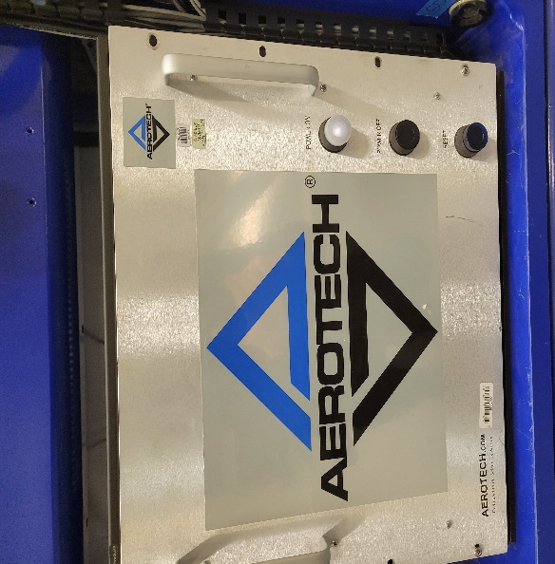
No light when power off
Push this button to turn the power off
- Check the pole adjustment table. Make sure the tuning instructions are clear; module number, pole number, adjustment sign, tuning side (bench/Aisle).

Location Type of correction Lower-Aisle(Blue) Lower-Bench(Red) Upper-Aisle(Blue) Upper-Bench(Red)
Pole :4- Module#1 :3/4 Pole Adjust: MB +25 um +25 um +25 um +25 um
Pole :6- Module#1 :5/6 Pole Adjust: TB -10 10 10 -10

- Log in into computer with SLAC account, go to:
C:\CVI\Data Acquisition\Capacitive Sensors Pole Motion\
Start the tuning program by double-clicking on “pole_motion.cws” project. Click on the green triangle on top of the panel to start the program:
Click
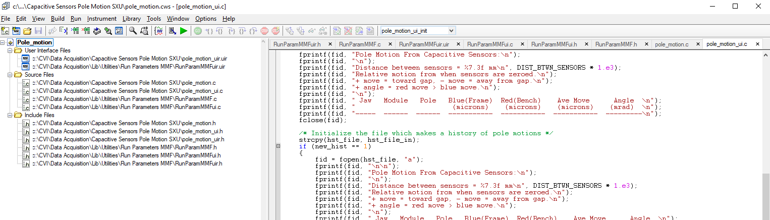

A parameter’s panel will appear. Make sure all fields filled in correctly and click “OK”.
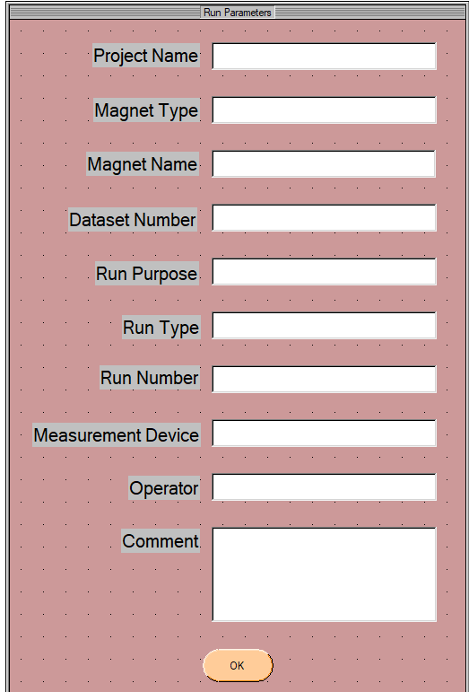
The next panel will show the sensors’ readings.
Select proper jaw (upper/lower), module #, and input pole #.
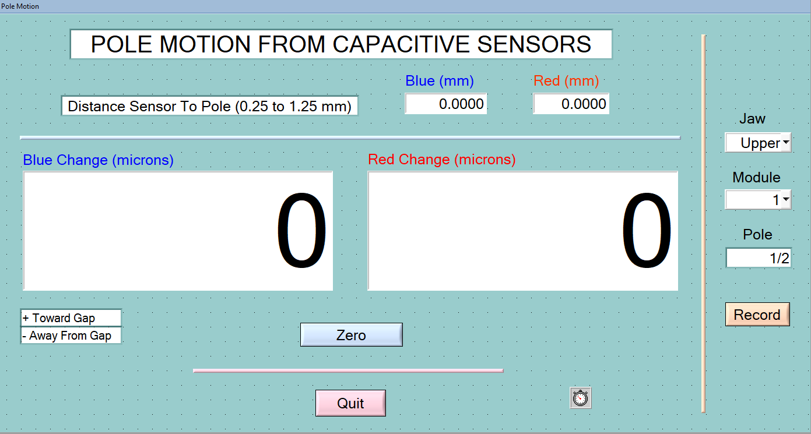
- Install G-10 fixture with sensors on the proper jaw/pole. The side marked with red tape should be toward the frame, the blue – toward the bench.
- Insert 3mm wrenches in the holes as in the picture below, slightly rotate and push them to make sure the engagement with the screw hex hole. The wrenches are magnetic, so, expect slight force from the magnetic field. On the top jaw, once inserted, the magnetic force will keep the wrenches in place.
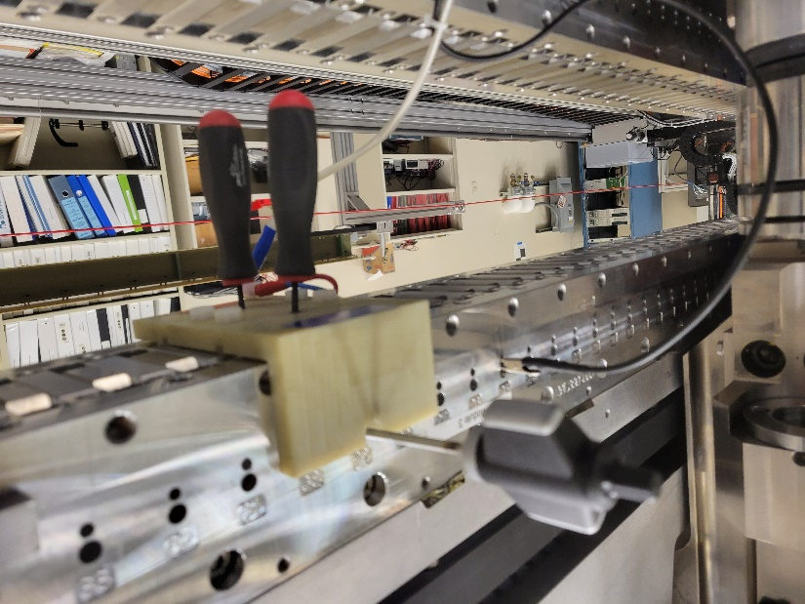
Pole number
Torque wrench
Ground clip
3mm wrench

- Insert torque wrenches in the holes on sides as in the picture. In areas close to the vertical supports use special low profile torque wrench on the frame side of the jaw.
- Attach the ground clip to the undulator at any point.
- Click on the “Zero” button on the GUI panel to zero the sensor readings. Slightly move the fixture left/right to make sure it is sitting correctly on the pole. Slightly push the fixture in the “Aisle” direction. (The reading should not change after the movement.) The system is ready for the pole adjustment.
- Rotate the torque wrenches simultaneously CCW to lose the pole locking screws. It is important to lose the screws simultaneously because otherwise the side force on the screw will push the pole horizontally creating x-field component of the field. The sensor readings will change from zero by about ~10µm. Remember or write down the number. It is the offset to the pole correction.
- Screw in/out the 3mm wrenches to change the pole position. The number on the screen should be the number from the list + the pole correction offset (see item 9). When the locking screws are tight, the number on the screen should be as on the list.
- Tighten the locking (side) screws with the torque wrenches. If numbers on the screen differ from the required by more than ±2µm, repeat the items 9 and 10.
- Click “Record” button on the screen to save the numbers.
- Remove wrenches, torque wrenches. Move G-10 fixture to the next pole.
- Continue adjusting poles (items 4-12, top and bottom jaws) to the end of the list.
- Quit the tuning program. Make sure nothing left in the gap upon completion of the pole adjustment.

