April 25, 2006
----DRAFT ------
Switching Effects of OCEM Power Supplies II

Briant Lam and Achim Weidemann
(Power Conversion & Magnetic Measurements, SLAC)

1. Introduction
This memo continues the investigation of switching effects in the O.C.E.M. power supply which first was described in a memo of March 29, 2006( at http://www-group.slac.stanford.edu/met/MagMeas/MAGDATA/ILC/OCEM-PS/2006-03/ocem-ps.pdf
or .odt or .doc or .html).
In the past measurements, the controller frequency (set by a RC circuit) had been about 6 Hz; this time we report measurements with this frequency changed to 10 Hz and 25 Hz. Also, the maximal current, which had been 120 A, is now 150A, and we report on switching at currents of 150 A, 75 A, and 25A, which corresponds to magnetic fields in the magnet of ~3.1 kGauss, 1.5 kGauss and 0.43 kGauss, respectively.

2. Setup and Method
As described in the previous memo, the effects of switching were observed and recorded with a Tektronix TDS 3014B 'eScope'. A typical trace is shown in Fig.1.

Figure 1. Oscilloscope trace of Hall Voltage (top, blue trace), current (middle, light blue trace) and voltage (bottom, green trace) .Time scale is 100 ms/division. (150A nominal current) .

The Hall Voltage, proportional to the magnetic field, the current, and the voltage were measured,
typically in a 400 ms time window (with ~40 ms before, and ~360 ms after the trigger for the switching; or 1000 ms, with ~100ms before, and ~900ms after).. The oscilloscope records 10,000 data points in this (400ms or 1000ms) time window.
As most data were overlaid with some high-frequency noise, the following procedure was adopted for the analysis and presentation of data: The data before the trigger were averaged to constitute the nominal value of field, current, and voltage. The data after the trigger, starting from the minimum point, and up to the last recorded point, was divided in several segments, and an average taken over each segment. For a time window of 400ms, one has thus nominal values from an average over slightly less than 40 ms before the switching trigger, and, for e.g. 9 segments, nine averages over a bit less than 360ms/9 = 40ms each after the maximal drop.
Dividing these averages by the nominal value, multiplying by 100 and subtracting 100, one
obtains then a percent deviation from the nominal value, which is shown in the tables below.
For an error estimate on this percent deviation, I take the standard deviation for each segment average,
and scale it by 100/(nominal value).
Appendix A shows tables for these averages and percent average deviations from the nominal values,
for 9 segments

The curve to the right of the minimum should possibly have the form (1-exp(t/τ)). To investigate the time constant τ, I also fitted (with MatLab) the negative logarithm of the averages to a linear function,
whose inverse slope it then τ. However, most of the time the fit was rather bad, and dominated by
noise at the late times, and leading to complex values for τ.

A total of 13 data sets were taken, at 150 A, 75 A, and 25A. The data files are marked by the nominal current (50 A, 75 A, and 25A) and the board version (10Hz, 25 Hz).--

3. Results
From looking at the figures and tables in Appendix A one can conclude the following:
- By looking at the figures, in all cases current and magnetic field have recovered their pre-trigger value in about 200 ms(for the 10Hz board) or about 150 ms for the 25 Hz board. This is definitely faster that the 400ms recovery time reported for the 6Hz board in our previous note. So the increase in controller frequency seems to hasten recovery.
- The voltage recovers faster, but overshoots by 2-4 percent, and then returns from above the nominal.
- For every segment average, also a standard deviation is calculated, typically ~0.009 kGauss for the field, 0.2 to 0.3 A for the current, 0.13 – 0.3 V for the voltage. When these are standard deviations are rescaled as percentages, they give a scale at which a percentage deviation from the nominal value cannot be distinguished from the nominal value. The percentage deviation from the nominal is less than this error for all fields and currents in the time segments with times greater than 200ms, and in several cases lower than that.

Appendix A
Here for every data file, a figure of B-field (top), current (middle), voltage (bottom) is shown, followed by a table of the average values and deviations from nominal of each segment (of ~40 ms or ~100ms).

Data File 1: 150A-10Hz
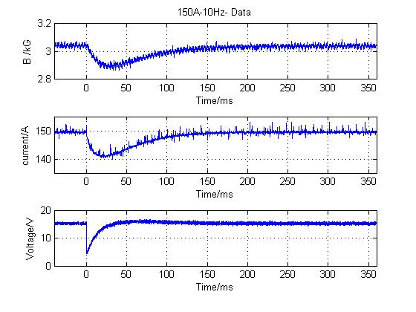
---- Data as measured : ----------------------------------------------------------
|Time interval [ms]| ch1 [kG] | ch2 [A] | ch4 [V] |
| -40.80 - -0.08 | 3.043 +/- 0.009 | 149.495 +/- 0.253 | 15.280 +/- 0.225 |
| 0.04 - 39.88 | 2.932 +/- 0.045 | 142.236 +/- 1.689 | 12.192 +/- 3.113 |
| 39.92 - 79.76 | 2.938 +/- 0.022 | 144.538 +/- 1.231 | 15.885 +/- 0.313 |
| 79.80 - 119.64 | 2.993 +/- 0.014 | 147.601 +/- 0.649 | 15.732 +/- 0.298 |
| 119.68 - 159.52 | 3.019 +/- 0.011 | 148.878 +/- 0.325 | 15.464 +/- 0.292 |
| 159.56 - 199.40 | 3.031 +/- 0.009 | 149.307 +/- 0.238 | 15.322 +/- 0.294 |
| 199.44 - 239.28 | 3.036 +/- 0.009 | 149.443 +/- 0.289 | 15.288 +/- 0.299 |
| 239.32 - 279.16 | 3.038 +/- 0.009 | 149.481 +/- 0.286 | 15.254 +/- 0.287 |
| 279.20 - 319.04 | 3.040 +/- 0.009 | 149.494 +/- 0.254 | 15.261 +/- 0.286 |
| 319.08 - 358.92 | 3.041 +/- 0.009 | 149.484 +/- 0.249 | 15.249 +/- 0.289 |

----Percent difference from 100:
----((chxave(i)/chxave(first seg)*100 -100) with scaled errors): --------------
|Time interval [ms]| ch1 | ch2 | ch4 |
| -40.80 - -0.08 | 0.000 +/- 0.296 | 0.000 +/- 0.169 | 0.000 +/- 1.474 |
| 0.04 - 39.88 | -3.660 +/- 1.478 | -4.856 +/- 1.130 |-20.208 +/- 20.373 |
| 39.92 - 79.76 | -3.451 +/- 0.711 | -3.316 +/- 0.823 | 3.955 +/- 2.046 |
| 79.80 - 119.64 | -1.663 +/- 0.471 | -1.267 +/- 0.434 | 2.955 +/- 1.950 |
| 119.68 - 159.52 | -0.782 +/- 0.358 | -0.413 +/- 0.217 | 1.202 +/- 1.908 |
| 159.56 - 199.40 | -0.399 +/- 0.294 | -0.126 +/- 0.159 | 0.272 +/- 1.925 |
| 199.44 - 239.28 | -0.237 +/- 0.293 | -0.035 +/- 0.193 | 0.052 +/- 1.955 |
| 239.32 - 279.16 | -0.175 +/- 0.280 | -0.010 +/- 0.191 | -0.171 +/- 1.878 |
| 279.20 - 319.04 | -0.105 +/- 0.301 | -0.001 +/- 0.170 | -0.126 +/- 1.870 |
| 319.08 - 358.92 | -0.062 +/- 0.284 | -0.007 +/- 0.166 | -0.205 +/- 1.894 |
----Done with file no. 1 ----------------------------------------------------------
Data File 2:150A-10Hz-Timesegment 100ms
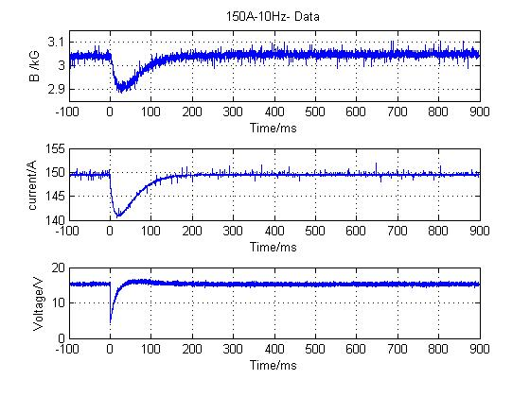
Notice: Time window segment here is about 100ms (all other files have ~40 ms).
The oscilloscope trace for this dataset is shown in Fig.1
---- Data as measured : ---------------------------------------------------------
|Time interval [ms]| ch1 [kG] | ch2 [A] | ch4 [V] |
| -102.00 - -0.20 | 3.040 +/- 0.009 | 149.480 +/- 0.156 | 15.352 +/- 0.218 |
| 0.10 - 99.70 | 2.952 +/- 0.037 | 144.120 +/- 2.222 | 14.497 +/- 2.634 |
| 99.80 - 199.40 | 3.028 +/- 0.014 | 148.895 +/- 0.501 | 15.548 +/- 0.295 |
| 199.50 - 299.10 | 3.042 +/- 0.009 | 149.460 +/- 0.137 | 15.327 +/- 0.284 |
| 299.20 - 398.80 | 3.046 +/- 0.009 | 149.491 +/- 0.131 | 15.311 +/- 0.292 |
| 398.90 - 498.50 | 3.046 +/- 0.009 | 149.485 +/- 0.121 | 15.279 +/- 0.279 |
| 498.60 - 598.20 | 3.047 +/- 0.009 | 149.499 +/- 0.113 | 15.280 +/- 0.280 |
| 598.30 - 697.90 | 3.047 +/- 0.009 | 149.488 +/- 0.140 | 15.323 +/- 0.298 |
| 698.00 - 797.60 | 3.048 +/- 0.008 | 149.493 +/- 0.124 | 15.328 +/- 0.303 |
| 797.70 - 897.30 | 3.048 +/- 0.009 | 149.489 +/- 0.117 | 15.342 +/- 0.278 |

----Percent difference from 100:
----((chxave(i)/chxave(first seg)*100 -100) with scaled errors): ---------------
|Time interval [ms]| ch1 | ch2 | ch4 |
| -102.00 - -0.20 | 0.000 +/- 0.280 | 0.000 +/- 0.104 | 0.000 +/- 1.423 |
| 0.10 - 99.70 | -2.892 +/- 1.207 | -3.586 +/- 1.487 | -5.570 +/- 17.161 |
| 99.80 - 199.40 | -0.388 +/- 0.449 | -0.392 +/- 0.335 | 1.276 +/- 1.920 |
| 199.50 - 299.10 | 0.072 +/- 0.285 | -0.013 +/- 0.091 | -0.162 +/- 1.851 |
| 299.20 - 398.80 | 0.188 +/- 0.286 | 0.007 +/- 0.088 | -0.263 +/- 1.900 |
| 398.90 - 498.50 | 0.207 +/- 0.291 | 0.003 +/- 0.081 | -0.472 +/- 1.820 |
| 498.60 - 598.20 | 0.220 +/- 0.283 | 0.012 +/- 0.076 | -0.470 +/- 1.823 |
| 598.30 - 697.90 | 0.235 +/- 0.287 | 0.005 +/- 0.094 | -0.185 +/- 1.944 |
| 698.00 - 797.60 | 0.250 +/- 0.267 | 0.008 +/- 0.083 | -0.157 +/- 1.976 |
| 797.70 - 897.30 | 0.250 +/- 0.293 | 0.006 +/- 0.079 | -0.061 +/- 1.811 |
----Done with file no. 2 ----------------------------------------------------------

Data File 3: 75A-10Hz
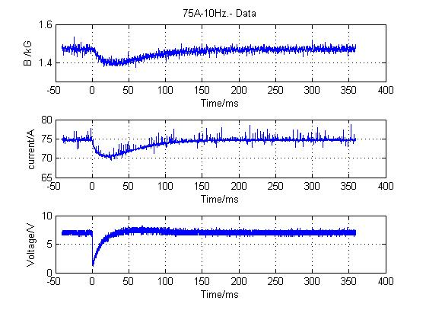
---- Data as measured : ----------------------------------------------------------
|Time interval [ms]| ch1 [kG] | ch2 [A] | ch4 [V] |
| -40.80 - -0.08 | 1.471 +/- 0.009 | 74.765 +/- 0.236 | 7.022 +/- 0.223 |
| 0.04 - 39.88 | 1.416 +/- 0.024 | 71.145 +/- 0.841 | 5.499 +/- 1.617 |
| 39.92 - 79.76 | 1.418 +/- 0.013 | 72.327 +/- 0.606 | 7.361 +/- 0.266 |
| 79.80 - 119.64 | 1.446 +/- 0.010 | 73.840 +/- 0.393 | 7.280 +/- 0.270 |
| 119.68 - 159.52 | 1.460 +/- 0.009 | 74.471 +/- 0.223 | 7.109 +/- 0.256 |
| 159.56 - 199.40 | 1.466 +/- 0.008 | 74.677 +/- 0.200 | 7.052 +/- 0.272 |
| 199.44 - 239.28 | 1.468 +/- 0.008 | 74.745 +/- 0.268 | 7.029 +/- 0.265 |
| 239.32 - 279.16 | 1.469 +/- 0.007 | 74.755 +/- 0.186 | 6.983 +/- 0.269 |
| 279.20 - 319.04 | 1.470 +/- 0.008 | 74.765 +/- 0.256 | 7.007 +/- 0.272 |
| 319.08 - 358.92 | 1.470 +/- 0.008 | 74.759 +/- 0.208 | 7.067 +/- 0.262 |

----Percent difference from 100:
----((chxave(i)/chxave(first seg)*100 -100) with scaled errors): --------------
|Time interval [ms]| ch1 | ch2 | ch4 |
| -40.80 - -0.08 | 0.000 +/- 0.581 | 0.000 +/- 0.316 | 0.000 +/- 3.169 |
| 0.04 - 39.88 | -3.757 +/- 1.603 | -4.842 +/- 1.124 |-21.692 +/- 23.032 |
| 39.92 - 79.76 | -3.591 +/- 0.883 | -3.261 +/- 0.810 | 4.826 +/- 3.786 |
| 79.80 - 119.64 | -1.724 +/- 0.705 | -1.238 +/- 0.526 | 3.666 +/- 3.847 |
| 119.68 - 159.52 | -0.710 +/- 0.585 | -0.393 +/- 0.298 | 1.238 +/- 3.652 |
| 159.56 - 199.40 | -0.355 +/- 0.521 | -0.119 +/- 0.267 | 0.424 +/- 3.871 |
| 199.44 - 239.28 | -0.200 +/- 0.522 | -0.027 +/- 0.358 | 0.096 +/- 3.774 |
| 239.32 - 279.16 | -0.139 +/- 0.504 | -0.015 +/- 0.248 | -0.559 +/- 3.824 |
| 279.20 - 319.04 | -0.089 +/- 0.546 | -0.001 +/- 0.342 | -0.210 +/- 3.879 |
| 319.08 - 358.92 | -0.043 +/- 0.533 | -0.009 +/- 0.278 | 0.644 +/- 3.731 |
----Done with file no. 3 ----------------------------------------------------------

Data File 4: 75A-10Hz- Timesegment 100ms
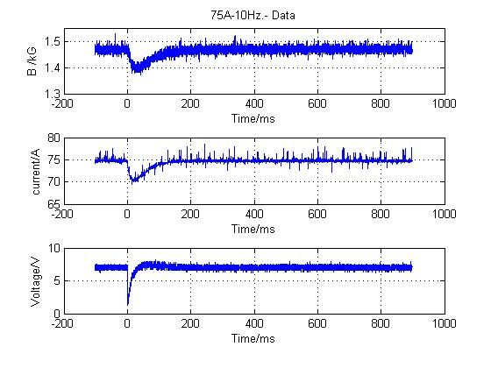
---- Data as measured : ---------------------------------------------------------
|Time interval [ms]| ch1 [kG] | ch2 [A] | ch4 [V] |
| -102.00 - -0.20 | 1.468 +/- 0.011 | 74.781 +/- 0.224 | 7.085 +/- 0.217 |
| 0.10 - 99.70 | 1.420 +/- 0.020 | 72.114 +/- 1.129 | 6.603 +/- 1.373 |
| 99.80 - 199.40 | 1.458 +/- 0.012 | 74.483 +/- 0.333 | 7.178 +/- 0.266 |
| 199.50 - 299.10 | 1.467 +/- 0.010 | 74.760 +/- 0.228 | 7.029 +/- 0.271 |
| 299.20 - 398.80 | 1.469 +/- 0.011 | 74.769 +/- 0.224 | 7.004 +/- 0.263 |
| 398.90 - 498.50 | 1.470 +/- 0.010 | 74.767 +/- 0.196 | 7.041 +/- 0.272 |
| 498.60 - 598.20 | 1.470 +/- 0.010 | 74.766 +/- 0.226 | 7.092 +/- 0.269 |
| 598.30 - 697.90 | 1.470 +/- 0.010 | 74.774 +/- 0.278 | 7.067 +/- 0.279 |
| 698.00 - 797.60 | 1.470 +/- 0.010 | 74.772 +/- 0.230 | 7.058 +/- 0.264 |
| 797.70 - 897.30 | 1.470 +/- 0.010 | 74.766 +/- 0.239 | 7.038 +/- 0.270 |

----Percent difference from 100:
----((chxave(i)/chxave(first seg)*100 -100) with scaled errors): ---------------
|Time interval [ms]| ch1 | ch2 | ch4 |
| -102.00 - -0.20 | 0.000 +/- 0.725 | 0.000 +/- 0.300 | 0.000 +/- 3.066 |
| 0.10 - 99.70 | -3.258 +/- 1.391 | -3.567 +/- 1.509 | -6.806 +/- 19.383 |
| 99.80 - 199.40 | -0.666 +/- 0.803 | -0.399 +/- 0.445 | 1.315 +/- 3.757 |
| 199.50 - 299.10 | -0.085 +/- 0.707 | -0.028 +/- 0.305 | -0.786 +/- 3.824 |
| 299.20 - 398.80 | 0.069 +/- 0.716 | -0.017 +/- 0.299 | -1.143 +/- 3.717 |
| 398.90 - 498.50 | 0.097 +/- 0.711 | -0.019 +/- 0.262 | -0.616 +/- 3.840 |
| 498.60 - 598.20 | 0.092 +/- 0.694 | -0.020 +/- 0.302 | 0.100 +/- 3.790 |
| 598.30 - 697.90 | 0.121 +/- 0.689 | -0.010 +/- 0.372 | -0.251 +/- 3.932 |
| 698.00 - 797.60 | 0.116 +/- 0.671 | -0.013 +/- 0.308 | -0.376 +/- 3.722 |
| 797.70 - 897.30 | 0.152 +/- 0.672 | -0.021 +/- 0.319 | -0.656 +/- 3.806 |
----Done with file no. 4 ----------------------------------------------------------
Data File 5: 25A-10Hz

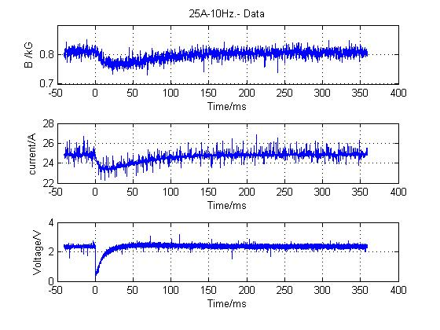
Notice: An amplification of Hall voltage of 200 (instead of 100) was used here,
hence B-field shown is a factor 2x high. (Should be 0.405 kG...)
---- Data as measured : ----------------------------------------------------------
|Time interval [ms]| ch1 [0.5 kG] | ch2 [A] | ch4 [V] |
| -40.80 - -0.08 | 0.810 +/- 0.009 | 24.859 +/- 0.187 | 2.362 +/- 0.068 |
| 0.04 - 39.88 | 0.776 +/- 0.015 | 23.623 +/- 0.281 | 1.876 +/- 0.547 |
| 39.92 - 79.76 | 0.777 +/- 0.011 | 24.093 +/- 0.238 | 2.434 +/- 0.088 |
| 79.80 - 119.64 | 0.792 +/- 0.010 | 24.545 +/- 0.161 | 2.426 +/- 0.090 |
| 119.68 - 159.52 | 0.801 +/- 0.009 | 24.744 +/- 0.145 | 2.397 +/- 0.088 |
| 159.56 - 199.40 | 0.804 +/- 0.009 | 24.814 +/- 0.164 | 2.377 +/- 0.088 |
| 199.44 - 239.28 | 0.806 +/- 0.009 | 24.840 +/- 0.160 | 2.366 +/- 0.091 |
| 239.32 - 279.16 | 0.807 +/- 0.009 | 24.862 +/- 0.153 | 2.362 +/- 0.087 |
| 279.20 - 319.04 | 0.807 +/- 0.009 | 24.856 +/- 0.153 | 2.364 +/- 0.086 |
| 319.08 - 358.92 | 0.807 +/- 0.009 | 24.868 +/- 0.149 | 2.364 +/- 0.085 |

----Percent difference from 100:
----((chxave(i)/chxave(first seg)*100 -100) with scaled errors): --------------
|Time interval [ms]| ch1 | ch2 | ch4 |
| -40.80 - -0.08 | 0.000 +/- 1.104 | 0.000 +/- 0.752 | 0.000 +/- 2.895 |
| 0.04 - 39.88 | -4.250 +/- 1.905 | -4.972 +/- 1.131 |-20.578 +/- 23.147 |
| 39.92 - 79.76 | -4.101 +/- 1.321 | -3.081 +/- 0.959 | 3.048 +/- 3.729 |
| 79.80 - 119.64 | -2.287 +/- 1.181 | -1.262 +/- 0.647 | 2.697 +/- 3.790 |
| 119.68 - 159.52 | -1.214 +/- 1.126 | -0.461 +/- 0.583 | 1.479 +/- 3.744 |
| 159.56 - 199.40 | -0.849 +/- 1.105 | -0.180 +/- 0.661 | 0.619 +/- 3.731 |
| 199.44 - 239.28 | -0.542 +/- 1.113 | -0.077 +/- 0.644 | 0.155 +/- 3.838 |
| 239.32 - 279.16 | -0.467 +/- 1.137 | 0.014 +/- 0.615 | -0.012 +/- 3.671 |
| 279.20 - 319.04 | -0.442 +/- 1.063 | -0.011 +/- 0.614 | 0.077 +/- 3.651 |
| 319.08 - 358.92 | -0.385 +/- 1.068 | 0.037 +/- 0.601 | 0.083 +/- 3.615 |
----Done with file no. 5 ----------------------------------------------------------

Data File 6: 25A-10Hz-Timesegment100ms
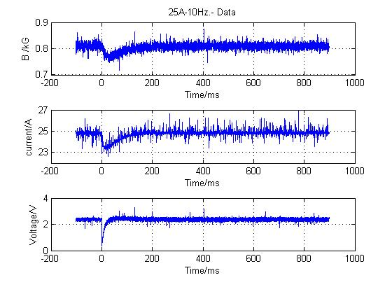
Notice: An amplification of Hall voltage of 200 (instead of 100) was used here,
hence B field listed (ch1) is a factor 2 too high.
---- Data as measured: ----------------------------------------------------------
|Time interval [ms]| ch1 [0.5 kG] | ch2 [A] | ch4 [V] |
| -102.00 - -0.20 | 0.812 +/- 0.010 | 24.827 +/- 0.158 | 2.369 +/- 0.063 |
| 0.10 - 99.70 | 0.781 +/- 0.014 | 23.971 +/- 0.396 | 2.224 +/- 0.440 |
| 99.80 - 199.40 | 0.803 +/- 0.010 | 24.742 +/- 0.159 | 2.401 +/- 0.092 |
| 199.50 - 299.10 | 0.808 +/- 0.009 | 24.845 +/- 0.135 | 2.375 +/- 0.088 |
| 299.20 - 398.80 | 0.810 +/- 0.009 | 24.851 +/- 0.144 | 2.374 +/- 0.085 |
| 398.90 - 498.50 | 0.810 +/- 0.009 | 24.847 +/- 0.148 | 2.370 +/- 0.089 |
| 498.60 - 598.20 | 0.810 +/- 0.009 | 24.848 +/- 0.143 | 2.366 +/- 0.082 |
| 598.30 - 697.90 | 0.810 +/- 0.009 | 24.851 +/- 0.143 | 2.374 +/- 0.086 |
| 698.00 - 797.60 | 0.810 +/- 0.009 | 24.843 +/- 0.154 | 2.369 +/- 0.089 |
| 797.70 - 897.30 | 0.810 +/- 0.009 | 24.848 +/- 0.147 | 2.369 +/- 0.086 |

----Percent difference from 100:
----((chxave(i)/chxave(first seg)*100 -100) with scaled errors): --------------
|Time interval [ms]| ch1 | ch2 | ch4 |
| -102.00 - -0.20 | 0.000 +/- 1.273 | 0.000 +/- 0.637 | 0.000 +/- 2.652 |
| 0.10 - 99.70 | -3.876 +/- 1.684 | -3.445 +/- 1.597 | -6.140 +/- 18.559 |
| 99.80 - 199.40 | -1.179 +/- 1.211 | -0.340 +/- 0.642 | 1.321 +/- 3.870 |
| 199.50 - 299.10 | -0.448 +/- 1.132 | 0.073 +/- 0.545 | 0.252 +/- 3.728 |
| 299.20 - 398.80 | -0.295 +/- 1.158 | 0.096 +/- 0.581 | 0.193 +/- 3.592 |
| 398.90 - 498.50 | -0.258 +/- 1.141 | 0.081 +/- 0.596 | 0.038 +/- 3.762 |
| 498.60 - 598.20 | -0.282 +/- 1.114 | 0.085 +/- 0.576 | -0.140 +/- 3.479 |
| 598.30 - 697.90 | -0.288 +/- 1.075 | 0.096 +/- 0.576 | 0.218 +/- 3.614 |
| 698.00 - 797.60 | -0.266 +/- 1.078 | 0.064 +/- 0.620 | -0.027 +/- 3.773 |
| 797.70 - 897.30 | -0.226 +/- 1.091 | 0.084 +/- 0.594 | -0.009 +/- 3.623 |
----Done with file no. 6 ----------------------------------------------------------

Data File 7: 150A-25Hz

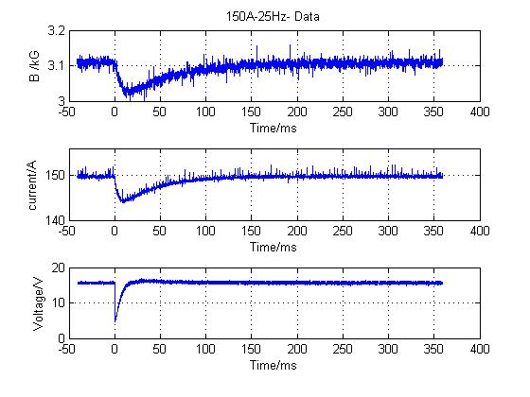

---- Data as measured : ----------------------------------------------------------
|Time interval [ms]| ch1 [kG] | ch2 [A] | ch4 [V] |
| -40.80 - -0.08 | 3.108 +/- 0.006 | 149.713 +/- 0.223 | 15.646 +/- 0.137 |
| 0.04 - 39.88 | 3.043 +/- 0.019 | 145.556 +/- 1.000 | 14.210 +/- 3.051 |
| 39.92 - 79.76 | 3.068 +/- 0.011 | 147.969 +/- 0.572 | 15.992 +/- 0.236 |
| 79.80 - 119.64 | 3.089 +/- 0.008 | 149.129 +/- 0.271 | 15.804 +/- 0.240 |
| 119.68 - 159.52 | 3.099 +/- 0.007 | 149.554 +/- 0.216 | 15.711 +/- 0.231 |
| 159.56 - 199.40 | 3.103 +/- 0.006 | 149.691 +/- 0.198 | 15.681 +/- 0.230 |
| 199.44 - 239.28 | 3.105 +/- 0.007 | 149.751 +/- 0.202 | 15.660 +/- 0.228 |
| 239.32 - 279.16 | 3.106 +/- 0.006 | 149.756 +/- 0.214 | 15.653 +/- 0.229 |
| 279.20 - 319.04 | 3.107 +/- 0.006 | 149.753 +/- 0.228 | 15.657 +/- 0.229 |
| 319.08 - 358.92 | 3.108 +/- 0.006 | 149.729 +/- 0.187 | 15.648 +/- 0.230 |

----Percent difference from 100:
----((chxave(i)/chxave(first seg)*100 -100) with scaled errors): --------------
|Time interval [ms]| ch1 | ch2 | ch4 |
| -40.80 - -0.08 | 0.000 +/- 0.201 | 0.000 +/- 0.149 | 0.000 +/- 0.878 |
| 0.04 - 39.88 | -2.111 +/- 0.626 | -2.777 +/- 0.668 | -9.176 +/- 19.499 |
| 39.92 - 79.76 | -1.307 +/- 0.342 | -1.165 +/- 0.382 | 2.210 +/- 1.510 |
| 79.80 - 119.64 | -0.619 +/- 0.246 | -0.391 +/- 0.181 | 1.013 +/- 1.534 |
| 119.68 - 159.52 | -0.291 +/- 0.221 | -0.107 +/- 0.144 | 0.415 +/- 1.477 |
| 159.56 - 199.40 | -0.165 +/- 0.208 | -0.015 +/- 0.132 | 0.226 +/- 1.469 |
| 199.44 - 239.28 | -0.096 +/- 0.209 | 0.025 +/- 0.135 | 0.092 +/- 1.459 |
| 239.32 - 279.16 | -0.078 +/- 0.195 | 0.028 +/- 0.143 | 0.047 +/- 1.464 |
| 279.20 - 319.04 | -0.039 +/- 0.201 | 0.027 +/- 0.152 | 0.070 +/- 1.464 |
| 319.08 - 358.92 | -0.004 +/- 0.200 | 0.010 +/- 0.125 | 0.015 +/- 1.471 |
----Done with file no. 7 ----------------------------------------------------------

Data File 8: 150A-25Hz

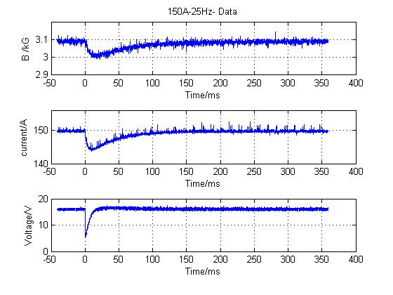
---- Data as measured : ----------------------------------------------------------
|Time interval [ms]| ch1 [kG] | ch2 [A] | ch4 [V] |
| -40.80 - -0.08 | 3.093 +/- 0.006 | 149.712 +/- 0.176 | 16.080 +/- 0.222 |
| 0.04 - 39.88 | 3.025 +/- 0.019 | 145.553 +/- 0.983 | 14.616 +/- 2.988 |
| 39.92 - 79.76 | 3.051 +/- 0.011 | 147.955 +/- 0.574 | 16.410 +/- 0.288 |
| 79.80 - 119.64 | 3.072 +/- 0.008 | 149.109 +/- 0.276 | 16.252 +/- 0.275 |
| 119.68 - 159.52 | 3.081 +/- 0.007 | 149.513 +/- 0.189 | 16.156 +/- 0.290 |
| 159.56 - 199.40 | 3.085 +/- 0.007 | 149.655 +/- 0.221 | 16.113 +/- 0.288 |
| 199.44 - 239.28 | 3.088 +/- 0.007 | 149.692 +/- 0.215 | 16.143 +/- 0.294 |
| 239.32 - 279.16 | 3.090 +/- 0.006 | 149.716 +/- 0.234 | 16.105 +/- 0.289 |
| 279.20 - 319.04 | 3.091 +/- 0.007 | 149.715 +/- 0.206 | 16.099 +/- 0.288 |
| 319.08 - 358.92 | 3.091 +/- 0.006 | 149.724 +/- 0.203 | 16.102 +/- 0.291 |

----Percent difference from 100:
----((chxave(i)/chxave(first seg)*100 -100) with scaled errors): --------------
|Time interval [ms]| ch1 | ch2 | ch4 |
| -40.80 - -0.08 | 0.000 +/- 0.209 | 0.000 +/- 0.118 | 0.000 +/- 1.382 |
| 0.04 - 39.88 | -2.186 +/- 0.607 | -2.778 +/- 0.656 | -9.104 +/- 18.582 |
| 39.92 - 79.76 | -1.371 +/- 0.351 | -1.174 +/- 0.383 | 2.056 +/- 1.791 |
| 79.80 - 119.64 | -0.695 +/- 0.243 | -0.403 +/- 0.184 | 1.069 +/- 1.710 |
| 119.68 - 159.52 | -0.374 +/- 0.236 | -0.133 +/- 0.126 | 0.473 +/- 1.801 |
| 159.56 - 199.40 | -0.244 +/- 0.224 | -0.038 +/- 0.148 | 0.205 +/- 1.791 |
| 199.44 - 239.28 | -0.171 +/- 0.228 | -0.014 +/- 0.144 | 0.392 +/- 1.831 |
| 239.32 - 279.16 | -0.098 +/- 0.210 | 0.003 +/- 0.157 | 0.155 +/- 1.798 |
| 279.20 - 319.04 | -0.079 +/- 0.215 | 0.002 +/- 0.137 | 0.116 +/- 1.789 |
| 319.08 - 358.92 | -0.050 +/- 0.208 | 0.008 +/- 0.135 | 0.136 +/- 1.812 |
----Done with file no. 8 ----------------------------------------------------------

Data File 9: 75A-25Hz

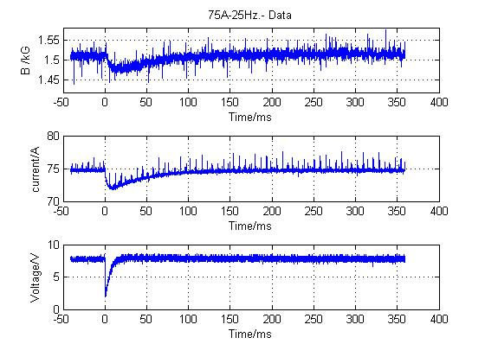
---- Data as measured : ----------------------------------------------------------
|Time interval [ms]| ch1 [kG] | ch2 [A] | ch4 [V] |
| -40.80 - -0.08 | 1.510 +/- 0.007 | 74.732 +/- 0.177 | 7.765 +/- 0.192 |
| 0.04 - 39.88 | 1.485 +/- 0.011 | 72.694 +/- 0.489 | 7.060 +/- 1.503 |
| 39.92 - 79.76 | 1.497 +/- 0.008 | 73.866 +/- 0.322 | 7.953 +/- 0.247 |
| 79.80 - 119.64 | 1.507 +/- 0.006 | 74.438 +/- 0.214 | 7.893 +/- 0.246 |
| 119.68 - 159.52 | 1.511 +/- 0.007 | 74.634 +/- 0.193 | 7.860 +/- 0.245 |
| 159.56 - 199.40 | 1.513 +/- 0.006 | 74.703 +/- 0.223 | 7.858 +/- 0.243 |
| 199.44 - 239.28 | 1.514 +/- 0.006 | 74.715 +/- 0.206 | 7.824 +/- 0.252 |
| 239.32 - 279.16 | 1.515 +/- 0.007 | 74.730 +/- 0.203 | 7.814 +/- 0.244 |
| 279.20 - 319.04 | 1.516 +/- 0.006 | 74.731 +/- 0.201 | 7.820 +/- 0.249 |
| 319.08 - 358.92 | 1.515 +/- 0.006 | 74.729 +/- 0.205 | 7.797 +/- 0.250 |

----Percent difference from 100:
----((chxave(i)/chxave(first seg)*100 -100) with scaled errors): --------------
|Time interval [ms]| ch1 | ch2 | ch4 |
| -40.80 - -0.08 | 0.000 +/- 0.463 | 0.000 +/- 0.236 | 0.000 +/- 2.467 |
| 0.04 - 39.88 | -1.693 +/- 0.741 | -2.726 +/- 0.655 | -9.084 +/- 19.353 |
| 39.92 - 79.76 | -0.907 +/- 0.540 | -1.159 +/- 0.431 | 2.417 +/- 3.178 |
| 79.80 - 119.64 | -0.212 +/- 0.422 | -0.393 +/- 0.286 | 1.647 +/- 3.167 |
| 119.68 - 159.52 | 0.043 +/- 0.439 | -0.131 +/- 0.258 | 1.221 +/- 3.151 |
| 159.56 - 199.40 | 0.168 +/- 0.428 | -0.039 +/- 0.298 | 1.190 +/- 3.130 |
| 199.44 - 239.28 | 0.237 +/- 0.409 | -0.022 +/- 0.276 | 0.758 +/- 3.250 |
| 239.32 - 279.16 | 0.295 +/- 0.467 | -0.003 +/- 0.272 | 0.622 +/- 3.147 |
| 279.20 - 319.04 | 0.380 +/- 0.419 | -0.001 +/- 0.269 | 0.704 +/- 3.208 |
| 319.08 - 358.92 | 0.294 +/- 0.423 | -0.004 +/- 0.274 | 0.402 +/- 3.215 |
----Done with file no. 9 ----------------------------------------------------------
Data File 10: 75A-25Hz

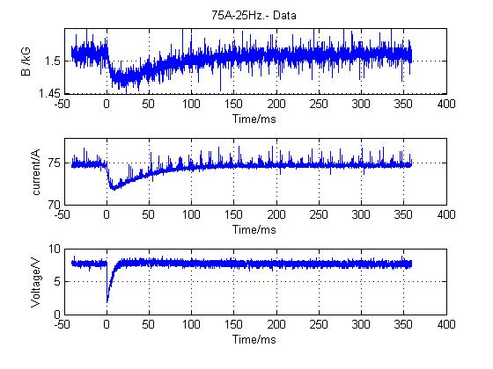
---- Data as measured : ----------------------------------------------------------
|Time interval [ms]| ch1 [kG] | ch2 [A] | ch4 [V] |
| -40.80 - -0.08 | 1.510 +/- 0.007 | 74.736 +/- 0.170 | 7.735 +/- 0.198 |
| 0.04 - 39.88 | 1.479 +/- 0.011 | 72.685 +/- 0.505 | 6.999 +/- 1.538 |
| 39.92 - 79.76 | 1.490 +/- 0.007 | 73.862 +/- 0.326 | 7.898 +/- 0.243 |
| 79.80 - 119.64 | 1.501 +/- 0.007 | 74.439 +/- 0.199 | 7.772 +/- 0.246 |
| 119.68 - 159.52 | 1.506 +/- 0.006 | 74.648 +/- 0.201 | 7.735 +/- 0.252 |
| 159.56 - 199.40 | 1.508 +/- 0.006 | 74.705 +/- 0.171 | 7.697 +/- 0.249 |
| 199.44 - 239.28 | 1.508 +/- 0.006 | 74.725 +/- 0.163 | 7.692 +/- 0.240 |
| 239.32 - 279.16 | 1.509 +/- 0.007 | 74.729 +/- 0.186 | 7.694 +/- 0.249 |
| 279.20 - 319.04 | 1.510 +/- 0.006 | 74.730 +/- 0.166 | 7.680 +/- 0.254 |
| 319.08 - 358.92 | 1.510 +/- 0.006 | 74.737 +/- 0.181 | 7.667 +/- 0.249 |

----Percent difference from 100:
----((chxave(i)/chxave(first seg)*100 -100) with scaled errors): --------------
|Time interval [ms]| ch1 | ch2 | ch4 |
| -40.80 - -0.08 | 0.000 +/- 0.432 | 0.000 +/- 0.227 | 0.000 +/- 2.556 |
| 0.04 - 39.88 | -2.086 +/- 0.697 | -2.745 +/- 0.676 | -9.517 +/- 19.880 |
| 39.92 - 79.76 | -1.336 +/- 0.481 | -1.170 +/- 0.436 | 2.104 +/- 3.142 |
| 79.80 - 119.64 | -0.596 +/- 0.434 | -0.398 +/- 0.266 | 0.480 +/- 3.181 |
| 119.68 - 159.52 | -0.289 +/- 0.413 | -0.119 +/- 0.269 | -0.004 +/- 3.262 |
| 159.56 - 199.40 | -0.126 +/- 0.405 | -0.043 +/- 0.229 | -0.500 +/- 3.220 |
| 199.44 - 239.28 | -0.126 +/- 0.412 | -0.016 +/- 0.218 | -0.559 +/- 3.106 |
| 239.32 - 279.16 | -0.073 +/- 0.438 | -0.010 +/- 0.249 | -0.539 +/- 3.216 |
| 279.20 - 319.04 | -0.015 +/- 0.405 | -0.008 +/- 0.222 | -0.710 +/- 3.284 |
| 319.08 - 358.92 | 0.008 +/- 0.427 | 0.001 +/- 0.243 | -0.878 +/- 3.224 |
----Done with file no. 10 ------------------------------------------------------

Data File 11: 25A-25Hz
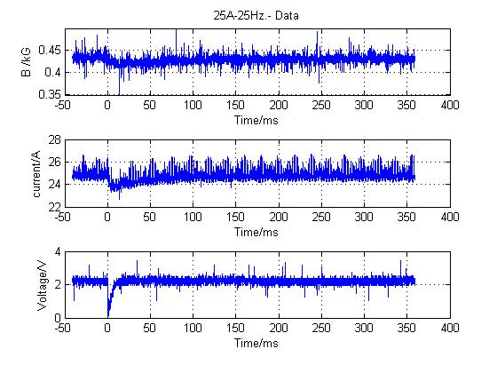
---- Data as measured : ----------------------------------------------------------
|Time interval [ms]| ch1 [kG] | ch2 [A] | ch4 [V] |
| -40.80 - -0.08 | 0.435 +/- 0.007 | 24.814 +/- 0.231 | 2.242 +/- 0.126 |
| 0.04 - 39.88 | 0.422 +/- 0.007 | 24.127 +/- 0.287 | 1.998 +/- 0.522 |
| 39.92 - 79.76 | 0.425 +/- 0.007 | 24.534 +/- 0.259 | 2.259 +/- 0.132 |
| 79.80 - 119.64 | 0.429 +/- 0.007 | 24.718 +/- 0.246 | 2.250 +/- 0.129 |
| 119.68 - 159.52 | 0.430 +/- 0.006 | 24.781 +/- 0.240 | 2.259 +/- 0.126 |
| 159.56 - 199.40 | 0.430 +/- 0.006 | 24.802 +/- 0.248 | 2.216 +/- 0.141 |
| 199.44 - 239.28 | 0.431 +/- 0.006 | 24.805 +/- 0.240 | 2.193 +/- 0.143 |
| 239.32 - 279.16 | 0.431 +/- 0.006 | 24.807 +/- 0.232 | 2.194 +/- 0.135 |
| 279.20 - 319.04 | 0.431 +/- 0.006 | 24.808 +/- 0.243 | 2.219 +/- 0.139 |
| 319.08 - 358.92 | 0.431 +/- 0.006 | 24.810 +/- 0.238 | 2.252 +/- 0.138 |

----Percent difference from 100:
----((chxave(i)/chxave(first seg)*100 -100) with scaled errors): --------------
|Time interval [ms]| ch1 | ch2 | ch4 |
| -40.80 - -0.08 | 0.000 +/- 1.561 | 0.000 +/- 0.930 | 0.000 +/- 5.599 |
| 0.04 - 39.88 | -2.822 +/- 1.724 | -2.769 +/- 1.156 |-10.890 +/- 23.303 |
| 39.92 - 79.76 | -2.153 +/- 1.553 | -1.130 +/- 1.042 | 0.783 +/- 5.877 |
| 79.80 - 119.64 | -1.362 +/- 1.596 | -0.386 +/- 0.993 | 0.349 +/- 5.744 |
| 119.68 - 159.52 | -1.009 +/- 1.456 | -0.135 +/- 0.965 | 0.792 +/- 5.634 |
| 159.56 - 199.40 | -0.959 +/- 1.449 | -0.048 +/- 0.999 | -1.145 +/- 6.292 |
| 199.44 - 239.28 | -0.856 +/- 1.489 | -0.038 +/- 0.969 | -2.166 +/- 6.370 |
| 239.32 - 279.16 | -0.809 +/- 1.446 | -0.027 +/- 0.934 | -2.134 +/- 6.019 |
| 279.20 - 319.04 | -0.711 +/- 1.441 | -0.025 +/- 0.979 | -1.034 +/- 6.206 |
| 319.08 - 358.92 | -0.723 +/- 1.392 | -0.016 +/- 0.958 | 0.479 +/- 6.137 |
----Done with file no. 11-------------------------------------------------------
Data File 12: 25A-25Hz

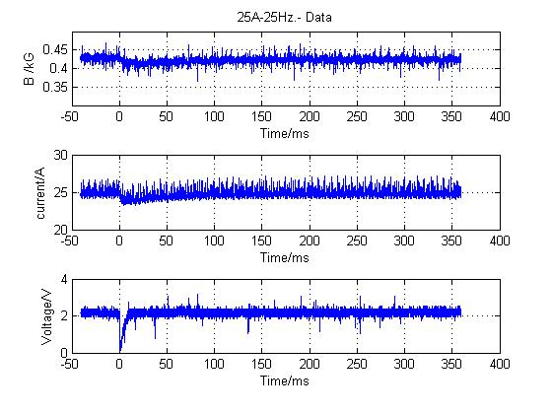
---- Data as measured : ----------------------------------------------------------
|Time interval [ms]| ch1 [kG] | ch2 [A] | ch4 [V] |
| -40.80 - -0.08 | 0.429 +/- 0.006 | 24.811 +/- 0.300 | 2.184 +/- 0.122 |
| 0.04 - 39.88 | 0.415 +/- 0.007 | 24.139 +/- 0.332 | 1.931 +/- 0.526 |
| 39.92 - 79.76 | 0.418 +/- 0.006 | 24.536 +/- 0.311 | 2.219 +/- 0.135 |
| 79.80 - 119.64 | 0.422 +/- 0.006 | 24.731 +/- 0.303 | 2.179 +/- 0.140 |
| 119.68 - 159.52 | 0.423 +/- 0.006 | 24.798 +/- 0.305 | 2.182 +/- 0.139 |
| 159.56 - 199.40 | 0.424 +/- 0.007 | 24.813 +/- 0.294 | 2.176 +/- 0.135 |
| 199.44 - 239.28 | 0.424 +/- 0.006 | 24.820 +/- 0.304 | 2.189 +/- 0.141 |
| 239.32 - 279.16 | 0.424 +/- 0.006 | 24.829 +/- 0.301 | 2.196 +/- 0.142 |
| 279.20 - 319.04 | 0.424 +/- 0.006 | 24.831 +/- 0.300 | 2.211 +/- 0.131 |
| 319.08 - 358.92 | 0.424 +/- 0.006 | 24.822 +/- 0.308 | 2.223 +/- 0.129 |

----Percent difference from 100:
----((chxave(i)/chxave(first seg)*100 -100) with scaled errors): --------------
|Time interval [ms]| ch1 | ch2 | ch4 |
| -40.80 - -0.08 | 0.000 +/- 1.435 | 0.000 +/- 1.209 | 0.000 +/- 5.601 |
| 0.04 - 39.88 | -3.175 +/- 1.571 | -2.710 +/- 1.339 |-11.606 +/- 24.059 |
| 39.92 - 79.76 | -2.394 +/- 1.464 | -1.109 +/- 1.254 | 1.567 +/- 6.181 |
| 79.80 - 119.64 | -1.542 +/- 1.477 | -0.325 +/- 1.223 | -0.255 +/- 6.429 |
| 119.68 - 159.52 | -1.269 +/- 1.383 | -0.055 +/- 1.228 | -0.131 +/- 6.380 |
| 159.56 - 199.40 | -1.038 +/- 1.557 | 0.007 +/- 1.186 | -0.398 +/- 6.202 |
| 199.44 - 239.28 | -1.082 +/- 1.489 | 0.033 +/- 1.223 | 0.222 +/- 6.462 |
| 239.32 - 279.16 | -0.989 +/- 1.438 | 0.070 +/- 1.214 | 0.539 +/- 6.517 |
| 279.20 - 319.04 | -0.966 +/- 1.470 | 0.077 +/- 1.208 | 1.232 +/- 5.993 |
| 319.08 - 358.92 | -1.068 +/- 1.474 | 0.043 +/- 1.240 | 1.756 +/- 5.922 |
----Done with file no. 12-------------------------------------------------------

Data File 13: 25A-25Hz

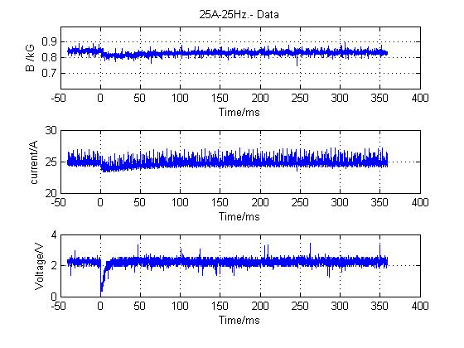
Notice: An amplification of Hall voltage of 200 (instead of 100) was used here,
hence the ch1 B-field values are a factor 2 too high.
---- Data as measured : ----------------------------------------------------------
|Time interval [ms]| ch1 [0.5kG] | ch2 [A] | ch4 [V] |
| -40.80 - -0.08 | 0.842 +/- 0.009 | 24.820 +/- 0.302 | 2.239 +/- 0.119 |
| 0.04 - 39.88 | 0.816 +/- 0.010 | 24.145 +/- 0.339 | 2.001 +/- 0.513 |
| 39.92 - 79.76 | 0.821 +/- 0.009 | 24.539 +/- 0.312 | 2.272 +/- 0.140 |
| 79.80 - 119.64 | 0.829 +/- 0.008 | 24.723 +/- 0.292 | 2.260 +/- 0.127 |
| 119.68 - 159.52 | 0.831 +/- 0.009 | 24.784 +/- 0.292 | 2.234 +/- 0.147 |
| 159.56 - 199.40 | 0.832 +/- 0.009 | 24.822 +/- 0.309 | 2.226 +/- 0.135 |
| 199.44 - 239.28 | 0.833 +/- 0.009 | 24.818 +/- 0.298 | 2.246 +/- 0.140 |
| 239.32 - 279.16 | 0.833 +/- 0.009 | 24.815 +/- 0.293 | 2.269 +/- 0.132 |
| 279.20 - 319.04 | 0.833 +/- 0.009 | 24.827 +/- 0.305 | 2.261 +/- 0.133 |
| 319.08 - 358.92 | 0.833 +/- 0.008 | 24.827 +/- 0.300 | 2.261 +/- 0.132 |

----Percent difference from 100:
----((chxave(i)/chxave(first seg)*100 -100) with scaled errors): --------------
|Time interval [ms]| ch1 | ch2 | ch4 |
| -40.80 - -0.08 | 0.000 +/- 1.075 | 0.000 +/- 1.217 | 0.000 +/- 5.331 |
| 0.04 - 39.88 | -3.120 +/- 1.188 | -2.720 +/- 1.366 |-10.662 +/- 22.927 |
| 39.92 - 79.76 | -2.465 +/- 1.076 | -1.134 +/- 1.256 | 1.453 +/- 6.250 |
| 79.80 - 119.64 | -1.582 +/- 0.989 | -0.392 +/- 1.175 | 0.916 +/- 5.690 |
| 119.68 - 159.52 | -1.311 +/- 1.033 | -0.143 +/- 1.175 | -0.240 +/- 6.582 |
| 159.56 - 199.40 | -1.139 +/- 1.011 | 0.007 +/- 1.247 | -0.616 +/- 6.021 |
| 199.44 - 239.28 | -1.061 +/- 1.058 | -0.008 +/- 1.202 | 0.280 +/- 6.249 |
| 239.32 - 279.16 | -1.065 +/- 1.108 | -0.018 +/- 1.182 | 1.305 +/- 5.910 |
| 279.20 - 319.04 | -0.998 +/- 1.104 | 0.028 +/- 1.231 | 0.978 +/- 5.951 |
| 319.08 - 358.92 | -1.082 +/- 1.005 | 0.029 +/- 1.209 | 0.970 +/- 5.883 |
----Done with file no. 13-------------------------------------------------------

