Revision History
Revision | Date Released | Description of Change
R0 | December 6, 2017 | Original Release.

This traveler is intended to cover reception, preparation, mechanical fiducialization, and magnetic measurements of 10 type 1.26Q3.5 quadrupole magnets needed for the FACET-II Injector (sector 10).
Receiving:
The following information is to be noted upon receipt of the magnets by the SLAC MFD group:
Received by (MMG initials): | SDA
Date received (dd-mmm-yyyy): | 2/7/2018
SLAC barcode number: | 4037
Vendor serial number on the magnet: | 039

Preparation:
A beam direction arrow, with text “beam direction”, is to be applied to the top and/or connector side of the magnet. The magnet orientation shall be such that looking in the beam direction, the electrical terminals are on the right side of the magnet.
Beam-direction arrow in place (initials): | SDA

Fiducialization:
Fiducialization may be done before or after magnetic measurements. The magnet is to be fiducialized by the CMM group. This will require the installation of removable tooling balls, location of the geometric axis of the poles of the magnet, and location of tooling balls with respect to the center of this geometric axis when the poles are aligned precisely horizontal.
CMM technician (initials): | KC

URL of on-line CMM fiducialization data (please modify or correct if necessary):
http://www-group.slac.stanford.edu/met/MagMeas/MAGDATA/FACET_II/quad/ Fiducial Reports/4037_Fiducial_Report.pdf
Magnetic Measurements:
Enter URL of on-line magnetic measurements data (please modify or correct if necessary):
http://www-group.slac.stanford.edu/met/MagMeas/MAGDATA/FACET_II/quad/1.26Q3.5-159974-039

- Determine the connection polarity (with supply outputting positive current) which produces a “positive” field polarity for the magnet as shown below:
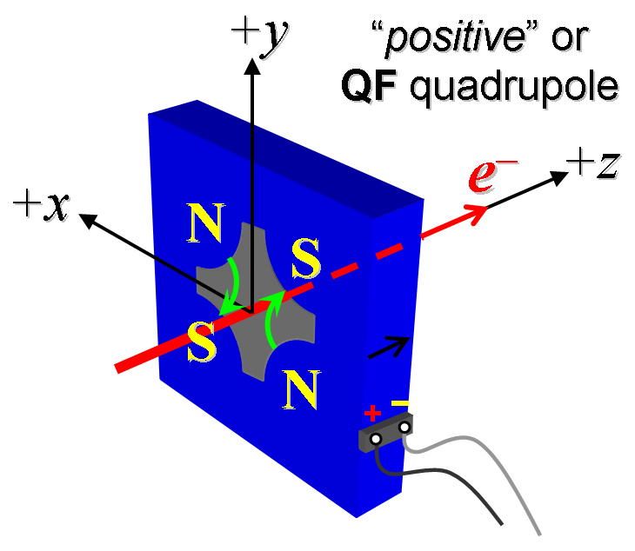
Figure 1: A “QF” focuses the electron beam in the horizontal plane, represented as positive k-value in the MAD-deck.

- Mark the terminals where the power supply cables are connected with clear “+” and “-” labels.
Polarity has been labeled (initials): | SDA

- Connect the magnet terminals in the correct polarity as established above, to a bipolar power supply with maximum current I ≥ 6 A (intended power supply type in installation is MCOR 6).
- For one of these 10 magnets, run the magnet up to 6 A for ~1 hr (or as needed) for a thermal test (record maximum temperature).
Ambient temperature (°C): | N/A °C
Final magnet temperature at 6 A maximum (°C): | N/A °C

- Standardize the magnet, starting from zero to +6 A and back to zero, then go through 3 full cycles from +6 A to -6 A and back up to +6 A, finally ending down at -6 A from which the first operating current will be reached, with a flat-top pause time (at both -6 and +6 A) of 5 seconds. Use a “3-linear” ramp rate of 1 A/sec, if possible, and record the ramp rate used.
Standardization complete (initials): | SDA
Ramp rate used (A/sec): | 1 A/sec

- Measure the length-integrated field gradient, ∫Gdl, from -6 to +6 A in 1-A steps (13 ‘up’ measurements), and then back down from +6 A to -6 A in 1-A steps (12 ‘down’ measurements).
Filename & run number of ∫Gdl up & down data: | Strdat.ru1, strplt.ru1

- With rotating coil, measure the magnet harmonics at the +6 A current setting. Multipole values should be given as a percentage of the quadrupole moment evaluated at the probe radius.
Filename & run number of harmonic data: | Hardat.ru1, harplt.ru1
Probe radius used for harmonics (cm): | 1.41349
Rotating Coil Designation (Name) | 1.124DQB22

- Confirm the pole-tip field using a Hall probe at an excitation current of +6 A.
Hall probe pole-tip field at +6 A (mean of 4 poles): | 0.150 Tesla

- Measure the inductance and resistance of the magnet:
Inductance of coil (mH): | 9.79 mH
Resistance of coil (Ohms): | 0.3771 Ohm
Ambient temperature in degrees C | 20.4 ºC

- Upon completion of tests, email URL of on-line magnetic measurements data folder where traveler is saved to FACET-II magnet engineer for acceptance (Martin J, martinj@slac.stanford.edu).
Magnet accepted (signed): | Via email

- FACET-II magnet engineer: Upon completion of installation, note location and save completed form.
Installed beamline location (MAD-deck name): | QE10551

