FACET2 BEND BE20CE FIDUCIALIZATION July 30, 2021
FG, HI
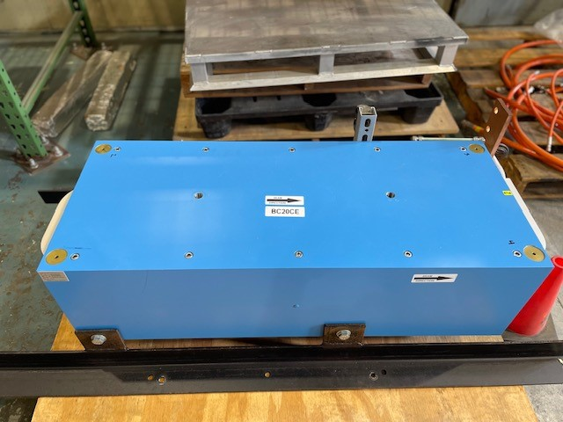
A, 1
B, 2
C, 3
D, 4

Coordinate System:
Primary axis: averaged the top and bottom pole tip planes for elevation, roll and pitch.
Secondary axis: averaged the grove on the top and bottom of the plus and minus pole tips for yaw.
Origin: created a point at the intersection of the bisected Z planes and the secondary axis

Tooling Balls
 | Z(in) | X(in) | Y(in)
A | -19.4100 | -6.9283 | 5.9575
B | -19.4085 | 6.9306 | 5.9608
C | 19.4167 | 6.9290 | 5.9623
D | 19.4168 | -6.9300 | 5.9595
1 | -19.4102 | -6.9273 | 6.6457
2 | -19.4092 | 6.9306 | 6.6489
3 | 19.4176 | 6.9286 | 6.6503
4 | 19.4165 | -6.9314 | 6.6474

Average US Gap: 0.910”
Average DS Gap: 0.908”

