Monumentation Drilling Specifications:

Floor Monuments:

- Floor is drilled using 1 3/4" core drill bit to a depth of 2” with a Hilti rotary hammer drill
- Quikrete is used to set monuments into the floor
- We generally allow 24 hours of curing time before starting any observations
- The lids of the monuments should be flush with the floor

Below is a floor Monument with a lid and 2 floor monuments with fixtures used for installation. The fixtures are marked with a cone for trip hazards and are removed once the Quikrete has set. The two fixtures shown below are interchangeable. Originally a limited number of the taller fixtures were purchased (far right of top picture). The T-shaped fixture (middle of picture) is our “in-house” version built so that more monuments can be installed at once.

Lid, Floor Monument and Two Installation Fixtures

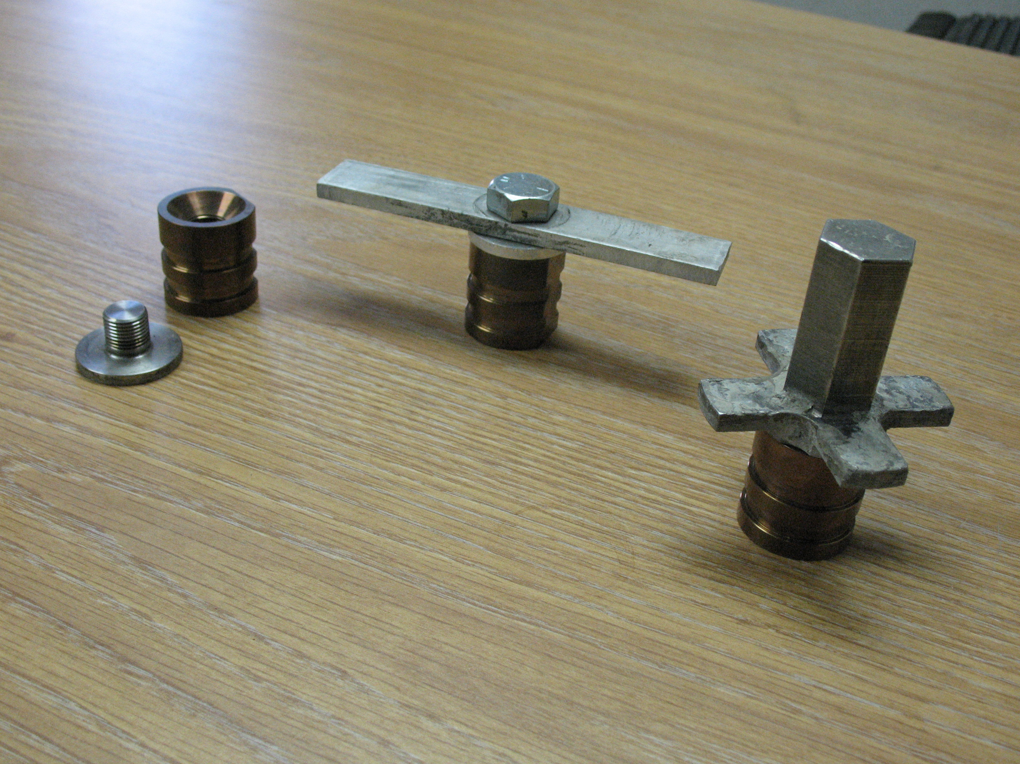

Floor Monument Installed with Lid On and Off

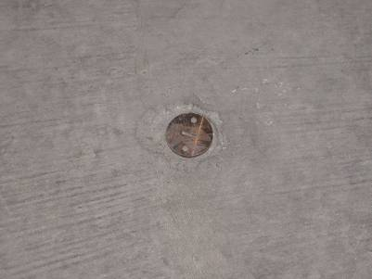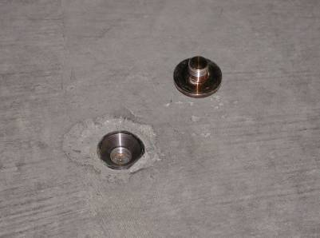

Protecting AEG Floor Monuments from Debris:

The AEG at certain times need to protect existing floor monuments from foreign debris, epoxy, wax etc. by replacing the lid with a temporary system of protection as shown in the following pictures.

Items Inserted into Existing Floor Monument

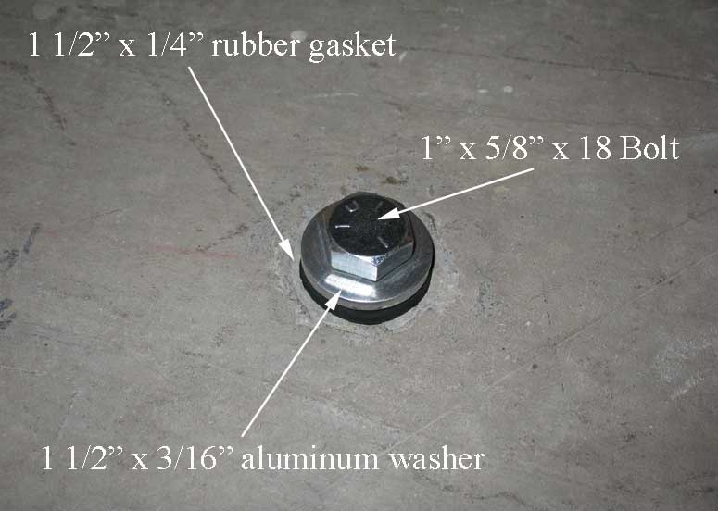

Cap with protection items in place

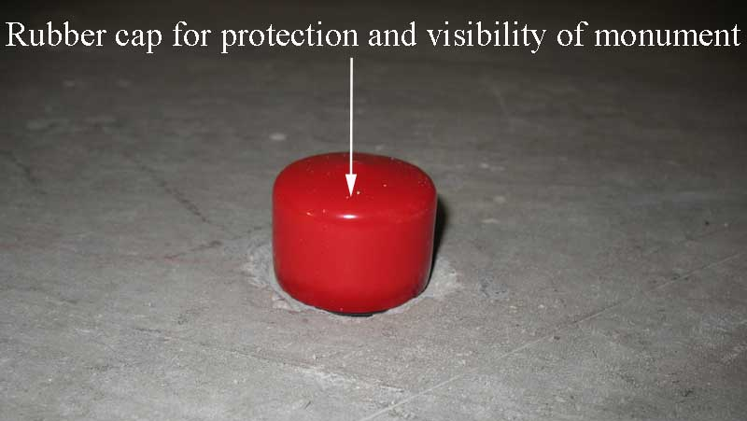

The items required are, 1” x 5/8” x 18 Bolt, 1 ½” x 3/16” aluminum washer, 1 ½” x ¼” commercial neoprene 60DUR0 rubber gasket, and a high visibility red rubber cap.
Regular Wall Monuments:

- Wall is drilled with a 5/8” drill bit to a depth of 2” with a Hilti rotary hammer drill
- Hilti 1/2-13 drop-in anchors are then installed
- Wall monument is screwed into anchor ( Loctite may be used on threads )
- Monumentation is ready for use right away, no waiting time necessary, unlike the floor monuments

Hilti Anchor, Wall Monuments With and Without Lid

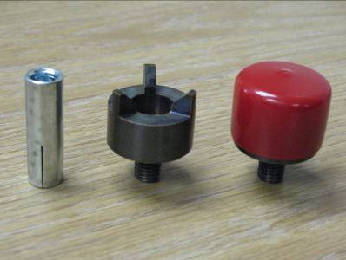

Installed Wall Monument

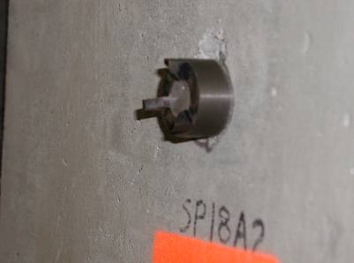

Extended Wall Monuments:

To allow more flexibility in working around obstacles (conduits, pipes, lights, unistrut, etc) AEG has modified our standard wall monument. The modification is a length extension and comes in two versions, long and short. The extended versions of the wall monument are installed in exactly the same manner as the standard wall monument which is covered in the original version of this document. Below is an explanation of the long and short extended wall monuments.

Long Extensions:

Long Extension and Standard Wall Monuments

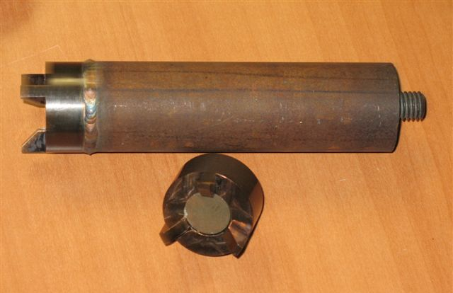

The long extension is intended to allow monument placement from 3 to 6 inches from the wall. This is accomplished by adding a length of 1½ inch diameter steel rod in between the wall monument and the wall. A standard wall monument is welded to one end of the rod and ½-13 all thread is welded to the other end.

Short Extensions:

Short Extension Wall Monument

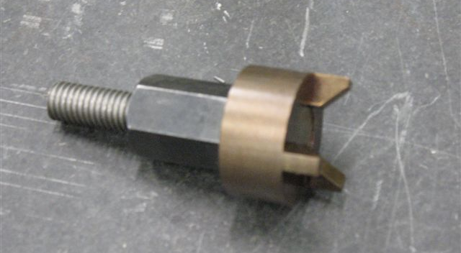

The short extension is intended to allow a 1¼ inch offset between the wall and the monument. This is accomplished by adding a ½-13 coupling nut (CarrLane CL-2CN) and a 1½ inch length of ½-13 all thread to a standard wall monument. The pieces are welded together for rigidity.
Brass Plugs:

- Floor is drilled using 1 1/2" drill bit to a depth of 1” with a Hilti rotary hammer drill
- A small amount of Duct Seal is used on the bottom of the Brass Plug
- 5 Minute Epoxy is poured into the hole and the Brass Plug is pushed down until it is flush with the floor
- We generally allow 24 hours of curing time before starting any observations
- The plugs are then cleaned off of any excess epoxy and are ready to mark

A Brass Plug with Most of the Equipment Used for Installation

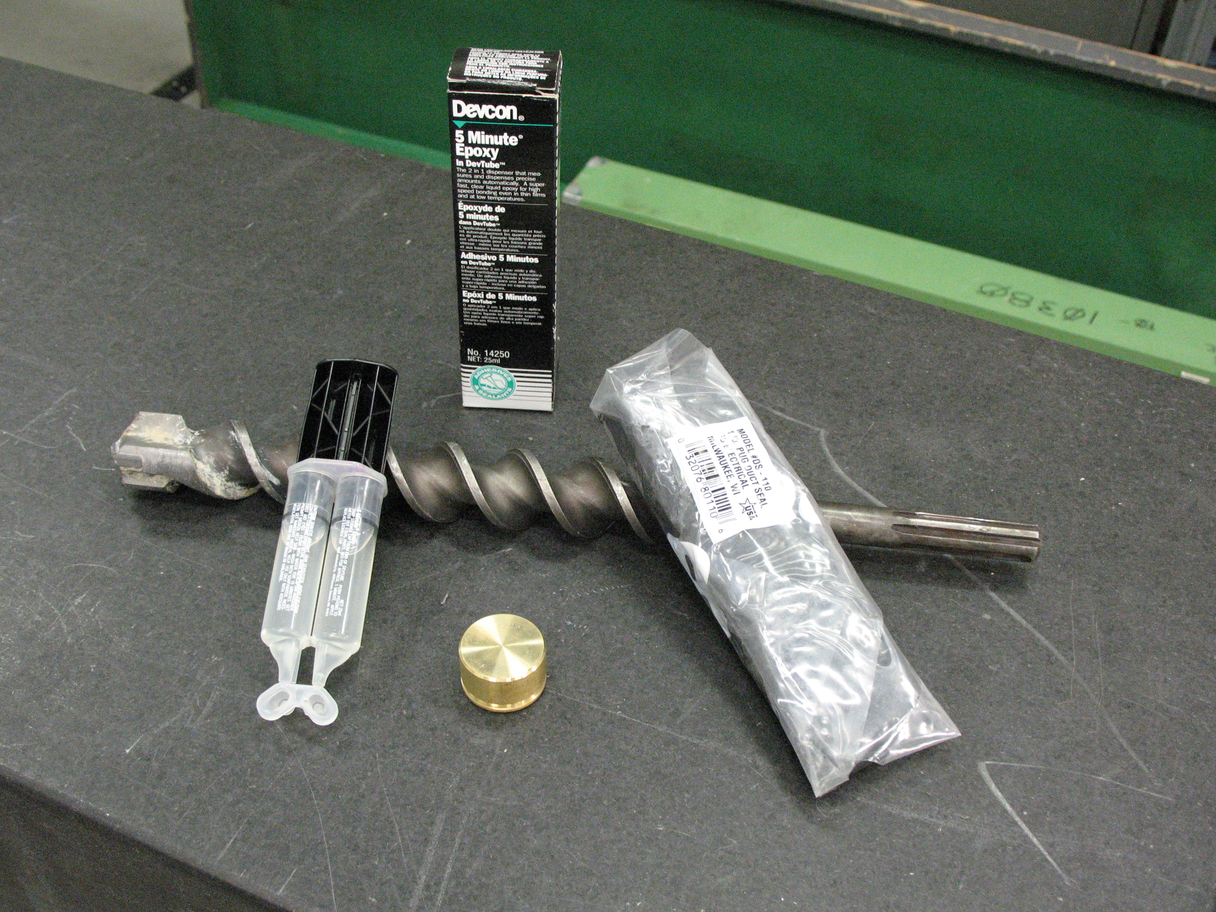

A Brass Plug Installed in Floor

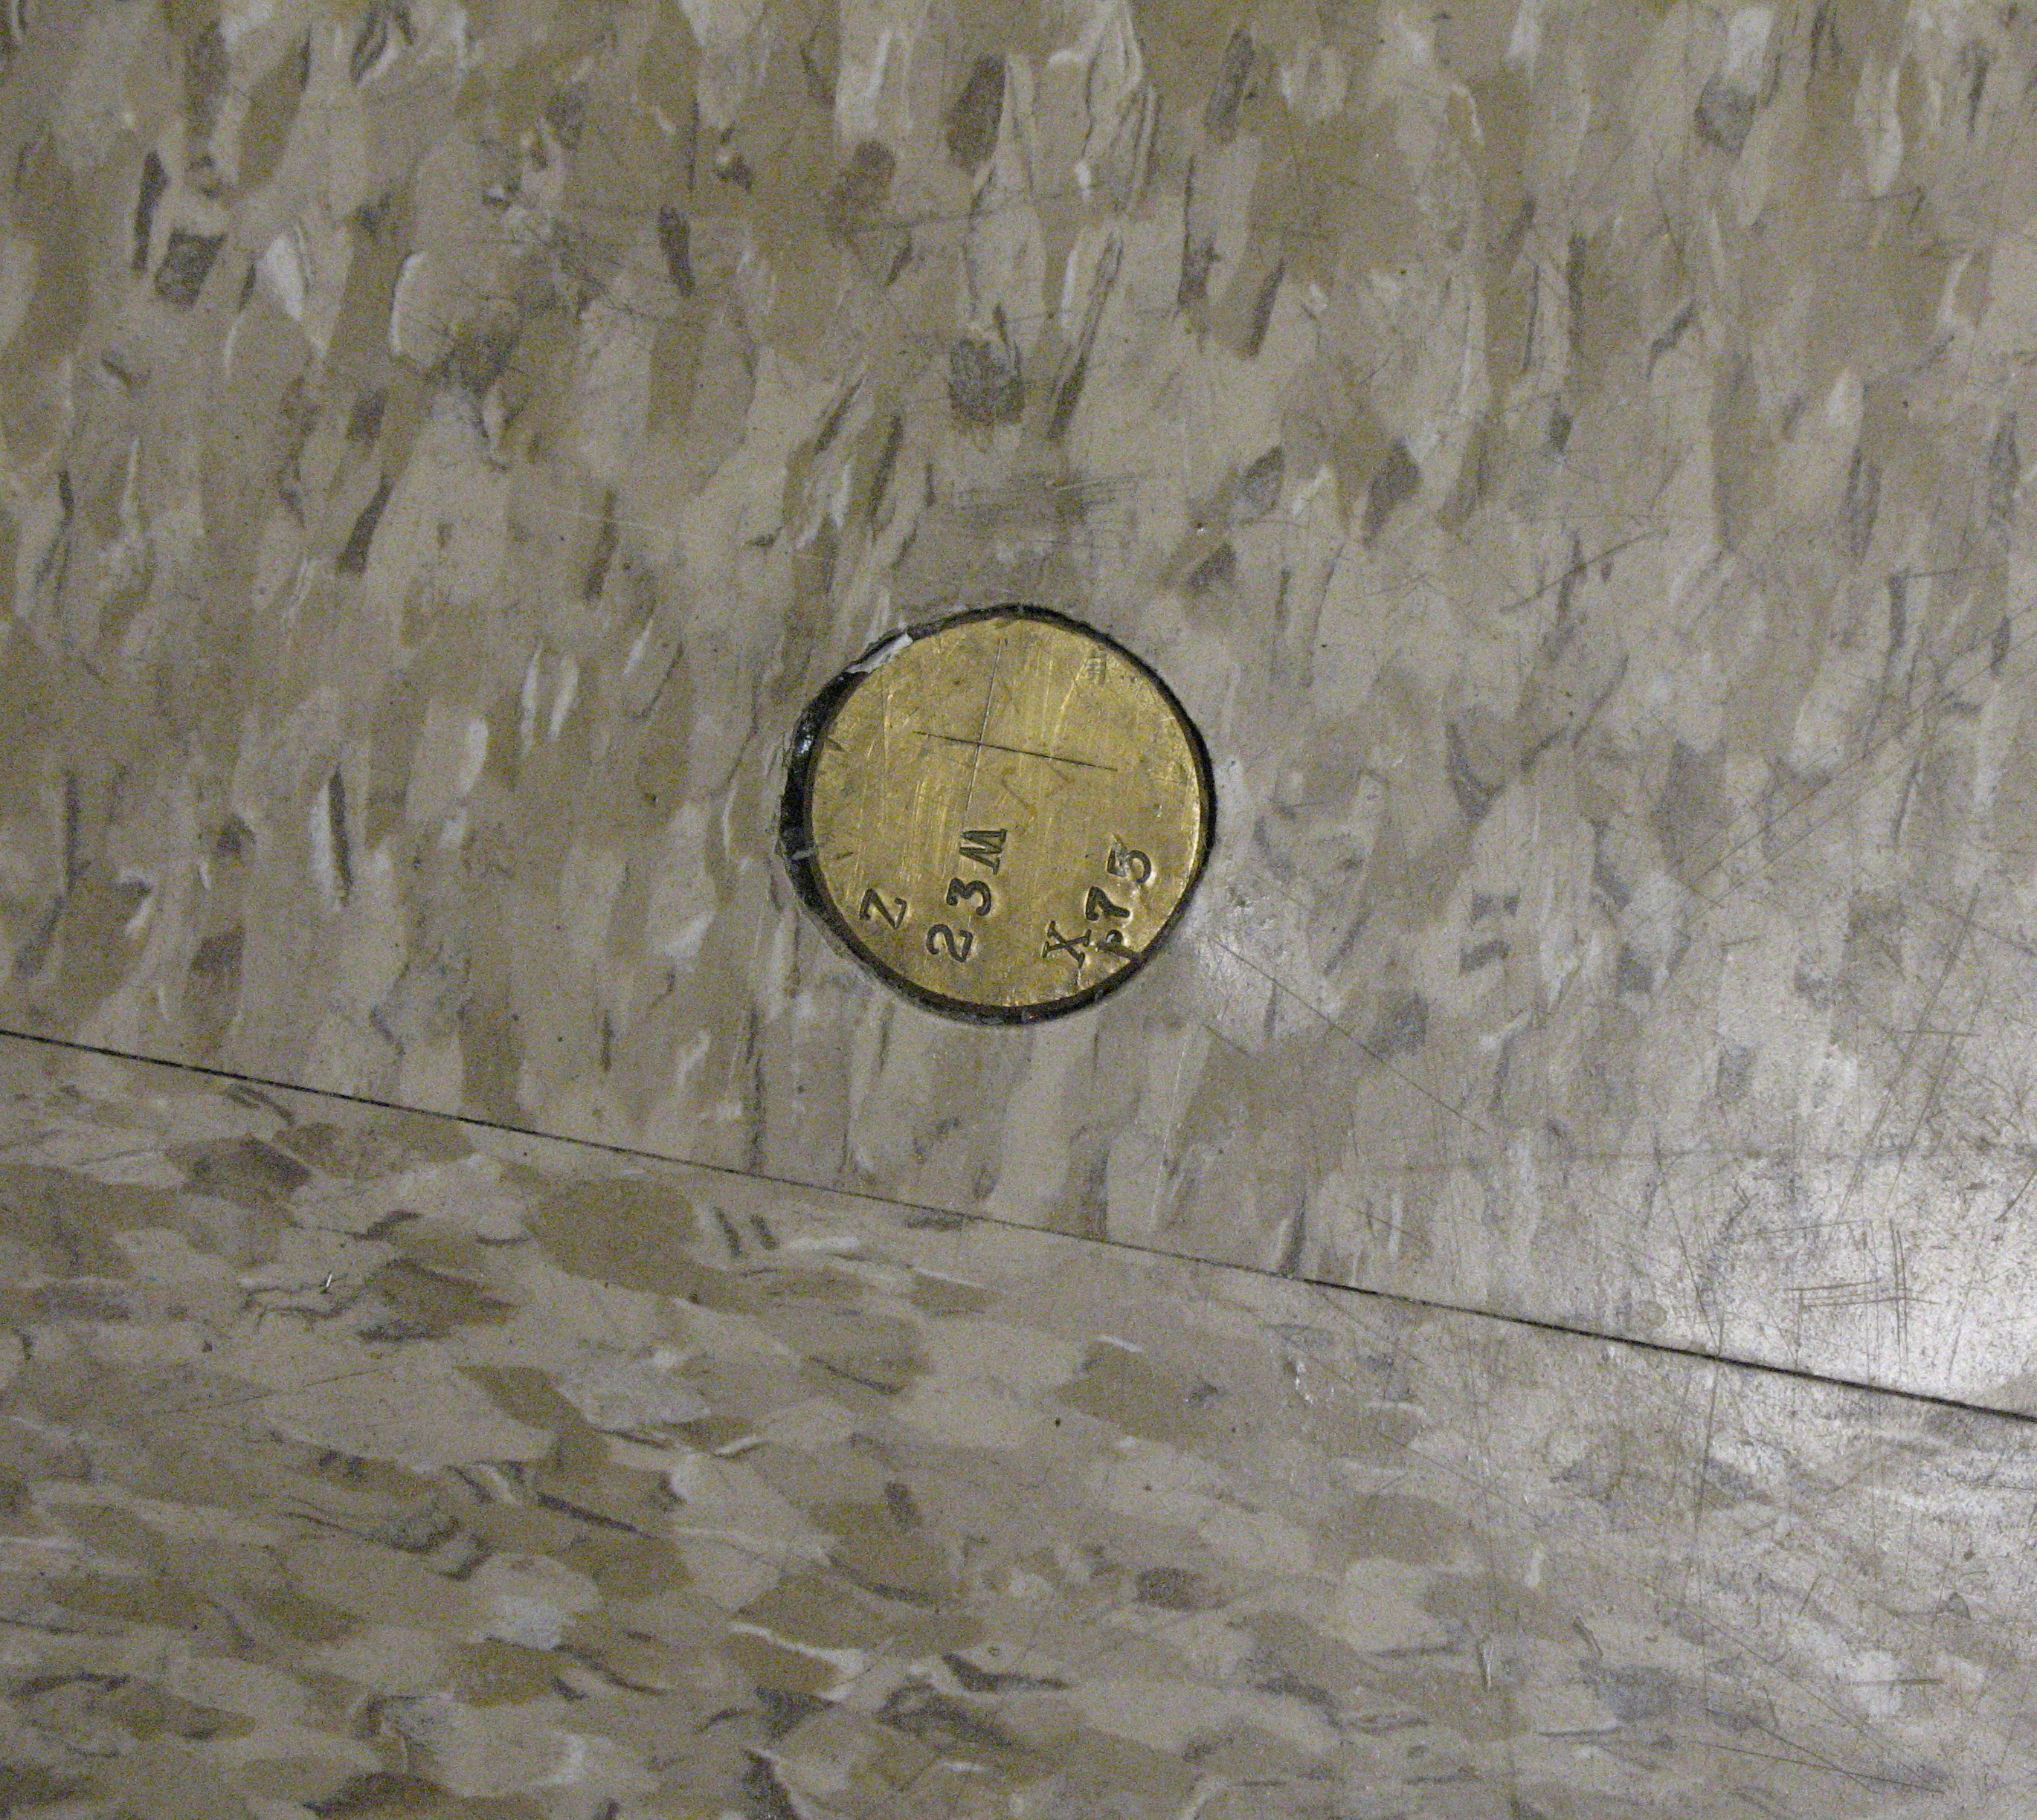

Rivets:

- Floor is drilled with a 5/8” drill bit to a depth of 2” with a Hilti rotary hammer drill
- 5 Minute Epoxy is used to set the rivets
- Generally wait 24 hours before using

Rivets Before Installation

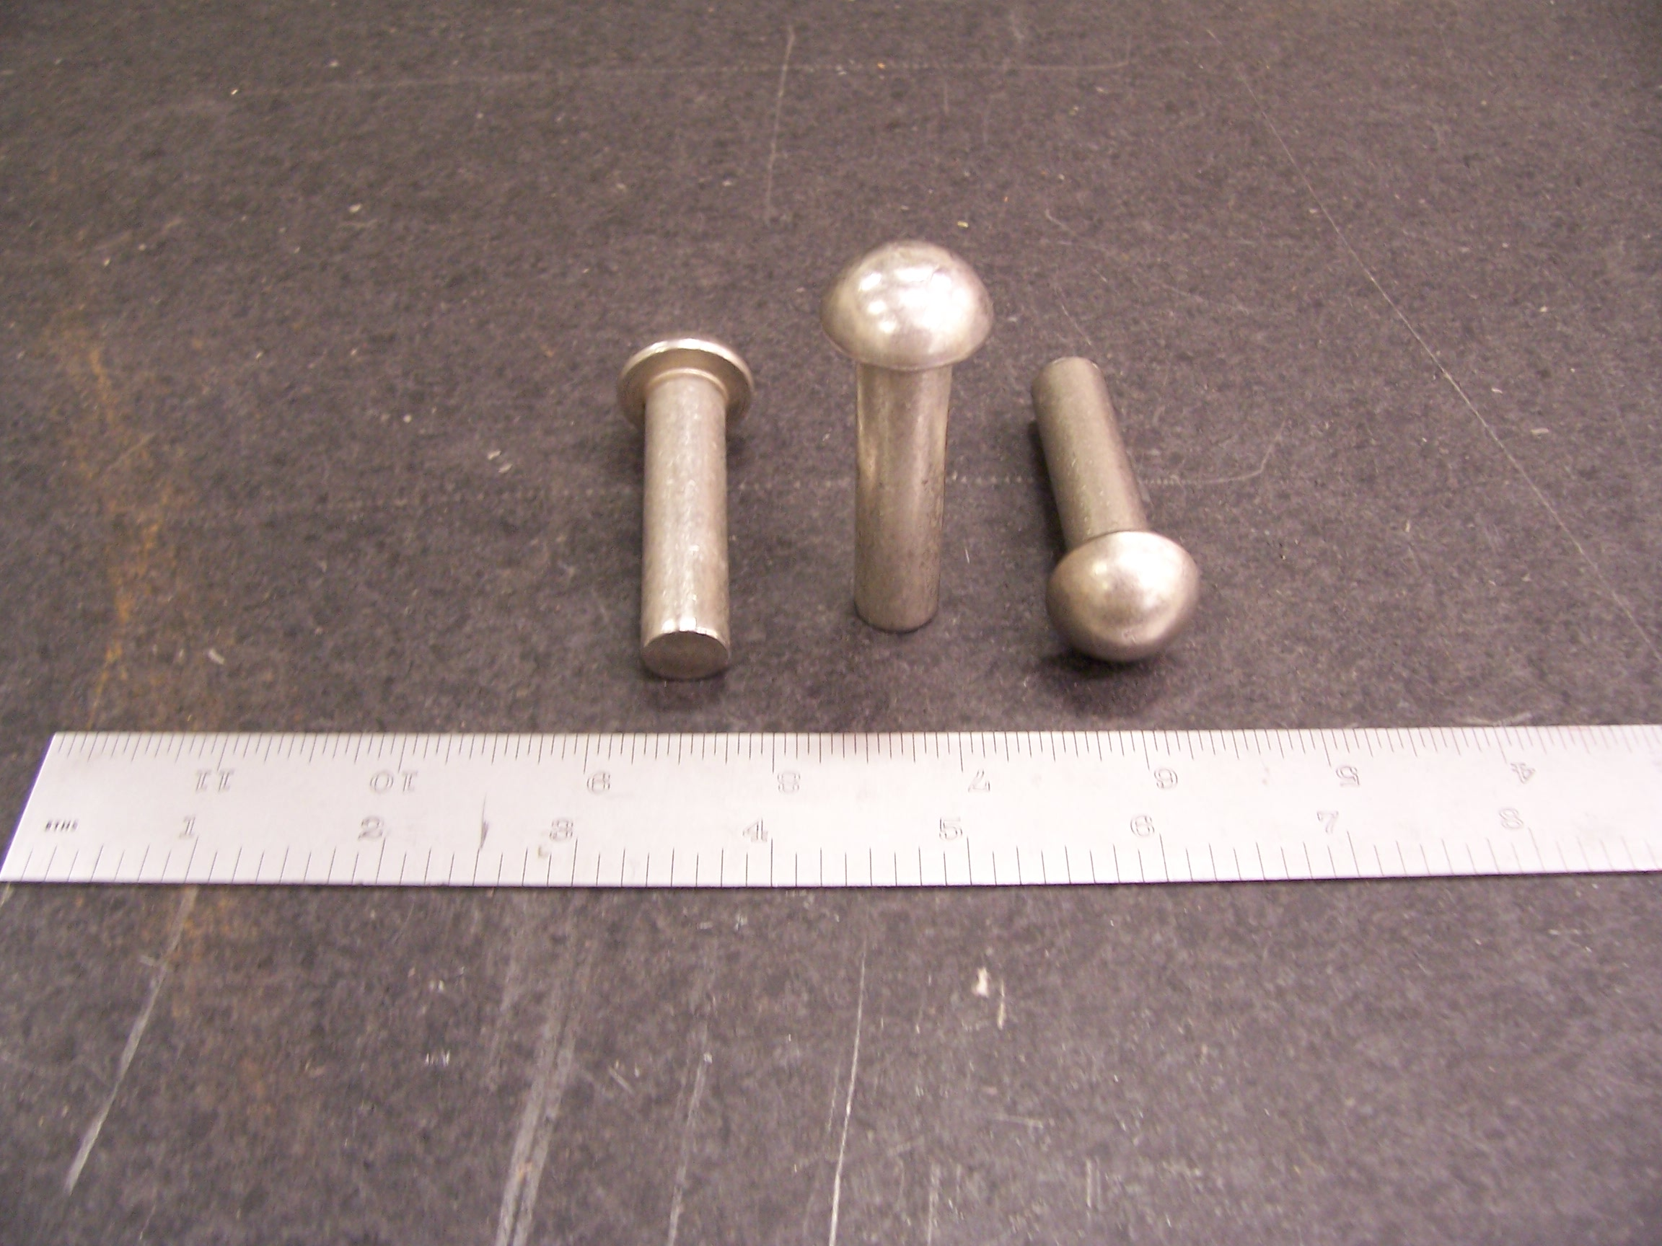

Installed Rivet



