3. Space-charge wave theory

In kinematic theory, which was the earliest formulation describing beam interaction with microwave fields, the fields due to space charge in the electron beam were ignored and calculations were based only the fields produced by the circuit in the beam interaction gap. Energy between cavities was transmitted through ballistic electron motion. Kinematic theory does not provide the tools necessary to analyze the small-signal behavior of multicavity klystrons. For this, a small-signal space-charge waves theory is necessary.
In what follows, we shall develop the space-charge wave formulation and employ it to derive expressions that are useful in calculating the gain and bandwidth of multicavity klystrons, and linear beam microwave tubes, in general. We shall also derive an equation for beam loading, which is consistent with Eq. (2-60), but cast in a form that is both more informative, and useful for computer calculations. The theory follows Chodorow, Zitelli, and Wessel-Berg. Derivations are abbreviated. The objective, as in Section 2, is to expose the student or engineer to the origins of design equations and highlight the assumptions that are involved in their derivation. These equations will be subsequently used in examples of actual klystron designs.
The initial basic assumptions are:

- No electron motion or current is assumed to exist along any dimension, other than the z-dimension. This requires the presence of a strong magnetic field, which is almost always the case with modern klystrons.
- The analysis assumes small-signal rf components. Products of rf quantities will be neglected.
- This will be a non-relativistic analysis. Relativistic correction formulae are provided in Appendix 2 (Mathcad code).

All electrical quantities will be written as sums of the dc and ac terms, the ac term being small compared to the dc term (small-signal). Cross products of ac terms will be neglected. The unit system is MKS.

Following are the equations for total velocity, current density and charge density, respectively, dc terms are denoted by the subscript 0. The ac terms u, i and ρ will be functions of the coordinates transverse to the electron motion (x and y in Cartesian coordinates) and the z dependence is exponential, indicating a traveling wave

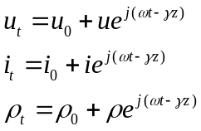∗ (3-1)
We shall derive expressions for space charge waves from three general equations, a) the wave equation for the electric field (derived from Maxwell’s equations), b) the continuity of charge and c) the force equation. Equations, initially in Cartesian and finally in cylindrical coordinates, will be derived for the quantities above and manipulated to find expressions for the wave motion of current between klystron cavities. This is expressed in the form e^{j(ωt-γz)}, representing a traveling wave with a propagation constant γ, which must be derived. It is intuitively obvious that γ will be a function of the space charge, the voltage, the frequency and the geometry of the drift tube. Furthermore, we should be able to derive an expression for the rf current imparted to the beam through velocity modulation by a cavity gap voltage V₁, with the small-signal condition V₁<<V₀, and with space charge taken into account.
The effect of the space charge is to act as an elastic medium between the concentrations of electrons (bunches) which form as a result of velocity modulation. The result is the formation of waves similar to those formed in spring-weight systems. In the early days of klystrons, the RF current calculated as in (2-18) was reduced by a “debunching factor” sin(hz)/hz, where z was the distance from the center of the cavity gap (with the V₁ modulating voltage) where the current was calculated, and h/2π was known as the “wave number”. In the derivations which follow, h will be replaced by its modern equivalent ω_{p}, the “plasma frequency”, a function of the charge density ρ, and modified further by a reduction factor R, which takes into account the effect of the drift tube walls in reducing the effects of the space charge between bunches (hence increasing the rf current which was reduced by the “debunching factor”.
Let us repeat here Eq. (2-18), which is a large signal expression of the fundamental current in a beam which has been modulated by a klystron cavity.

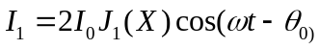

the series representing the Bessel function reduces as follows, for V₁<<V₀,

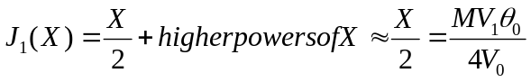..

The magnitude of small-signal current, reduced by the “bunching factor”, would then be,

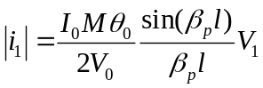

We shall now derive the above formula and show that β_{p} must be modified by the presence of a drift tube. The mathematics follows.

The electric field in the drift tube is ,

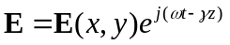 (3-2)

As indicated above, γ is  the unknown propagation constant, whose value is to be determined. We begin with the inhomogeneous wave equation (i.e., a differential equation containing “sources”, involving the charge and the current to the right of the equal sign). It is the equation that governs the operation of every electron device.

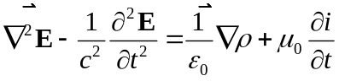 (3-3)

where c is the velocity of light, ε₀ and μ₀ the permittivity and permeability of free space,
and k = ω/c is the wave number in free space.

We will work with the z-components of the vectors E, i and ∇ . The other components can be derived from E_{z}. We then have (in Cartesian coordinates),

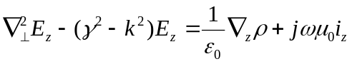 (3-4)

where,
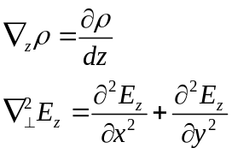 (3-5)
The objective in what follows is to eliminate ρ and i_{z} from (3-4) and obtain an equation in E_{z} alone. The equation of continuity is,

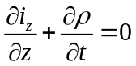 (3-6)
which can be written (from Eq. 3-1)

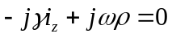 (3-7)

If we write current and space charge as the sums of dc and small-signal rf quantities, and neglect products of rf current and rf charge. In what follows the z-subscripts will be omitted for current and velocity.

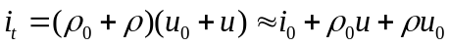 (3-8)

and

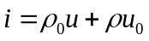 (3-9)

The force equation is (neglecting the term 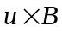 (which is negligible, except for relativistic velocities), and where η= e/m

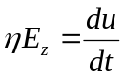 (3-10)

The total velocity derivative with time in the equation above needs to be distinguished from the partial derivative used to observe the behavior of the beam at a fixed point. The total derivative of u(z,t) is equal to the sum of changes, both with time and distance.

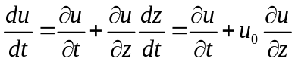 (3-11)

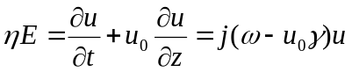 (3-12)

We now need to eliminate ρ and i from (3-4) and reduce it to a homogeneous form. To do that, we require two more relationships. From (3-7) and (3-9)

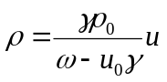 (3-13)

and

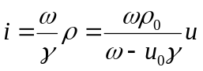 (3-14)

Substituting for u in both equations above from (3-12) we have

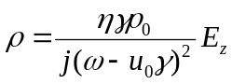 (3-15)

and

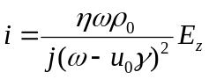 (3-16)

Substituting these into , we obtain, omitting much of the arithmetic, and using
c² = 1/ε₀μ₀ (velocity of light),

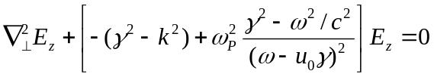

which can be finally written as

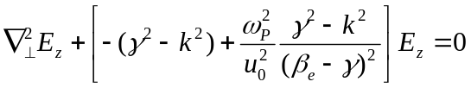 (3-17)

We re-introduce the electron wave number β_{e} = ω/u₀, and define the plasma frequency,

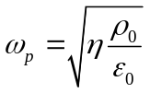 (3-18)
We thus have obtained a homogeneous wave equation of the form

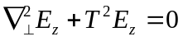 (3-19)

and defining β_{p} = ω_{p}/u₀ the plasma wave number,

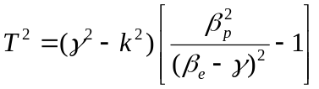 (3-20)

The propagation constant γ continues to be the unknown to be determined.

To solve (3-20) we must specify appropriate boundary conditions. Depending on the coordinate system, the solutions will be trigonometric or Bessel functions. They will be summations over the T_{n}’s, with four separate β_{n}’s to be calculated from each T_{n}, since (3-20) is quartic in β. Before deriving a useful solution, let us consider the case of an infinite beam, with no transverse dimension variations. Then, (3-19) becomes

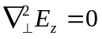 (3-21)

which requires T = 0 and results in the following values for the propagation constant: from (3-20). The first pair of roots is

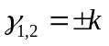 (3-22)

The second pair is, from (3-20)
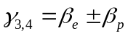 (3-23)

The first two solutions are obviously plane waves in free space, traveling with the velocity of light. The second two are plasma waves with propagation velocities above and below the beam velocity. There are no transverse boundary conditions to be considered since the transverse space is infinite. The overall solution of equation (3-21) must include all four solutions, properly matched to the initial conditions at z = 0. If we write for the velocity

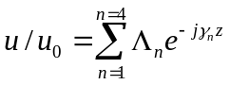 (3-24)

then from (3-14)

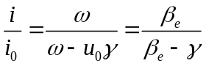 (3-25)

and

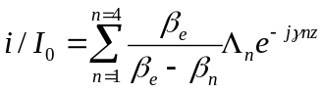 (3-26)

The Λ_{n}’s (lamdas) are constants to be determined from the boundary conditions for velocity and current at z = 0. At the boundary z = 0, the total velocity is based on the approximation first used in Eq. (2-4). The current is zero. Using the definition for the β_{n}’s,

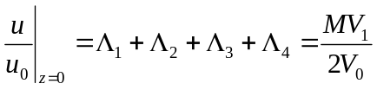 (3-27)

and
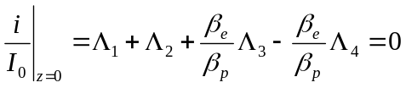 (3-28)

The equations above have the solutions

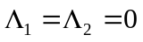

and

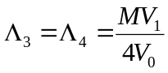 (3-29)

The rf current in the beam can then be written as

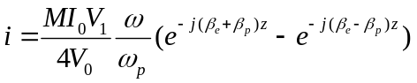

and finally

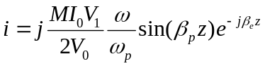 (3-30)

This is close to the desired result, except of course we need an expression for a cylindrical or sheet beam, not one of infinite dimensions.

For a pencil beam, not filling a cylindrical drift tube, the solution in cylindrical coordinates contains ordinary Bessel functions (J_{o}) in the beam and modified Bessel functions (I₀, K₀) in the region between the beam and the drift tube.

This equation has, as before, four solutions, of which two correspond to perturbed waveguide modes, and the other two to space-charge waves. We will make the assumption that the former have velocities almost equal to velocity of light, and hence that βe>>k, and Eq. (3-20) then becomes,

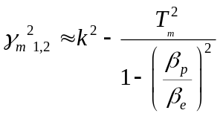

which are perturbed waveguide modes, and reduce to these if β_{p}=0

For the plasma wave modes, we can set γ ≈ β_{e} , except for the difference between the two.
Then,

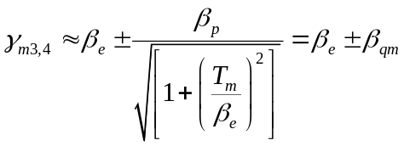

and, finally,

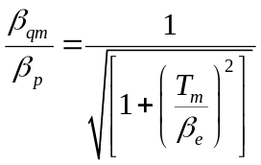

where the ratio of the “reduced plasma frequency “ to the plasma frequency is defined as “R”, the “plasma reduction factor.” To determine R, we must first solve the wave equation (3-19) for the particular geometry of beam and drift tube, and then use
to determine T_{m}. We shall neglect all higher order T’s and use only the T₀ eigenvalue. Branch and Mihran have published solutions and graphs for a number of geometries. For the pencil beam in a cylindrical drift tube, the solution of (3-19) can be determined from the transcendental equation below, which results from matching solutions, at the boundary r = a, inside the beam (J₀s and J₁s) and in the space between beam and drift tube (K_{o}s and K₁s).

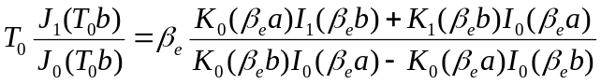 (3-31)

where a and b are the drift tube and beam radii, respectively. A graphical solution for this case is shown in (Fig 12), which plots the plasma reduction factor against β_{e}a, with a/b as a parameter. The factor R is usually less than 0.5.

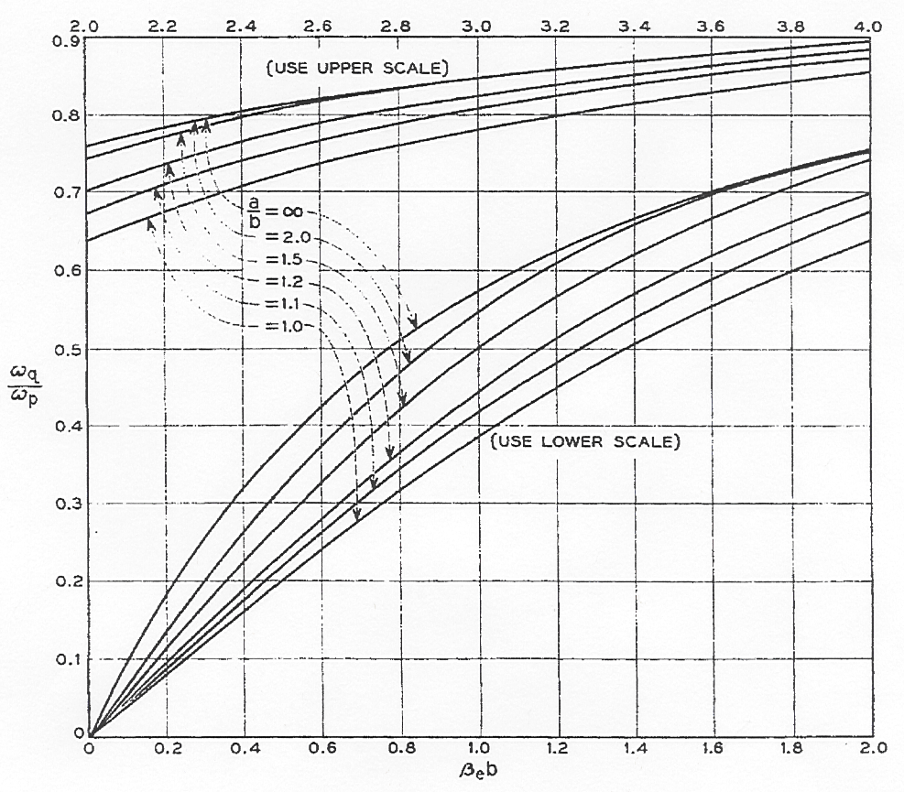

Using a similar procedure as in the case of no drift tubes, it can be shown that the current is the same, with β_{q} substituted for β_{p}. The drift tubes is assumed to be cut off.

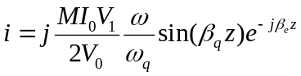 (3-32)

A similar equation can be used to determine the plasma reduction factor for a sheet beam of thickness t centered between parallel plates spaced by a distance W. In rectangular coordinates, the transcendental equation corresponding to (3-31) is

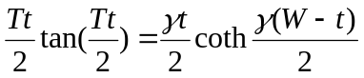 (3-33)

It should be remembered that Equations (3-31) and (3-33) contain the approximation 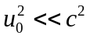 and are therefore not relativistic. A simple relativistic correction is not readily available, but the correction is not thought to be significant.

Having derived expressions for the plasma reduction factor R, we can now proceed to analyze the interaction between beam and rf circuit in one dimension, using plasma theory. We shall consider only the z-dimension, along the path of the electron beam. This is not restrictive, because formulae exist, e.g. Eq. (2-59), which average beam parameters over the beam, when transverse dimensions matter; and computer simulations do the same thing, even more accurately. Higher-order modes in the drift tubes or in the circuits with which the beams interact are also neglected. Drift tubes are cut off below the operating frequency. Beams are assumed “cold,” with no thermal velocities.
The mathematical treatment follows Wessel-Berg, who, in addition. However, we shall only follow it long enough to show the method and jump to the final, very useful, beam-loading formula. This reduces to the G_{b}/G₀ formula derived in Section 2.
The objective is to derive equations relating gap fields to the voltage, current and plasma density of the beam interacting with these fields. Although the mathematics are similar to those employed in the kinematic theory of Sec. 3, the concept of positive and negative energy space-charge waves provides important insight to the operation of the klystron.
We proceed as earlier in this section by using the equations for continuity (3-6), current (3-9) and force (3-10). Wessel-Berg defines the “kinetic voltage” U(z)

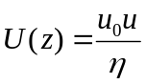

We are omitting z-subscripts since s is the only dimension. We can then write, after some algebra

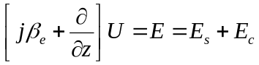 (3-34)
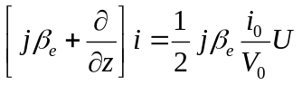 (3-35)

where E_{s} is the field due to the space charge and E_{c} is the circuit field. These will be used to relate the detailed gap fields to electron motion and eventually derive expressions for energy transfer and beam loading.
Now, notice that E_{s} can be related to the current i through the Maxwell equation .

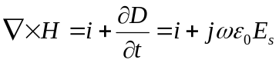 (3-36)

Taking the divergence, which is zero, we obtain for the truly one-dimensional case, where there are no transverse fields and the z-dependence of field and current are the same,

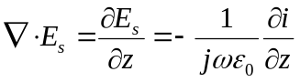 (3-37)
Integrating,

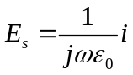 (3-38)

Recall that in the earlier three-dimensional derivation, where there were no circular fields and E_{z} was equivalent to the present E_{s}, we obtained Eq. (3-16). This can be rewritten as,

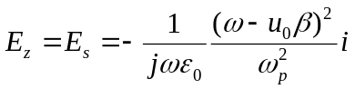 (3-39)

In the case where the beam does not fill the drift tube, we write, as before,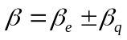. Then,

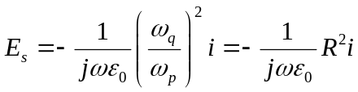 (3-40)

Comparing (3-40) with (3-38), we see that for a finite beam, the effect of the radial field leakage to the walls of the drift tube is to reduce the longitudinal space-charge field E_{z} by R², a number less than unity, previously derived. The effect of the walls is illustrated in the figure below, which shows how the field between bunches are weakened by the drift tube wall.
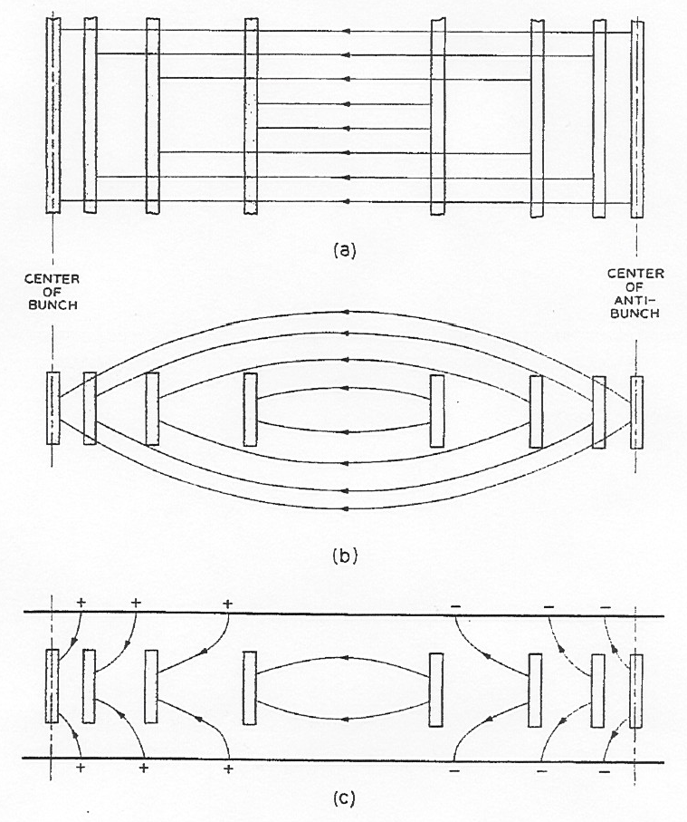

Wessel-Berg now defines a quantity W as the “beam characteristic impedance”

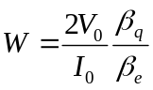 (3-41)

Then, after manipulating, , and the expressions for 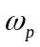and R

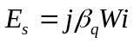 (3-42)

Further, equations (3-37) and (3-38) become

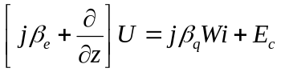 (3-43)

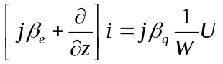 (3-44)

Wessel-Berg uses both of these equations in analogy to transmission line equations to further develop details of the space-charge theory. He combines them to form a second order equation for the current i, and drops the partial signs, since the only variable is z.

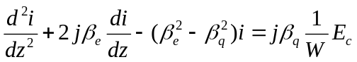 (3-45)

He then assumes a two-cavity klystron with interaction regions 1 and 2, centered at z = 0 and z = l₁₂, with lengths 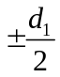 and 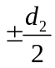 (these are not gridded gaps, only regions with z-varying axial electric fields). He calculates the current at 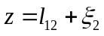 in the second cavity. Using Laplace transforms, Equation can be integrated subject to the initial conditions, 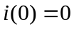 and 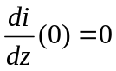 to give

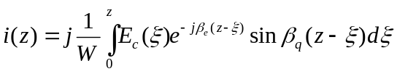 (3-46)

The integration only needs to be performed over the gaps, where the circuit fields are E_{c1} and E_{c2}. The fields are zero elsewhere. The result is,

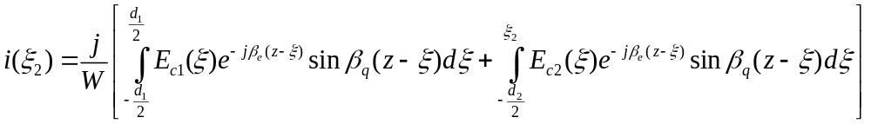 (3-47)

Considerable algebra then follows, where the sine functions are expanded into their exponential equivalents two coupling coefficients are defined, for a slow and fast space-charge waves, as follows

Slow wave 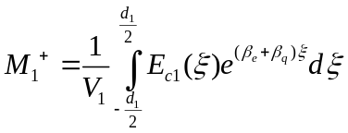 (3-48)
Fast wave 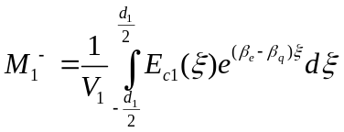 (3-49)

We add another short-hand notation for simplicity,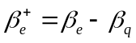, and 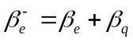. There should be no confusion about the plus and minus signs, since a lower propagation constant indicates a higher velocity and hence a fast wave. We now have

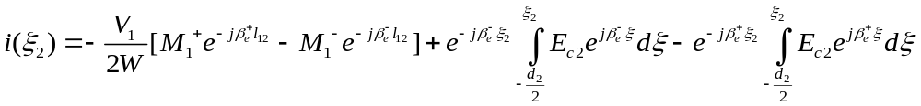 (3-50)

The significance of the above equation is the following: The current in the interaction Region 2 is composed of a superposition of fast and slow space-charge waves originating in Region 1, as a result of the voltage V₁ there, plus currents originating in within
Region 2
The complex power imparted or extracted from the beam at Region 2, is given by the following expression

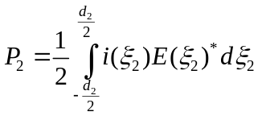 (3-51)

This, and a great deal of algebra is used to arrive at the final result,

(3-52)

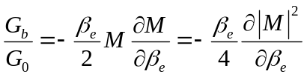 (3-53)

Equation above, which was derived by the ballistic theory, can be shown to be equivalent to as 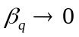 by recognizing that

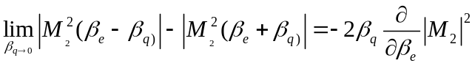 (3-54)

Equation (3-52), along with (3-48) and (3-49) are fundamental to the design of extended interaction klystrons, since they can be used for testing a circuit for stability. A negative value for G_{b} can imply a “monotron” instability. This is a condition where the exchange of energy between beam and circuit is such that net energy flows to the circuit, which will develop excessively high fields, i.e. an oscillation, unless it is sufficiently loaded or sufficiently lossy.
The values for Gb/Go calculated by (3-52) and by the kinematic formula (2-62) are almost identical for realistic values of the beam perveance. However, (3-52) is more general and can be evaluated by the same method as the coupling coefficient M, i.e. by using (2-33) and numerical integrations using tabulated E_{z} values from a SUPERFISH simulation of the cavity fields.

 In Lecture 2, the symbol used for the total current was I_{t}, and for the rf current I₁. These were not necessarily small-signal currents. Here, everything is small-signal and lower-case letters will be used. Naturally, i₀ is identical to I_{o}.

