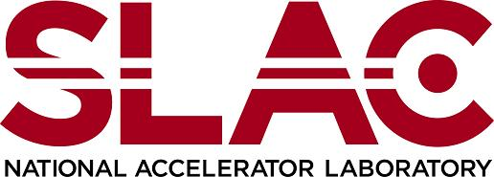  Environment, Safety & Health Division | Chapter 40: Chemical Lifecycle Management  Storage Area Inspection Form  Product ID: 217 | Revision ID: 2389 | Date Published: 26 May 2021 | Date Effective: 26 May 2021  URL: https://www-group.slac.stanford.edu/esh/eshmanual/references/chemmanageFormStorageInspect.pdf | docx
Monthly inspections must be carried out by the chemical storage asset custodian or designated person for all chemical storage assets and areas. (See Chemical Lifecycle Management: Chemical Storage Asset Requirements [SLAC-I-730-0A09S-018].)
For remote areas that are not visited daily, these inspections must be documented and the results kept on record for a minimum of one year and made available to ESH when requested. The following form may be adapted to meet the specifications of your storage area, but all basic inspection elements must be included.
Note When a storage area contains both hazardous materials and waste, the most restrictive combination of inspection requirements applies. For inspection requirements for hazardous waste storage areas and waste containers, see Chapter 17, “Hazardous Waste”.

Documenting Inspection Results
- Enter the inspection location on the form. If the location is new, or information is missing or out of date, inform the chemical lifecycle management program manager or the ESH coordinator of any updates.
- Each month, enter the date and your initials and place a check in every square that applies to this location if the condition meets all safety requirements. The form accommodates 12 inspections, or one full year.
Note If the item does not apply, cross the section out. For example, if there are no compressed gas cylinders (CGCs), mark one large line or X through the section. Alternatively, modify the form to meet more closely the conditions of the storage area.

Inspection location:

Inspection Date | Inspector’s Initials | Storage Area |  |  |  |  | All Containers |  |  |  |  | Additional Inspection Items for Compressed Gas Cylinders (CGC) |  |  |  |  | Observations / corrective action  (list full details on back of form)
 |  | Storage area has proper signage and signs are legible | Storage area free of spills and leaks and containers are not in contact with standing water | Eye wash\safety showers serviced and tagged (weekly) | ER equipment and spill kits functional and maintained | Fire extinguishers serviced and tagged (monthly) | Containers properly labeled and labels are legible | Containers free of damage, residue, or corrosion | Appropriate secondary containment is in place | Containers sealed with tight-fitting lids/bungs | Incompatibles properly segregated | CGCs double-chained to rack or wall or approved alternate | CGC valves closed and fitted with safety caps | CGCs containing toxic or flammable gases leak tested (monthly) | Empty CGCs labeled “empty” and segregated from CGCs containing product | CGCs well ventilated, not blocking exits or near a heat source (>125 F)

Observations and Corrective Actions Log
Inspection Date | Inspector Initials | Observation or Comment | Corrective Action Required | Date Action Completed

